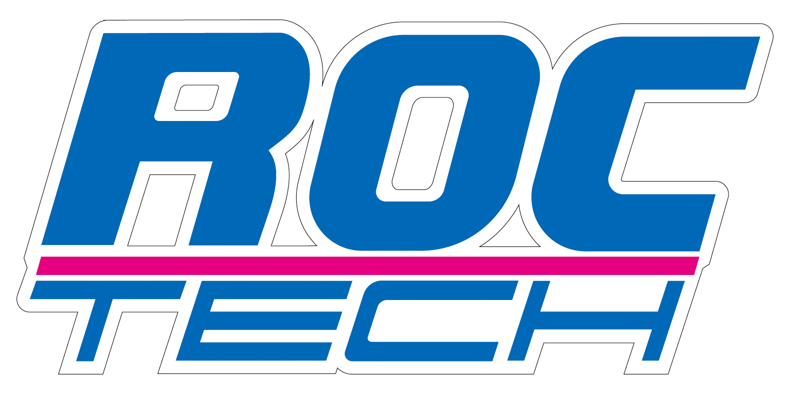

ROCTECH MACHINERY CO., LTD.

Professional supplier for CNC Routers, CNC Laser machines

HIGH PRECISION, HIGHER SPEED, FAST SERVICE

www.roc-tech.com
s_yue@roc-tech.com
From: Roctech Machinery Co., Ltd

Woodworking Machine RC1325S-ATC

- The 9.0 KW HSD ATC (Auto tool changer) spindle is original from Italy

2. The Delta inverter is original from Taiwan, the Schneider contactor is original from France. Syntec control system is original from Taiwan.

3. Carrousel tool magazine moving with the gantry

- The Omron limit sensor is original from Janpan.

5. Taiwan TBI 2510 ball screw:

6. 850W Yaskawa Servo motors original from Japan.

7. Strong side board

8. Hiwin linear and block, original from Taiwan.

9. 5.5Kw Air cooling Vacuum pump, with high-quality form China.

10. Control system: Syntec control system is original from Taiwan

- Rotary system for cylinder materials, maximum can carry 200mm Diameter, 2000mm length,
Sistema rotatorio para materiales de cilindro, máximos puede llevar a 200 mm de diámetro, los registros de longitud 2000mm
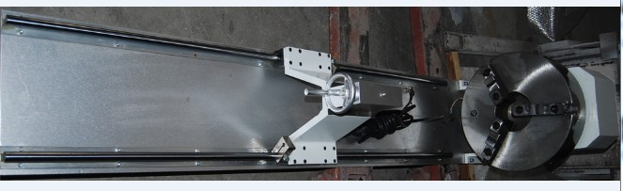

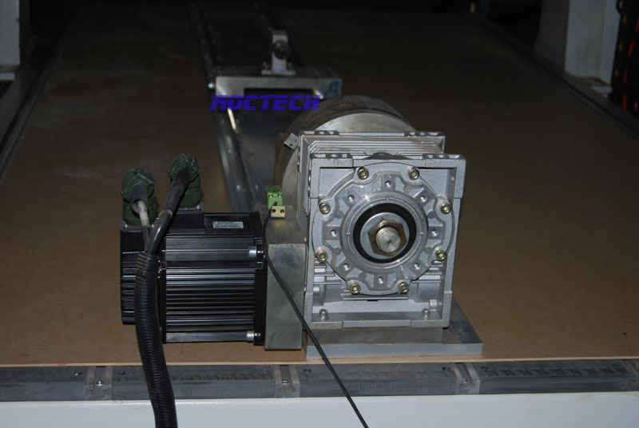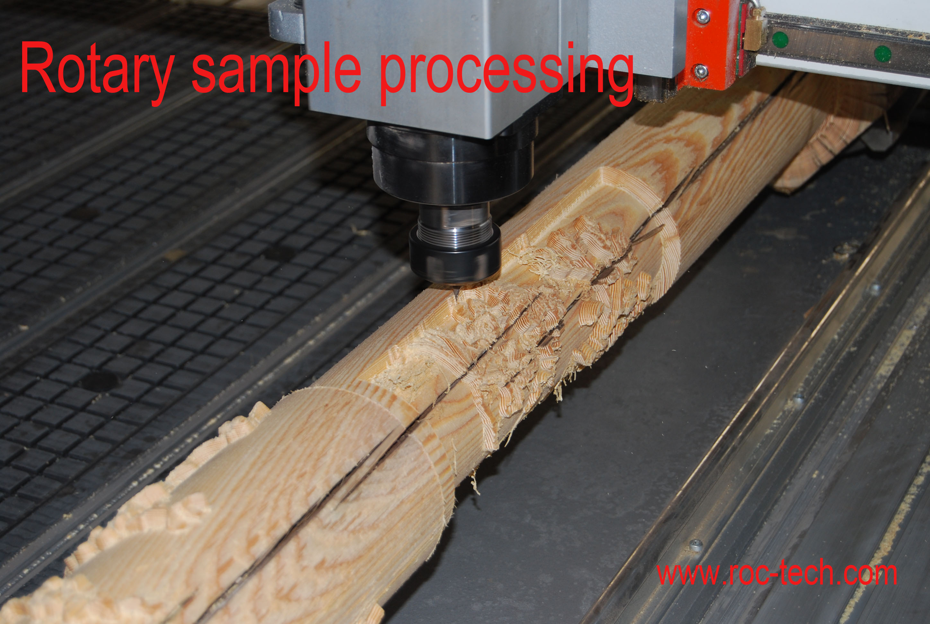

This is the quotation of the machine:
CNC Router RC1325S-ATC
Big Steel tube frame
1300mm x 2500mm x 250mm
Rack and Pinion transmission
SYNTEC control system
X, Y transmission: rack and pinion, Hiwin linear (20mm diameter)
Z transmission: ball screw (25mm diameter, 10mm lead), Hiwin linear
Separated control box
850w Yaskawa servo motor
9.0kw HSD ATC spindle
11.0 kw Delta inverter
Carrousel tool magazine loaded on gantry
Tool holder x 4pcs
Tool holder fork x 8pcs
Vacuum & T-slot table
5.5kw vacuum pump air cooling
3.0kw dust collector with 2 bags
Lubrication system
Mist cooling system
Rotary system (200mm diameter * 2000mm length, servo motor)

The FOB Qingdao price is 31,100.00 USD.

CNC Machine RC1325-ATC

The tool holder forks (6 pieces)
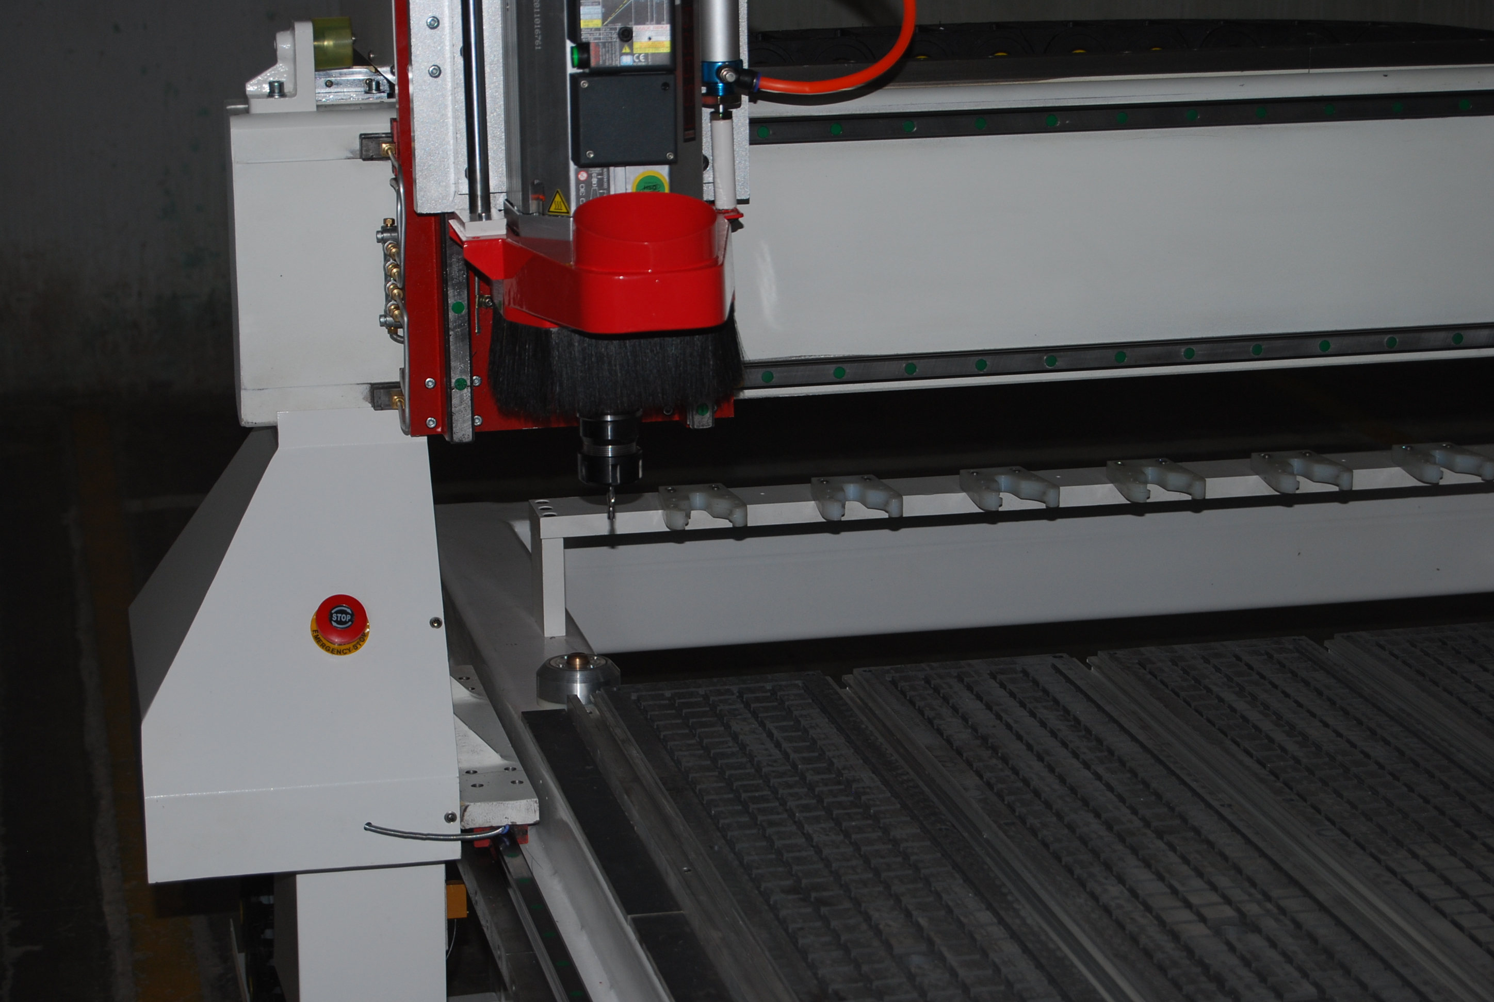

CNC Router RC1325-ATC changing on linear
Big Steel tube frame
1300mm x 2500mm x 200mm
Rack and Pinion transmission
Syntec control system
X, Y transmission: rack and pinion, Hiwin linear (20mm diameter)
Z transmission: ball screw (25mm diameter, 10mm lead), Hiwin linear
Separated control box
850w Yaskawa servo motor
9.0kw HSD ATC spindle
11.0kw Delta inverter
Tool holder x 4pcs
Tool holder fork x 6pcs
Vacuum & T-slot table
5.5kw Vacuum pump air cooling
Lubrication system
Mist cooling system
Rotary system (200mm diameter * 2000mm length, servo motor)

The FOB Qingdao price is 24,200.00 USD.

