
HUADA
Add.: Industrial Building, Huaqiao University, Quanzhou City, Fujian, China
Tel: +86-595-22691763 Fax: +86-595-22692763
E-mail: diamond@hqutool.com Website: www.hqutool.com

Quotation
1-1. AUTOMATIC wire saw machine for marble quarry
Model | Main motor power | Length of wire (m) | Line speed (m/s) | USD/set
DWS-37AX-6P | 37kw (50HP) | 20~80 | 0~40 | 15,400
DWS-45AX-6P | 45kw (60HP) | 20~100 | 0~40 | 16,700
DWS-55AX-6P | 55kw (75HP) | 20~120 | 0~40 | 18,700
Function: | 1. Controlled by dual inverter + PLC, make the diamond wire saw strain constantly and the speed of moving truck automatically controlled.  2. When under the automatic control state, the machine can track changes in the load so as to make the diamond wire saw work efficiently all the time by adjusting the move speed of the machine.  3. Protect the diamond wire saw from break, overload, lack of phase, terminal limit.  4. Easy-operating functions of electric turnover, electric horizontal movement and quick moving.
Accessory: | three pieces rail(2 m*3)/ one pc of big fly wheel and four pcs of small flywheels/ one pc hydraulic presser/ one pc scissor
Remark: | Both the line speed and move speed can be automatically changed.

1-2. AUTOMATIC wire saw machine for granite quarry

Model | Main motor power | Length of wire (m) | Line speed (m/s) | USD/set
DWS-37AX-8P | 37kw (50HP) | 20~80 | 0~30 | 15,700
DWS-45AX-8P | 45kw (60HP) | 20~100 | 0~30 | 18,600
DWS-55AX-8P | 55kw (75HP) | 20~120 | 0~30 | 19,700
Function: | 1. Controlled by dual inverter + PLC, make the diamond wire saw strain constantly and the speed of moving truck automatically controlled.  2. When under the automatic control state, the machine can track changes in the load so as to make the diamond wire saw work efficiently all the time by adjusting the move speed of the machine.  3. Protect the diamond wire saw from break, overload, lack of phase, terminal limit.  4. Easy-operating functions of electric turnover, electric horizontal movement and quick moving.
Accessory: | three pieces rail(2 m*3)/ one pc of big fly wheel and four pcs of small flywheels/ one pc hydraulic presser/ one pc scissor
Remark: | Both the line speed and move speed can be automatically changed.

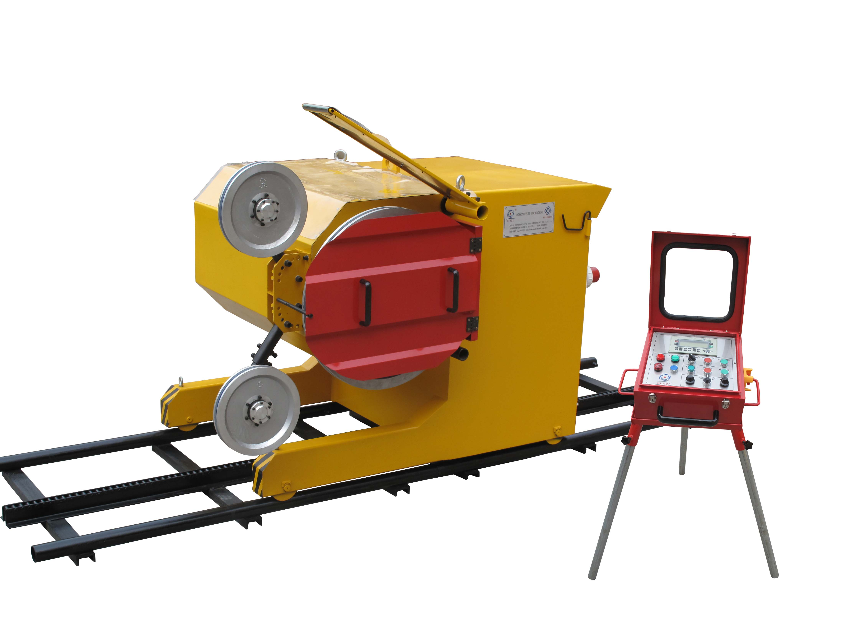

2. D-T-H Drilling Machine
Model | Pneumatic D-T-H Drilling Machine  [QZ65-90B] | Pneumatic & Electric D-T-H Drilling Machine  [QDZ65-90B]
Max. depth of drilling | 35~40m | 35~40m
Diameter of drilling | 90mm | 90mm
Drilling speed | 6~8m/h | 6~8m/h
Minimum air pressure | 0.5~0.7MPa | 0.5~0.7MPa
Total compressed air consumption | 12~14m³/min | 7~9 m³/min
Track travel | 1m | 1m
Advance device | Pneumatic motor, reducer, chain | Pneumatic motor, reducer, chain
The pneumatic rotation head | Pneumatic motor, reducer | Motor, reducer
Drilling direction | Any direction | Any direction
USD/set | 5450 | 5250
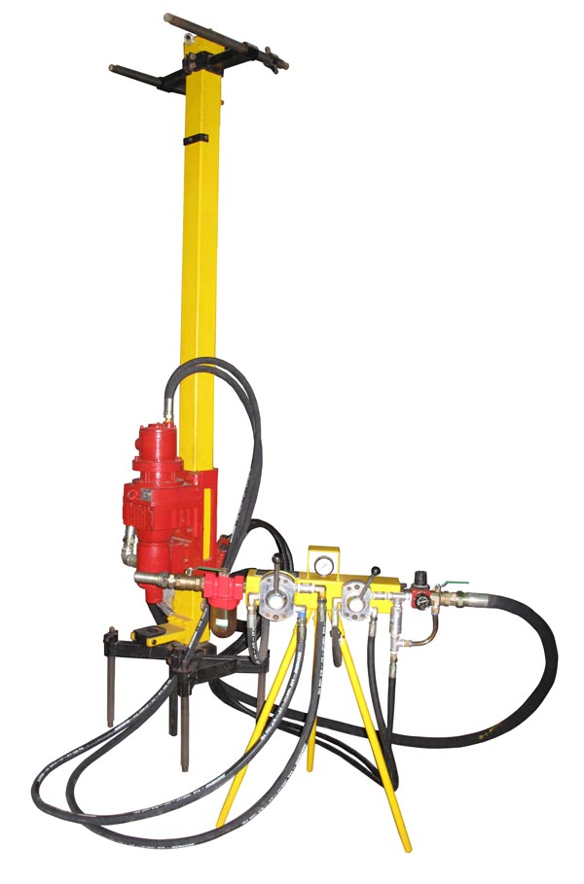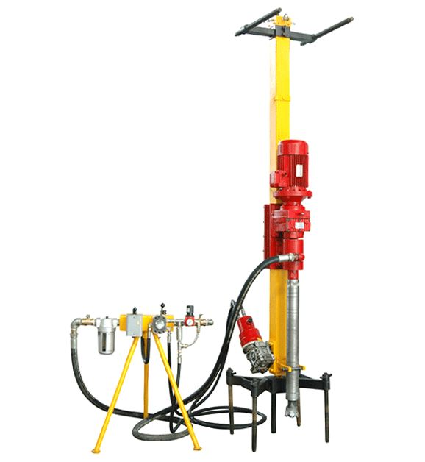

3. Horizontal Core-boring Machine
Model | WQZ80 | WQZ80B
Drilling hole diameter | 80mm | 80mm
Max. drilling length | 40m | 40m
Speed of drilling hole | 3~12m/h | 3~12m/h
Min. water supply pressure | 0.1MPa | 0.1MPa
Single advance stroke | 1.5m | 1.5m
Rotation device | Motor + reducer | Motor + reducer + inverter
Advance device | Chain + reducer | Chain + reducer
Drilling direction | Horizontal | Horizontal
Control method | Moving automatic control  Main motor constant speed | Moving automatic control  Main motor speed is adjustable
USD/set | 4950 | 5750
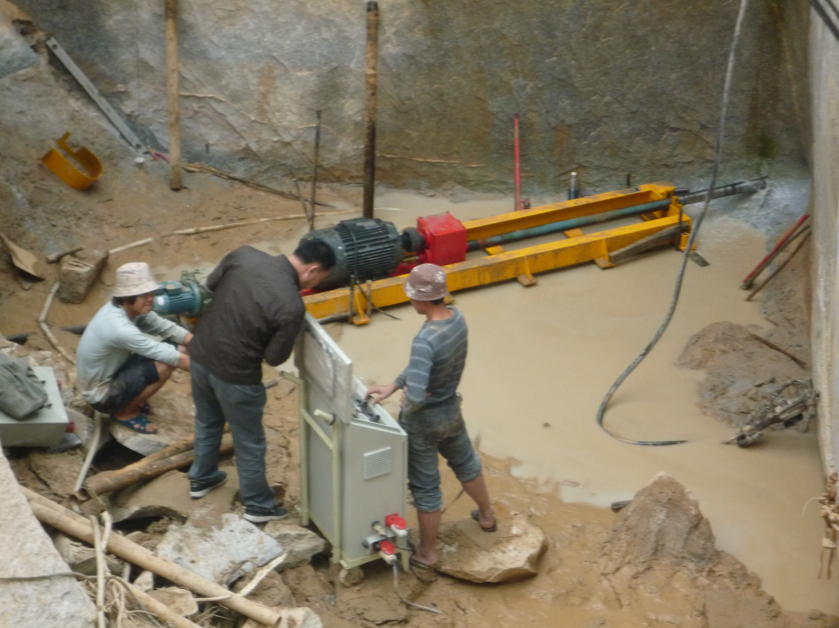

4. Diamond wire saw for marble/granite quarry
Specification | USD/meter
11.5mm, rubber, 40 beads/meter | 47(marble) 50(granite)
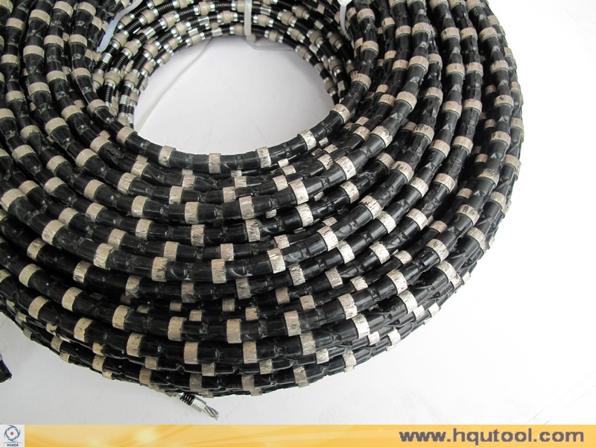

Price term: Ex work
Payment terms: 30% T/T in advance, the balance 70% T/T before shipment
Delivery time: within 30 days after receiving deposit
Package: carton and crate

