WATERJET TECHNOLOGY CO., LTD
Tel: +86-517- 83717533 FAX: +86-517-3717-532
Mobile: +86-1385-23-437-31 Website: http://www.xshcn.com
E-mall：sunrisecutting@hotmail.com

3 axis CUX4002515
PRICE: USD45000 FOB SHANGHAI
TIME OF SHIPMENT: we can arrange shipment within 30work days after receive 30% payment in advance.
TERMS OF PAYMENT: 30% TT paid as advanced payment, 70% TT paid before shipment.
INSTALLATION AND TRAINING:
We will dispatch one or two engineer to install and train for 7 days. Customer bear round-trip tickets and accommodation, we charge USD100/day for engineer.
WARRANTY: Guarantee period of machine is one year from the date of commission of the machine, we will arrange free replace of any defective parts. During guarantee period, this guarantee will not cover wearing parts, consumable parts and also failures cause due to Malfunctioning by customer. And customer should strictly follow instructions and of our engineer and instructions.
You got below specifications:

ITEM | DESCRIPTION |  | STANDARD CONFIGURATION
 |  |  | BRAND | MODEL
1 | UHP SYSTEM | UHP Intensifier | JE STYLE(USA) | CUX400
 |  | UHP Reversing Sensor | CONTRINEX(Switzerland) | DW-AS-501-P20
2 | LP SYSTEM | 3 Phase AC Motor | WNM(China) | Y2-225S-4-B35
 |  | Displacement Pump | Jing Gong(China) | 63SCY14-1B
 |  | Electro-hydraulicReversing Valve | YUKEN(Japan) | DSHG-04-2N2-T-D24-N1-50
 |  | Eletromagnetic Relief Valve |  | S-BSG-06-2B3B-D24-N1-51
3 | COOLING SYSTEM | Water cooling system | Sunrise(China)
 |  | Panel cooler | Colliers(Taiwan)
4 | CNC SYSTEM | Ball screw | TBI(Taiwan) | SFUR SERIES
 |  | Linear Motion Guide |  | BRH SERIES
5 | CNC SYSTEM | Control System | Washing(China) | 320W
 |  | Program Software | CNCKAD(Israel) | V10.306
 |  | Servo Motor | Yaskawa(Japan) | SGMGV-30ADC61, SGMGV-09ADC61
 |  | Servo Drive |  | SGDV-200A01A, SGDV-7R6A01A
6 | Electron Component | PLC | Siemens(Germany) | S7-200-CN
 |  | Breaker | Schneider(France) | 3P C65N C63
 |  | Relay |  | RXMZLB1JD, 24V(DC)
 |  | Fuse |  | RT18-32
 |  | Power Supply |  | ABL1REM24062,24V
 |  | AC Contactor |  | LC1-D80M7C,220V (AC)
 |  | Temperature Controller |  | SW-C4
 |  | Proximity Switch |  | DW-AS-501-P20,NPN
 |  | Thermal Protection |  | LRD-3359(48-65A)

BANK INFORMATION:
Bank Name: BANK OF JIANGSU CO., LTD
Swift Code: BOJSCNBN
Beneficiary: Jiangsu Sunrise Water jet Technology Co., Ltd.
Account number: 10201488000004557
Add: 18# North Feiyao Road Huaian city Jiangsu Province China

: TECHNICAL DECRIPTION:
Sunrise Water jet Machine is UHP CNC water jet machine with complete functions and it’s independently innovated by our team based on the introduced American advanced technologies.
The machine includes the following features:

√ A High Pressure pump
√ A CNC machine tool
√ A cutting table
√ An automatic abrasive delivery system
√ A CNC controller cabinet
√ A cutting head

UHP Automatic Abrasive Machine tool
Pump Delivery System
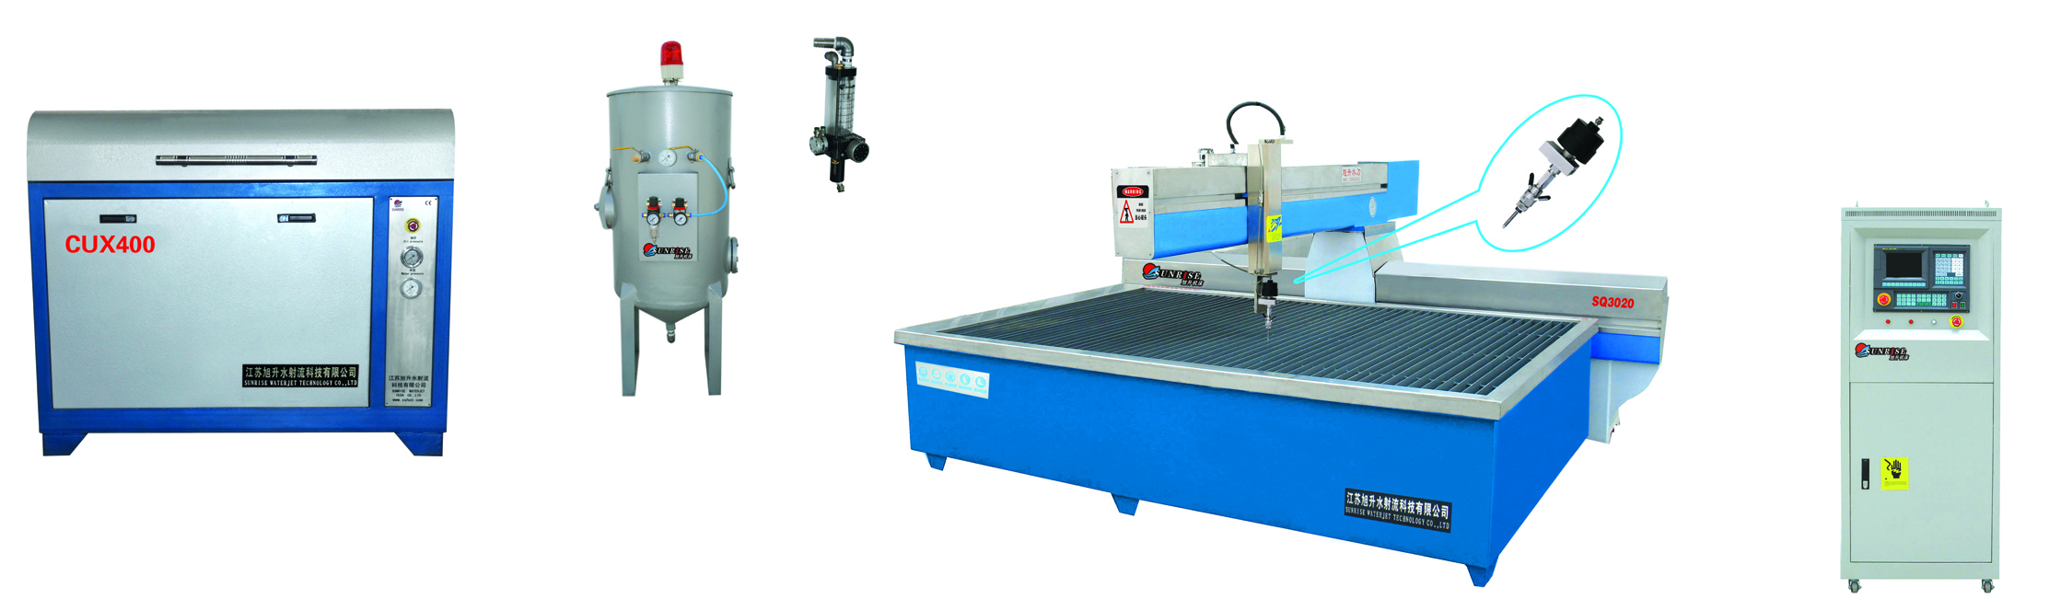
Cutting head Cutting Table Controller Cabinet

X axis travel | 2.5M
Y axis travel | 1.5M
Z axis travel | 0-150mm
Type of machine | Cantilever Type
Max material thickness | 120mm-150mm
Control Accuracy | ±0.002mm
Cutting Accuracy | ±0.1mm
Max working pressure | 60000 psi (400Mpa)
Motor Power | 22kw/30kw
High pressure pump type | intensifier type,30 HP (Minimum)
Power | 380 Volt / 3 Phase / 50 Hz
*Power supply for the system and its controller cabinet, can be manufactured meet to customer’s needs, as long as it 3 phase
THE HIGH PRESSURE PUMP :
The High Pressure pump is the core power of the water jet machine. It is the heart of the whole machine, it pressurizes the water which has been filtered to 300Mpa-400Mpa (45000psi-60000psi), then form about triple velocity of sound water jet when pass the orifice. It changes pressure energy into the concentrated kinetic energy to achieve the goal of cutting any materials.
√Adopt technology and parts of America (such as high pressure cylinder, plunger, seals and so on），prolong the using life, upgrade cutting precision （one of the advantages of our product）。
√Adopt technology and parts of America (such as high pressure cylinder, plunger, seals and so on），prolong the using life, upgrade cutting precision （one of the advantages of our product）。
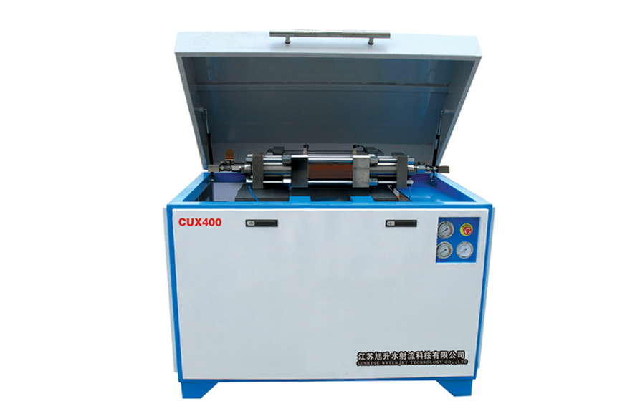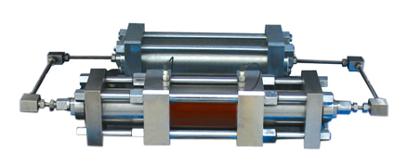
UHP intensifier Pump
√ Imported reversing sensor，reversing become more placidity and credibility (one of the advantages of our product)Solve the problem such as actuator stem broken, oil leakage from seal, collar cap of the end of actuator stem become flexible and other defect cause by typical exchange sensor, with steady and credibility exchange, safety, wear well, as for this part the cost is higher than other producer, so it can bring higher efficiency for the client.
√ Double protection system by high pressure and low pressure, automatic power off system, make sure operation safety.
THE CNC MACHINE TOOL
√ Adopt cantilever structure. X、Y axis boll screw via elasticity coupling connect with motor directly, reduce libration, transmission precision more higher.
√ Load and unload work piece from three directions. It solve the problem in overpass machine which can only load and unload the material from two side and limit the dimension of the material. It can put larger work piece in bed of cantilever machine which can larger than the bed of the machine. During the process of running , it will not have the problem which two boll screw is out-of –step , and it will not owning to the unbalanced pressure on synchro strop which will cause breakage of machine so that it can’t insure the precision of cutting.
√ Adopt high grade servo drive system，ball screw and guidway is also adopt international brand. X axis adopt the boll screw which diameter is 50mm, ensure the whole machine can transmission steady
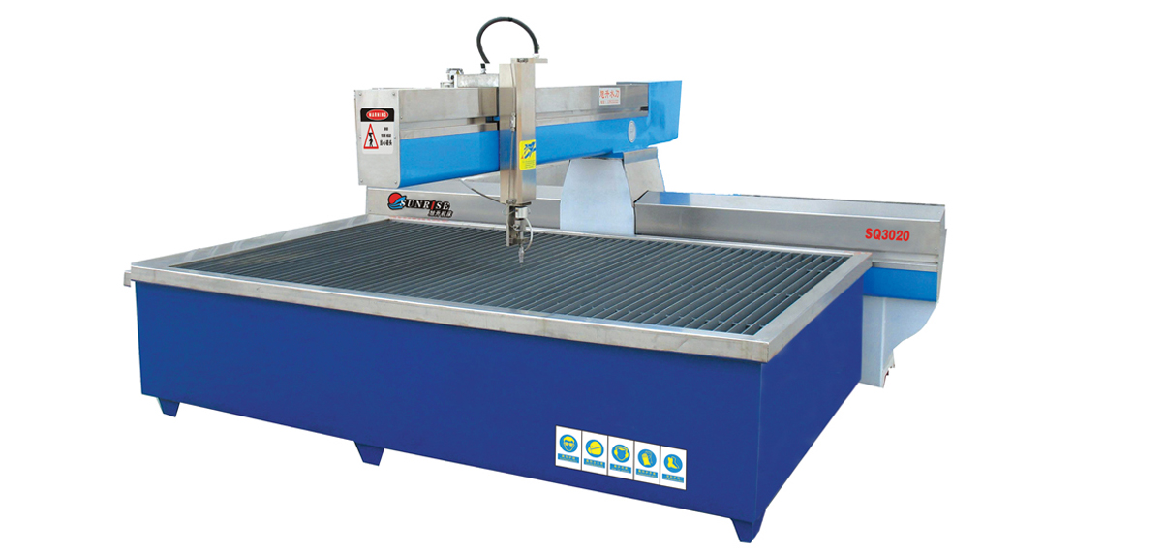
√ Select high grade dustproof equipment。The life of dustproof equipment we select is more the three times than ordinary ones.
√ Adopt the design that bed of the machine is separate with the cutting flat.
It will not effect by shack when cutting, increase the precision of cutting.

CUTTING TABLE:

√ The machine tool is designed to be separated from the cutting table, so the cutting process is vibration free and can get higher cutting precision.
√ All grizzly bars of the cutting table is insert style, so it is easy to change if one of the grizzly bar is broken.

AUTOMATIC ABRASIVE DELIVERY SYSTEM:
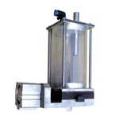
√ Alleviate load of machine beam greatly.
√ High delicacy inductor and signal lamp can clew operator when will add the abrasive to the tank.
√ Big capacity abrasive tank can offer the abrasive for cutting for about 500 to 800 minutes continually. No need add abrasive frequency.
√ Operation is simple, running credibility, no need for maintenance.

√ Automatic Abrasive Delivery System is a part of the whole machine but other company is the select part for buy.

CNC CONTROLLER CABINET:

√ high light 8LCD display.
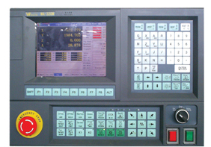
√ Federate can achieve adjustment of magnification at any time.
√ Adopt PLC control of SIEMENS，which have higher reliability, stronger anti-jamming, more simple maintenance. 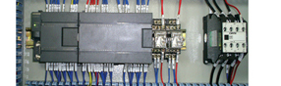
√ Via COM、USB interface and PC or U disk for interface directly.
√ Hand-hold machine tool controller is used for control the remove of axis X,

Y, Z took to the machine side by operator.
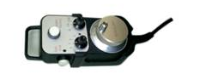
CAM SOFTWARE:
√ It can be compatible with many format of drawing design software in international，such as ASC、IGS、DXF、DWG、STL、NFL、PRT、STEP and so on.
√ It has the function of automatic radius compensation of cutter.
√ Automatically entering lead-in line.
√ Automatic calculates the length of cut line.
√ Automatic Nesting
AUTOMATIC NESTING INTERFACE

CUTTING SAMPLE:
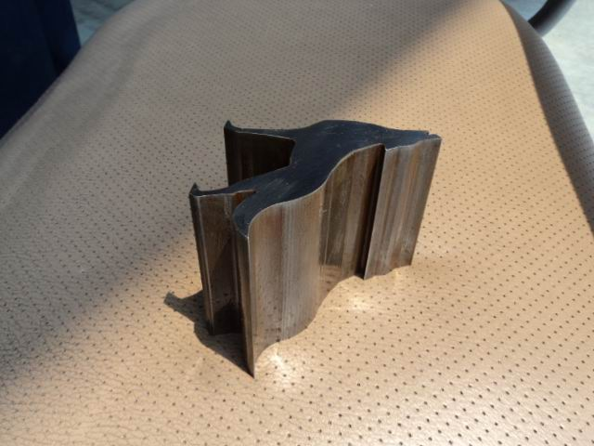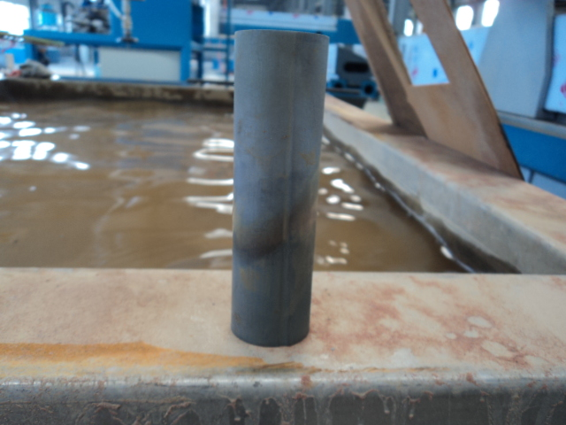
Metal
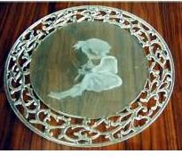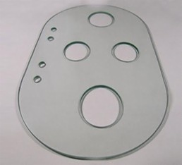
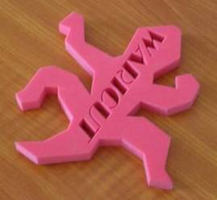
Glass

Marble PVC

