Products list

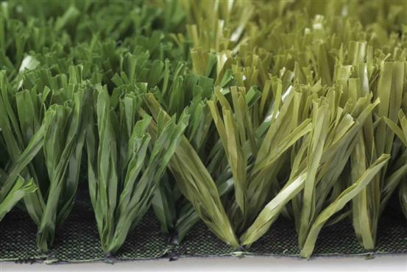
TYPE 1: Economic Turf
YARN: Tencate Thiolon
DTEX: PE9000
COLOR: Field green or olive green
PILE HEIGHT: 20-50mm
GUAGE: 3/4”or 5/8''
STITCH RATE: 13-20stitches/10cm
DENSITY: 6825-12600 stitches/square meter
WARRANTY: 7 years

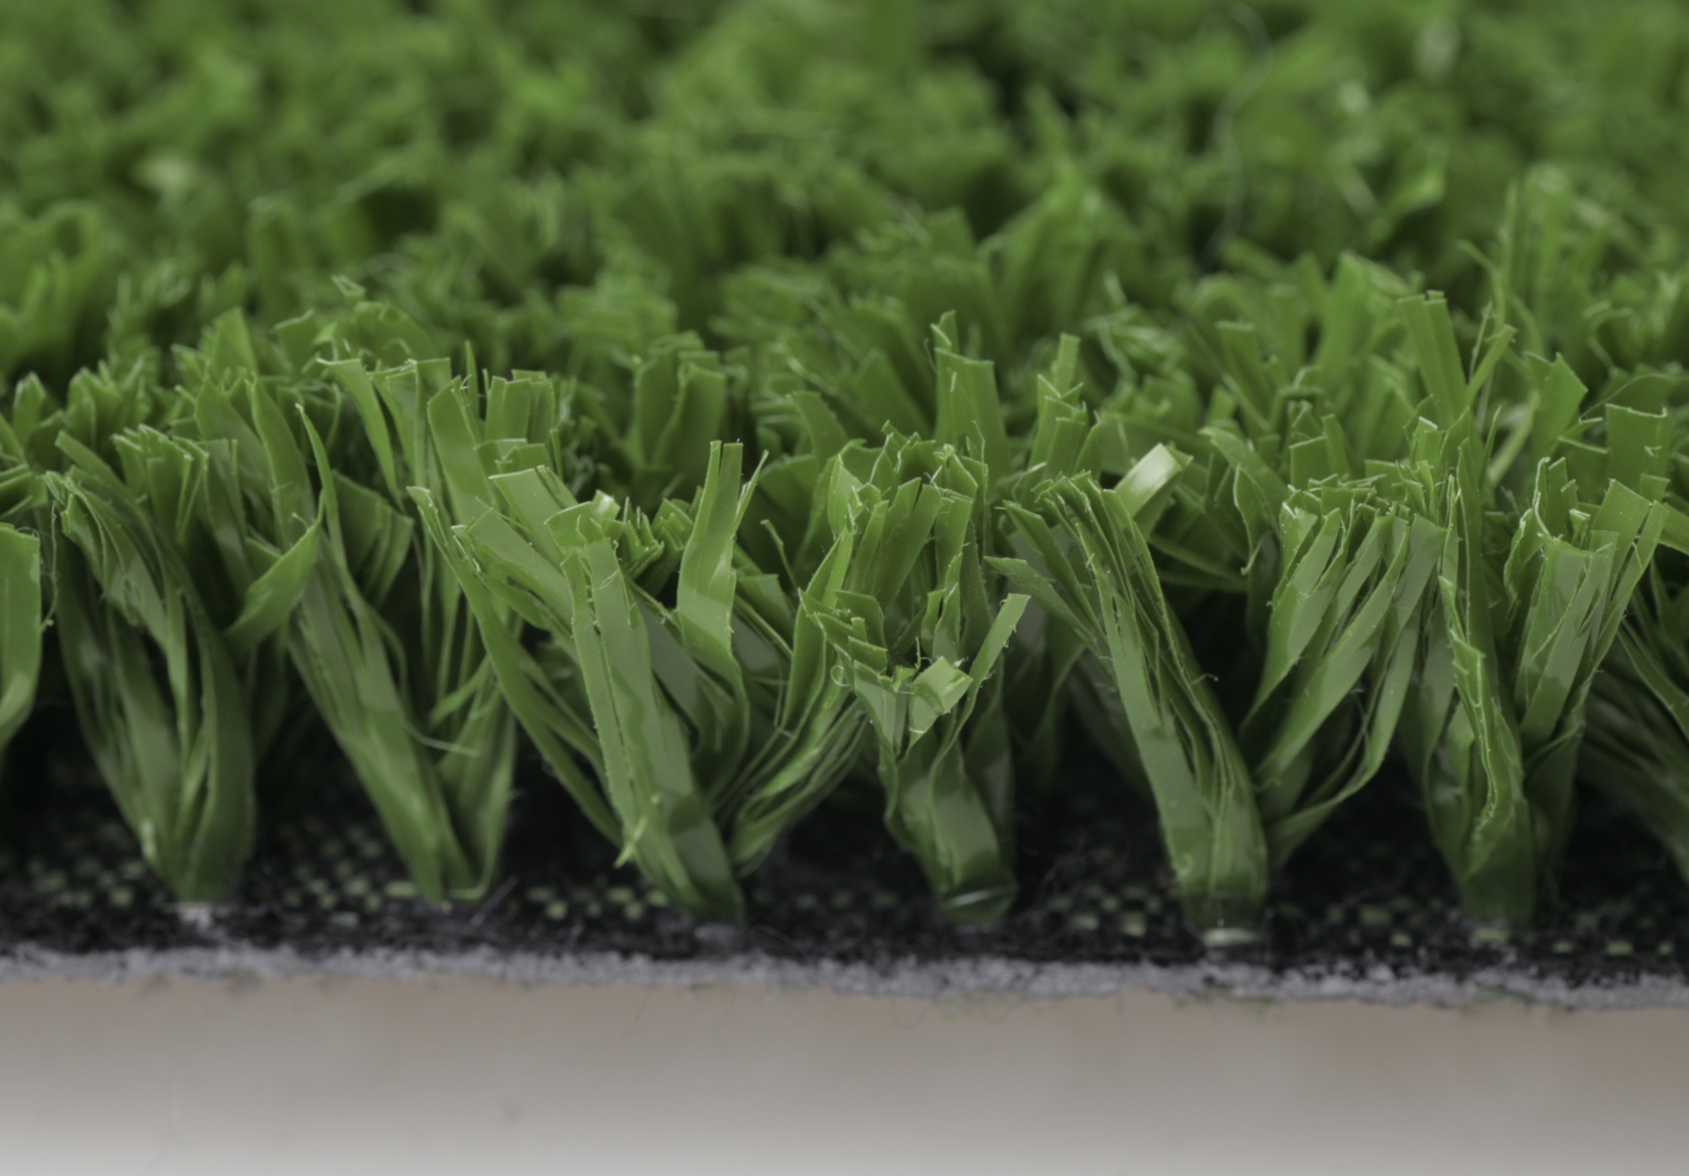
TYPE 2: Solid Turf
YARN: Tencate Thiolon
DTEX: PP8800
COLOR: Green/White/Red/Blue/Yellow/Green
PILE HEIGHT: 10-40mm
GUAGE: 5/8’’, 5/16”, 3/16’’
STITCH RATE: 20-30stitches/10cm
DENSITY: 20000-60000 stitches/ square meter
Application: Muti-sports
WARRANTY: 8years

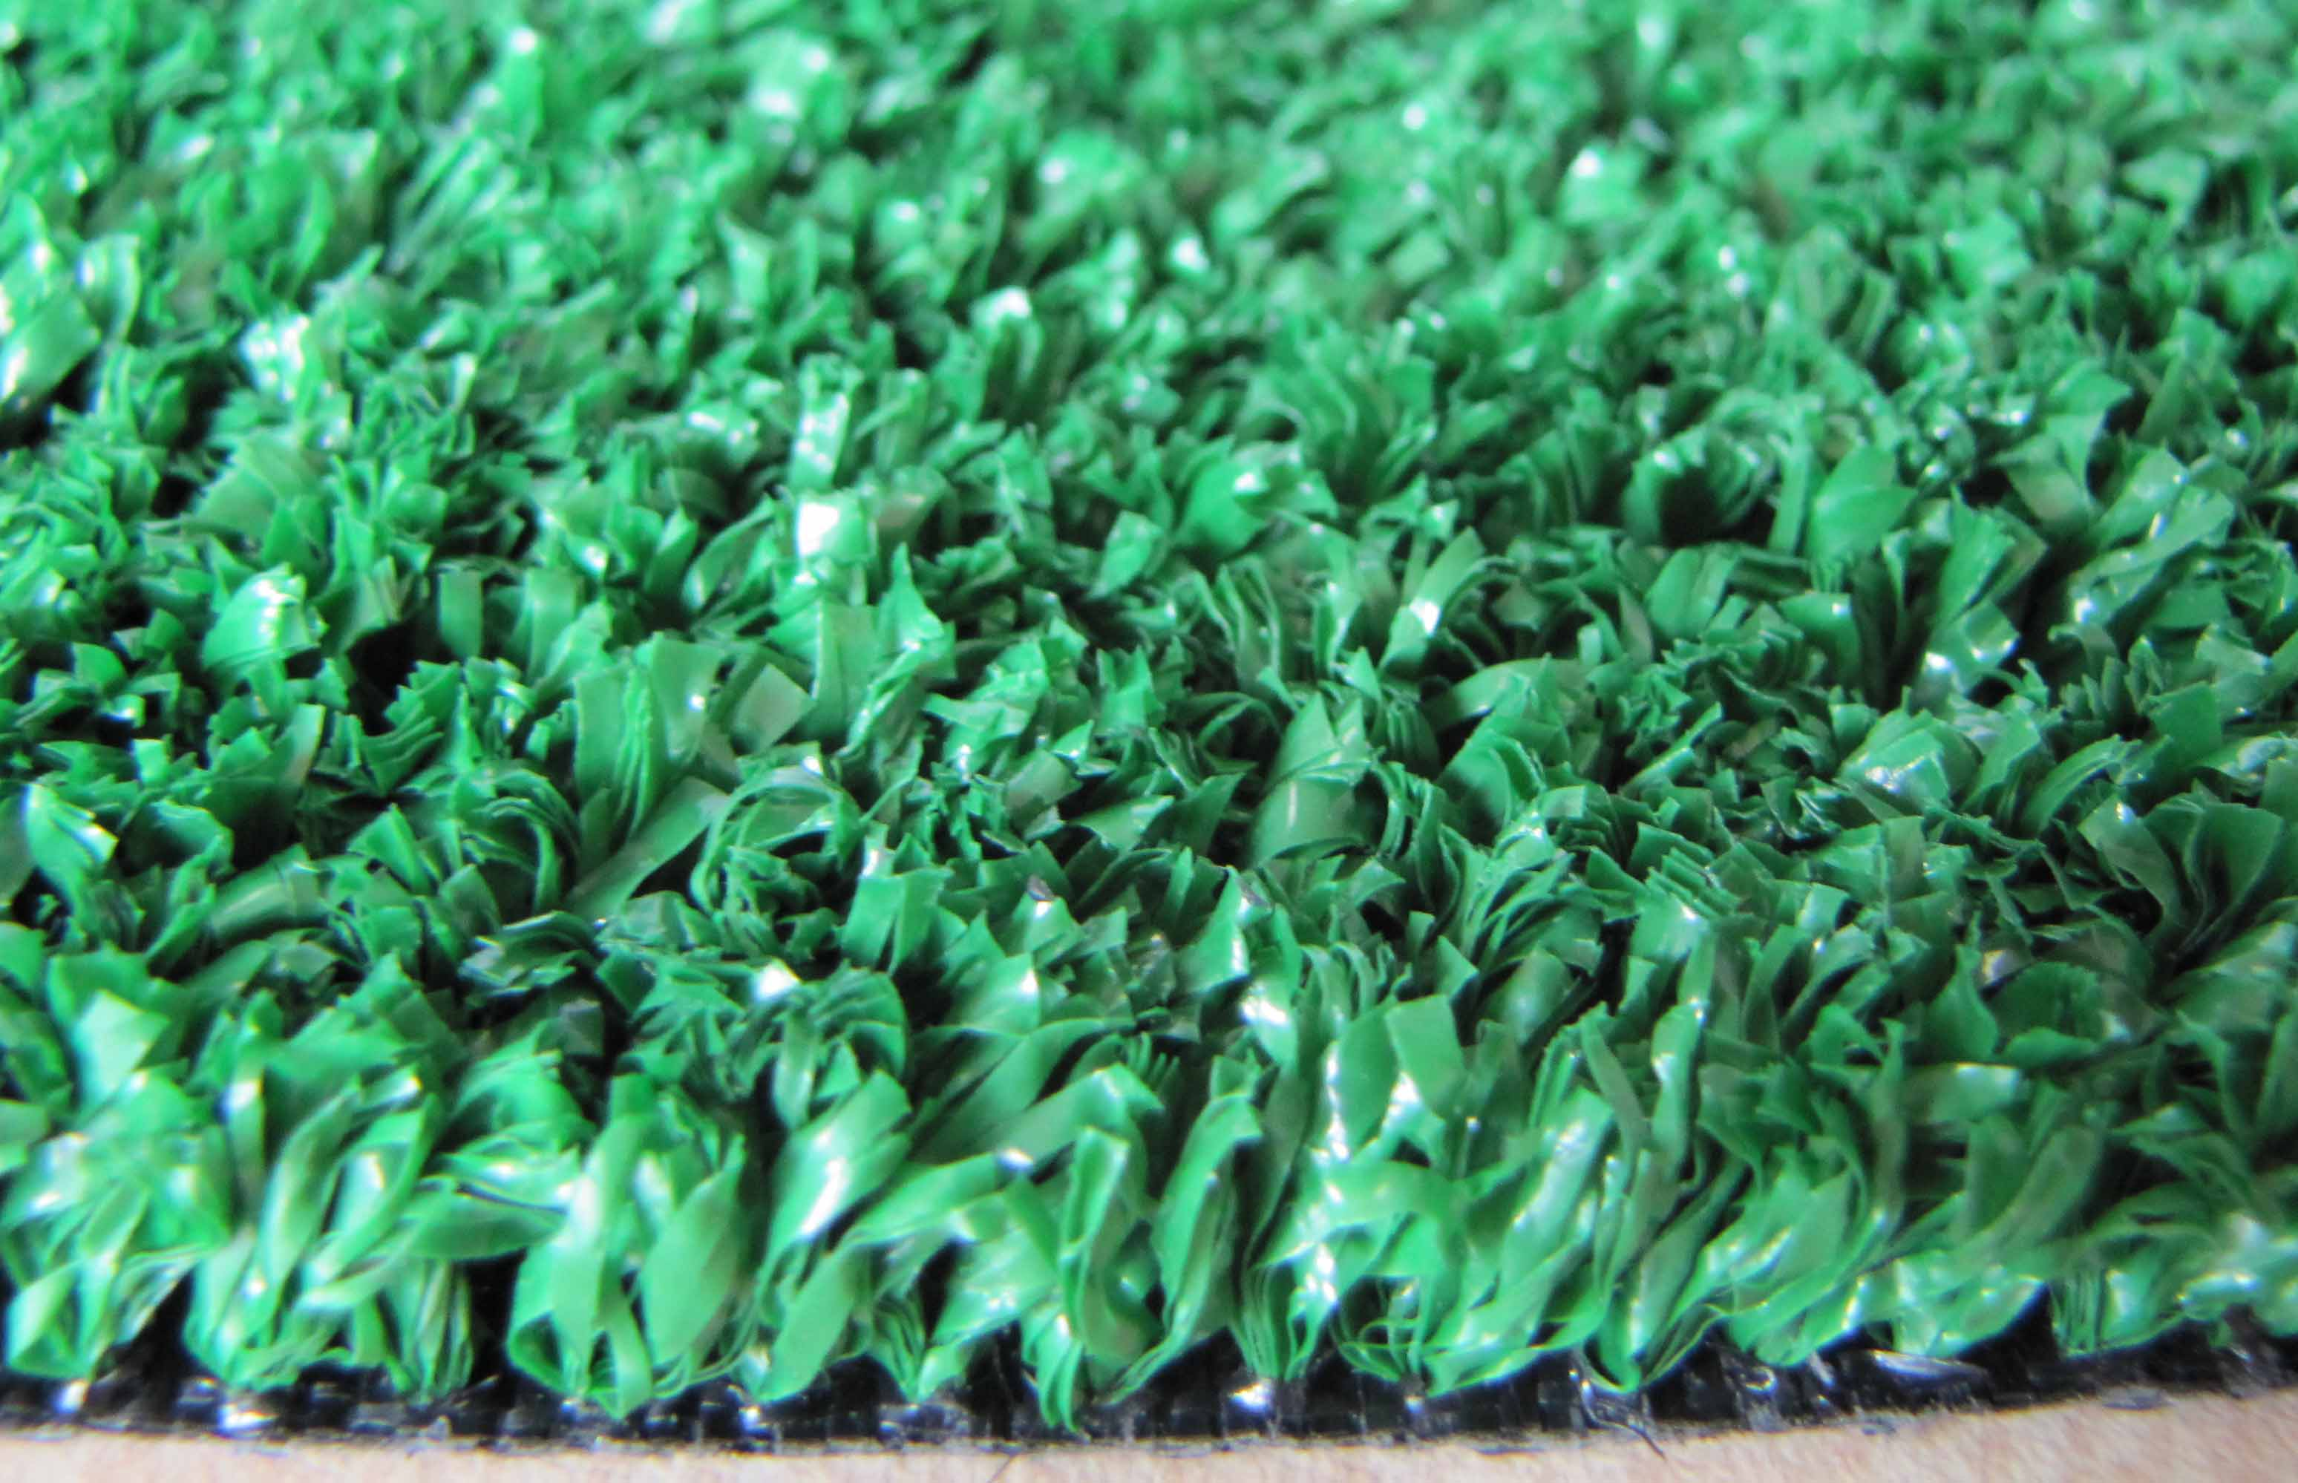
TYPE 3: Hockey Turf
YARN: Tencate Thiolon
DTEX: PE9000
COLOR: Green
GUAGE: 5/16”, 3/16’’
STITCH RATE: 20-35stitches/meter
DENSITY: 25200-73500stitches/square meter
Application: Muti-sports
WARRANTY: 10 years

