Quotation
We supply YT Series Flexographic Printing Machine, the newest information and quotations as follow:
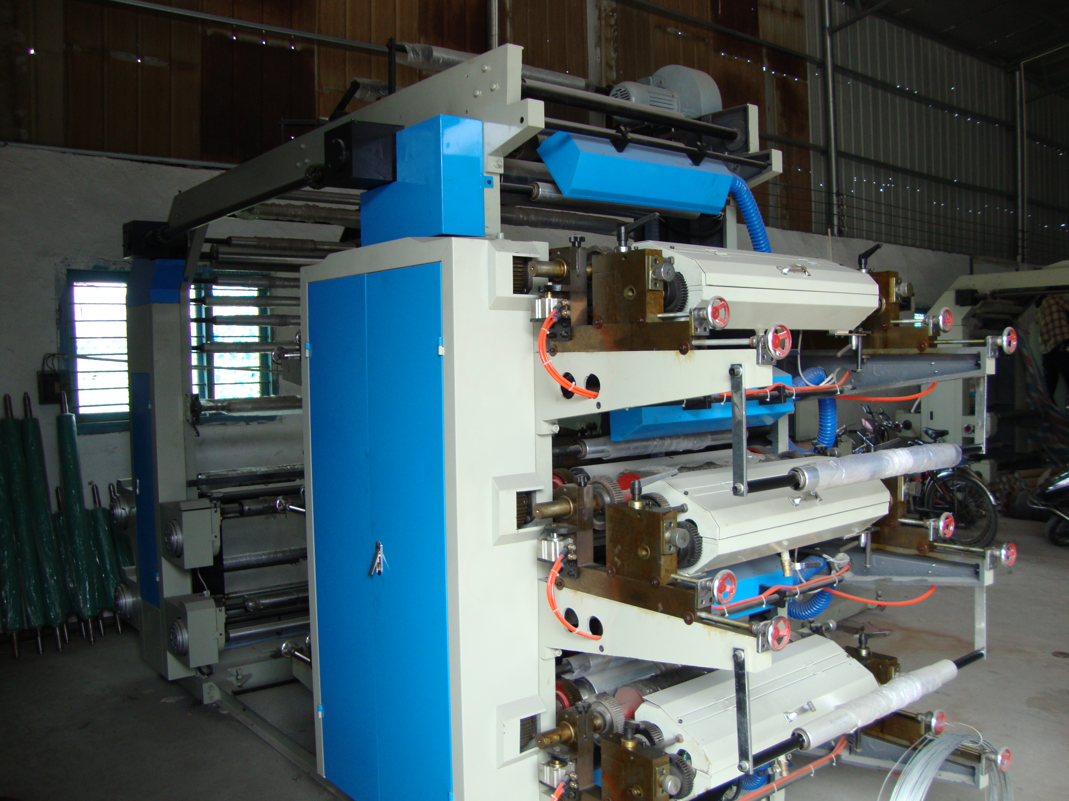
Ⅰ.Feature:
1. Easy operation, flexible starting, accurate color register .
2.The meter counter can set printing quantity according to the requirements, stop the machine automatically at the quantity or when the material is cut off.
3.Pneumatic printing cylinder lift and lower, it will stir the printing ink automatically after lifting.
4.The printing ink is spread by the anilox cylinder with even ink color.
5.Reliable drying system coordinated with high-speed rotation, it will automatically break circuit when the machine stops.360continuous and adjustable longitudinal register device.
6.The frequency control of motor speed adapts to different printing speeds.
7. Suitable for printing the packing material as PE and PP plastic bags, glass papers rolling papers, etc.
Ⅱ. Main Technical Parameter
Model | YT-6600
Printing Extrance Width | 600mm
Printing Width | 560mm
Length of Printing Production | 191-990mm
Diameter of Roll Material | φ450mm
Printing Speed | 5-80m/min
Thickness of Printing Plate | 2.3mm
Total Power | 10.87kw
Overall Dimension | 6800×1600×2400mm
Weight | 3500kg
Detail specifications:
1. Unwinding parts
1) roller length: 800mm
2) effective printing roller length: 600mm
3) roller core diameter: 76mm
4) max. unwinding diameter: 800mm
5) unwinding type: mechanical
2. Traction parts
1) traction composed: roller, chrome plate roller
2) group count: 6groups
3. Printing parts
1) printing composed: chrome plate roller, printing plate roller, cob-webbing roller, rubber roller
2) plate roller perimeter: 100-350mm
3) printing plate material: resin or rubber
4) drive pattern: bevel wheel drive
5) printing topping: 360 degree rotate
6) adjustable type: by hand
7) rise and fall plate adjust: by hand
4. Heating and drying parts
1) heating pattern: first blower then heating
2) heating range: 6colors 6pc
3) heating power: 600mm model: 1.1kw
4) auxiliary heating length: 600mm
5) fan: 2 sets
6) fan power: 600mm model: 2×0.25kw
5. Motor parts
Main motor: 6colors 600 mm : 1.5kw
Transport ink motor: 0.25kw
6. Rewinding parts:
1) roller length: 800mm
2) effective roller length: 600mm
3) roller core diameter: 76mm
4) max. rewinding diameter: 800mm
5) rewinding pattern: mechanical
7. Main device list:
1. main motor( frequency conversion motor): 1 set 1.5kw ( LiBiao, Shanghai)
2. transport in motor: 1 set 0.25kw ( Libiao, Shanghai)
3. Main frequency converter: 1 set ( Nengli, Hongkong)
4. Fan: 2 sets 2×0.25kw ( Fengyang, Shanghai)

5. Aluminum running roller: Oxidation the surface, staticanddynamicequilibrium
Treatment
6) metal cob webbing roller: 1 pcs per color
7) rubber roller: 1 pcs per color
8) low-voltage apparatus: (China Zhengtai Group)
9) photo electricity correct : 1 set ( made by ourselves)
10) switch: SCHNEIDER, France
11) electrical control box: 1 set ( made by ourselves)
12) Main frame: 1 unit ( made by ourselves)
13) Completely machine casting: Chuangxin casting corp., Henan)
8. Spare component for present:
A tool box include: 1-10 scripts screwdriver; 1 pcs oil gun; 1 set socket head wrench; 2pcs electric switch; 1pcs cocontactor; 2 pcs tubular electric heating element; 1 part of instruction; 1 part of frequency converter instruction)
9. Optional devices
Error-correcting device 650 USD / Set
Full automatic Magnetic tension controller 1500 USD / Set
Digital corona treatment 600 USD / Set(Depends on the width)
Air shaft 160 USD / Set
Ceramic Anliox roll: 1600USD/Set
Doctor blade: 200USD/Set
10. Ink: This flexographic printing machine support water base ink.
Ⅲ. Quotation (F.O.B Price to Ningbo port)
Model | Price
YT-6600 | 12500USD（6colors）
Our price valid period last for 2 months.
Ⅳ.Delivery
Within 25 days shipment the machine, we manufacture the machine after we receipt 30% deposit.
Payment: 100% T/T
Warranty period time: 1 year ( all the main device changed for free within 1 year)
Packing: with stretch film and bubble film.
It also can be packing with wooden box (you need to pay the extra fee)

