Paper details cost:

Type name | Single PE coated paper
Price | 1140usd/ton FOB Ningbo(Double PE add 130usd/ton)
Printing cost | One color | 57usd/ton
 | Two colors | 100usd/ton
 | Three colors | 140usd/ton
 | Four colors | 165usd/ton
Printing mould cost | 100usd/color
Pictures | 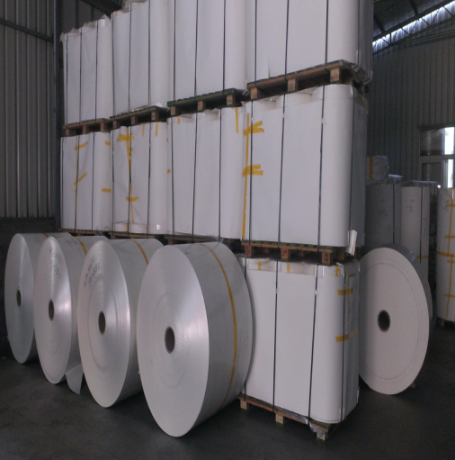 |  | 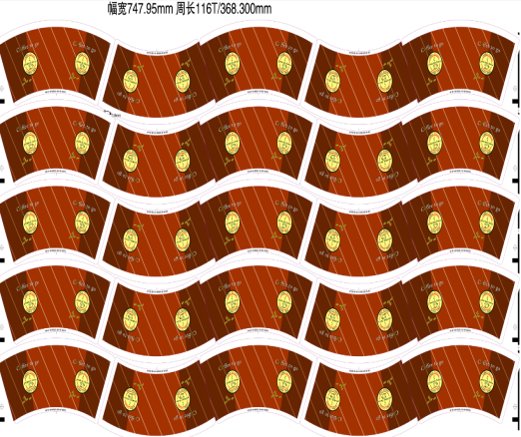 | 