QUOTATION

No. | Commodity | Quantity | Unit price | Amount
1 | RY-320 flexo label printing machine with water based ink  (include 5color  5 IR dryer  1 lamination system  1 turn bar  1 web-guide  1 die cutting station  1 waste collection  12 printing cylinder  4Anliox cylinder) | 1 unit | USD27500.00 | USD27500.00
Total value: |  |  |  | USD27500.00

1)RY320 flexo printing machine with5colors
Printing speed:around 10m/min-80m/min
Max Printing color: 6
Max web width: 330mm
Max print width: 320mm
Max unwind diameter: 650mm
Max rewind diameter:600mm
Print length: 175-380mm
Overprint precision (mm): ±0.15MM
:Package size: 14 CBM
Gross weight: 4000kgs
Net weight: 3500kgs
Mian power: 380V/AC(3phase)50HZ
Tention control (unwind): Japan
Tention control (rewind): China
Main motor: China
Transducer: Taiwan
Printing cylinder: 3set*5=15pcs (57teeth to 120teeth)
Anliox roller: 5pcs (300lines to 1000lines)
The machine with web guide, turn bar, waster wrapper.

1) Printing roller: 3sets, the size is determined by the user from 57teeth to 120teeth
2)anilox cylinders: 1set, the lines can be chosen from 200 to 1000 by the user.
3) Mounting machine: 1 set
4) turn bar: 1set
5) unwind tension controller: 1piece Mitsubishi of Japan
6) transducer: 1pc Taiwan
7) rewind tension controller: 1piece made in China
8) magnetic power brake:3pcs China
9) electromagnetism valve: 2pcs Japan
10) inverter: Taiwan
11) stop automatic when paper lack
12) machine stop automatic when the paper broken
13) Contactor: Schneider France
14) time replay: 1pc Taiwan
15) solid reply: 2pcs Japan
16) Temperature Controller: China
17) All air Switches: Schneider France
18) Other low-pressure wiring Schneider? France/ China
All the rollers are deal with high temperature.

Characteristics:
1) The main motor adopts imported inverter to govern a stepples speed adjustment.
2) The printing units are all equipped with a group of infrared dryers respectively.
3) Each IR dryer device of printing unit
4) Feeding and rewinding are controlled through magnetic particle brake and clutch
(Japanese Mitsubishi auto tension controller).
5) Un winder and re winder adopt air core holder.
6)one unit rotary station
7) Adopt ceramic anliox roller which offers durability, wear resistance and corrosion resistance, also is more efficient on production by reducing the times of
changing rollers.
8) The printing unit can register in 360 degrees. Each printing unit can be
independently geared and loosen to have rest of units continue to printing.
9) The inking roller will be automatically off impression when press stop and rotate
at lower speed in order to keep the ink from being drying.
10) Paper unwind, printing, laminating, rotary diecutting, waste removal
and rewinding can be processed in one pass. It has characterized by wide
application, fast printing speed and high economic efficiency ink will not
contaminate environment. So it is an idea printing machine for the business form,
Tag and high end pressure sensitive label.

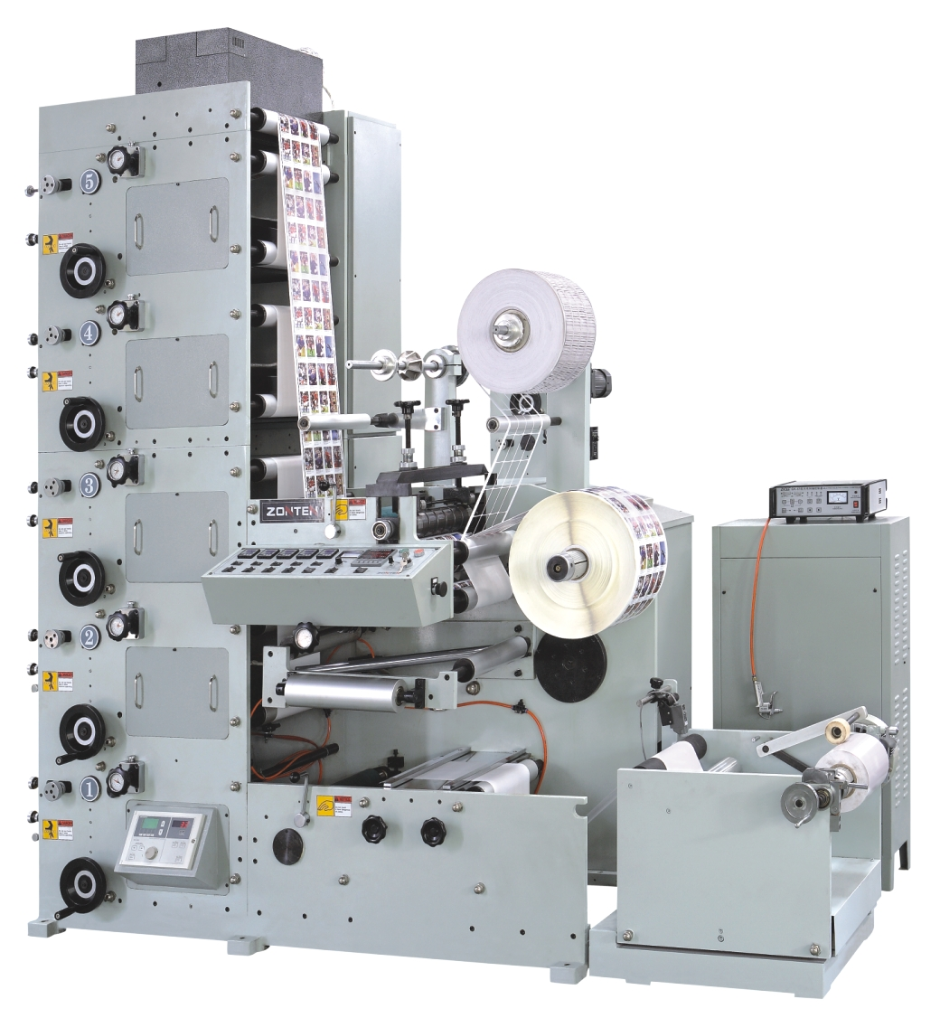

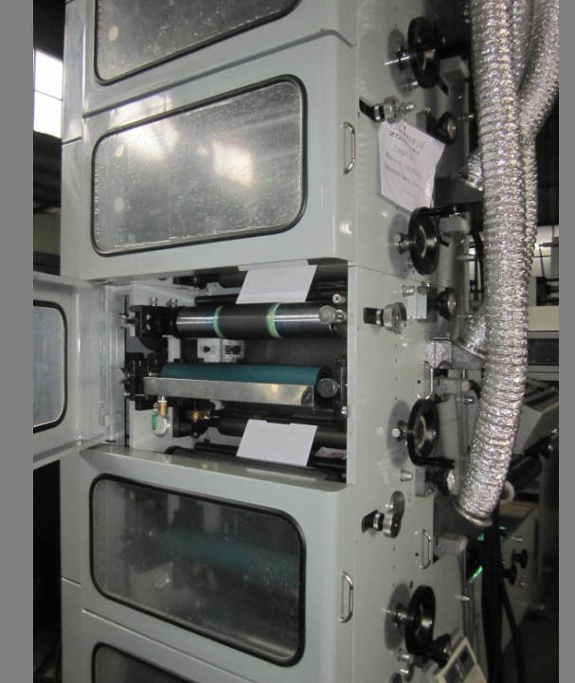

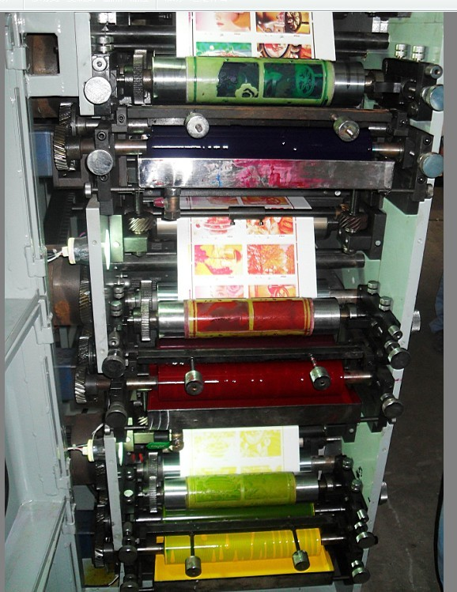

Sample:

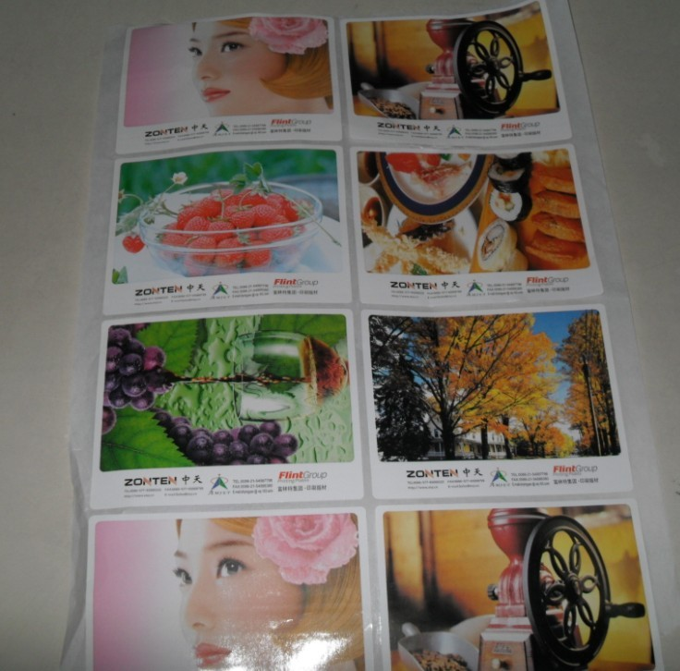

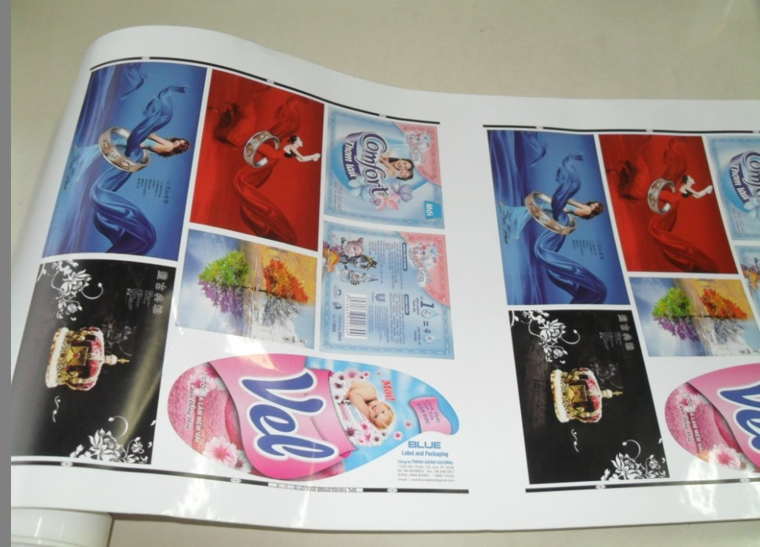

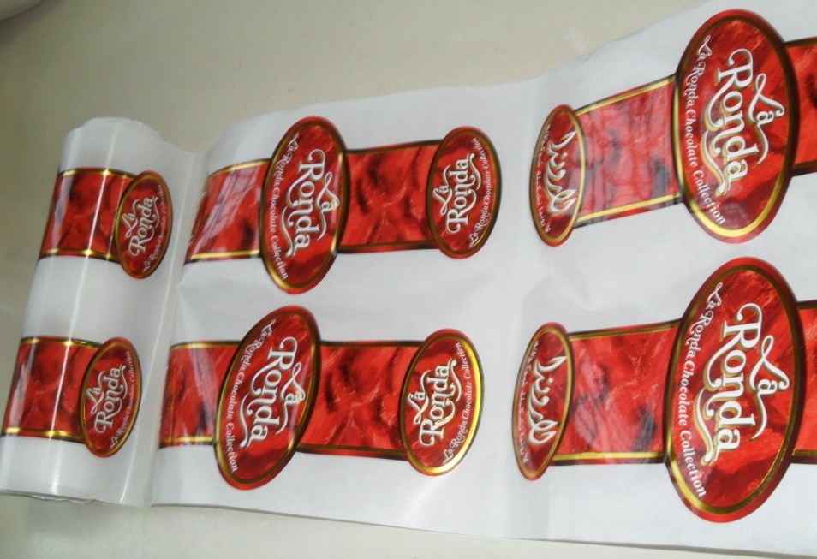

2) Other information:
A. Packing: Sea worthy wooden case
B.Quality Guarantee: within one-year guarantee from B/L date. If the machine need repair within this period, the seller shall dispatch technician to buyer’s side in time. But the buyer shall bear all the expense during the repair period.
C.Term of trade: FOB Wenzhou, shall be subject to the International Rules for the Interpretation of Trade Terms (INCOTERMS 2000) Provided by International Chamber of Commerce (ICC)
D.Payment: 30% T/T payment for deposit, 70% T/T payment before shipment.
E.Delivery time:40 days after receiving the 30% T/T payment.
F.Insurance: to by covered by buyer
G.Expense for installment and test machine: The seller will dispatch the engineer to buyer side in time when the machines arrive at buyer’s place. The buyer pays all the expenses including the go and come back air-ticket, feeding and accommodation during the testing machine period.
H.Time of install and testing machine at buyer side: 5 days

This quotation is valid for 30days.

If you want to know more information, please feel free let us know.

Best Regards
Jared Lin,

