GYQS1500D Road Brusher

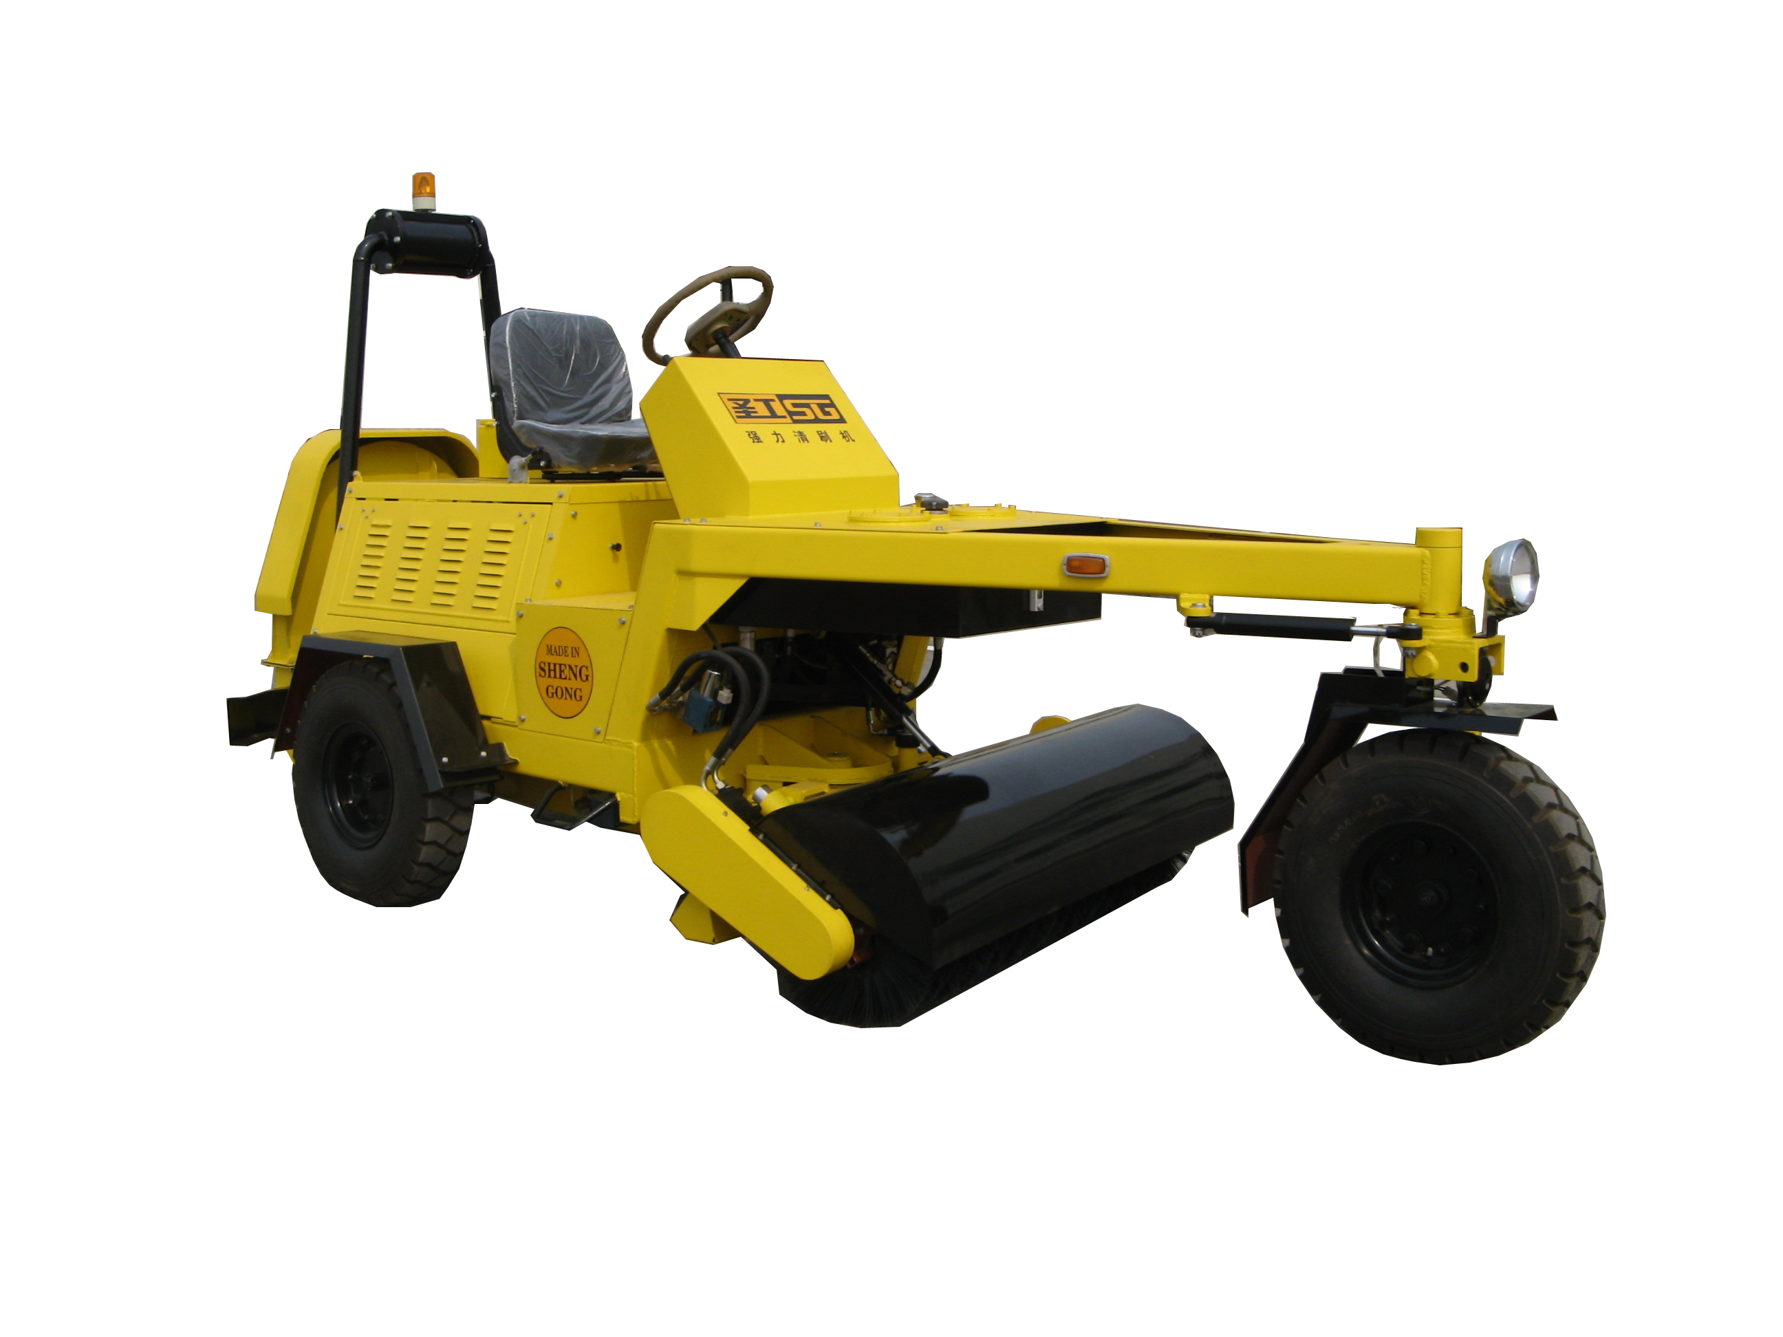
GYQS1500D road brusher is mainly applied to get rid of the solid foreign matters such as the bleeding cement and soil clod on the pavement of road and bridge, and brush the dust away.

Technical Parameters

Model | GYQS1500D
Overall Power | 26kW/2000rpm
Brushing Width | 1500 mm
Brush Diameter | 500 mm
Brush Rotation Speed | 300 rpm
Swing Angle of Brush Holder | ±15°
Blower Rotation Speed | 2500 rpm
Travel Speed | 0～15 km/h
Total Weight | 1750 kg
Overall Dimensions | 4550×1800×2200 (mm)

