We supply YT Series Eight Colors Flexographic Printing Machine, the newest information and quotations as follow:
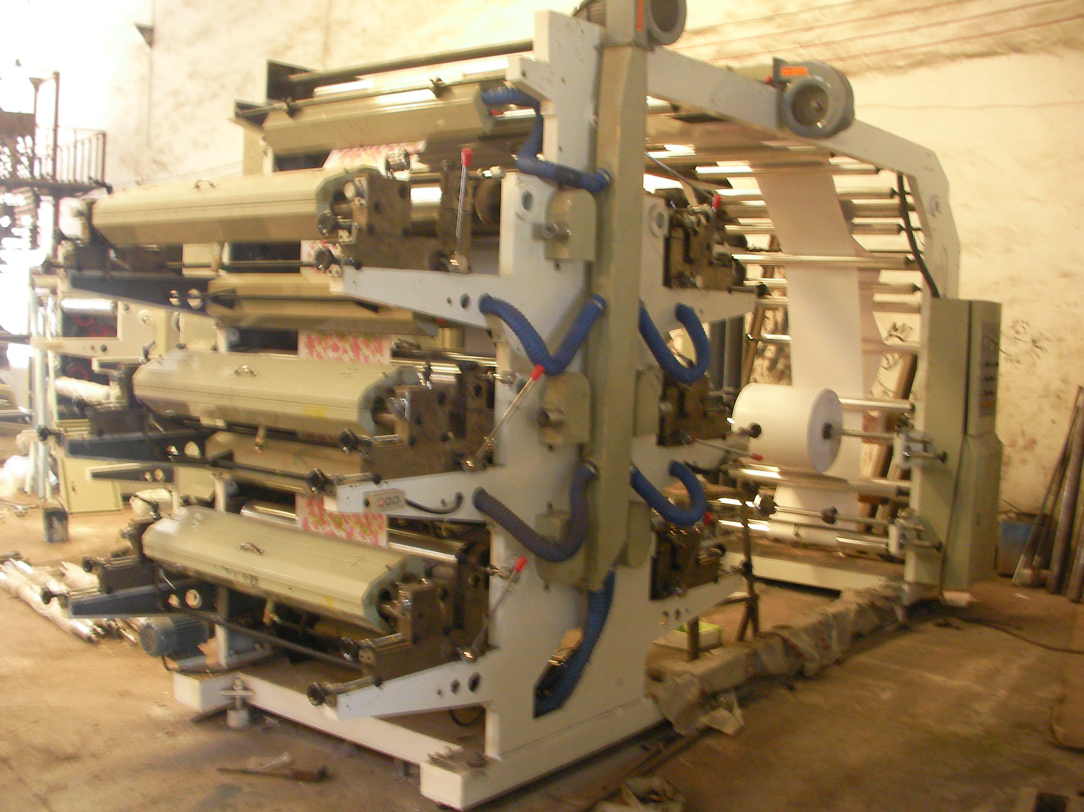
Ⅰ.Feature:
1. Easy operation, flexible starting, accurate color register .
2.The meter counter can set printing quantity according to the requirements,stop the machine automatically at the quantity or when the material is cut off.
3.Pneumatic printing cylinder lift and lower, it will stir the printing ink automati-cally after lifting.
4.The printing ink is spread by the anilox cylinder with even ink color.
5.Reliable drying system coordinated with high-speed rotation, it will automati-cally break circuit when the machine stops.360continuous and adjustable longitudinal register device.
6.The frequency control of motor speed adapts to different printing speeds.
8.Suitable for printing the packing material as PE and PP plastic bags,glass pap-ers rolling papers,etc.
Ⅱ. Основные технические параметры
Пункт | YT-81000
Ширина при входе печати | 1100мм
Печатная ширина | 1000мм
Длина продукта для печати | 191-1000мм
Диаметр рулонного материала | φ450мм
Скорость печати | 5-50м/мин
Толщина печатной доски | 2,3мм
Общая мощность | 50квт
Габаритный размер Д×Ш×В | 4800×2000×3500мм
Вес | 8000кг
Ⅲ. Detail specifications:
1： Main Parameter
A.：Model：8 colors 1000mm
B：Material ：Film, Non-woven fabric, Paper, Aluminum and so on
C：Max.Width of Printing: 760mm
D：Max.Length of Printing: 200-1000mm
E：Max.Speed of Material Printing 10-50m/min
F：Thickness of Plate (including the glue) 2.38mm
G：Weight:8000kg
H：Dimension：4800×2000×3500mm
2.：Unwind Unit:
A：Max.Length of Roller: 1500mm
B：Max.Length of Effective Roller:1000mm
C：Dia.of Roller: 76mm
D：Max.Dia. of Unwind: 600mm
E：Type of Unwind: auto tension with magnetic powder and EPC
3.：Traction Unit:
A.：Constitution of Traction: Rubber Roller and Chrome plated Roller
B：Traction Zones: 8
4：Printing Unit：
A.：Constitution of Printing： Chrome plated Roller, Rubber Roller, Metal Anilox roller, Plate-glued roller
B：Girth of Pressing Roller: 400mm
C：Material of Plate: Resin and Rubber
D：Principle of Work: Gears Drive
E：Type of Chromatically: 360 degree circulating
F：Way of Adjusting: air shaft
G：Plated-glued roller adjusting: manual
5：Heating and Drying Unit：
A.：Type of Heating and drying ： blowing first then heating
B：Heating Zones : Heating Tubes 8 colors ：10zones
C：Power of Heating ：
Model 800mm: 20kw
D：Assistance of Drying Length ：2m
E：Blowers：2 Fans
F：Power of Blowers：
Model 800mm: 2×1.2kw
6：Electrical Parts：
A.：Main motors：
Main motor ：8colors1000mm:10kw
B：Ink-Transfer Motor:
Ink-Transfer Motor: 8colors:1000mm:1.2kw
C：An Inverter Equips With the Main Motor
7：Wind Unit：
A：Max.Length of Roller: 1500mm
B：Max.Length of Effective Roller: 1200mm
C：Dia.of Roller: 76mm
D：Max.Dia of Wind: 600mm
E：Type of Wind: auto tension with magnetic powder
8.：Main Machine Specification List:
A.：Main Motor: 1 pcs 10kw (Libiao Shanghai)
B：Ink transfer motor: 1 pcs 1.2kw (Libiao Shanghai)
C：The inverter :( Nengshi Hong Kong)
D：Blower:2 pcs 1.2kw (Fengyang Shanghai)
E：Aluminum Rollers: (Taiwan invested made in Shanghai, Surface oxidation, blance treatment)
F：Metal Anilox Roller: 1 pcs/per color (Shanghai)
G：Rubber rollers: 1 pcs/per color (own products)
H：Low pressure Electrical parts :( Zhengtai, China)
I.：Switches: (Schneider emluator)
J：Electrical control Box: 1 set (own products)
K：Main machine body: 1 set (own products)
L：Main machine casting: (Chuangxin Cast iron Co., ltd, Henan)
M：Pneumatic component: (Chuangfeng Qidong)
9. Optional devices
Error-correcting device 650 USD / Set
Full automatic Magnetic tension controller 1500 USD / Set
Digital corona treatment 600 USD / Set(Depends on the width)
Air shaft 160 USD / Set
Ceramic Anliox roll: 1600USD/Set
Doctor blade: 200USD/Set
10. Ink: This flexographic printing machine support water base ink.
Spare parts for free:
Tool Box 1 set (1-10# screwdriver, oil gun, Inner Hexagon Spanner 1 set, Switches 2 pcs,Contactor 2 pcs ,heating tube 2 pcs, machine operation instruction 1 pcs,the inverter instruction 1 pcs)
2. Предложение (F.O.B цена включает налог)
Модель | Цена
YT-8800 | 28000USD （8 цветов）
Срок действия: 2 месяца
3. Доставка
Доставка машины за 30 дней, мы будем производить машину после получения 30% аванса.
Условие платежа: T/T
Гарантия: 1 год (все основные устройства изменены бесплатно в течение 1 года)
Упаковка: упаковка поверхностей в стретч-пленках , размер упаковки: 8800×2400×2600мм. Или может быть доставлена перевозкой навалом. Из-за высоты, эта модель не может принять упаковку деревянным ящиком.

