2.2 Gas engine structure introduction
.
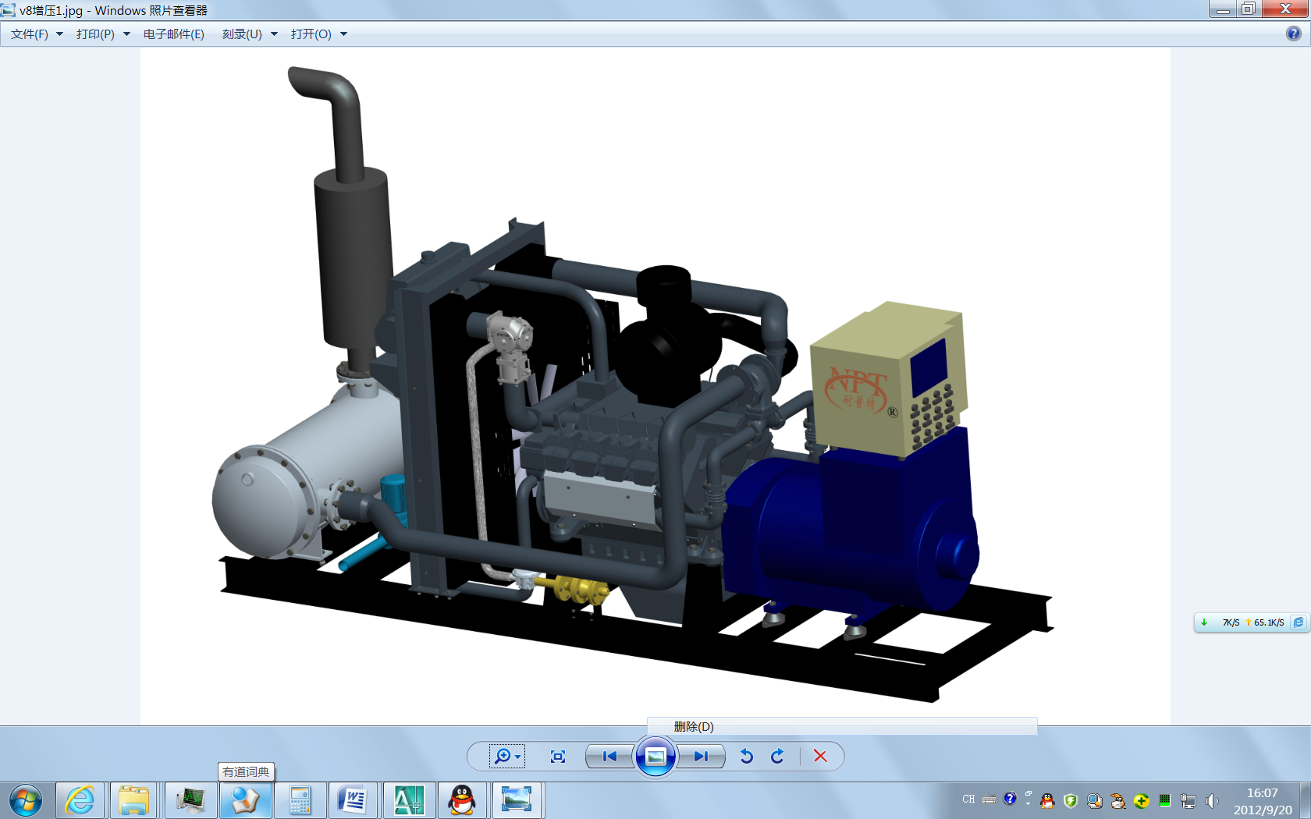
Control cabinet
Generator
Flame arrester
Engine
Air-cooled cooler
Turbocharger
Air Filter
Shock absorber
Pressure reducer
Gas
Mixer
Vat water &heat exchanger
Silencer
Exhaust gas& heat exchanger
Electric
High-tension line

2.2.2.3 Woodward E3 electric control loop turbocharged lean burn system
Woodward's U.S. E3 electronic control system includes speed, oil pressure, water temperature, pressure and temperature before and after the throttle, throttle position, phase, the oxygen concentration in the exhaust pipe, power and other sensors, with a gas control valve and electronic throttle, both the wide-range oxygen sensor can detect the oxygen content of the exhaust pipe and the gas valve by adjusting the size of the lean air-fuel ratio correction control loop, the power sensor can also be used to correct air-fuel ratio feedback power and with position feedback using integrated electronic throttle response faster and more accurate positioning control, integrated ignition system and is equipped with intelligent ignition coil, ignition advance angle adjustment more convenient, by detecting the rotational speed, oil pressure and coolant temperature to achieve "water low oil pressure, overspeed "and multiple protection features, with self-learning function, can automatically record the normal operation of the relevant parameters, so that the next call directly, eliminating the need for feedback adjustment process, through the RS485 and CAN connected to the computer, the software used TOOLKIT , easy online calibration and diagnostic functions. EGS-TRIM (E3) electronic control system block diagram shown in Figure 16.
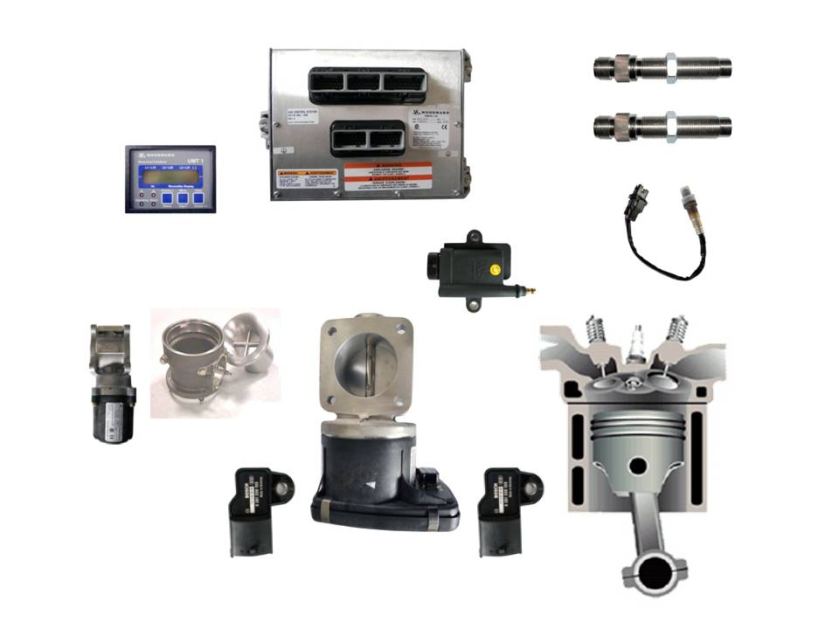
Power sensor
EGS-TRIM modul
Speed Sensor
Oxygen Sensor
Gas mixer
PTP Sensor
Phase Sensor
Spark Plug
High Voltage Coil
Engine
The gas control valve
MAT/MAP Sensor
Electronic
Throttle
Gas
Air
Mixed Gas
Exhaust Gas
Fig16 E3 electrical control system
4 Periodical inspection and maintenance
4.1 Regular maintenance
Form 11 Maintenance items & content
Item | Maintenance period | Maintenance items
Daily maintenance | Every day | Check lube oil level indicator, add oil if necessary.
 |  | Remove the leakage of lube oil and coolant
 |  | Check if there is any leakage in gas supply pipeline and pipe joint (by the peculiar smell in surroundings); If there exists any leakage, operator should notify the special repair works in time instead of disassembling the parts by self.
 |  | Check the ignition system and the generator for electrical leakage or spark over. Repair them in time if necessary. Check if there are loosened spark lead between coil and spark plug.
 |  | Check all indicator working properly or not.
 |  | Check all accessory connection. Find the loosened bolts ,nuts and clips.
 |  | Clean the air the surface of air cleaner and engine body.
 |  | Check the explosion-proof valve, repair if necessary.
First order maintenance | Working 100hrs. | Add proper lube oil or grease to every filling port.
 |  | Check the density of electrolyte in the battery.Normorly the density is 1.28-1.29kg/dm³(at 15℃ ambient temperature).Check the electrolyte level (over 10-15 mm the electrode).Add distilled water if necessary.
Check the pipelines and joints:
1. Without damage and chap on the pipe body. Without leakage checking by leak detector and testing liquid.
2. Check the pipe joints and valves for leakage and tightness.
Check and tightening of pressure reducer:
1. Check the reducer and joints for leakage with leak detector and testing liquid.
2. Check the bracket for tightness, retightening if necessary.
Check the circulating water pipeline and joints:
1. Check dirt in the warm water pipe, clean up if necessary.
2. Check the water pipes for chap and ageing cracks, damage and leakage, replace if necessary.
3. Check the pipe joints for tightness, retightening if necessary.
 |  | Check the lube oil quality. Change new oil every 200 hrs.for heavy load application.
Power supply system:
The low voltage circuit be reliable connected and well contacted, without damaged insulator and short /open circuit, with completed and reliable fuse, without lap jointed wire.
 |  | Clean and check spark plug, check ignition lead . Gap of the spark plug electrode 0.5-0.7mm.
 |  | Clean the air cleaner.
 |  | Clean the rotor and Scroll of turbocharger for TL type engine.
Second order maintenance | Every 5000Hrs. | All first order maintenance.
 |  | Replace all the spark plug.
 |  | Check the gas regulator and clean it.
 |  | Clean mixer: The gas ports of mixer throat must be unblocked.
 |  | Check the inlet and exhaust valve timing.
 |  | Check all the joint of the electric wirings.
 |  | Check the coolant system and clean the radiator.
 |  | Check the cylinder head nuts ,connecting rod bolts and crankshaft screw and retightening them.
 |  | Check the water pump .if there are some leakage ,repair it.
 |  | Check the jet of the gear train.
 |  | Clean the lube system include oil pan ,oil cooler, oil pipe ect.
 |  | Take off the turbocharger and repair it on the bench.
Third order maintenance | Every 15000Hrs. | All second order maintenance.
 |  | Check the piston and piston rings ,replace them if necessary.
 |  | Take off the cylinder head clean the valve, valve seat, guiding tube, spring and push rod.Repare or replace if necessary.
 |  | Check the crankshaft assembly .Repair or replace some parts if necessary.
 |  | Check and replace the seal gasket of the inlet and exhaust manifold.
 |  | Take off the oil pump and repair it on the bench.
 |  | Check the alternator and starter ,clean the separate part and bearing ,fill up grease.
 |  | Replace the ignition coil and lead.

