QUOTATION
We supply SLW-1200 Double Layers Stretch Film Production Line, the newest information and quotations as follow:
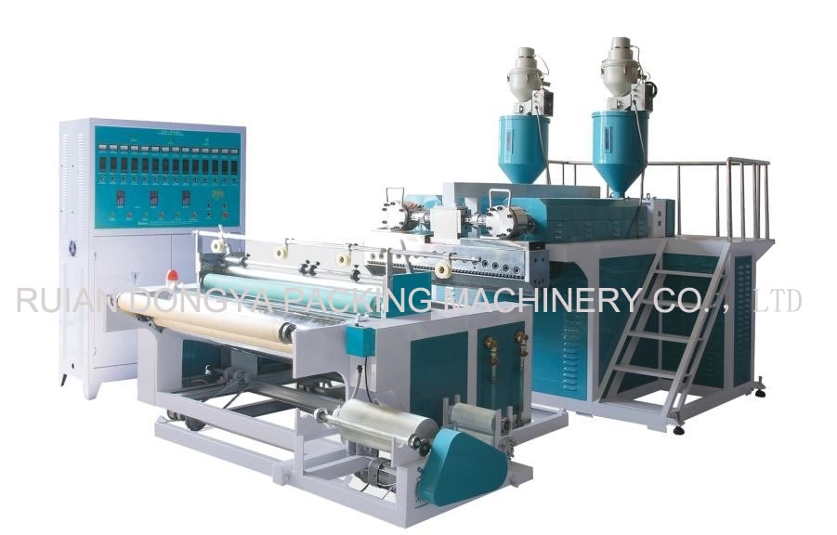
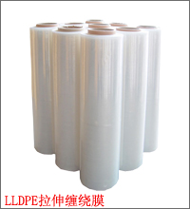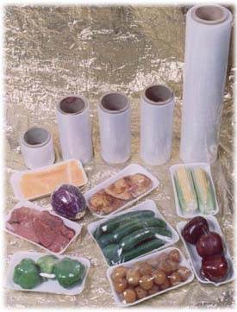
Ⅰ.Feature:
1. It profits advanced technology from aboard and manufacture by absorption, improvement, innovation.
2. It is entire frequency conversion control, movement stable, highly effective and the low energy consumption.
3. The product adopts the craft of one time forming.
4. It can produce two-side sticks for stretching film.
Ⅱ. Unit introduction
1. This series unit is mainly used in producing the polyethylene plastic film for unidirectional stretch (stretching film, twines membrane) as well as fresh film.
2. Therefore it applies in building material, hardware fitting packing widely. The screw of unit adopts 38CRNOALA alloy steel. It manufactured by nitric and precise processing so that it is highly hardness and durable long time.
3. Temperature controls adopts advanced automatic control system and the T mold adopts the multi- spots adjustment. They could cause the film thickness to be evener.
4. The cooling system adopts the circulating water cool and it cooling effect is good.
5. The rollout installment adopts the friction type of rollout and has the cutting edge installment and side material rollout element by round-trip. This causes the film which rollout to be neater.
Ⅲ. Main Technical Parameter
Model: | SLW-1200 double layers | SLW-1200
Screw Diameter | 60mm×2 | 65mm
L/D ratio | 28:1 | 28:1
Screw Barrel Material | 38CRMOLA | 38CRMOLA
Die width | 1450mm | 1450mm
Film Width | 500-1200mm | 500-1200mm
Thickness | 0.008-0.05mm | 0.008-0.05mm
Rollout Diameter | 300mm | 300mm
Output | 70-90kg/h | 65kg/h
Main Motor Power | 15kw×2 | 15kw
Heating Power | 65kw | 65kw
Overall dimension: | 6000×3000×2600mm | 6000×2200×2500mm
Total Weight | 5000kg | 4500kg

Standard configuration
Item | Description | quantity
1 | Automatic Winding changer | 1pcs
2 | Automatic Air shaft | 2pcs
3 | Automatic Trimming device | 1pcs
4 | Automatic Temperature Control | 12unit
4 | Step less Inverter | 1set
5 | Step Motor | 1set
6 | AC Motor | 1set
7 | Gear box | 1set
8 | Panel box | 1set
9 | Switch (ZHENGTAI) | Several pcs
10 | Electrical component (ZHENGTAI) | Several pcs
11 | Hopper | 2pcs
12 | Cooling roll (diameter: 270mm) | 1pcs
13 | Air compressor | 1pcs

Spare Accessories
Item | Description | Quantity
1 | Tools | 1pcs
2 | Instructions | 1pcs
3 | Schematic | 1pcs
4 | Current meter | 1pcs
5 | Voltage meter | 1pcs
6 | Thermocouple | 1pcs
7 | Relay | 1pcs
8 | Out color | Dark blue
Ⅳ. Quotation (F.O.B Price to Ningbo port)
Model | Price
SLW-1200 single layer | 24000USD
SLW-1200 double layers | 37000USD
Our price valid period last for 2 months.
Optional Device with Extra
Item Unit Price Discount price
1).Auto loader 750USD/Piece 1400USD/Two Pieces
2) Dry Hopper 450USD/Piece 800USD/Two Pieces
3) Auto Screen Changer 850USD/Piece 1500USD/Two Pieces
4) Glue Pump 750USD/Piece 1400USD/Two Pieces
5) Mixer 2400USD/SET 2200USD
6) Air Compressor 200USD 150USD
7) Chiller 2000USD 2000 USD
Ⅴ.Delivery
Within 30 days shipment the machine， we manufacture the machine after we receipt 30% deposit.
Ⅵ.Guarantee
- One year guarantee the quality of machine. But the buyer need pay the cost of maintenance if it is break down due to incorrect operation.
- Spare parts attached for free, problem parts can be changed for free in 1 year, but the express fee should be paid by users, others(if needed) suggest to be bought at the first time to save the cost of transportation.
Ⅶ. Technical services
- We will teach your staff to learn all the operation instruction in our factory if needed, this operation is easy to learn and only 1 person is enough to control !
- If need our engineer go to your country or teach and install ,the flight fee, the living fee, engineer salary (60 USD/per day) should be in charge by buyer
- We would present buyer the specification and Video or CD along with the machine when shipment.
Ⅷ. Package
In wooden box, or stretch film package or in bulk just according to the situation of shipment or clients, wooden box need pay extra package charge.

Extra Equipment Details
1. DYFS-60 stretching film crusher & mixer
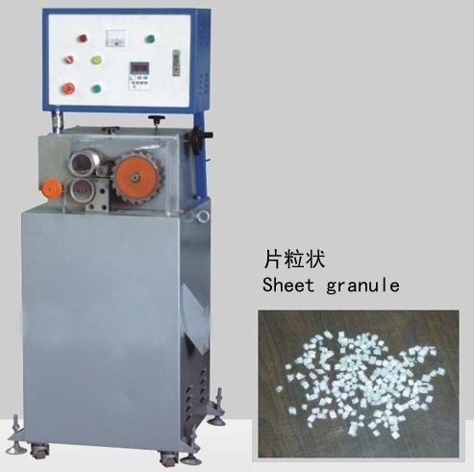
Application:
The machine is characterized by sound reliability, easy maintenance and stability in design. It is specially applied to recycling the hydrostatic film materials and other materials, such as CPE，PE，PO，PP，PET，PA and etc, which will bring you sound economic result. It is suitable for crushing the stretching film with some glue, it is of excellent operation system and high output capacity.
Characteristics:
It only recycles directly the film materials without changing the chemical contents or compositions so the pellet can be recycled to utilize. Its master motor adopts import name converter to govern, which is characterized by saving power, good for environmental protection ,simple construction, ease of operation(one person operation ) and high automation.
Main Technical Data:
Main Motor Power | 3kw
Machine Weight | 300kg
Overall Dimensions | 700*700*1600mm

2. Industrial Air Cooled Chiller
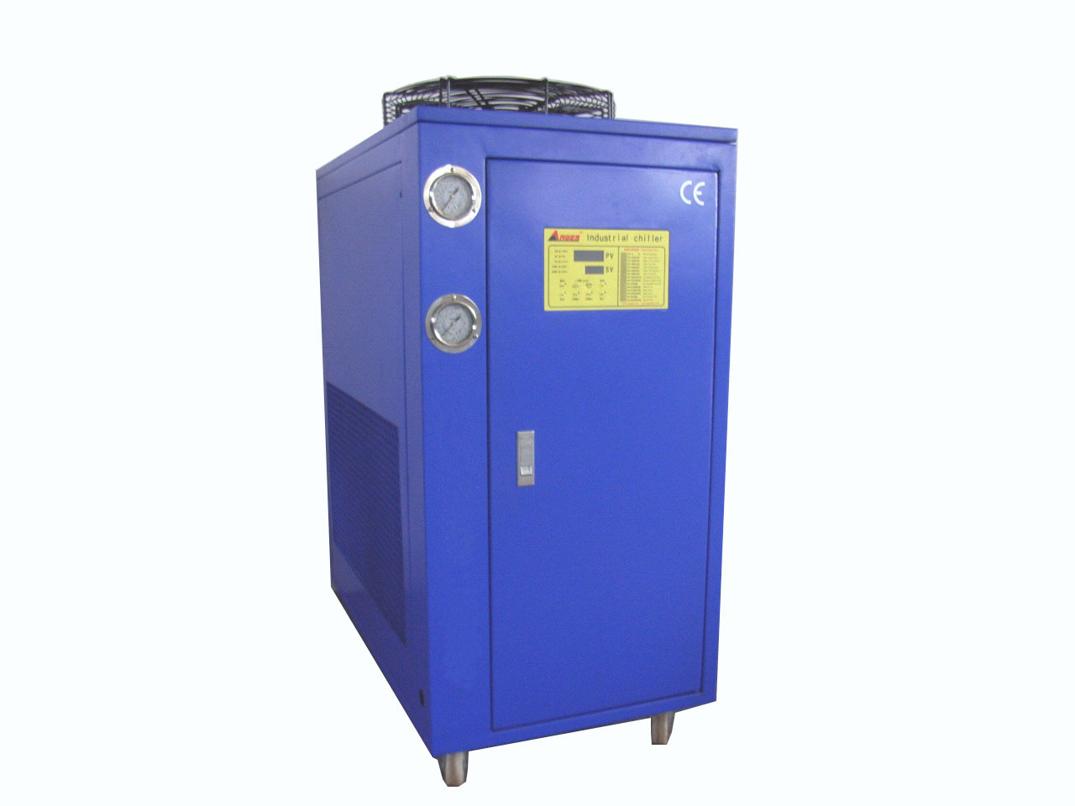
A. Technical Parameters
Model  Item |  | AC-3
nominal cooling capacity | kcal/h | 6803
nominal cooling capacity | kw | 7.91
input power | kw | 3.33
power supply | 3PH~380V/50HZ
refrigerant | type | R22
refrigerant | type of control | capillary
compressor | type | hermetic scroll(piston)
compressor | power(kw) | 2.8
condenser | type | finned copper tube + low noise outer rotor fan
condenser | cooling air flow (m³/h) | 3000
evaporator | type | tank with coil(shell and tube)
evaporator | chilled fluid flow (m³/h) | 1.36
evaporator | volume (L) | 50
evaporator | inlet and outlet pipe diameter (inch) | 1
water pump | power (kw) | 0.37
water pump | lift (m) | 20
safety protection | compressor over temperature, over current, high and low pressure, over temperature,flow  switch, phase sequence, phase-missing, exhaust overheating, antifreezing
weight | kg |  | 135
dimension | mm |  | 930*520*975

- Note: 1. Nominal cooling capacity is according to:
- Inlet chilled fluid temperature: 12℃
- Outlet chilled fluid temperature: 7℃
- Inlet cooling air temperature: 30℃
- Outlet cooling air temperature: 38℃
- 2. Working range:
- The temperature range of chilled fluid is from 5℃ to 35℃;
- Temperature difference between inlet and outlet chilled fluid is from 3℃ to 8℃.
- It is better to use the chiller while the ambient temperature at or below 35℃.
- We reserve the right to modify the above dimensions or parameters without further notice.
B. Main parts of 3-5 HP Air cooled chiller
- Main parts | - Brand | - Origin
- Compressor | - Hitachi | - Japan
- Electrical components | - Schneider | - France
- Water pump | - Pentax | - Italy
- Evaporator | - ANGES | - Hong Kong
- Condenser | - ANGES | - Hong Kong
- Pressure Controller | - JUNLE | - TAIWAN
- Oil type pressure gauge  （High pressure） | - HONGSEN | - CHINA(Taiwanese capital)
- Oil type pressure gauge  (Low pressure) | - HONGSEN | - CHINA(Taiwanese capital)
- Thermostat | - ANGES | - Hong Kong
- Expansion Valve | - ALCO | - America
- Filter Dryer | - ALCO | - America
- Cooling Fan(outer-rotor blower) | - MAER | - TAIWAN

3. Air compressor
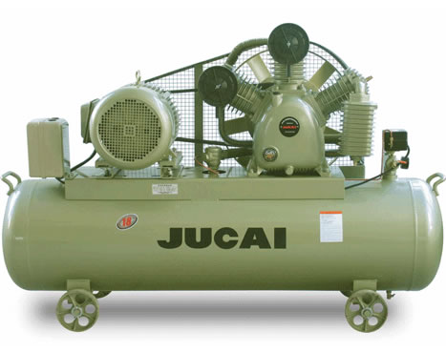
Application: it is used for stock and compress the air, adjust air load, delay to use the air.
Detail specification:
Item | Air compressor
Pressure | 0.8Mpa
Weight | 80kg
Dimension | 900×450×790mm
Power | 1.5kw
4. Auto feeder
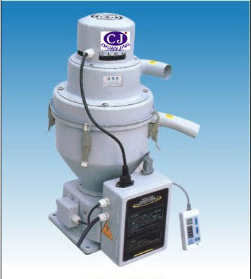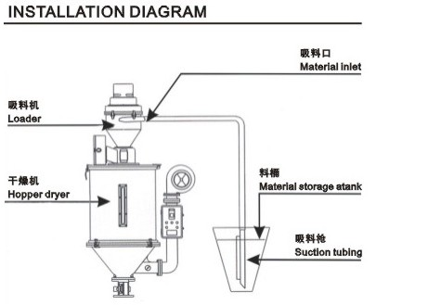
Feature:
1. Small dimension, light weight, can be install on the dryer or other raw material holder.
2. It adopt microcomputer control, unload or shortage material automatic alarming.
3. High speed motor, convenient operate, lower noise, long use time.
Main Specification:
Item | Auto feeder
Motor | 1kw
Speed | 200kg/h
Capacity | 6L
Lift | 5-7m
Weight | 13kg
5. Glue Pump
Application: This glue pump used for put glue into the raw material and produce the stretch film.
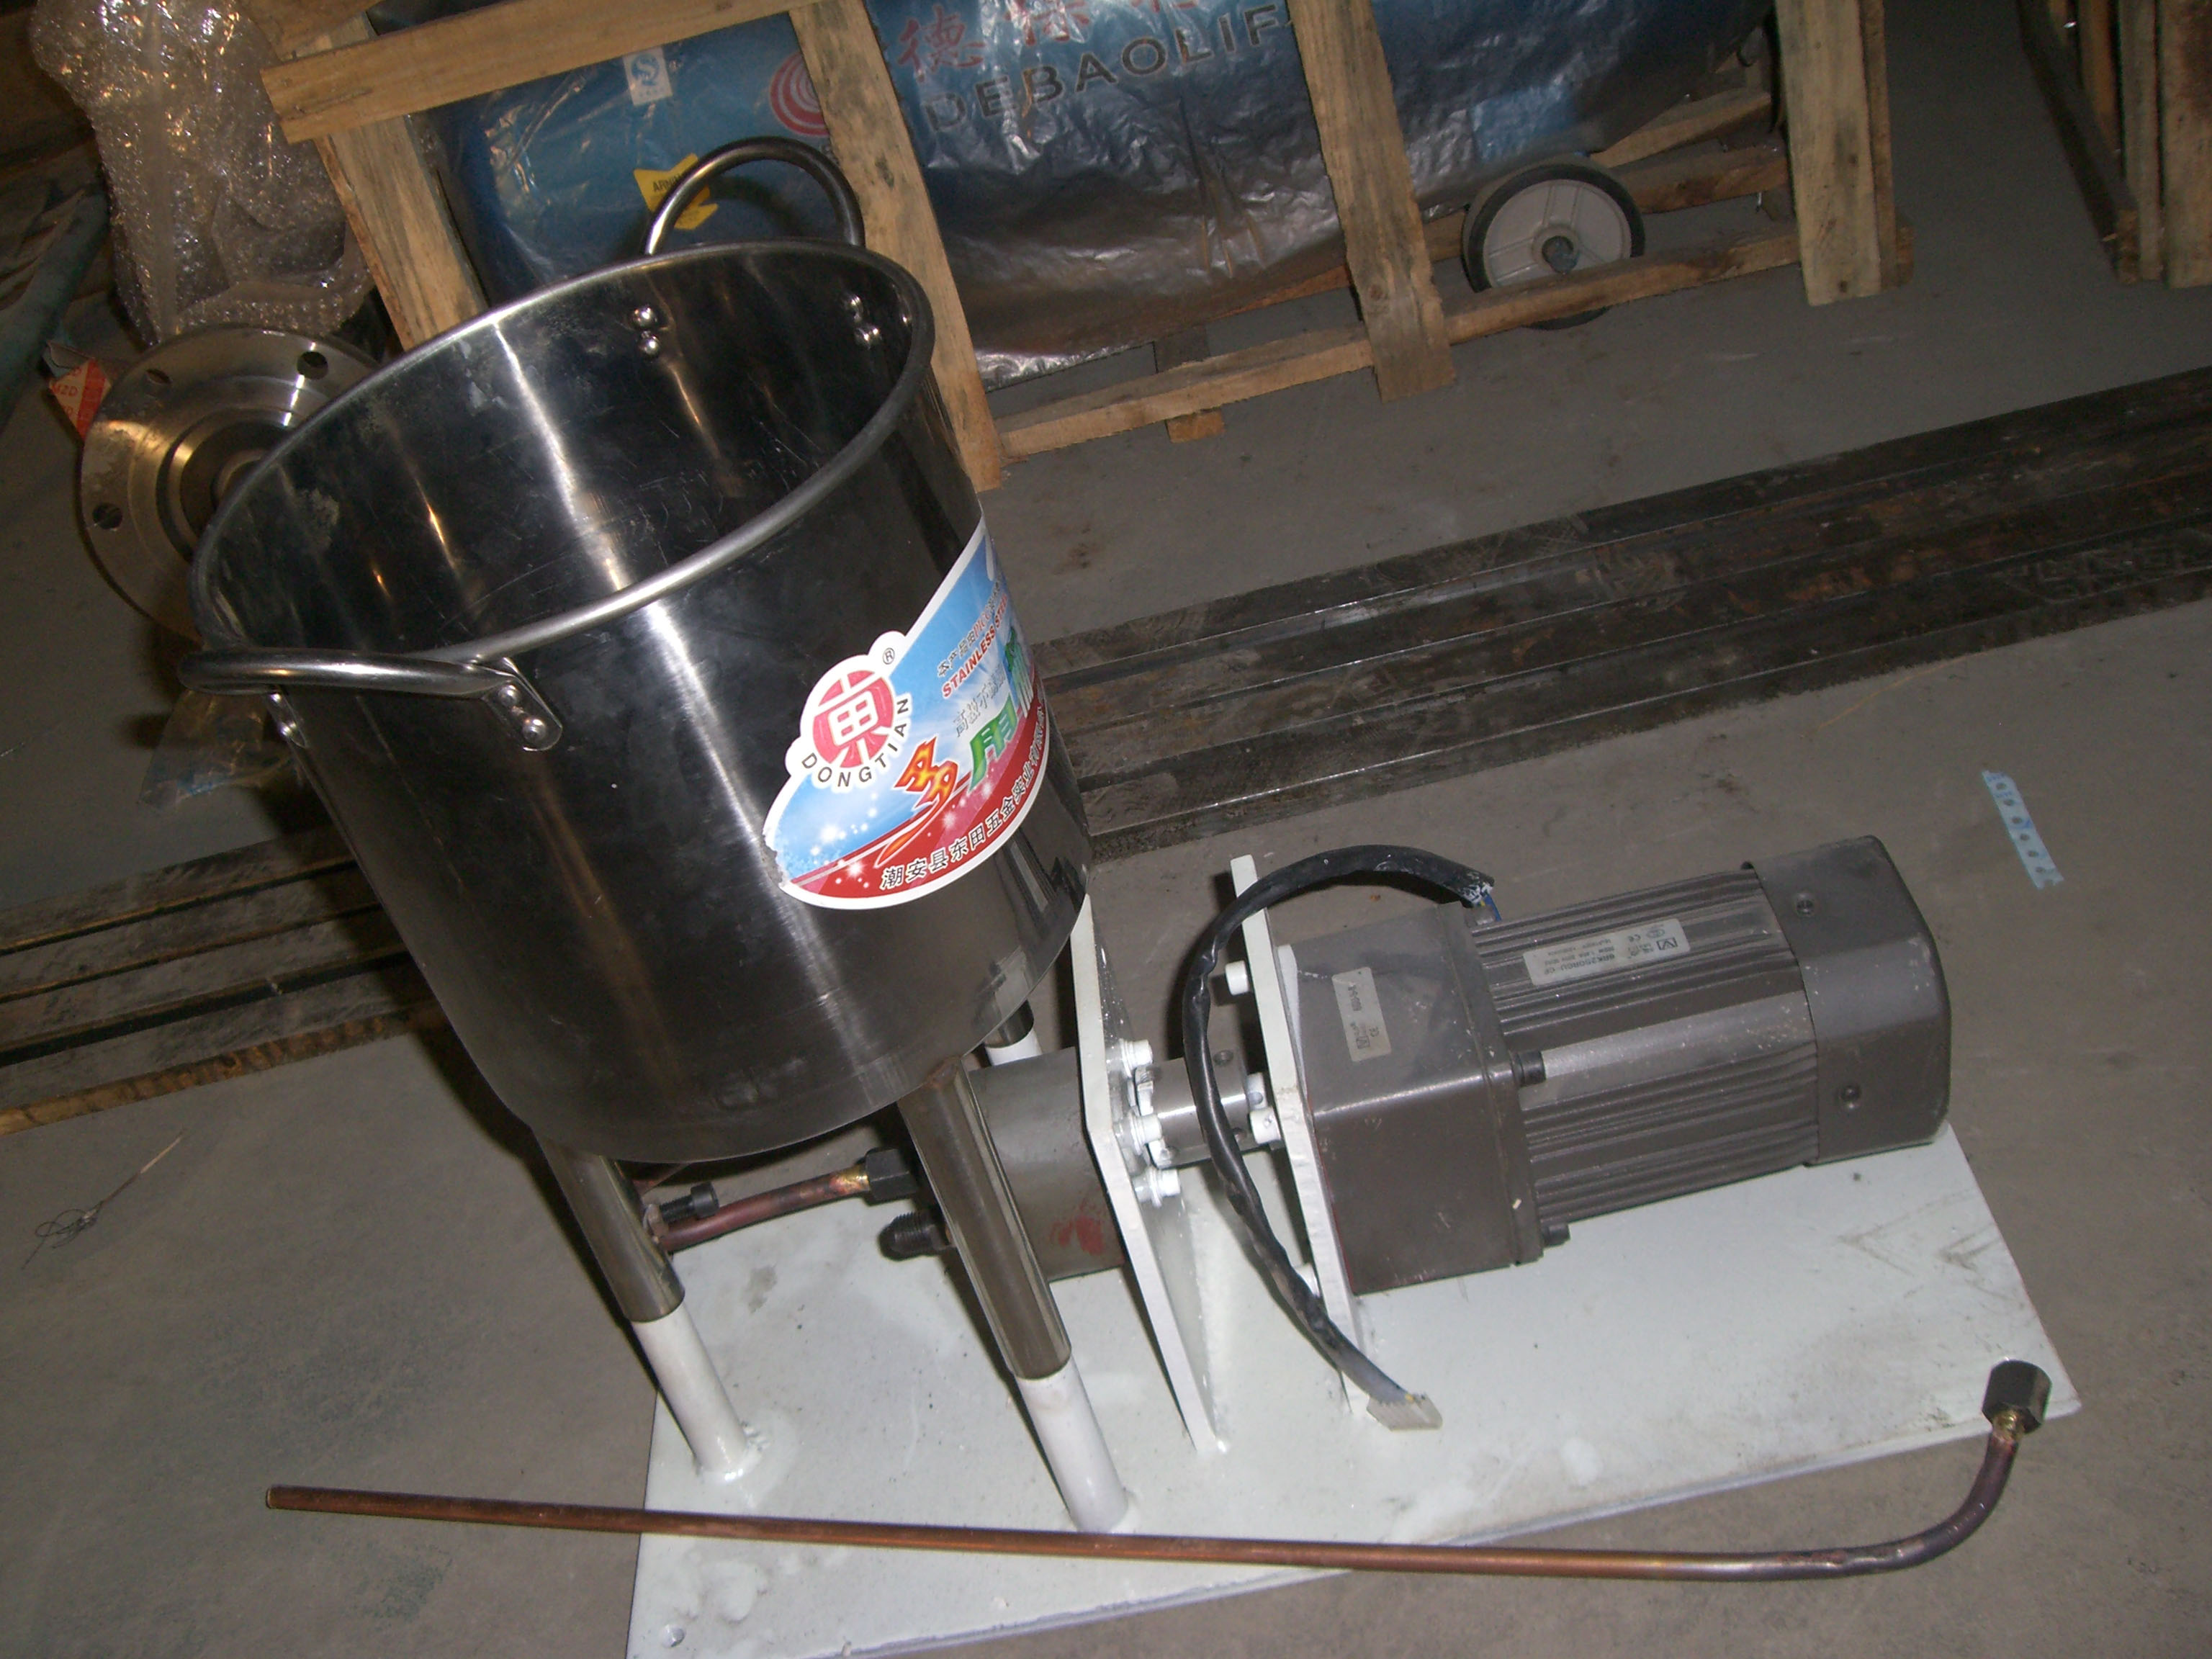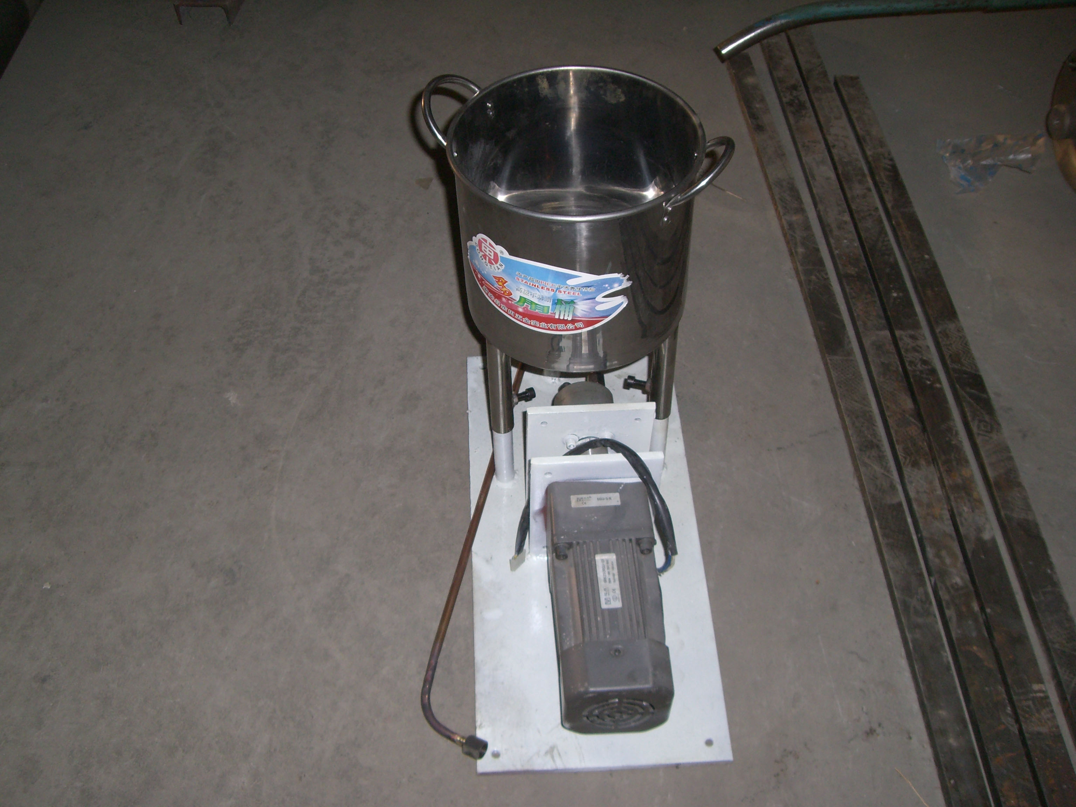
Main specification
Item | Glue pump
Volume | 5kg
Material | Stainless steel
Power | 0.5kw
Weight | 50kg

Gear Box Hopper
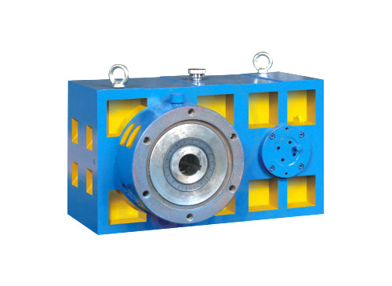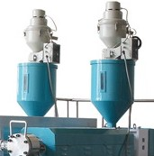
Packing: with stretch film and bubble film.
It also can be packing with wooden box (you need to pay the extra fee)

