Commissioning and maintenance training

Trainer: Ma Junfei
Trainee: pump operator and maintenance staff
Region: Mid-east and Africa
Company: Excellence Pump Industry Co., Ltd.

Content
- Slurry Pump Installation and Commission
  - Installation ………………………………………………………… Page 3
  - Commission and trial run ………………………………………… Page 7
- Slurry Pump Daily Maintenance
  - Pump…………………………………………………………………Page 8
  - Usual maintenance …………………………………………………Page 9
- Slurry Pump Transportation and Storage
  - Slurry Pump Transportation………………………………………Page 10
  - Slurry Pump and Wear Parts Storage ……………………………Page 10
- Conclusion…………………………………………………………………Page 11

Slurry Pump Commissioning and Daily Maintenance
Slurry pumps are widely applied in many industrial fields for the delivery of relatively more complex working conditions with liquid and solid particles. Routine check and daily maintenance is the best way to prolong the service life and improve stability of slurry pumps. Scientific maintenance would extend the life of slurry pump parts and guarantee its safe and stable operation. Therefore, it is necessary to learn the slurry pump commission and maintenance.

- Slurry Pump Installation and Commission
1.1 Installation (Please read the Slurry Pump Manual before installation.)
    - The foundation for the placement of slurry pump must be of enough strength to withstand the whole weight of pump equipment and eliminate vibrations (avoid resonance);
    - Install the base plate and the slurry pump separately;
    - Concrete foundation: The slurry pump should be installed on the baseplate after the concrete intensity reaches more than 75% of its designed strength and all the dimensions meet the requirements;
    - The base location and dimension tolerance of the base plate shall conform to Table I:
Base Location and dimension tolerance (Table I)
Item |  | Dimension tolerance（mm）
coordinate position |  | 20
Standard height of different planes |  | 0，-20
Outline dimension of the plane |  | ±20
Outline dimension of the pointed plane |  | 0，-20
Outline dimension of the dent plane |  | ±20
Horizontality | Per meter | 5
 | Total Length | 10
Verticality | Per meter | 5
 | Total Length | 10
Built-in Anchor Bolt | Standard Height | +20，0
 | Center Distance position | ±2
Built-in Anchor Bolt Hole | Center Line | 10
 | Depth | +20，0
 | Verticality of Hole Wall | 10
Built-in Mobile Anchor Bolt Anchor Plate | Standard Height | +20，0
 | Center Line Location | 5
 | Horizontality of anchor plate with Groove | 5
 | Horizontality of anchor plate with Thread | 2
    - After installation, the center line of machine set is consistent with that of base plate. The dimension tolerance of center height is less than 2mm, while the base plate or foundation should find the level in accordance with 0.1/1000 standard;
    - The recommended method is second grouting;
    - Tighten the bolts when the concrete intensity is more than 75% of the designed strength. Each bolt should be equally tightened.
    - Please refer to Table II for the preload force of each anchor bolt:
Preload Force of Anchor Bolt (Table II)
Bolt performance  Grade | Nominal Bolt Diameter
 | M12 |  | M16 | M20 | M22 | M24 | M27 | M30 | M36 | M42 | M45
 | Construction Preload (KN)
8.8S | 45 | 75 |  | 120 | 150 | 170 | 225 | 275 | 340 | 470 | 550
10.9S | 60 | 110 |  | 170 | 210 | 250 | 320 | 390 | 480 | 660 | 770
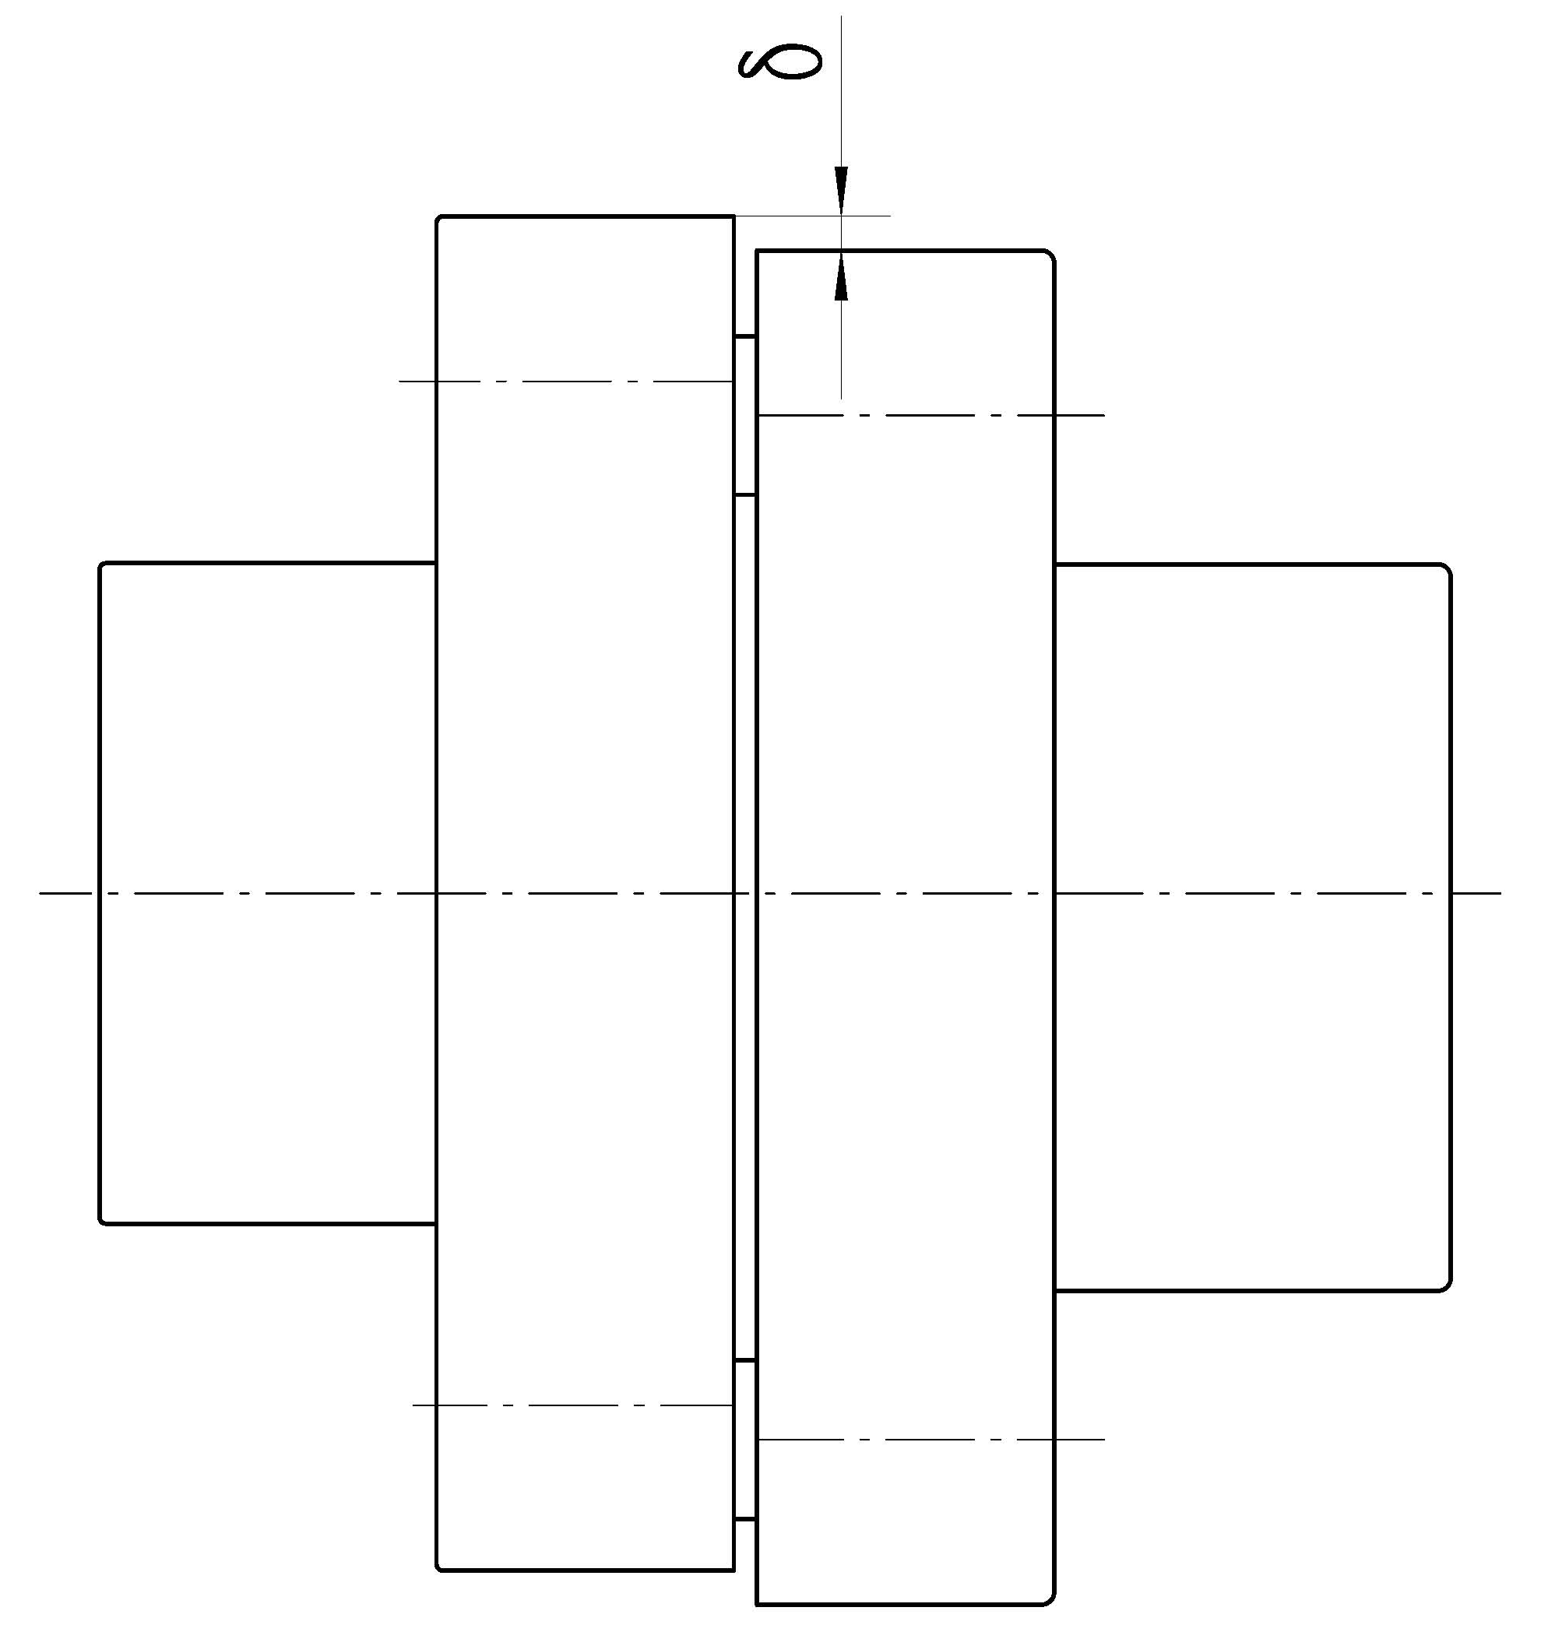
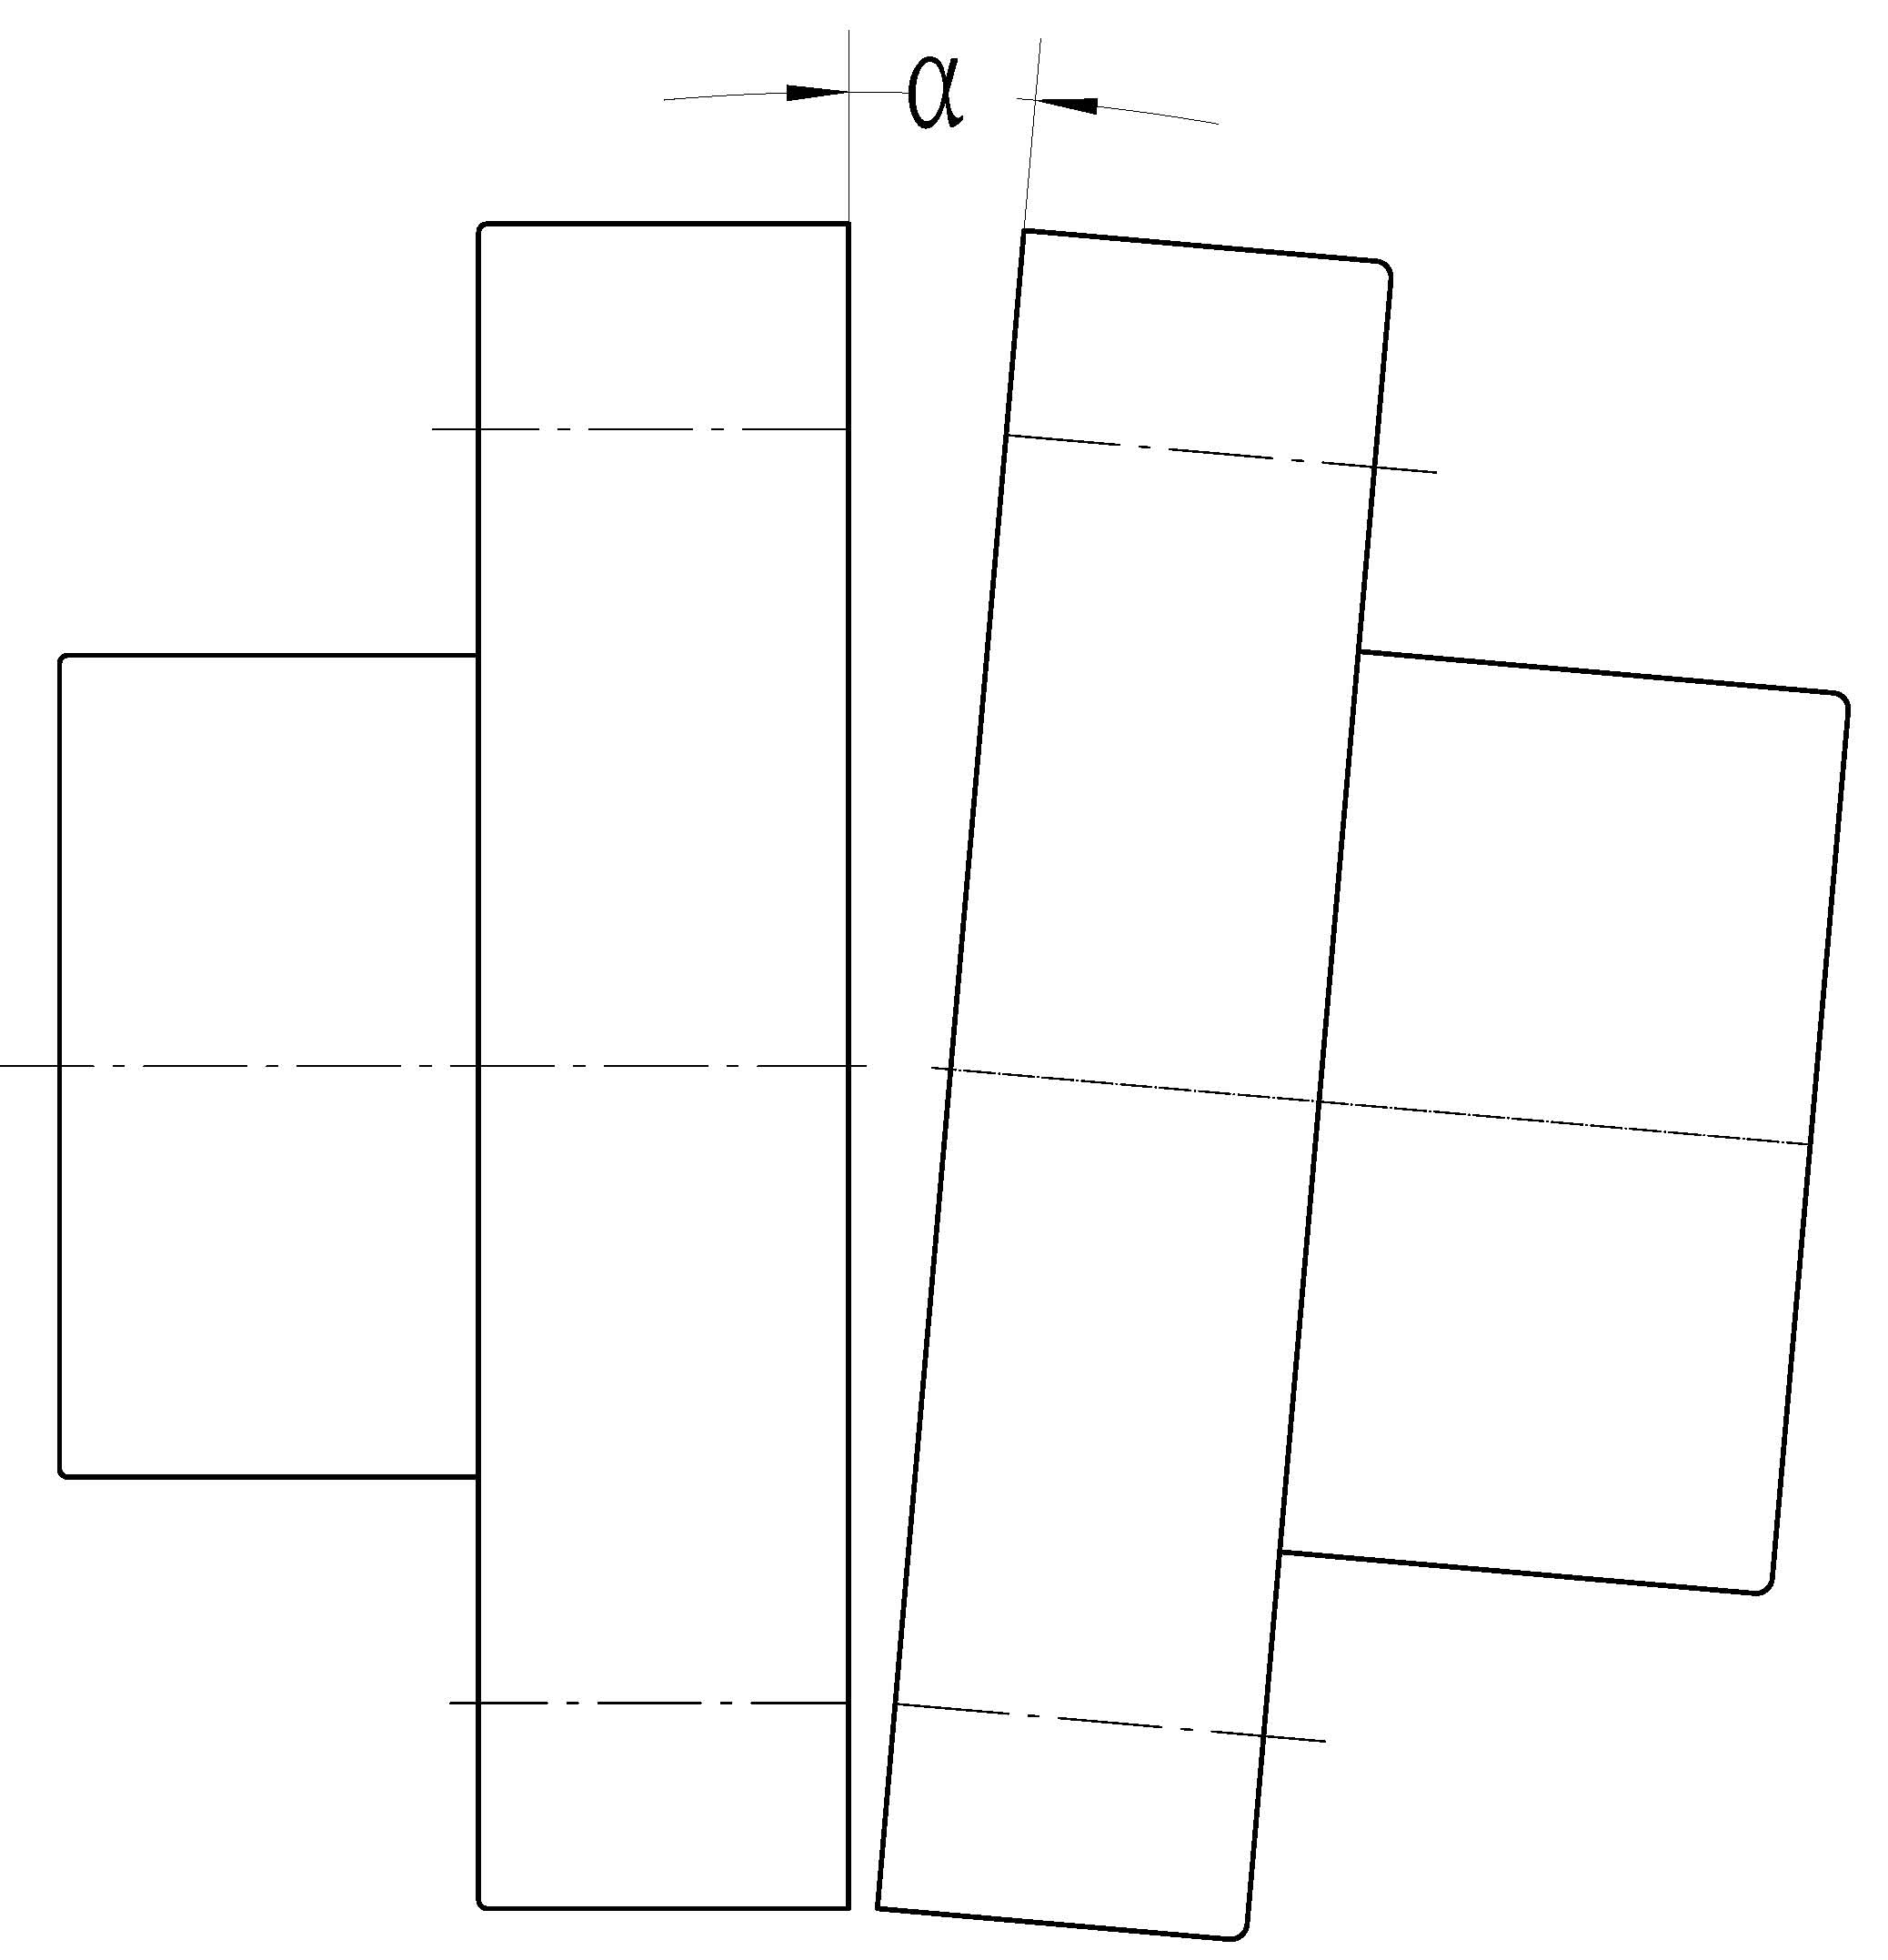
    - When the connection type is DC (direct connection), the axiality between slurry pump and driving device should comply with Table III:

(Figure.1)

Axiality Allowance (Table III)
Coupling  Outer Diameter (mm) | Max. permissible Deviation  δ(mm) | Max. permissible Axis Tilt  Α | End Clearance  S  (mm)
71 | 0.1 | 0.2/1000 | 2～4
80
95
106
130 | 0.15 |  | 3～5
160
190
224 | 0.2 |  | 4～6
250
315
400 | 0.25
475 |  |  | 5～7

    - If the connection type is V-belt, the slurry pump shaft should be parallel with drive shaft, usually centering by the pulley. The parallelism should not be less than 0.2/1000;

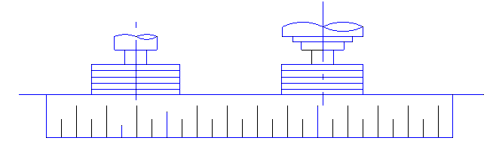
（Figure 2）
    - The diameter of inlet pipe should the same with or slightly larger than that of suction, which is based on the principle of avoiding cavitation or blockage caused by the velocity of the slurry below sedimentation velocity.
    - To facilitate the repair and maintenance of the pump, the suction valve should be installed in the suction with the same diameter as inlet pipe. The suction valve should be placed as far away from the suction as possible.
    - The adapter bonnet in the inlet pipe is recommended to adopt parallel up busbar to avoid cavitation , as illustrated in figure 3:
(Figure 3)
    - The pipeline connection between shaft seal water and cooling water is described in the manual for each type of pump.

  - Commissioning and trial run
Slurry pump commissioning and trial run should be operated by an experienced operator. Any abnormal condition should be immediately removed, and stop and examine the machine if necessary. The equipment should not be started until the malfunction is positively removed.

    - Before start up
      - All equipment and auxiliary facilities should be firmly installed, and the pump piping system should be supported separately. All fasteners are reliable connection (tightening ) ;
      - Tighten all fasten pieces;
      - The rotating direction should be consistent with pump operating direction. When to test rotation direction, the motor should be completely detached from slurry pump;
      - Check the axiality of coupling, parallelism of pulley and tightness of belt;
      - Rotate the shaft. There should not be any sign of stuck or abnormal sound;
      - Clean up the site. There should not be any debris which would affect the operation of device;
      - The slurry pump’s bearing assembly lubricated by oil should be filled before running according to the manual, which should be ± 2mm of the oil level line. If the slurry pump is lubricated by grease, the grease has already been added at the factory. Note: Do not run the slurry pump without lubricant!
      - Make sure that the shaft seal water meets the requirements: The flow is generally 1 to 3% of the normal flow of the pump and the pressure should be 0.035 MPa more than pump outlet pressure but within 0.2MPa;
      - Open the seal water first (if any );
      - Note:
Only start the pump when its suction valve is fully opened (if any). Do not use suction valve to influence pump performance, if so, it may lead to equipment damage or personal injury!
      - The outlet valve should be opened 1/4 firstly or in accordance with the starting procedures, then gradually open the outlet valve after the pump is running smoothly (especially long-distance transport);
      - Check if there is any abnormal leakage;
      - Do not start the pump if the feeding is significantly less than the design flow because it may cause cavitation and pump damage.
      - If the pump stops for a long period, please use the flushing water to wash away the sediments in pump chamber before starting the pump.

    - During installation

      - The temperature of the bearing shall not exceed 75°C at any time (the temperature of the bearing should be measured at the interval of less than 0.5 hour and the optimal operating temperature is between 40°C to 65 °C during commissioning);
      - Check the operating power (current) is consistent with the designed value;
      - Check the operating power (current) is stable or not;
      - Make sure the seal (especially packing seal) isn’t either too tight or too loose. If it is too tight, it would raise the shaft power and easily wear out the packing and shaft sleeve. We could judge the degree of packing compression by observing leakage at the seal. Generally, the allowable packing seal leakage rate is in the table below:
Packing leakage allowed (Table IV)
Capacity  m³/h | ≤50 | ＞50  ～100 | ＞100  ～300 | ＞300  ～1000 | ＞1000
Leakage  mL/min | ≤35 | ≤45 | ≤65 | ≤85 | ≤125
      - Check the condition of shaft seal water leakage regularly. If the leakage increases, you can tighten the clamp bolts of the packing gland or replace packing/ shaft sleeve properly. Note:
There should be no leakage of slurry from the stuffing box at any time, otherwise it will aggravate the abrasion between packing and shaft sleeve, consequently affect the life of the seal;

      - Measure the capacity and head. If they are not up to the designed request, you can adjust them by changing the speed, cutting impeller, or direction of the discharge valve and so on.
Note:
Do not adjust the pump operating parameters by adjusting the suction valve;
      - Check if there are abnormal noises;
      - Check if there are vibrations;
      - Check if there is abnormal leakage;
      - Check if there are other anomalies;
      - Note:
Slurry pump shall not work with lower capacity or even no capacity for a long time. Otherwise, it may damage the equipment or even cause personal injury. (Insufficient and no feeding will lead the slurry vaporize).
      - Note:
Do not touch the rotating parts of slurry pump when the pump is working;
      - Please run the clear water for a while before official running if possible.

    - Turn off pump
      - Close the valve first and then shut down the pump;
      - Keep the shaft seal water running for another five minutes;
      - Run clear water for a while before shut down the pump if possible.
      - Check if there is abnormal leakage;
      - Note:
Do not stop the pump if the discharge valve is wide open, or the slurry in the pipeline would flow back and form the water hammer which would cause damage to the pump.

- Slurry Pump Daily Maintenance
It is necessary to check and maintain the slurry pump according to the following steps after the installation for pumps life and efficiency.
  - Pump
    - Bearing assembly lubricated by oil
      - Please replace the oil completely after the new pump has been put into operation for 120 hours (5 days);
      - Change the oil after at the interval of 800 to 1000 hours according to the site working situation;
      - Or customize the replacement period according to the actual situation;
      - Check the quality of oil regularly to prevent water or other contaminants into the oil chamber;
      - Always pay attention to the operating temperature of the bearing (the bearing housing or the outer side of the frame near bearing). Under no circumstances shall the temperature above 75°C, and the temperature rise should be within 35°C;
      - If there is any unusual temperature rises or noise of bearing, please dismantle and check the bearing assembly.

    - Bearing assembly lubricated by grease
      - The grease should be replaced completely after 1500 hours. Then it is recommended to be replaced every 7000 hours.ac
      - The replacement of grease could refer to Table V or according to site working condition;
Grease Quantity and Lubrication Periodic Chart of Bearing Assembly (Table V)
Frame Type |  | Lubricant  Quantity of Each Bearing  (g) | Bearing Rotating Speed (r/min)
 |  |  | 200 | 300 | 400 | 600 | 800 | 1000 | 1200 | 1800 | 2000
B |  | 12 |  |  |  |  | 3000 | 2400 | 1800 | 1500 | 1000
C |  | 18 |  |  |  | 3600 | 2400 | 1800 | 1600 | 1200 | 900
D |  | 28 |  |  |  | 2500 | 2000 | 1500 | 1200 | 800 | 500
E |  | 44 |  | 5000 | 3600 | 2200 | 1600 | 1100 | 800 | 500
F |  | 71 | 7000 | 4200 | 2000 | 1800 | 1200 | 700 | 400
Pump | R.RS | 102 |  |  | 3000 | 2000 | 1400 | 1000 | 600 | 400 | 100
 | S.ST | 132 |  | 3800 | 2800 | 1500 | 900 | 500 | 300
 | T.TU | 304 | 4800 | 3000 | 1800 | 900 | 400
 | G | 304 | 4800 | 3000 | 1800 | 900 | 400
 | U | 621 | 4000 | 2400 | 1500 | 500
Drive | R.RS | 61 |  |  | 8000 | 4800 | 3500 | 2800 | 2200 | 1500 | 900
 | S.ST | 74 |  | 8000 | 6000 | 3600 | 2400 | 1600 | 1200
 | T.TU | 133 | 8000 | 7000 | 4500 | 2500 | 1500
 | U | 192 | 7000 | 6000 | 4000 | 2000
 | G | 304 | 4800 | 3000 | 1800 | 900 | 400
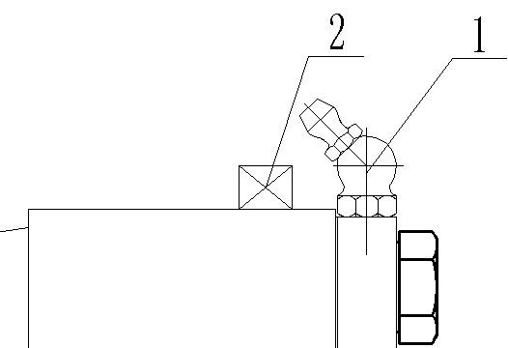
      - The wrong lubrication plan would cause excessive or insufficient lubricant, both of which should be avoided because too much or too little amount of grease may cause overheating or bearing damage;
      - Do not add lubricant to the newly installed slurry pump, which has been filled up with grease at the factory.
      - The grease nipple in the end cover (Figure. 4.1) is used for the lubrication of the piston ring. You have to open the bolt (Figure.4.2) to find where to add grease for bearing.

    - Attend to condition of wet parts which are subject to wear and replace them if necessary. When replacing the wet parts, make sure the right installation and clearance;

    - If there is any malfunction during operation, please follow the instruction of possible problems and solutions. If the problem still persists and cannot find the cause, please contact the customer service.

  - Usual maintenance

2.2.1 For the longer service life and higher performance of the pump, you should adjust the impeller clearance periodically (often);
2.2.2 Often check fastening pieces to ensure all parts are firmly connected to avoid equipment damage;
2.2.3 Check the water seal, shaft power, and bearing temperature at all times.

- Slurry Pump Transportation and Storage
  - Slurry Pump Transportation
    - Slurry pump must be firmly fixed during lifting and transporting because of its big size and weight.
    - The pump components are just used for the pump only including pump casing/cover, bearing housing, lifting eye or ring bolts. Do not lift the pump by the pump parts, or it may result in personal injury or equipment damage (Figure 5):
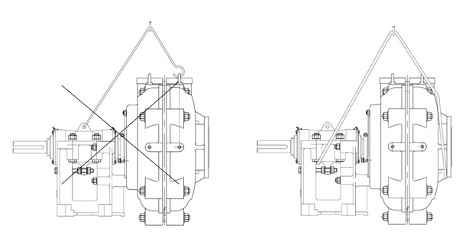
(Figure 5)

  - Slurry Pump and Wear Parts Storage
    - The slurry pump for long-term inventory should be clean, no oil stain and kept in dry place.
    - The shaft of the slurry pump in warehouse should be rotate for about 1/4 lap every week to make the bearing and shaft evenly sustain the static load and external vibration;
    - If the pump is put outside for over 6 months, please dismantle and check the pump before use. Replace the rubber ring (pad) or lubricant ( grease), if needed;
    - If the pump is in the warehouse for more than 12 months, please dismantle and check the pump before use. Replace the rubber ring (pad) or lubricant ( grease), if needed;
    - The rubber products are easy to be aged and breakable. It is recommend to store the rubber parts indoors and not to exceed 12 months, and the maximum inventory period is 18 months under normal circumstances;
    - The main spare parts of double-casing slurry pumps are liners (volute liner, throatbush and frame plate liner insert), impeller, shaft sleeve, bearing, sealing materials (such as packing) and stuffing box (expeller, expeller ring, mechanical seal box). The quantity of spare parts of each pump should be determined by their service life;
    - Usually, every 10 (or less than 10) slurry pumps of the same model should have one set of bearing assembly in reserve to ensure quick replacement. Then check the detached bearing assembly and repair it in the workshop for the preparation of next pump.

- Conclusion
All mentioned above are only general guidelines rather than only determining factor. The best solution will be found through continuous observation, careful record and analysis during the initial operation.

