Product Description

Par38 E27 12w cob Led Spot Light

Parameter:
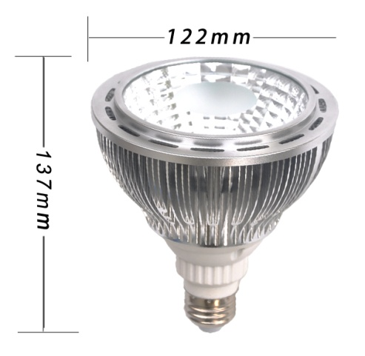 | Model | BC-PH12*1W-PAR38
 | Input Power | 12w
 | Input Voltage | DC12V; AC85-264V
 | Working Frequency | 50-60Hz
 | Lumens | 1050-1100lm
 | CCT | 2800-3200K;4000-4500K;6000-6500K
 | CRI | 80
 | Beam Angle | 30° / 60°
 | Housing Material | aluminum
 | Led working life | 50,000H
 | Option | Dimmable/Non Dimmable
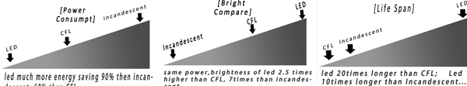

Product show:
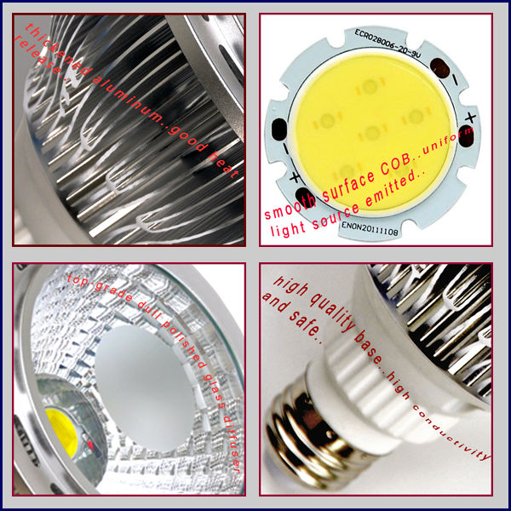
Application:
Corridor lights, architectural point of light, windows Gallery lighting. Furniture,
lighting, commercial lighting, museums, exhibition lighting. lighting projects,
banks, hotels, schools, bookstores, sports and other lighting..
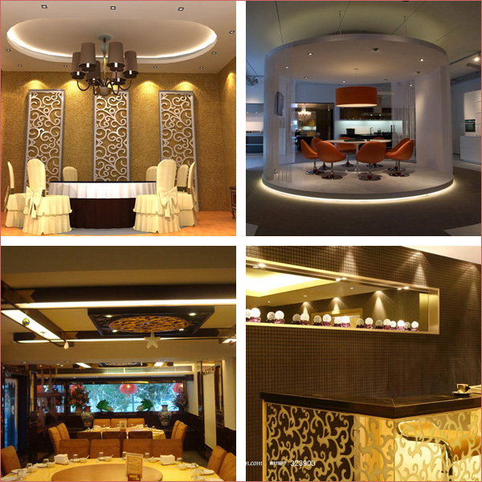

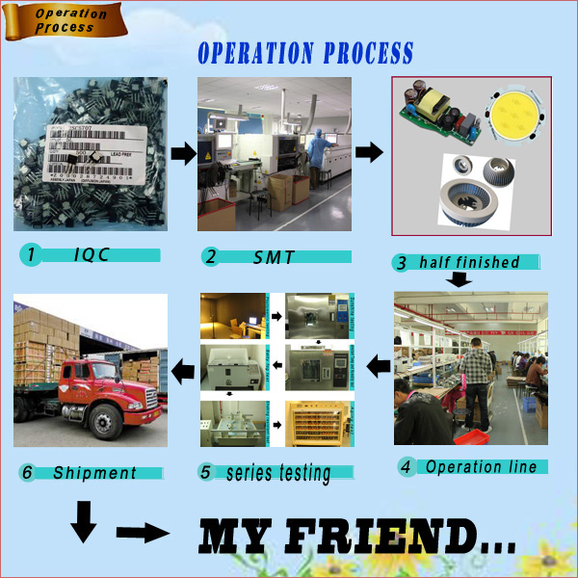
Quality Control
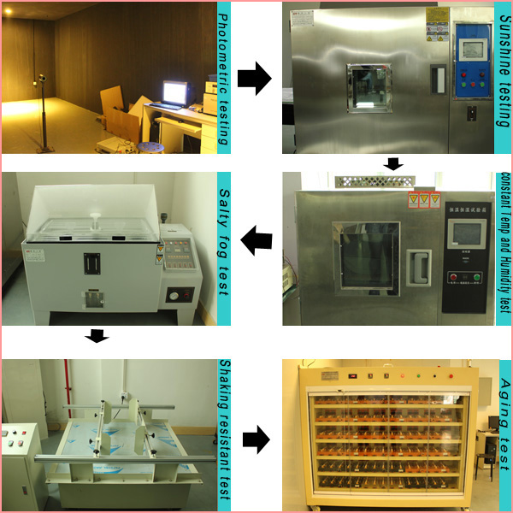

Company Information
Boocca Shanghai Industry Company is a professional LED light manufacturer in China,founded in 2005.Our plant
covers an area of 2,000 square meters. More than 300workers,15R&D teams and QCs will ensure the quality and
delivery for you.
Factory Office:
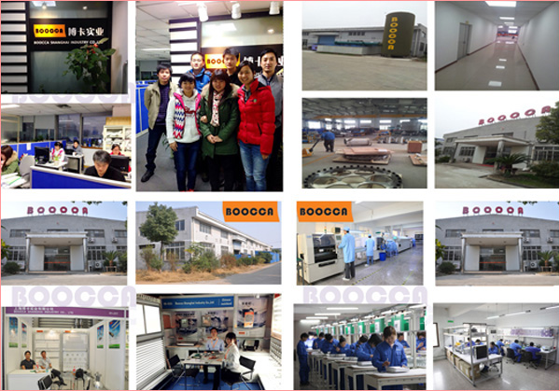

Emc & Lvd Certificates:
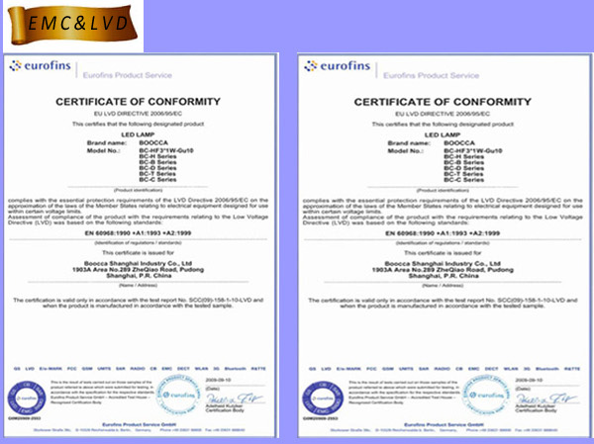

TUV Certificates:
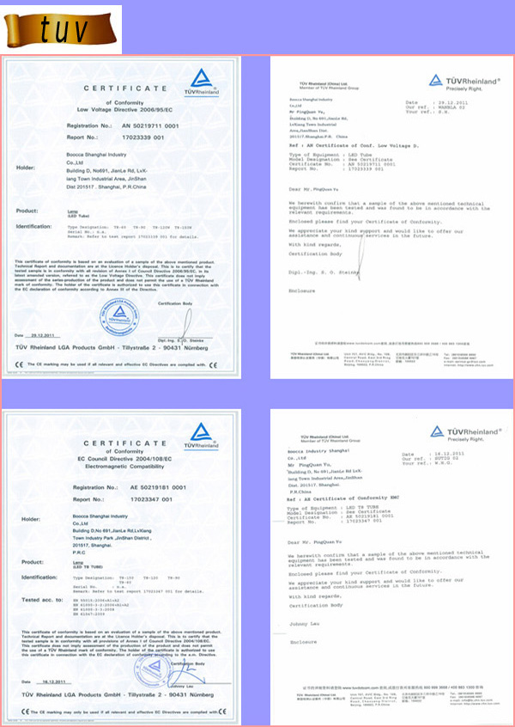

FAQ

FAQ:
01. What's ur products range?
1. Indoor: tubes..panel lamps..plug lamps..spot lamps..bulbs..downlights..etc.
2. Outdoor: highbays.. flood lamps..tunnel lamps..street lamps..
02. Are u a manufacturer?
1. Yes.. Boocca has been a professional manufacturer in led lighting area for 7years since 2006.
03. Do u have stock products to sell?
1. Yes.. As a professional and matural factory in led field.. each model exhibited on our catalogue
is exhist volume products in stock to see..
04. What information shoud I let u know if I wanna get a quotation?
1. the color temterature for the lamps u enquired..there're 3colors for options:2800-3200k(warm)/
4000-4500k(normal)/6000-6500k(cold).
2. the voltage range we should know.. 2 ranges for options: DC12/DC24v; AC85v-264v .
3. Lamps base for options: there're E27/E26/G24 for bulbs..G24/E27/E26 for PL lamps..Mr11/Mr16/
Gu10 for spot lamps..
4.Quantity for lamps..Destination.. contact person..phone no..Shipping by Sea or by Air or BY Expr-
ess..
5. If possible, it'd be appreciating for ur providing pictures of designing..graphic etc for OEM mod-
el.. samples will be best for clarifying.. for we can recommed relevent products with detail and
relevence.
05. How many days will samples be finished? and how about the mass production?
1. Generally speaking.. 5-7days for samples making..
2. The lead time of mass production would depand on quantity..production art etc..FYI ..30-45days
for 3,0000 pcs 240w flood lamps..
06. Do u inspect the finished products?
1. Yes.Each step of production and finished products will be carried out inspection by QC depart-
ment before shipping.
07. How do u ship the finnal production?
1. By Sea
2. By Plane
3. By couriers,TNT,DHL,FEDEX,UPS, etc..
09. What Advantages do u have?
1. Punctual..Have your orders met with late delivery? Weare a Manufacturer.It ensures we have
the ability to carry out the production schedule for punctual delivery.
2.Strength.. We invested on SMT equipment value up 3,076,923 usd, make sure consistency on
volume production; sunshine test ,raining test ,salty fog corrosion test, constant temperature a-
nd humidity test ,shaking resistant test ,voltage withstanding test ,ground resistance ,current l-
eakage test,photometry test ..strictly guarantee production quality..
3.7-year Experience..We have over 7-year experience in this idustry. That means,we can preview
the problems for the orders and production..Therefore.it willmake sure to reduce the risk of bad
situation to happen.
4. Point to Point Service..There is one sales represening who service you from inquiry to products
shipped out . During the process. you just need to discuss with him for all the pronblems and the
way saves much more time..
5.Strict QC.. For each order..strict inspection will be carried out by the QC department before ship-
ping.The bad quality and situation will be avoied within door..
6.Stable Suppliers..Wwe have worked with many accessory suppliers for many years,so we can
get cheapest material.electronic components..we believer stable quality with competitive price
makes profits..
7.Smooth Shipping.. We have export shipping department and forwarder.So we can promise fast-
er delivery and made the goods well protected.
8. Customers all over the world..Enough experience in foreign trade.We have many big customers
in Australia.USA.Japan. Germany. UK etc.
9. Certificates..CE&ROHS ..saa..Testing reports and more will guarantee the production process in
good orders and products in high quality.
10. Fast Reply..Our team will respond your requests with 8-working-hour..

Packaging & Shipping

Market & Delivery
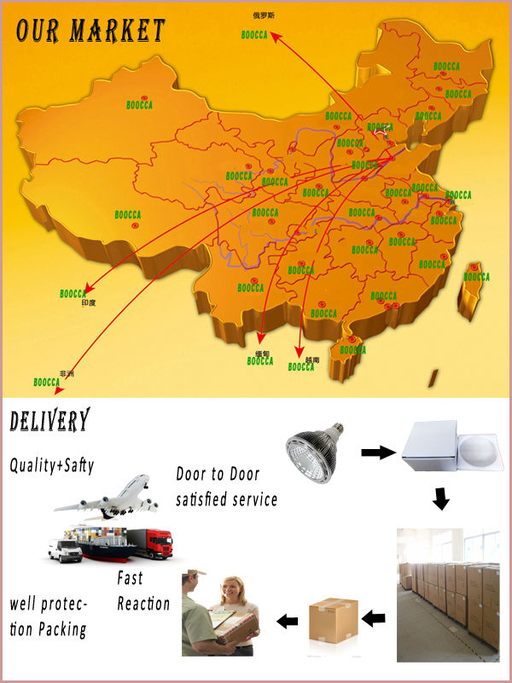
Paymet & Shipment
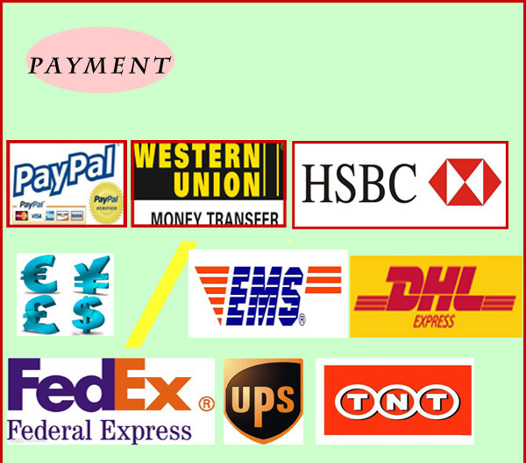
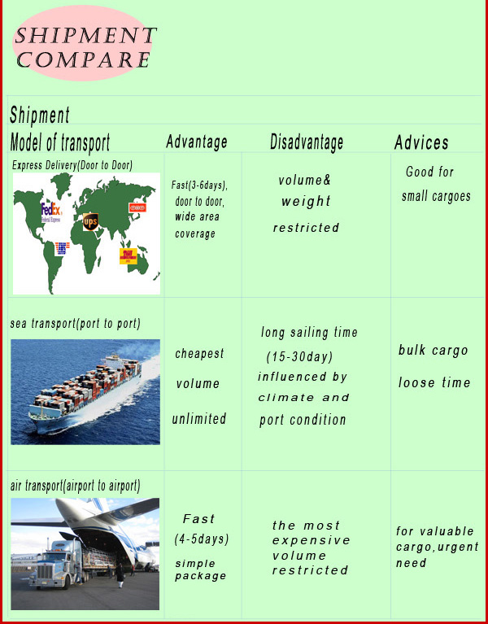

Our Services

OEM SERVICE
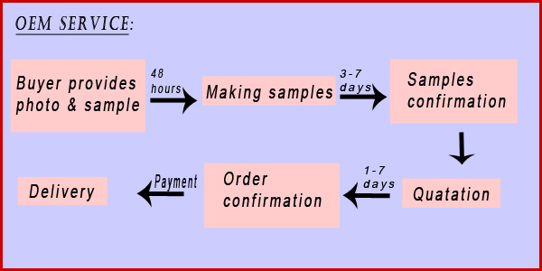

How to make an order
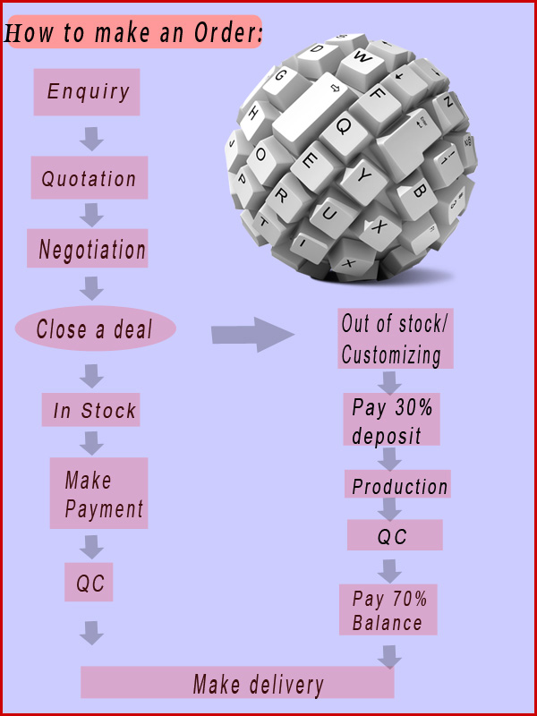
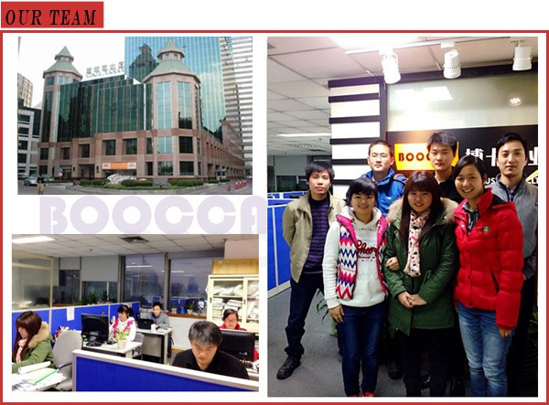
1. Reply your enquiry in 8 working hours.
2. Customized design is available . OEM and ODM are welcomed.
3. Delivery the goods to our customer all over the world with speed and precision.
4. Offer customer the lowest price with high quality LED light.

