温州市益彰贸易有限公司

WENZHOU CHANGS INTERNATIONAL
ADD:#1105,Guoguang Mansion 发 票 No : 0808CHS14
(Opposite railway station
PROFORMA INVOICE DATE:108th august /2014

WENZHOU CHINA
Tel:+86-577-86051848

ATTN: KACETE HOCINE
Tizi ouzou Algerie
Number | Description &Specification | Quantity | Unit Price | Amount
 | MULTILAYER KRAFT PAPER BAG MAKING MACHINE  FL-1200 Four Color Flexo Press（1200MM）  HD-400 Automatic Food Paper Bag Making Machine  YT2600 2-COLOR FLEXO PRESS  Total  1, Delivery time: within 50workdays to finish the machine production after reciving 30% payment  2, Country of Origin: China  3, Payment Term:30% TT in advance, 70% balance before shipment  4,Warranty: 1 year limited warranty after installation.  Bank Information    BENEFICIARY:  WENZHOU CHANGS INTERNATIONAL  BENEFICIARY BANK：  CHINA CONSTRUCTION BANK  WENZHOU BRANCH  SWIFT：PCBCCNBJZJW  BENEFICIARY A/C NO.：  33014013100229004101 | 1Set  1SET  1SET  1SET | EXWORK  USD48800.00  USD29000.00  USD44950.00  USD8250.00 | USD48800.00  USD29000.00  USD44950.00  USD8250.00  USD131000.00

MULTILAYER KRAFT PAPER BAG MAKING MACHINE
Quotation: 48800USD (EX-WORK)
Video: http://v.youku.com/v_show/id_XMTU3NDkwNTQw.html

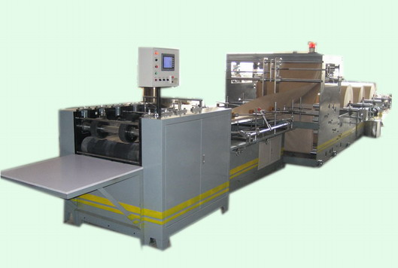

Main Technical Parameter:
Bag length: 800-1000  (also can be customize) | Bag width : 300-600mm
Paper weight : 70-140 gram | Material width: 620-1250mm
Speed: 40-60pcs/min | power：11.2KW
Kraft paper layers : 2-3layer | Machine weight : 4000kg

FL-1200 Four Color Flexo Press
Max Paper Width: 1200mm
Quotation: 29000USD (EX-WORK)
Video link: http://v.youku.com/v_show/id_XMjgxNDYyOTQ0.html
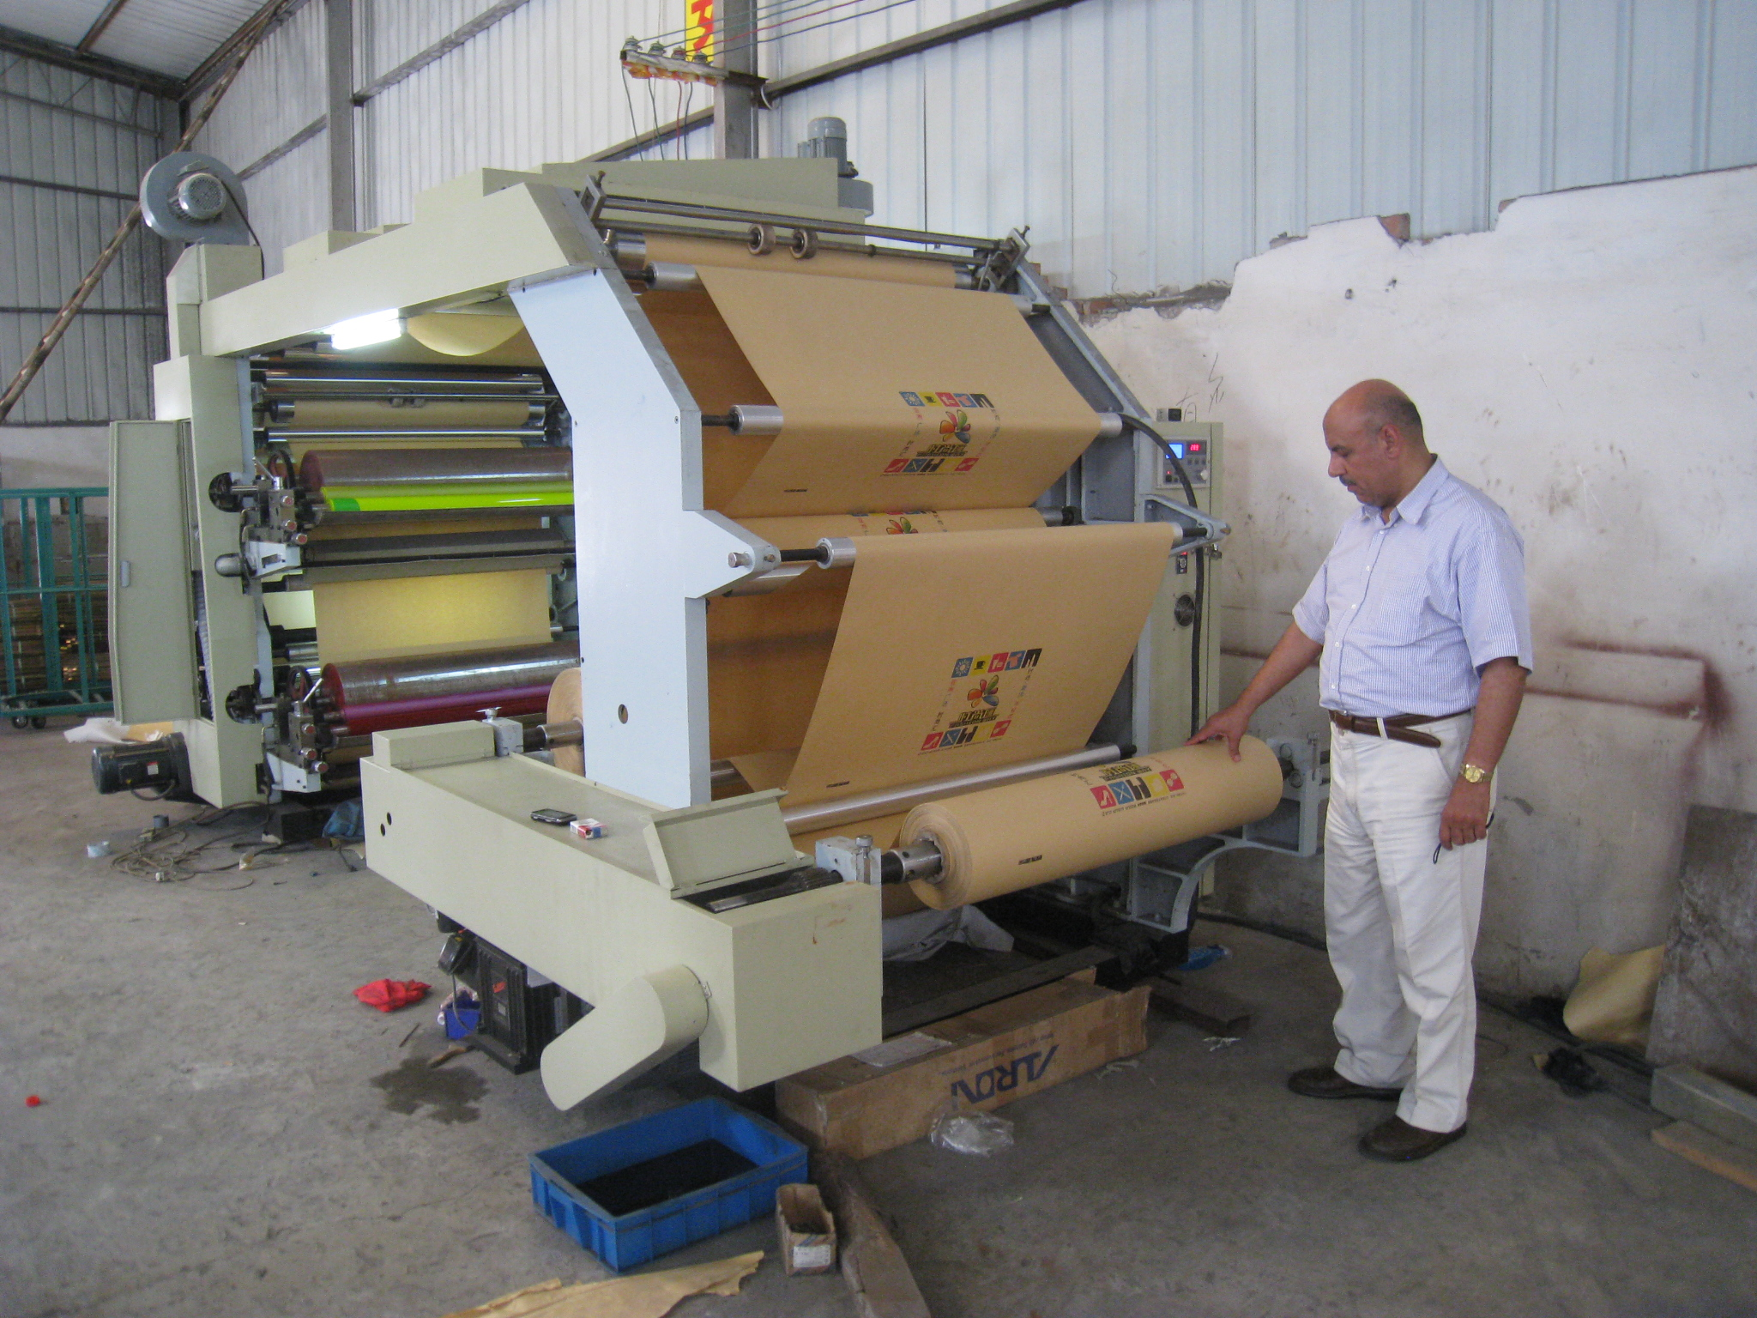

HD-400 Automatic Food Paper Bag Making Machine
Quotation: 44950 USD(EXWORK)
Delivery Time: 45 days ESTIMATED
Video: http://v.youku.com/v_show/id_XMjAwMzE0MzY0.html
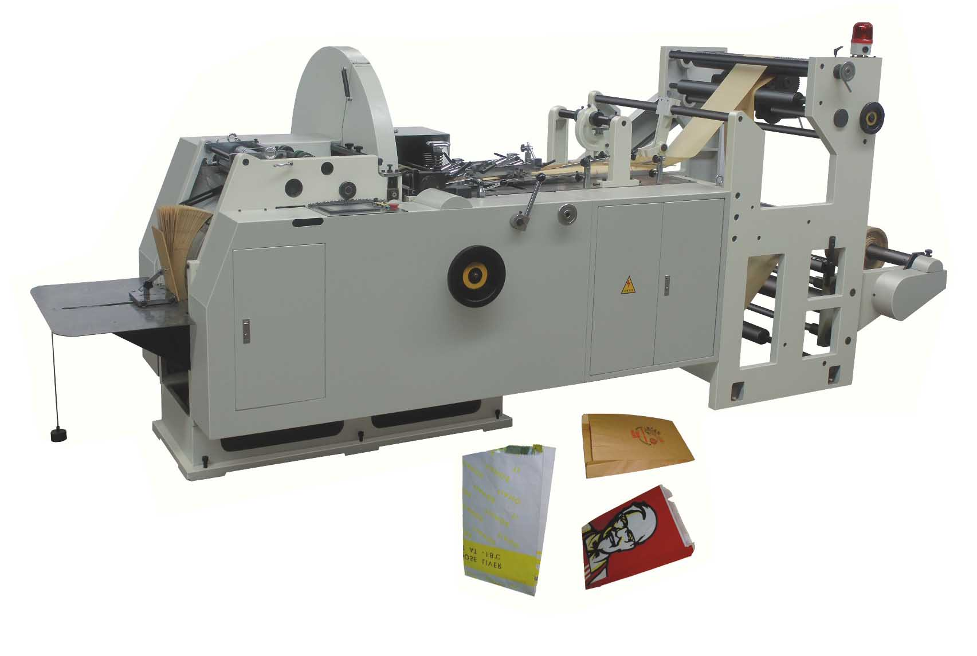

Specifications:
Cutting Length(C): 150-400mm
Bag Length(H): 140-390mm
Bag Width(L): 80-250mm
Gusset Depth: 10-50mm
Standard Flap: 12-17mm
Speed: 100_300pcs/minPaper Weight: 30-80GSM
Power: 6Kw
Total Weight: 3500KG
Dimension: 4400*1650*1850mm

YT2600 2-COLOR FLEXO PRESS
Quotation: 8250 USD(EXWORK)
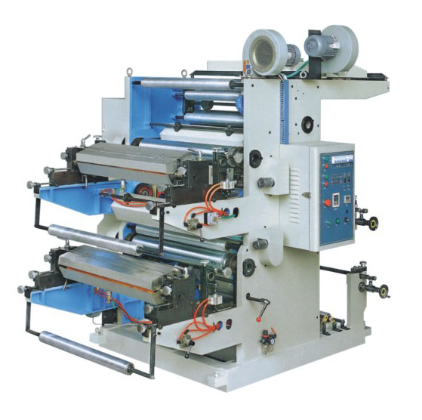

Features:
The photo above is just for your reference.
YT Series Double-color Flexograp
Main Technical Parameters：
Type | YT-2600 | YT-2800 | YT-21000
Max. Web Width | 600mm | 800mm | 1000mm
Max. Effective Printing Width | 560mm | 760mm | 960mm
Range of Repeat Printing Length | 191～914mm | 191～914mm | 191～914mm
Max. Diameter of Roll Material | ф450mm | ф450mm | ф450mm
Printing Speed | 5～50m/min | 5～50m/min | 5～50m/min
Plate Thickness(Both side adhesive tape included) | 2.38mm | 2.38mm | 2.38mm
Total Power | 8Kw | 10Kw | 12Kw
Overall Dimension | 2300×1860×2145mm | 2300×2060×2145mm | 2300×2260×2145mm

