Inquiry No.: KLE0815DK10S
Date: 2014-08-15
Contact: -
Tel.: -
Fax: -
E-Mail: -
Quotation

To:
Attn.: | -
Country: | Vietnam
Tel.: | -
Fax:
E-Mail: | -

1. Price list:
Manufacturer | KOLLER | Customs No. |  | 8418699020
Payment Terms | T/T | Validity of price |  | 30 DAYS
Item | Products’ Name | Quantity  (SET) | Unit Price  （USD） | Delivery time  (days) | Amount  （USD）
1 | Direct Cooling Ice Block Machine DK100 | 1 | $- | 50 | $-
2 | 40GP Container | 1 | $- | 50 | $-
3 | VCR15 Cold Room | 1 | $- | 50 | $-
4 | Total FOB Guangzhou port price: $- USD

Note：
- The above price is FOB Guangzhou port price, not including shipping cost to Vietnam.

- Terms of Payment: 100% by T/T. 50% of total value as the deposit before production, 50% balance should be paid before shipment.

- Delivery time: within 50 days after receiving the advanced payment.

4. Installation: we will fix the ice block machine and cold room well inside the 40feet container, so that you just need to get through water and power to the machine directly. Besides, CD and operation manual will be provided to guide how to install and operate the machine step by step.

5. Warranty: We provide 12 months warranty for our machine. For after sales service, once the machine out of work, you can send us pictures or video about the fault, we will email/phone you the solution to solve problems to save time. Or we also can send one engineer to your place for door to door service. If the parts is broken and proved by our engineer for non-personal reason, we will offer free parts to replace within guarantee period; if it is beyond guarantee period, we will charge market price for the new parts.

DK100 directly cooling ice block machine:
-1. Working Conditions for DK100:
1. Max. Ambient temp. | +40⁰C
2.Max relative humidity | 90%
3.Supply water temp | 16~21⁰C
4.Condenser temp | 40℃
5. Evaporating temp. | -15℃
4.Power supply | 380~420V 3P 50HZ
5.Refrigerant | R-404a, will not damage Ozone.
6.Compressor type | Semi-hermetic piston compressor
7.Cooling system | Water cooling condenser

-2.Working Parameters for DK100：
No. | Name |  |  |  |  | Technical Data
1 | Daily capacity |  |  |  |  | 10 tons/24h
2 | Material for framework |  |  |  |  | Painted carbon steel
3 | Material for ice moulds |  |  |  |  | Aluminum plate
4 | Compressor |  | Brand name |  |  | Semi-hermetic, Bitzer compressor
 |  |  | Horse power |  |  | 25 HP
 |  |  | Quantity |  |  | 2 set
 |  |  | Cooling capacity |  |  | 63KW
5 | Cooling tower |  | Cooling water flow |  |  | 46.8m³/h
 |  |  | Air flow |  |  | 420 CMM
 |  |  | Measurement |  |  | 2145mm*2145mm*1955mm
6 | Total power |  |  |  |  | 48KW
Ice moulds
Weight |  | Quantity |  | Ice freezing time/shift | Shifts/day |  | Production | Size(mm)
25kg |  | 2 sets, totally  100 pics |  | 6 hours | 4 |  | 400 pieces/day  ( 10000kg/day) | 300*130*700mm
Power consumption: 70~85KW*H for making 1Ton ice;
Water consumption: 1.1 Ton water for making 1Ton ice.
Note: The above data is just for your reference and is subjected to final design.

-3 Components list for DK100
Item | Name of Components | Brand Name/  Original country | Picture
1 | Compressor | Bitzer /Germany  （toppest quality in the world） | 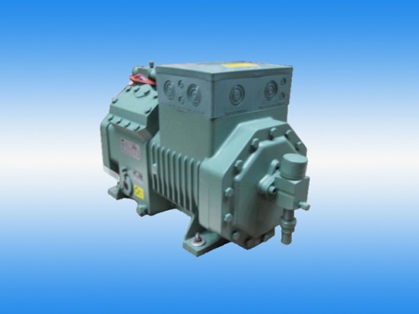
2 | Electrical components | Schneider / France | 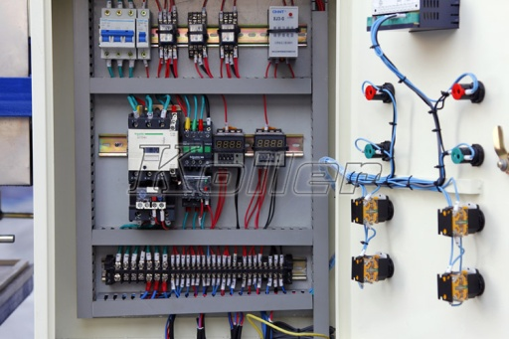
3 | Expansion valve | DANFOSS/ Denmark | 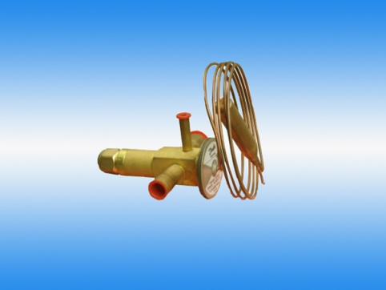
4 | Solenoid Valve | CASTEL/Italy | 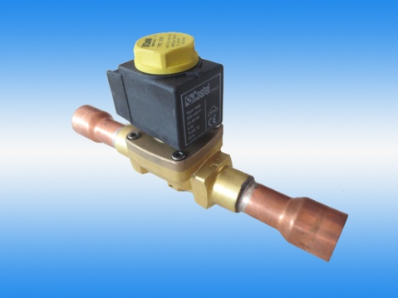
5 | Pressure controller | DANFOSS/Denmark | 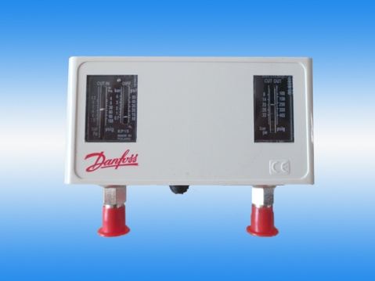
6 | Oil separator | Emerson/U.S.A | 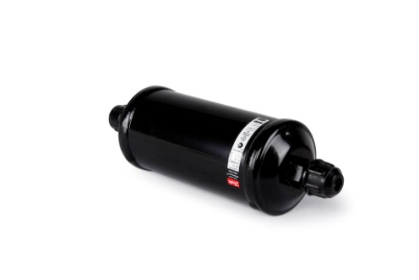
7 | Aluminum plate | Koller/Germany | 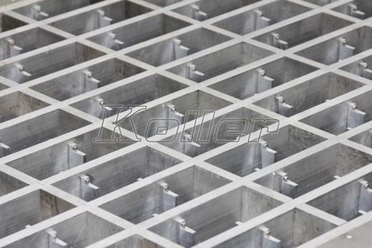

VCR15 cold room:

NO. | Parameters |  | Technical data
Basic Information
1 | Dimension |  | 3m(L)*2.3m(W)*2.3m(H)
2 | Temperature |  | -12℃ (±5℃)
3 | Power supply |  | 380V 50HZ 3P
4 | Refrigerant |  | R404a
5 | Cooling system |  | Air cooling
Refrigeration Unit
1 | Compressor | Brand name | Copeland
 |  | Horse power/set | 2 HP
 |  | Quantity | 1 set
2 | Air cooler | Type | Full automatically hot gas defrost
 |  | Quantity | 1 sets
Insulation panels
1 | Thickness |  | 100 mm
2 | Material |  | PU Double-sides color-bond steel
Door
1 | Size |  | 1.8m*0.8m
2 | Thickness |  | 100mm
3 | Quantity |  | 1 PCS
Installation accessories:
Thermal insulation cotton, heat reserving belt, PVC line tube，PVC defrost parts，screw, bracket, foam glue, Gasket, Glass glue, Rivets Steel, small hardware and so on.

Pictures:

DK100 in 40GP container

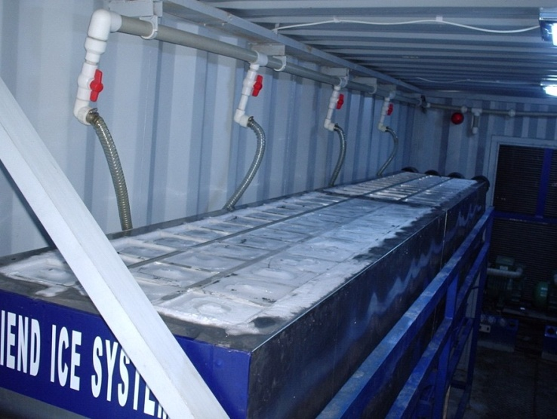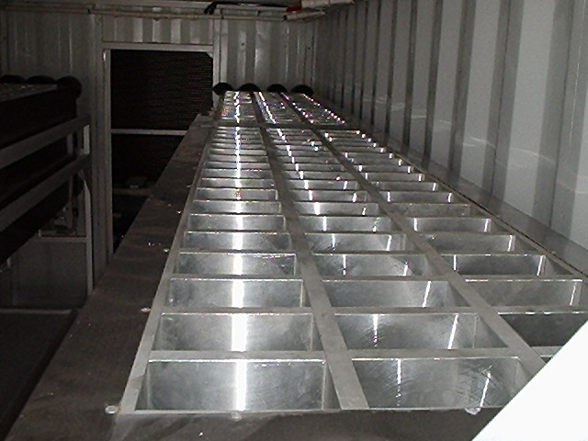
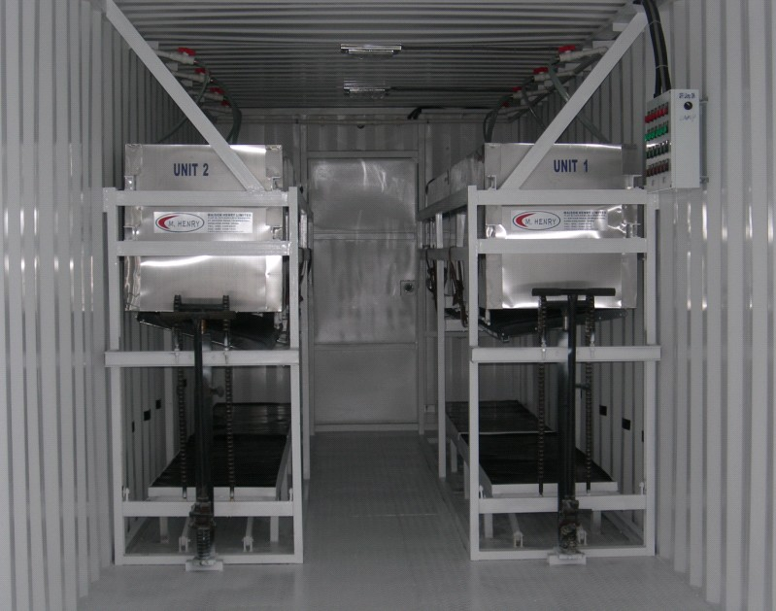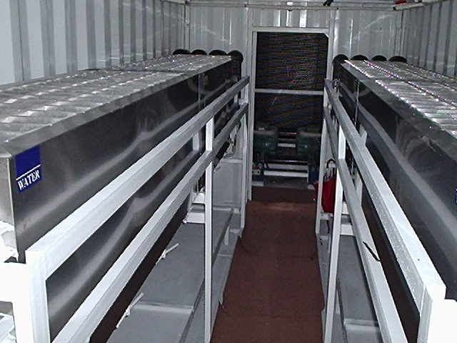
Ice Moulds

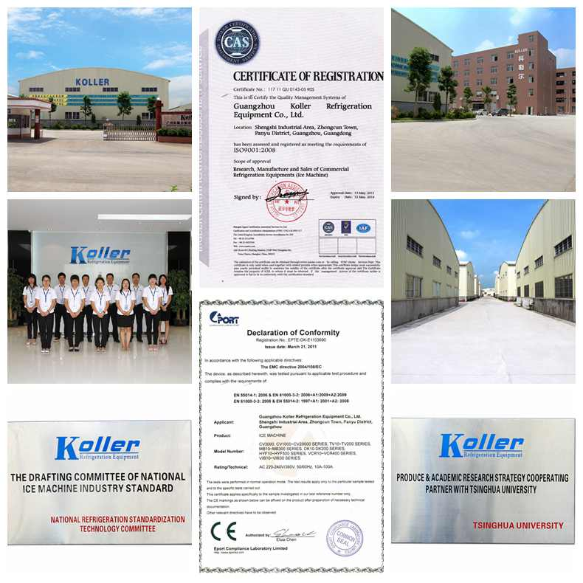
Koller factory and certifications

