 Shanghai Saidone Technologies Co., Ltd. No.18 building, Lunming Industrial Park, No.60,Zhong Hui Rd.,
Maqiao Town, Minhang District, Shanghai, China 201111
Tel：86-21-64096877，Fax：86-21-51593291
www.saidone.com
info@saidone.com
Price list
(Valid in 30 days, since 2014/9/15)
I. Production Price:
No. | Description | Model | Unit Price | Notes
1 | Semi-Automatic Piston Filler | SVFA1-250P |  | - 1 No-drip filling nozzle  - Filling Volume: 250~2500ml  - Filling Speed:  about 15~20 bottles per minute (for 500ml/bottle medium viscous product like shampoo or oil)  For foaming products, the speed will be lower  The speed is different according to the filling volume, viscosity, bottle neck opening’s diameter, operator’s experience, etc.  - Accuracy-- ±0.5~1%  - The pneumatic components are from Airtac.  - The parts come in touch with product are made of 316L stainless steel.  - Pneumatic control, no electricity is required
1 | Semi-Automatic Piston Filler | SVFA1-500P |  | - 1 No-drip filling nozzle  - Filling Volume: 500~5000ml  - Filling Speed:  about 15~20 bottles per minute (for 1000ml/bottle medium viscous product like shampoo or oil)  For foaming products, the speed will be lower  The speed is different according to the filling volume, viscosity, bottle neck opening’s diameter, operator’s experience, etc.  - Accuracy-- ±0.5~1%  - The pneumatic components are from Airtac.  - The parts come in touch with product are made of 316L stainless steel.  - Pneumatic control, no electricity is required

II. Terms of payment
100% payment before delivery.

III. Time of Shipment:
In 20 days after the advance payment reaches the Seller’s account.

IV. Production Introduction:
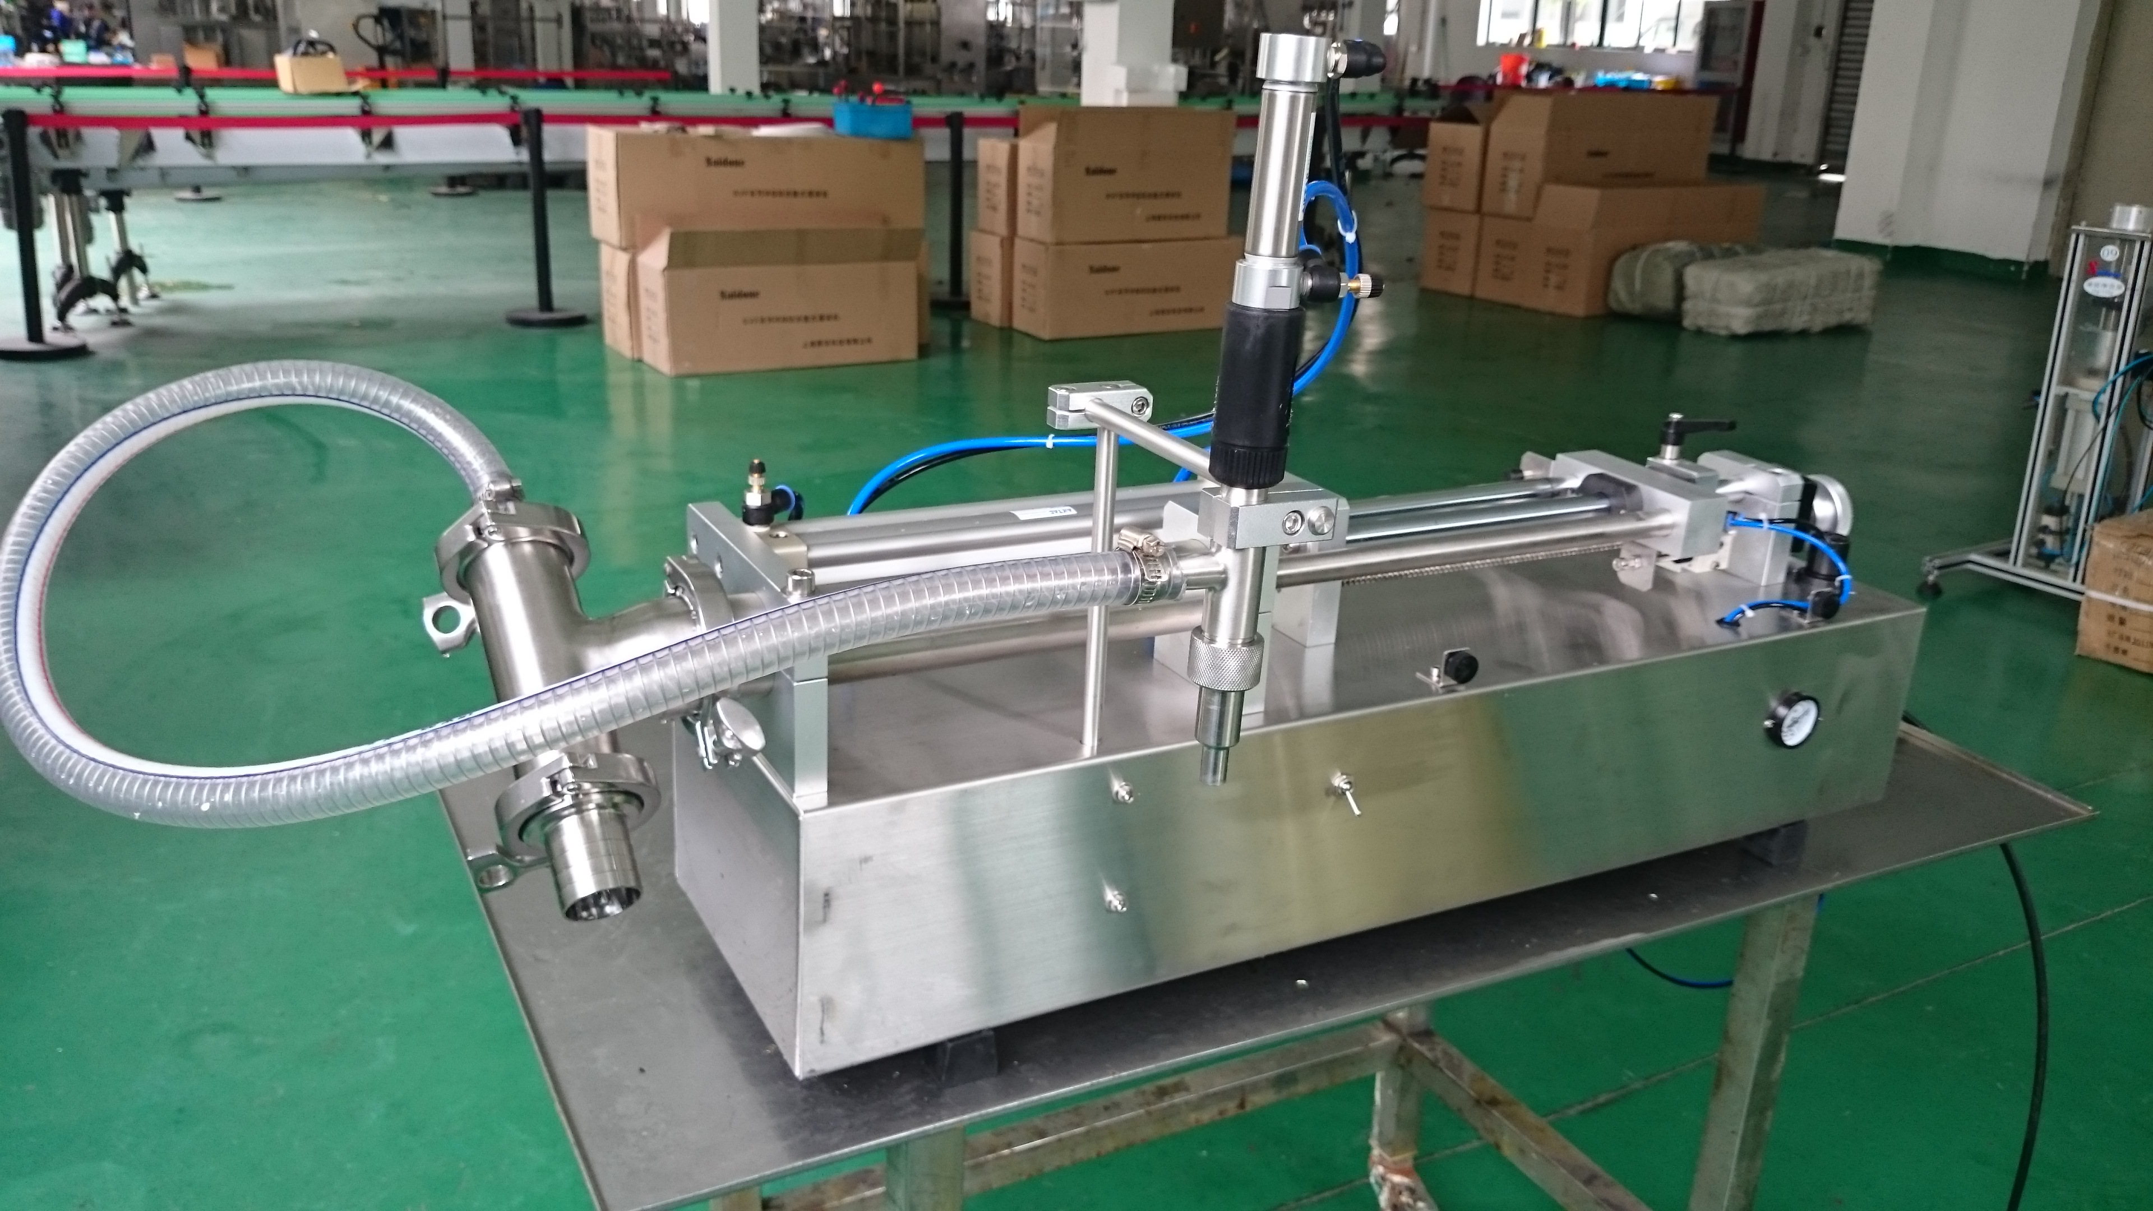
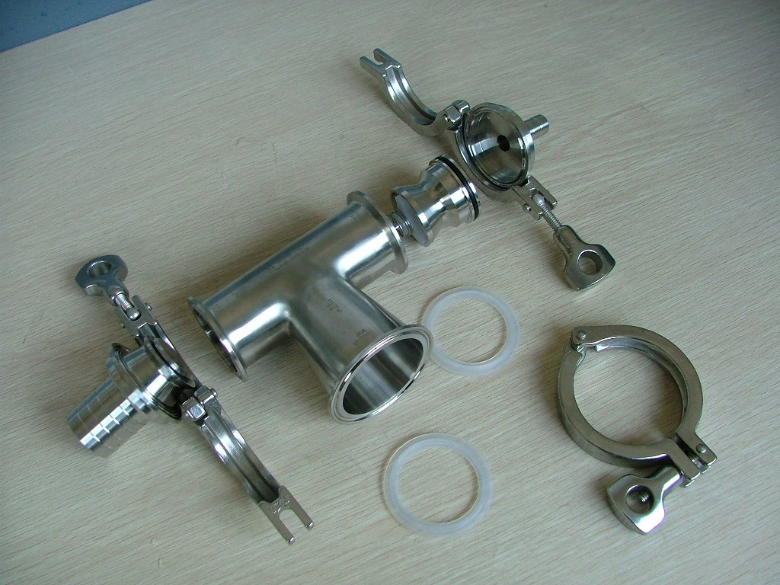(T WAY and CHECK VALVE)
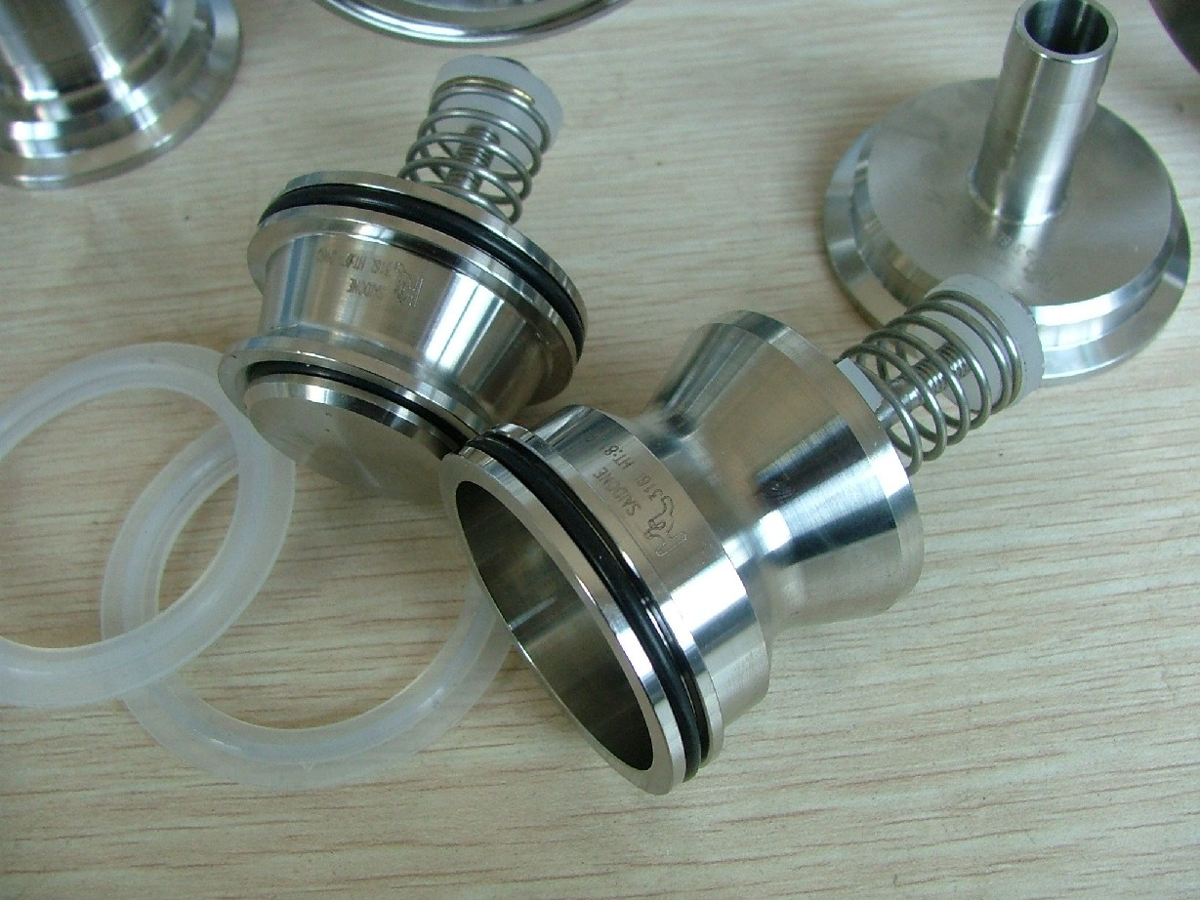(CHECK VALVE)

