- JFZD Electrical Dough Farinograph
Principle
- USB connection, support plug and play.
- 300g and 50g can be changed to use; procedure can identify the cylinder size and auto carry out different arithmetic, no need to adjust manually.
- Computer procedure monitors the instrument on or off, and auto data gathering.
- Torque overload alarm and auto stop. avoid sensor and motor overload.
- Procedure interface can display 12 curves at the same time convenient to compare the minute error.
- Data save as Access format, may consult with Mirosoft Access.
Features
-Accurate, speedy: adopting electric analyzing technology instead of mechanical testing power system and its tested data is more accurate and quick.
- Reliable, steady: the result has good repeatability and recurrence
-High automation: computer to process the data, judge the result automatically, and is able to re-judge the tested result according to local national standard and international standard.
Application
- Electric Dough Farinograph is special used to analyze the quality of wheat flour, mainly for controlling and monitoring the quality of wheat and wheat flour during wheat breeding, purchasing, storage, flour processing, and foodstuff producing process.
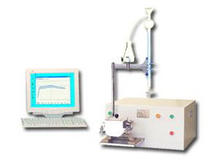
Please feel free to contact us if more information is needed.

- JMLD Electrical Dough Extensograph

Features
- Accurate, speedy: adopting electric analyzing technology instead of mechanical testing power system, and its tested data is more accurate and quick.
- Reliable, steady: the result has good repeatability and recurrence
- High automation: computer to process the data, judge the result automatically, and is able to re-judge the tested result according to local national standard and international standard.
Application
-Electric Dough Extensograph is special used to analyze the quality of wheat flour, mainly for controlling and monitoring the quality of wheat and wheat flour during wheat breeding, purchasing, storage, flour processing, and foodstuff producing process.
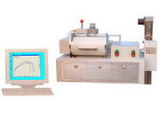
Please feel free to contact us if more information is needed.

- JJLF Falling Number Test Meter

Principle
- Alpha-amylase activity is crucial for final product quality of bread, pasta, noodles and malt. FN Falling Number Test Meter measures the alpha-amylase enzyme activity in grains and flour, can accurately judge sprout damage, optimize flour enzyme activity and guarantee soundness of traded grain.
Features
- With micro control CPU to record each time result, wit micro printer for printing.
- Excellent fabricating, simple operation.
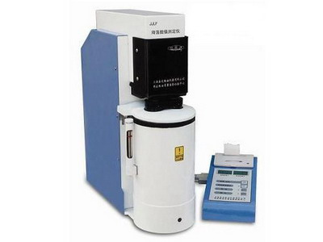

Please feel free to contact us if more information is needed.

- JJLF Falling Number Test Meter

Features
- 10 layers sieves for several samples in one time.
- Compact design and high efficiency.
- Used for flour granularity testing.

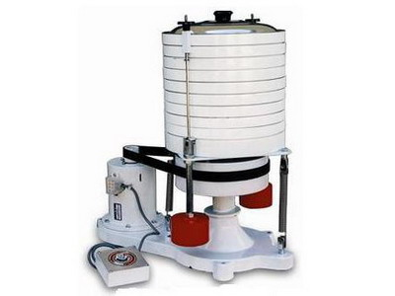

Please feel free to contact us if more information is needed.

