RESIN EDGE POLISHING TOOLS
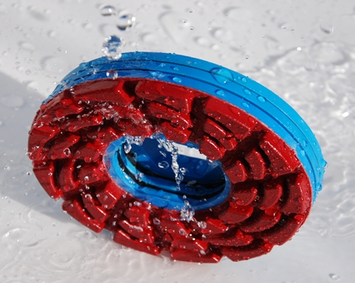
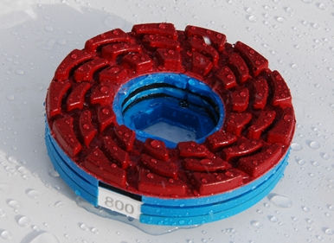

For Granite:
Grit number: 60# 120# 220# 300# 800# 1800# 3500# (3500# or Lux)
Price:

The polishing results:
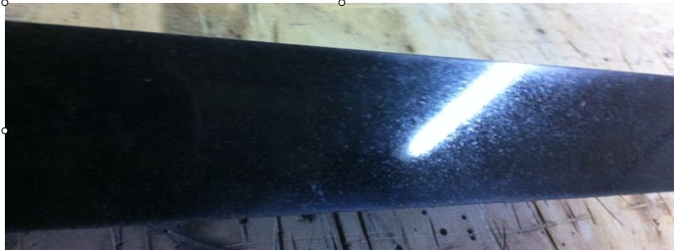
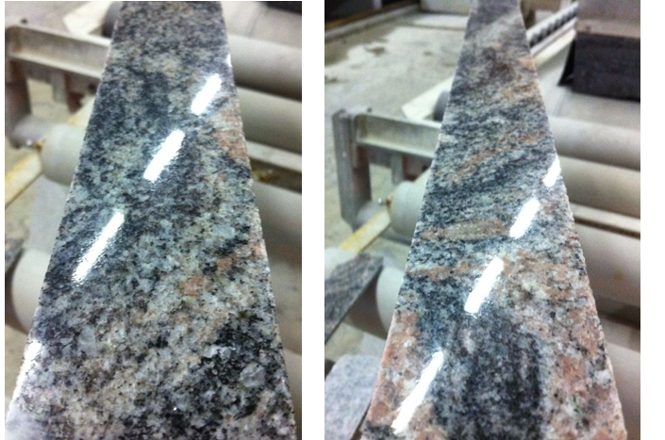
For Marble:
Grit number: (60# ) 120# 220# 300# 800# 1800# (5 EXTRA)
Price:

The polishing results:
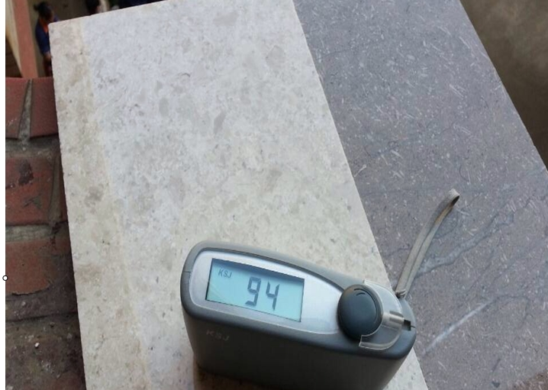
For Quartz:
Grit number: 60# 120# 220# 300# 800#
+1800# 3500# (soft formula)
Price:
The polishing results:

Brown Quartz

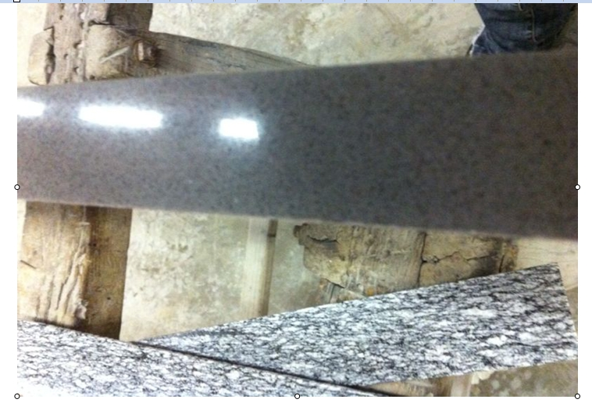

White Quartz


