This is Jane Chan from Zhejiang New Debao Machinery Co.,LTD
As for different design and quality.
please ceck following points concluted:

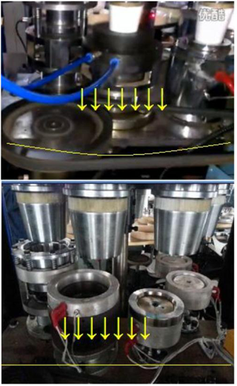
OTHER FACTORY:
Ordinary Iron plate

The plate is easy getting after deformed and broken two/three years running.You know, Warranty is one year. (one of my domestic customer told)

MY COMPANY:
Nodular cast iron

Nodular cast iron has much more
impact and fatigue resistance due to
Its nodular graphite inclusions.The plate won’t get out of shape in long time running

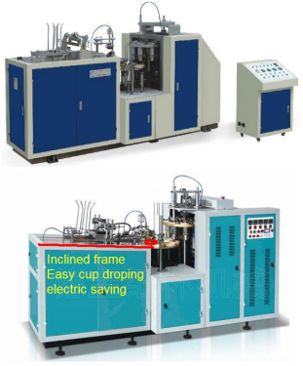
OTHER FACTORY:

Their front frame is flat.

MY COMPANY:

Our machine front frame is
inclined,which can help cup the dropping easily.(saving electricity)

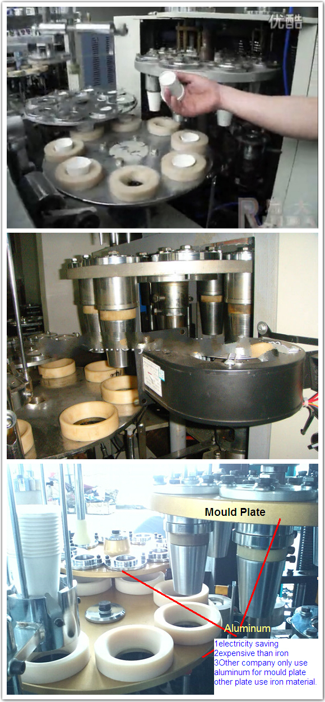

OTHER FACTORY:

Please check the photo of three turnplate.
They use aluminum for mould plate only,remainding other two plate use ordinary iron.
As we all know, Iron is more heavy than aluminum in machine running.
Because of inertia,Ordinary iron is really bad for machine.
The component will be badly abrased under long time working.

MY COMPANY:

Our three turnplate is all aluminum.
Electric saving,and Aluminum is more
expensive than iron.

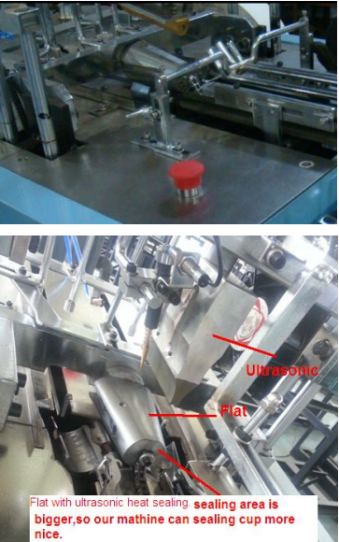

OTHER FACTORY:

The sealing body is round.

MY COMPANY:

Our sealing body is flat.
Sealing area is bigger,which can sealing cups more nice.

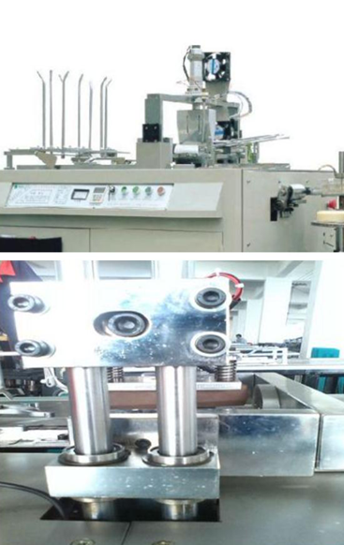

OTHER FACTORY:

They only use iron slab
Speed is slower than us.

.

MY COMPANY:

The optical axis are
imported from Korea.
More flexible and stable.

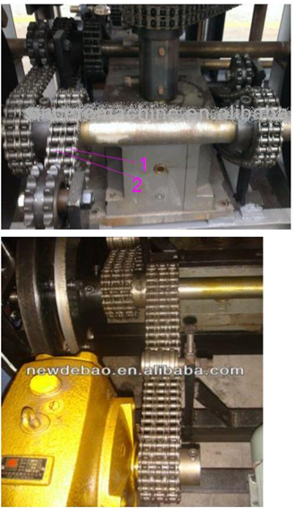
OTHER FACTORY:

Only two chains for driving.
Oth

MY COMPANY:

We supply 3 chains for driving
system,which is more stable for machine running.

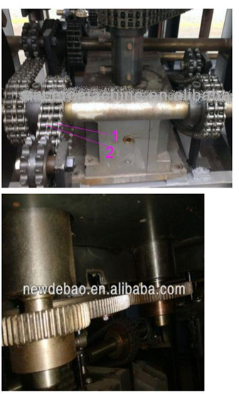

OTHER FACTORY:

They use chains for main driving

MY COMPANY:

We use three gears for three turnplate
driving
As we all know,chain will get loose under
a long time working.
And the turnplate will get shake when
machine working.Bad cup rate will go up.
So we suppliy gears for driving and
chains for assistant.

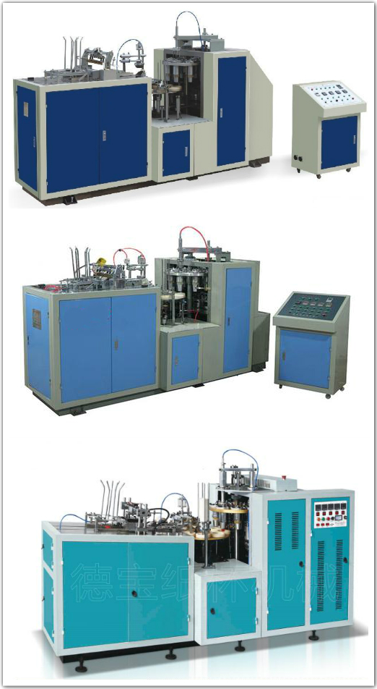

OTHER FACTORY:

They still use distribution box electric wire Scattered on the ground. It looked in a mess.
We design machine unified,more safe.

MY COMPANY:

We design machine unified,more safe.

Speed Capacity:
Our speed normal:45-50pcs/min
Others:40-50pcs/min
5pcs more a min
300pcs more one hour

There is profits.
Electricity:1.5KW/hour Actual Power
power rating:3.8KW
Others 5KW more
It can save 1300 USD more as I know.
More cost saving in a long time running.
So maybe our price is higher,but you will earn back soon.

