Pumping motor is made in Germany same used by Putzmeister.

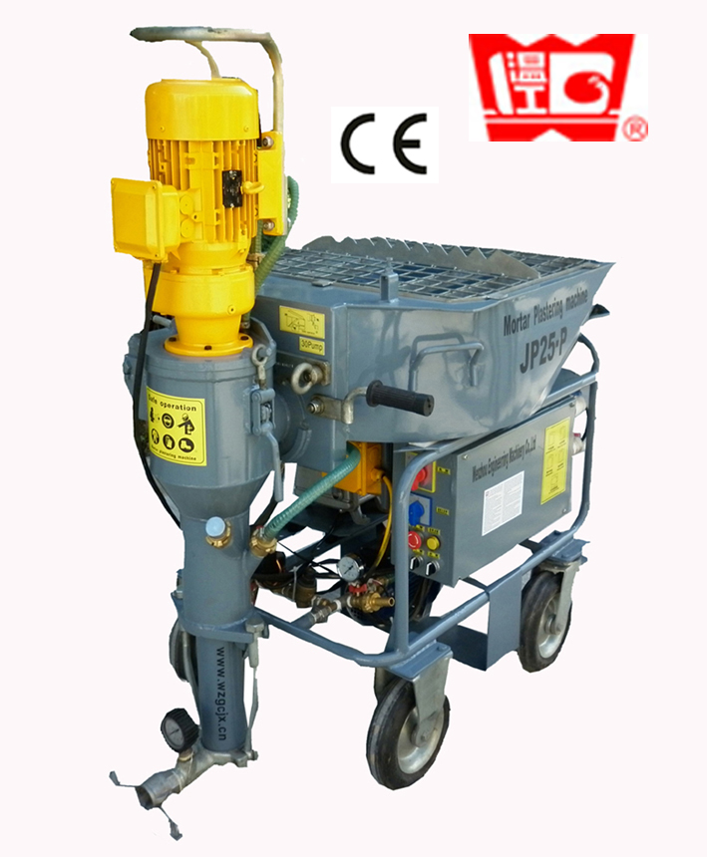
JP25 can be dismantled into 3parts for easy carrying to different floors.
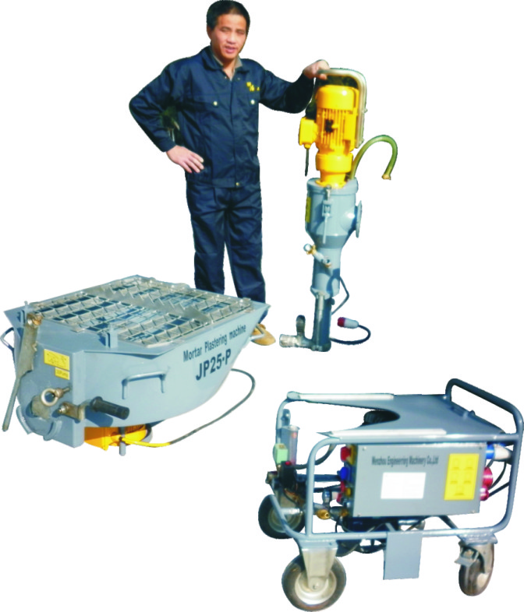
Stator & rotor design is same as Putzmeister D5-2.
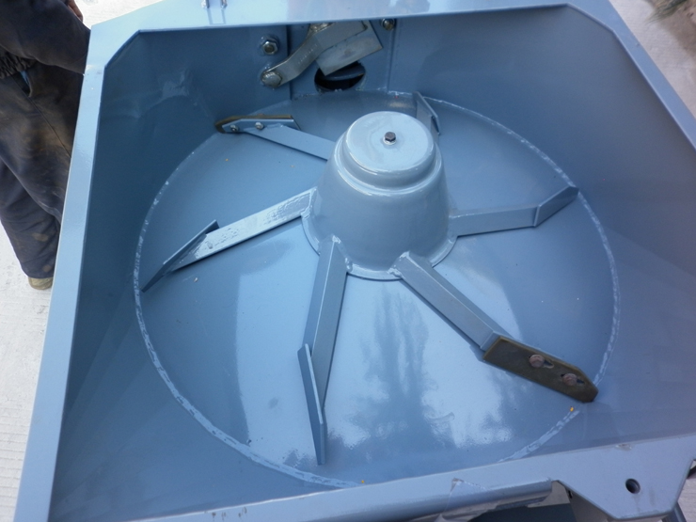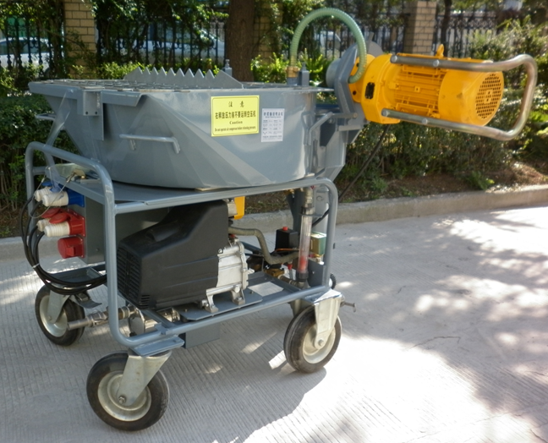

Pan mixer is only for feeding premixed mortar uniformly.
Air compressor made in China
Supply water system

