Specifications of Evaporative Cooling Pad
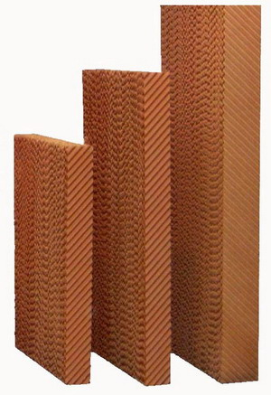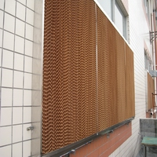
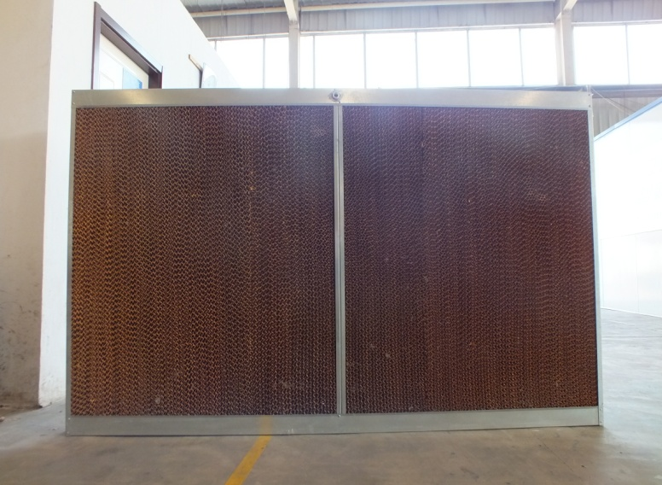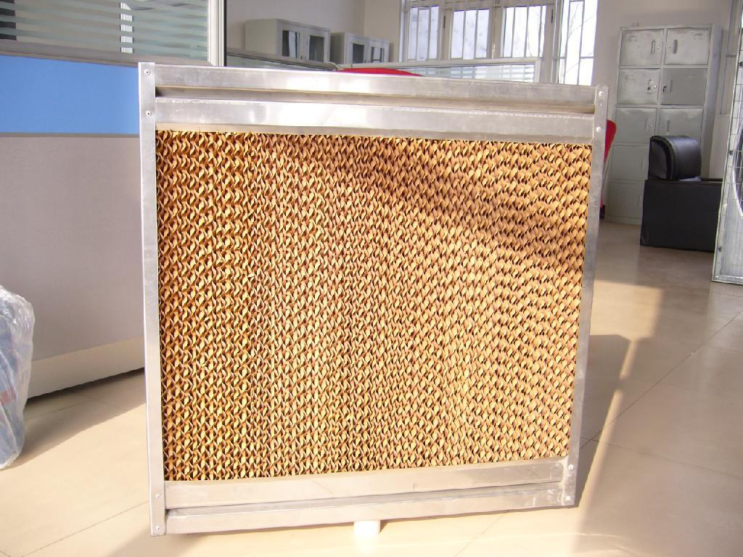

- Specifications of GYCP- 5090 Cooling Pads:
Model | . Height  （mm） | Width  （m） | Thickness  （mm） | Corrugation height（mm） | Corrugation  angle | Color | Material
GYCP-5090 | 1500/18  00/2000 | 600 | 100 | 5.00 | 45 º ×45 º | Brown/  Green+ Brown | Fiber paper

- Specifications of GYCP- 6090 Cooling Pads:
Model | . Height  （mm） | Width  （m） | Thickness  （mm） | Corrugation height（mm） | Corrugation  angle | Color | Material
GYCP-6090 | 1500/18  00/2000 | 600 | 100 | 6.00 | 45 º ×45 º | Brown/  Green+ Brown | Fiber paper

- Specifications of GYCP- 7090 Cooling Pads:

Model | . Height  （mm） | Width  （m） | Thickness  （mm） | Corrugation height（mm） | Corrugation  angle | Color | Material
GYCP-7090 | 1500/18  00/2000 | 600 | 100 | 7.00 | 45 º ×45 º | Brown/  Green+ Brown | Fiber paper

Note: The size and color can be customized if the quantity is big enough!

Our company website:
http://gy-ecotech.com.ar/product-3-1-evaporative-cooling-pad-es/147580
MSN: Sophia201109@hotmail.com
EMAIL: GY.yusophia@gmail.com
SKYPE: Sophia201109
Trade manager: cnguangyuanhuanbao Wechat: 13356265705
TEL:86- 0534-2728818 FAX:86-534-2728596
MOBILE： 0086-15053416882 AND 0086-13356265706
Old Address: Baide Road Economic Development Zone, Dezhou, Shandong, China
New Address: Intersection of Tianqu East Road and Chongde Twelve Road, Eastern Project Zone, Economic and Technological Development Zone, Dezhou，Shandong, China
Company: Dezhou Guangyuan Environmental Protection Technology Co., Ltd

Sophia Yu

