ABOUT US
- COMPANY INTRODUCTION
Founded in the early 1980s as one of the few state-authorized packing machinery enterprises, and re-founded as a private company in 2000. Shanghai Zhonghe Packing Machinery Co., Ltd. Specializes in designing and manufacturing different kinds of automatic packing machines and has developed more than 80 different models, which are well applied in the food, chemical, pharmaceutical, and light industries, etc.

Based on the solid home market, Shanghai Zhonghe Packing Machinery Co., Ltd. is now gradually promoting the international market with effective and efficient sales and after sales services.

Shanghai Zhonghe Packing Machinery Co., Ltd. will continually be innovative and updating its service in all aspects to ensure that the machines are worth the trust of customers all over the world.
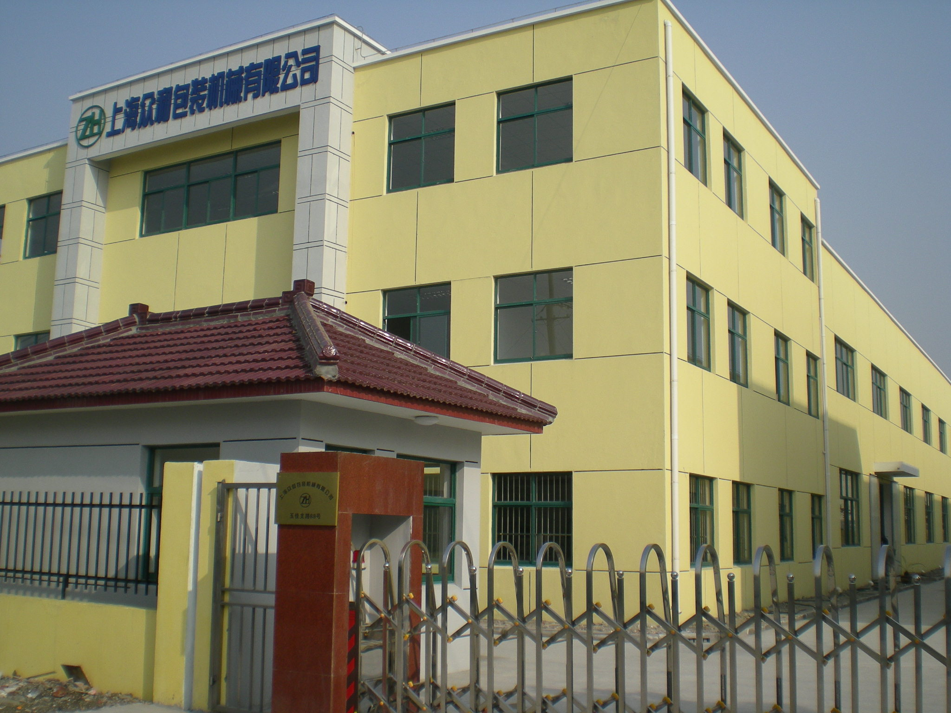

DCJ-240 PASTE PACKING MACHINE
This series installed piston pump dosing system paste products such as chocolate paste, shampoo,sauce, ketchup, honey, cream, etc.

Features
- Bag-making, measuring, filling, sealing, cutting and counting are all finished automatically.
2. Either under set length control or photo-electronic color tracing, we set bag length and cut in one step. Time and film saving.
3. The temperature is under independent PID control, more suitable for different packing materials.
4. The driving system is simple and reliable, and maintenance is easy.
5. Applicable material should be composite films like: PET/PE, Paper/PE, PET/AL/PE, OPP/PE.

Finished sample pouch (3-side sealing, straight end-cut, with tear notch)
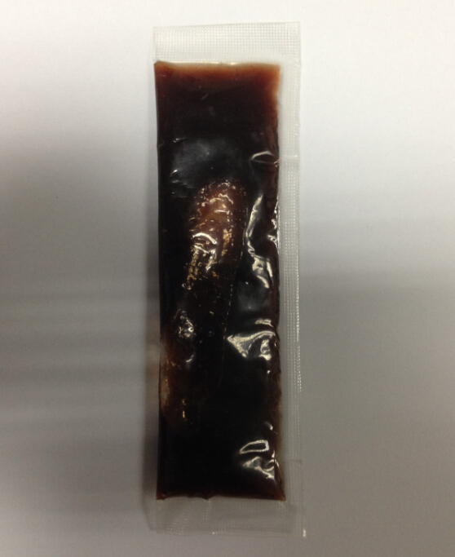
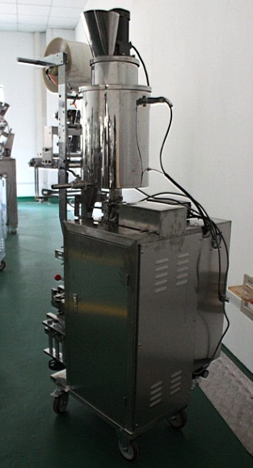
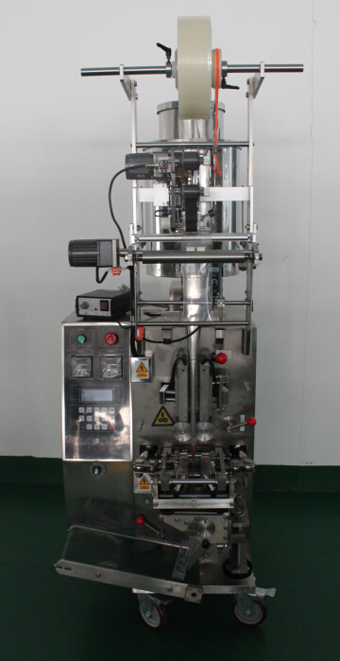
MACHINE PICTURES

Technical Specification (FCA Seaport Shanghai price in US$)

Item | Description of Item |  | Unit Price | Qty. | Total Price
Item |  |  | in USD | Qty. | in USD
1 | Machine | Automatic Paste Packing Machine | 6000 | 1 | 6000
1 | Model | DCJ-240 | 6000 | 1 | 6000
1 | Sealing type | 3-side sealing | 6000 | 1 | 6000
1 | Measurement | Piston pump type (20-100mladjustable) | 6000 | 1 | 6000
1 | Cutting type | Rotary straight cutter with tear notch | 6000 | 1 | 6000
1 | Hopper volume | 20L | 6000 | 1 | 6000
1 | Sealer | Horizontal sealer:line,  Vertical sealer: diamond | 6000 | 1 | 6000
1 | Packing speed | 30 - 50bag/min （Depend on Products） | 6000 | 1 | 6000
1 | Bag size | W:70mm(film width/bag former:140mm) L:90mm | 6000 | 1 | 6000
1 | Total power | 2050W | 6000 | 1 | 6000
1 | Voltage | 220V or 380V (to be confirmed) | 6000 | 1 | 6000
1 | Machine Net Weight | 200Kg | 6000 | 1 | 6000
1 | Mainframe Dimensions | L×W×H： (625x751x1558)mm | 6000 | 1 | 6000
1 | Material | Stainless steel 304 | 6000 | 1 | 6000
1 | Includes | Inverter, photo sensor, short output belt conveyor, a bag former, jacketed heating hopper (keep set temperature melt chocolate paste) and stirring bar (avoid product has different levels, mix them well) | 6000 | 1 | 6000
1 | Optional | Date coding ribbon printer | 250 | 1 | 250

Guarantee: One year from the date of shipment against any manufacturing defects
Shipment: Within 20 working days from receiving 30% deposit
Payment:T/T, 30% deposit in advance and full payment before delivery

DETAILS PICTURES
- Sealing and cutting part with tear notch
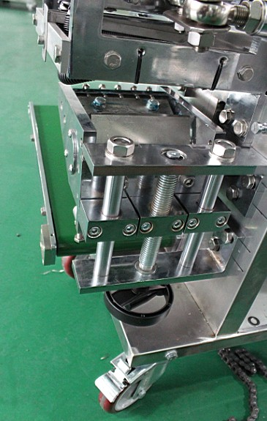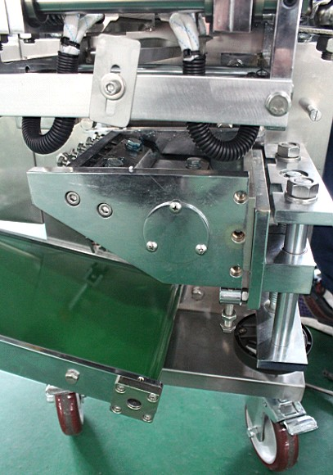
2. Paste dosing system – plunger pump kind
It is volume way not weigh. You can get different volume (ml) after pump adjusted.
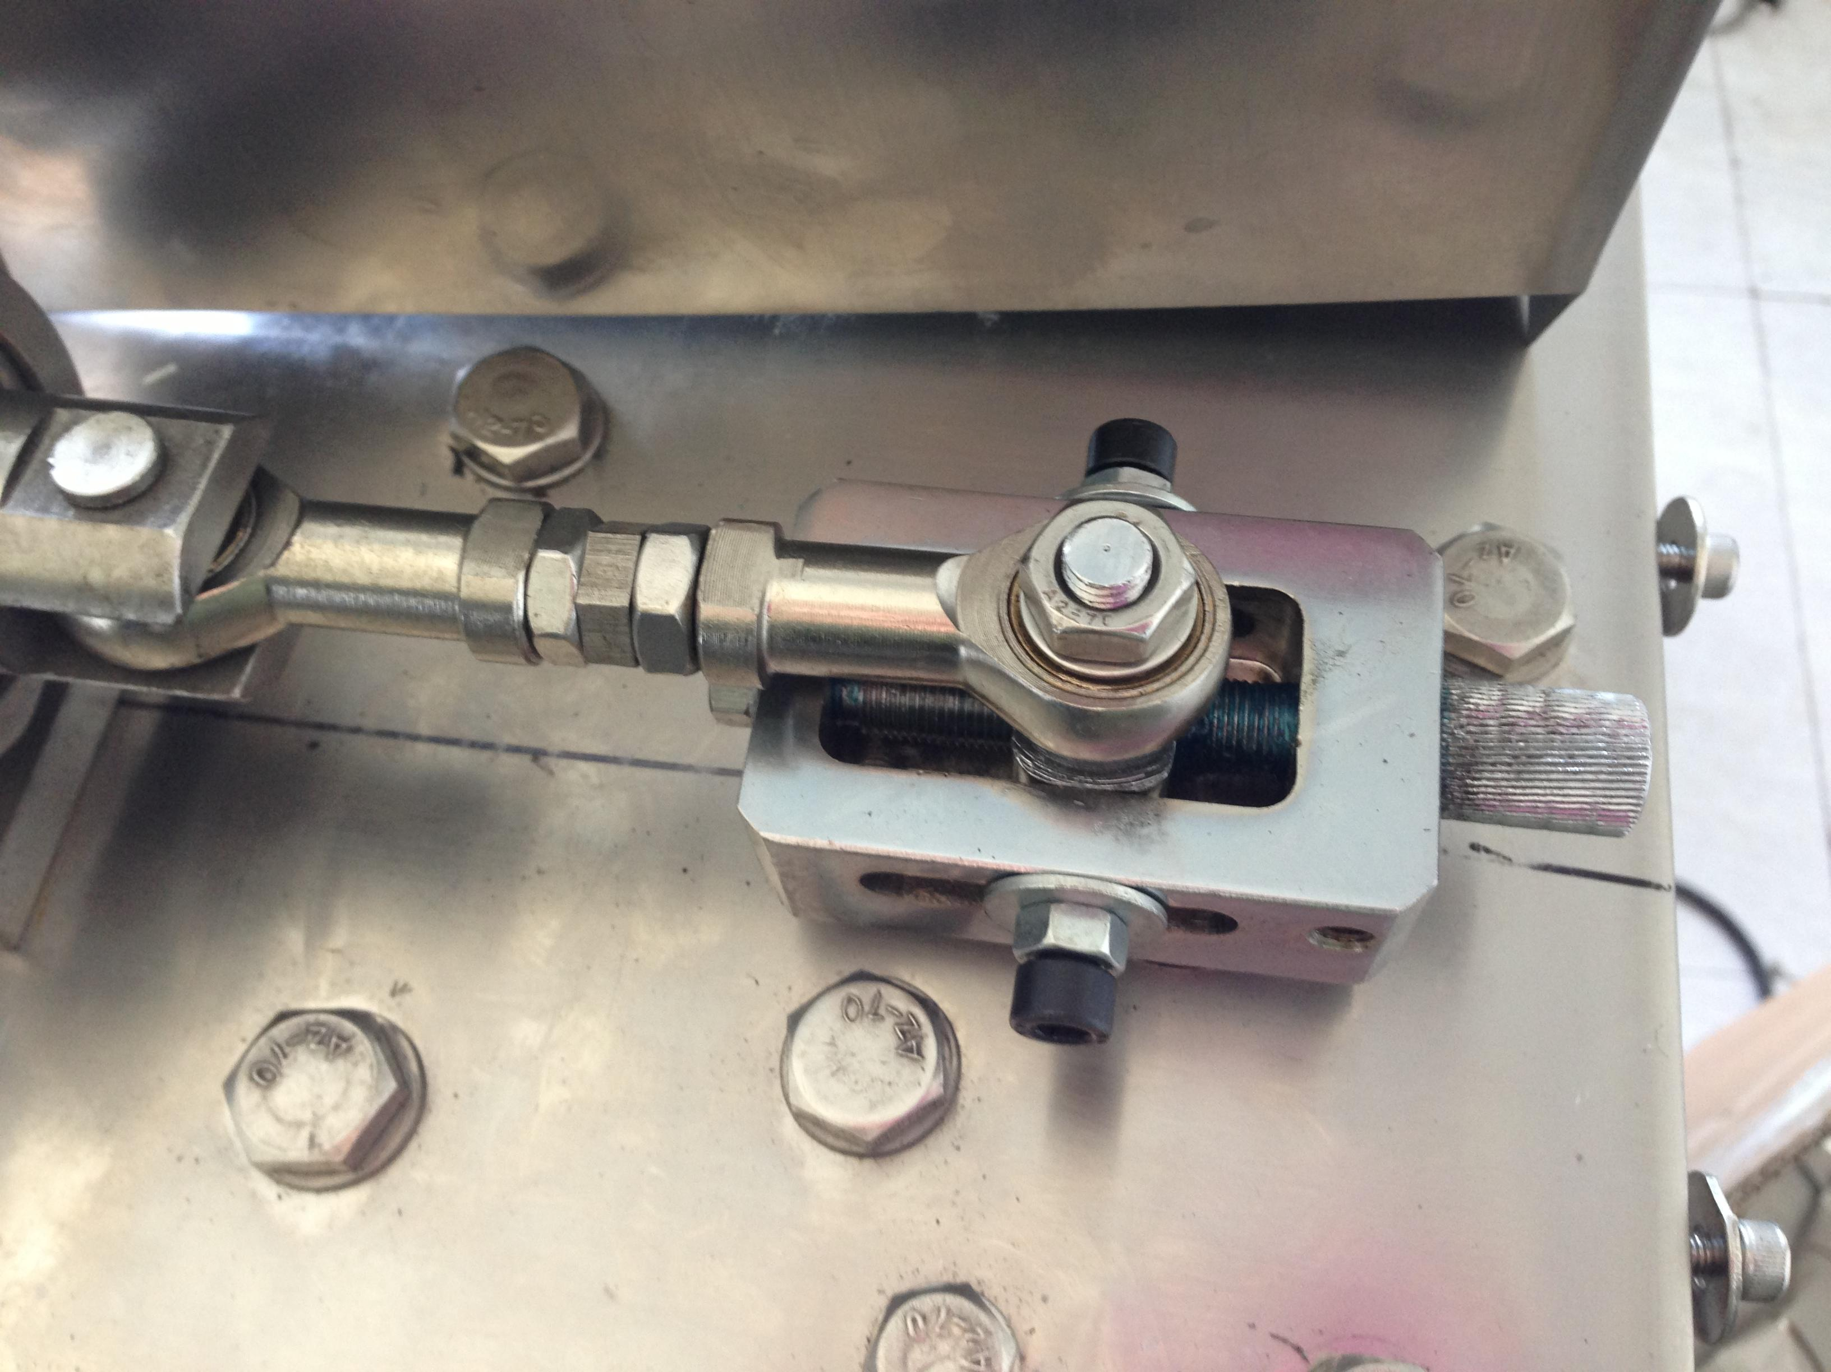
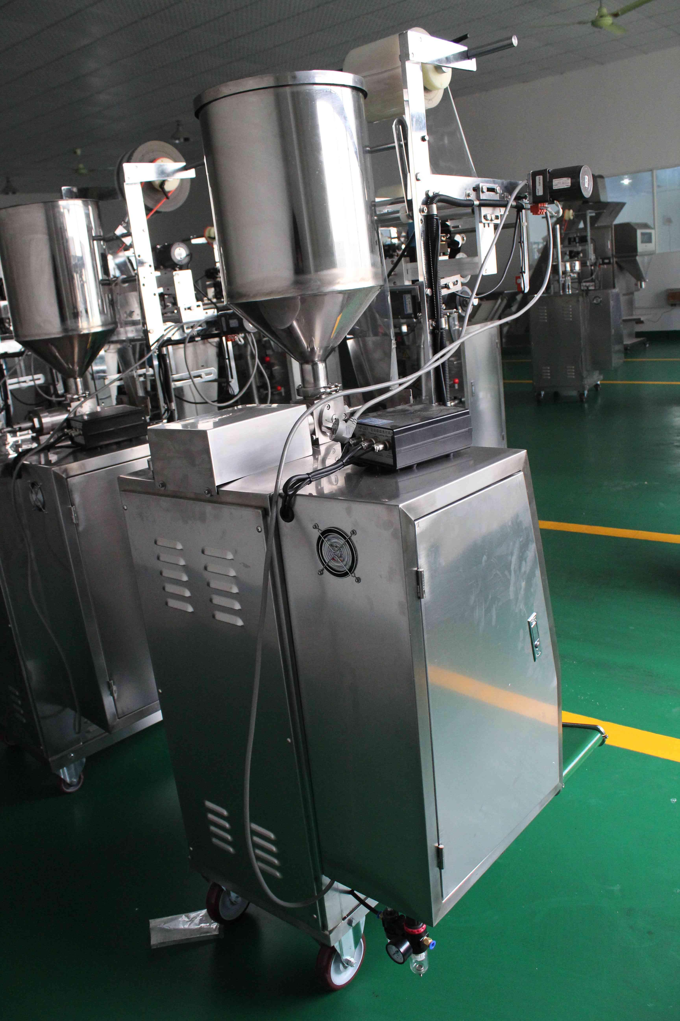
3.Date coding ribbon printer
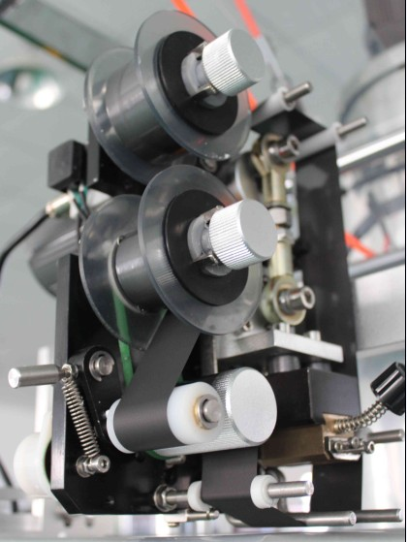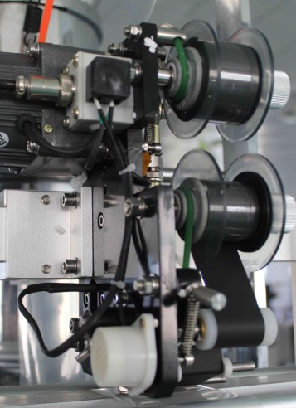
Features
1. heating code printer
2. three lanes
3. each lane can put 13 codes (each code W2mm H3mm)
4. easy to change codes (0-9, A-Z)
5. Use ribbon, each roll 100m
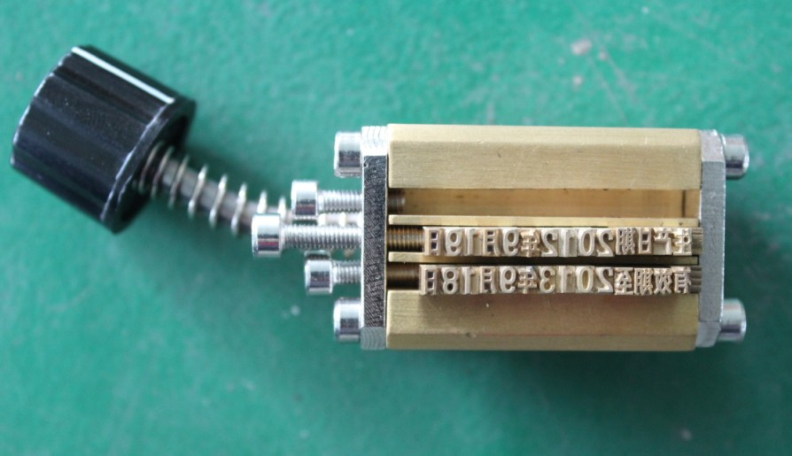

Electrical Element List
Name of Equipment | Factory Brand | Quantity
Inverter | China ENC | 1 set
Decelerates motor | China Taiwan Gongji | 1 set
Step motor | China Jintan Sihai | 1 piece
Step motor driver | China Jintan Sihai | 1 piece
Temperature controller | China Yatai | 2 pieces
Pulling film motor | China Linix | 1 piece
Stirring motor | China Linix | 1 piece
Photo sensor | China Longyi | 1set
Induces switch | Taiwan Roko | 4 pieces
Solid state relay | France Schneider | 2 pieces
Thermocouple | China ordered | 2 pieces
Pneumatic element | China Taiwan AirTAc | 1set
Bearings | Main from German and Japan
Tool box (includes free part, free tools and doc)
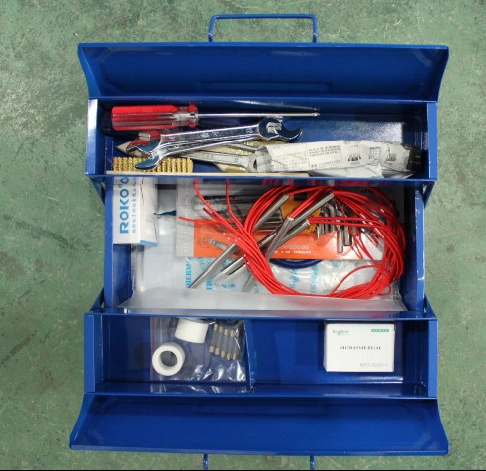
- Free part with Machine
Item | Description of Item | Qty.
01 | Gum over (fix the film etc) | 02
02 | Solid relay | 01
03 | Heat pipe | 04
04 | Thermocouple | 02
05 | Proximity switch | 01
06 | Fuse(set) | 01
- Free tooling with Machine
Name | Spec | QTY
socket head wrench | STD | 1set
cross screwdriver | STD | 1Pc
straight screwdriver | STD | 1Pc
screwdriver | STD | 1Pc
scissors | STD | 1Pc
copper brush | STD | 1Pc
hairbrush | STD | 1Pc
Toolbox | STD | 1Pc

- Doc with Machine
Name | Spec | QTY
Manual | According to ordered machine | 1
Certificate of Quality | According to ordered machine | 1
Frequency conversion manual | According to ordered machine | 1
Temperature controller Manual | According to ordered machine | 1
Proxmity switch Manual | According to ordered machine | 1

