MACHINE PICTURES
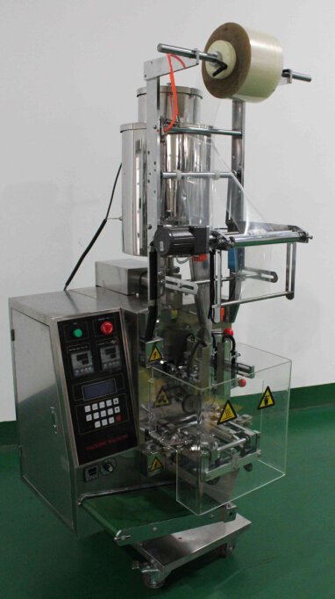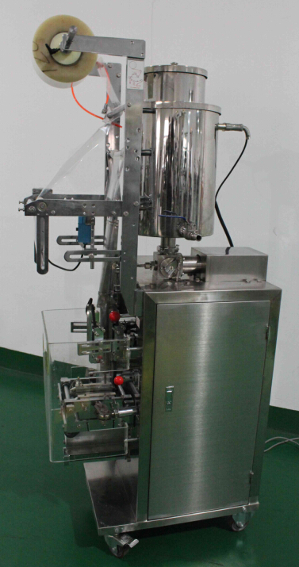
DCJ-240 machine, 4-side sealing with heating hopper to keep honey temperature
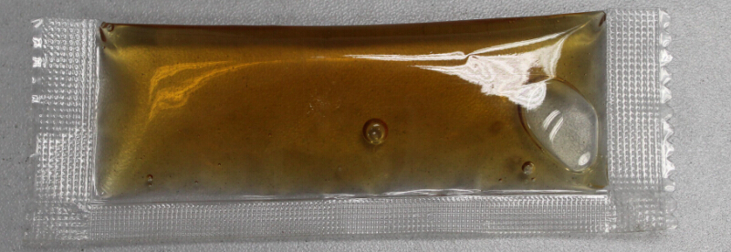
Honey sample pouch
(3-side sealing)

Technical Specification (FCA Port Shanghai price in US$)
Item | Description of Item |  | Unit Price | Qty. | Total Price
Item |  |  | in USD | Qty. | in USD
1 | Machine | Automatic Paste Packing Machine | 5500 | 1 | 5500
1 | Model | DCJ-240 | 5500 | 1 | 5500
1 | Sealing type | 4-side sealing | 5500 | 1 | 5500
1 | Measurement | Mechnical piston pump type (0-20ml, 10-30ml, 30-100ml depend on requested) | 5500 | 1 | 5500
1 | Cutting type | Zigzag cutter with tear notch | 5500 | 1 | 5500
1 | Product | Honey need heating jacketed hopper | 5500 | 1 | 5500
1 | Hopper and volume | Heating jacketed hopper with separate temperature controller, 20L | 5500 | 1 | 5500
1 | Sealer | Horizontal sealer: line  Vertical sealer: diamond | 5500 | 1 | 5500
1 | Packing speed | 40 - 60bag/min （Depend on Products） | 5500 | 1 | 5500
1 | Bag size | W:30-110mm(through change bag former) L:30-170mm(adjustable through panel) | 5500 | 1 | 5500
1 | Total power | 2050W | 5500 | 1 | 5500
1 | Voltage | 220V or 380V | 5500 | 1 | 5500
1 | Machine Net Weight | 200Kg | 5500 | 1 | 5500
1 | Machine size | L×W×H： (625x751x1558)mm | 5500 | 1 | 5500
1 | Material | Stainless steel 304 | 5500 | 1 | 5500
1 | Includes | Inverter, photo sensor, short output belt conveyor, a bag former | 5500 | 1 | 5500
1 | Optional | Ribbon printer, | 250 | 1 | 250
Features
- Bag-making, measuring, filling, sealing, cutting and counting are all finished automatically.
2. Either under set length control or photo-electronic color tracing, we set bag length and cut in one step. Time and film saving.
3. The temperature is under independent PID control, more suitable for different packing materials.
4. The driving system is simple and reliable, and maintenance is easy.
5. Applicable material should be composite films like: PET/PE, Paper/PE, PET/AL/PE, OPP/PE.
Guarantee: One year from the date of shipment against any manufacturing defects
Shipment: Within 10 working days from receiving 30% deposit
Payment:T/T, 30% deposit in advance and full payment before delivery
DETAILS PICTURES
- Sealing and cutting part with tear notch
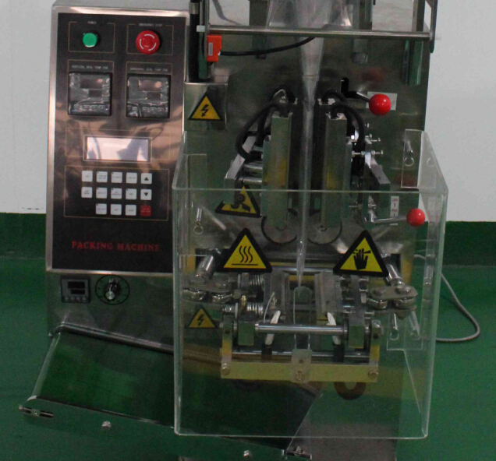

2. Paste dosing system – plunger pump kind
It is volume way not weigh. You can get different volume (ml) after pump adjusted.
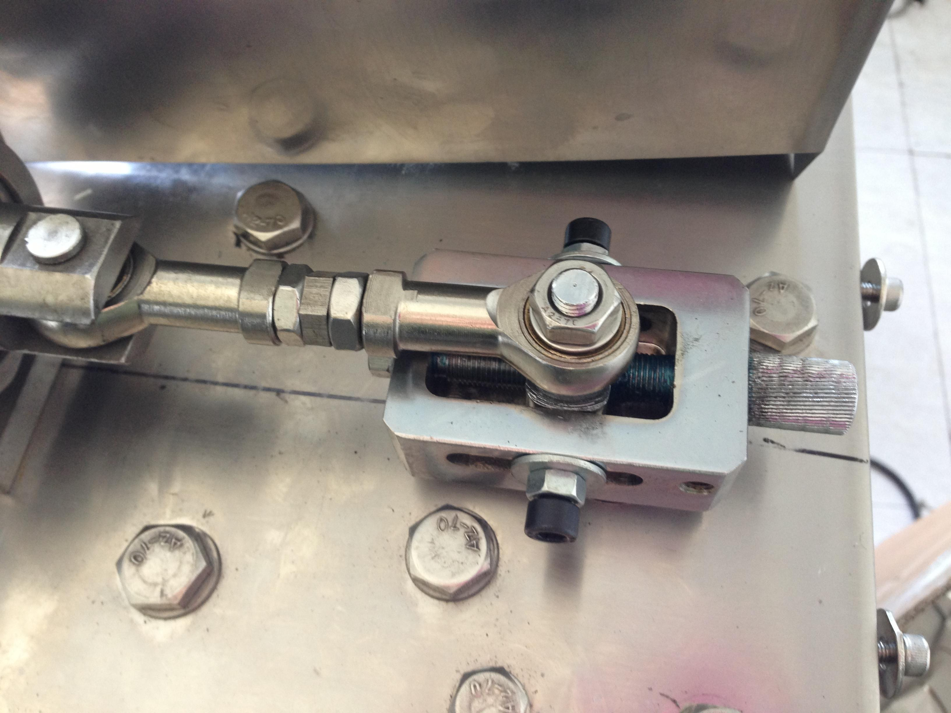
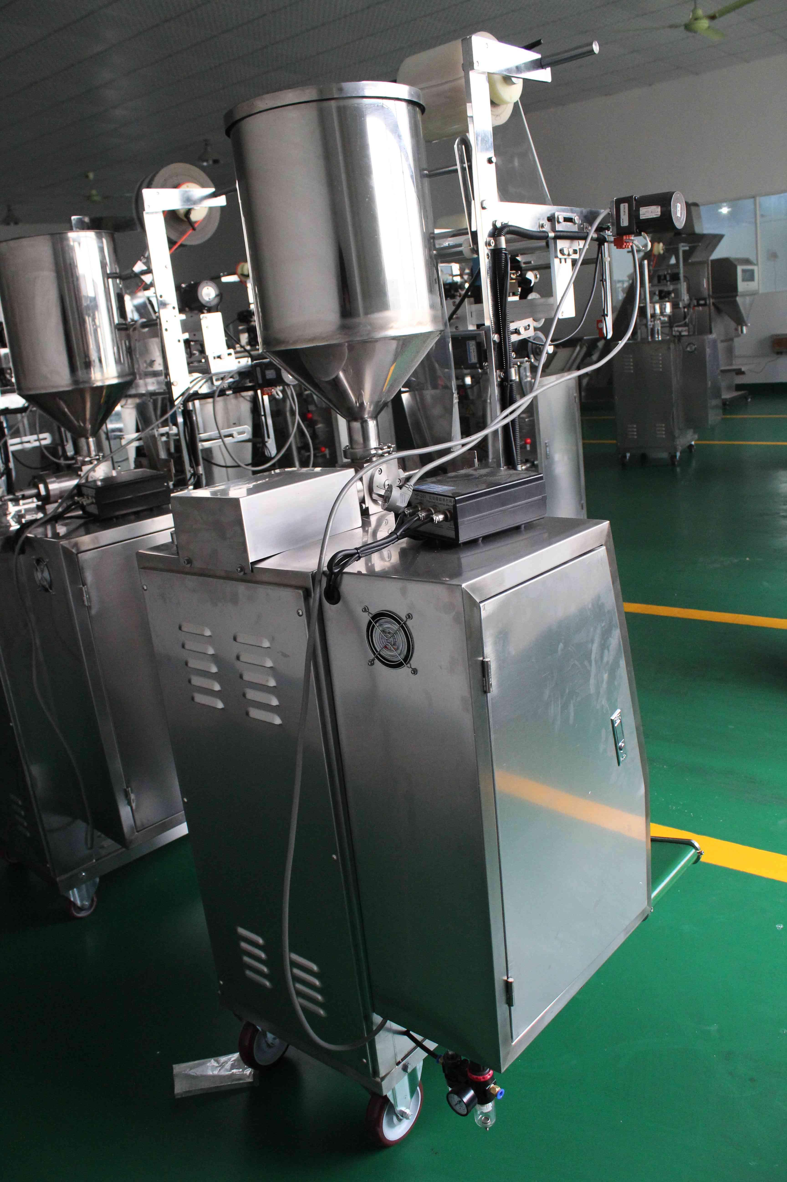
3.Date coding ribbon printer
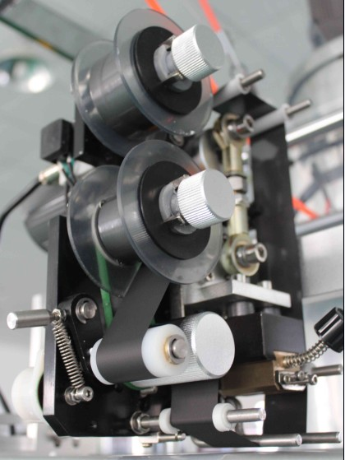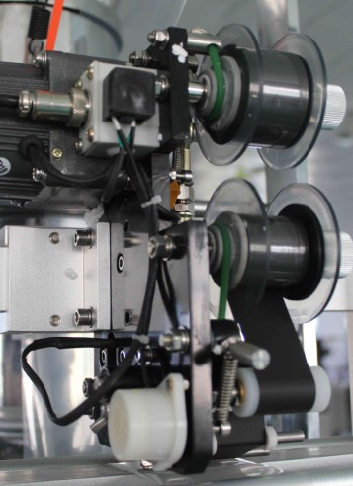
Features
1. heating code printer
2. three lanes
3. each lane can put 13 codes (each code W2mm H3mm)
4. easy to change codes (0-9, A-Z)
5. Use ribbon, each roll 100m
6.There is alarm of ribbon lack
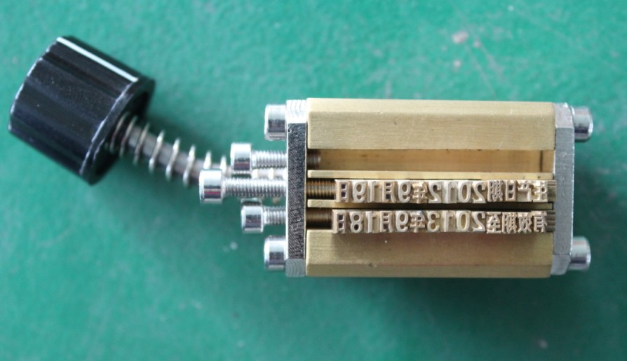

4. sample bag
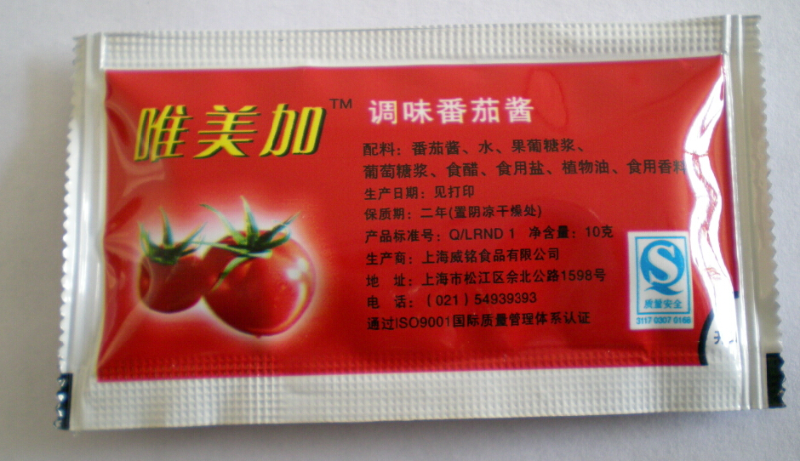
5.heating jacketed hopper
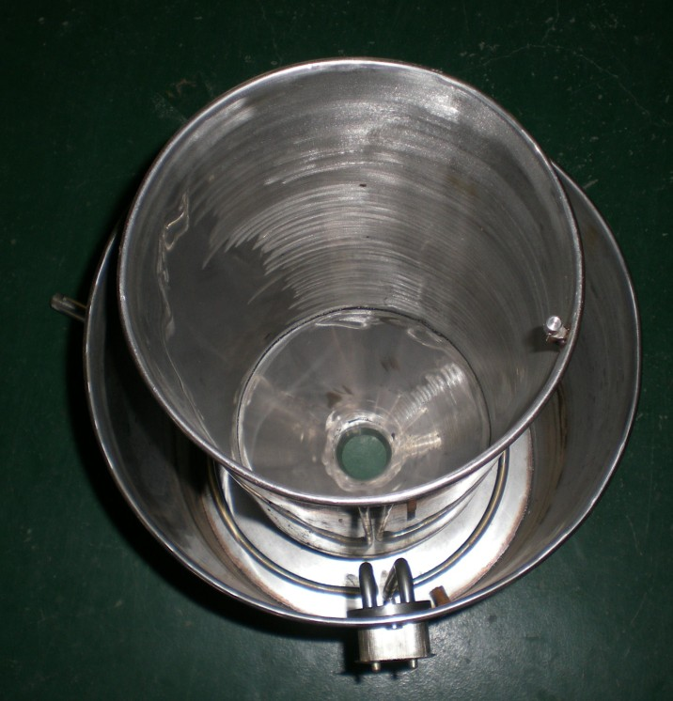
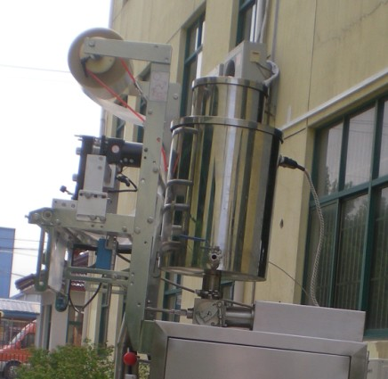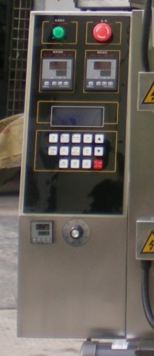
separate temperature controller for heating jacketed hopper, which one you can set temperature depend on material
Electrical Element List
Name of Equipment | Factory Brand | Picture | Quantity
Inverter | China ENC | 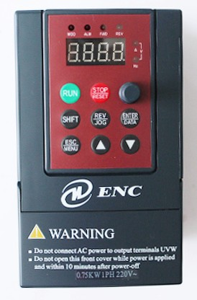 | 1 set
Decelerates motor | China Taiwan Gongji | 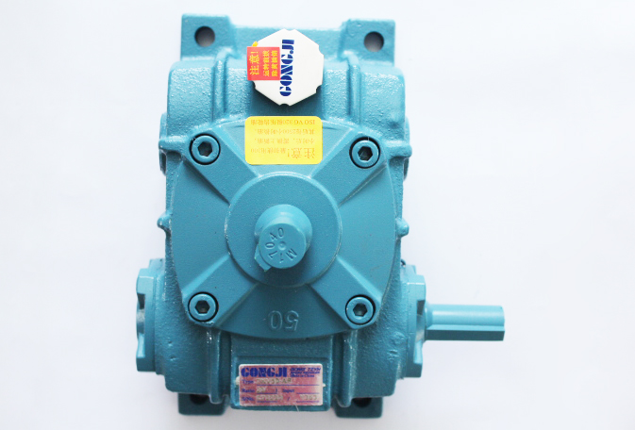 | 1 set
Step motor | China  Jintan Sihai | 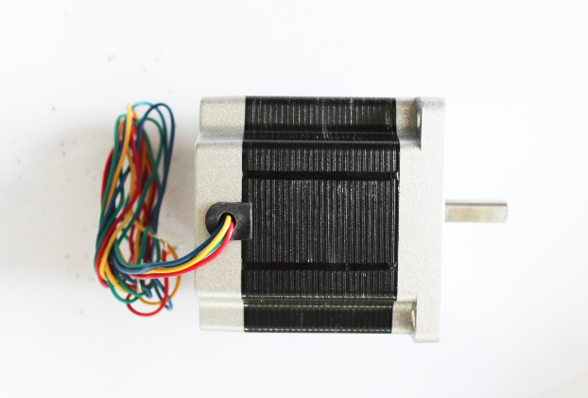 | 1 piece
Step motor driver | China  Jintan Sihai | 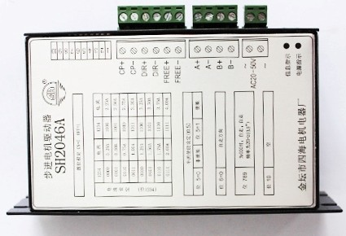 | 1 piece
Temperature controller | China  Shanghai Yatai | 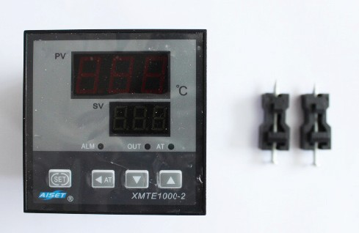 | 2 pieces
Pulling film motor | China Linix | 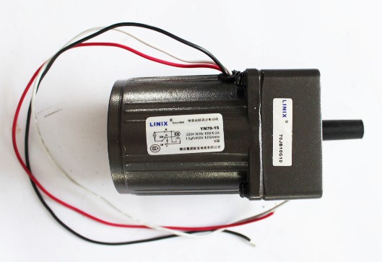 | 1 piece
Photo sensor | China Longyi | 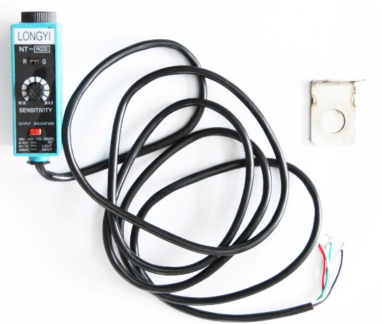 | 1set
Induces switch | Taiwan Roko | 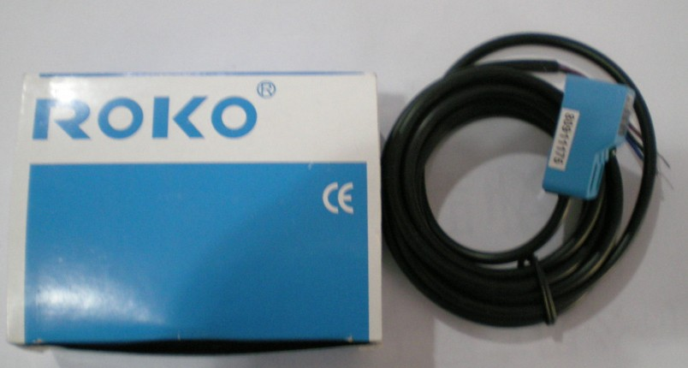 | 4 pieces
Solid state relay | France Schneider | 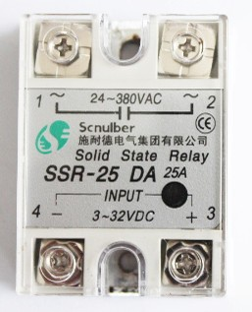 | 19 pieces
Thermocouple | China ordered | 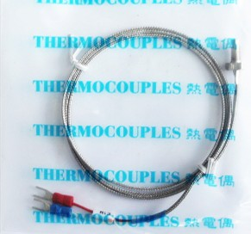 | 2 pieces
Pneumatic element | China  Taiwan AirTAc | 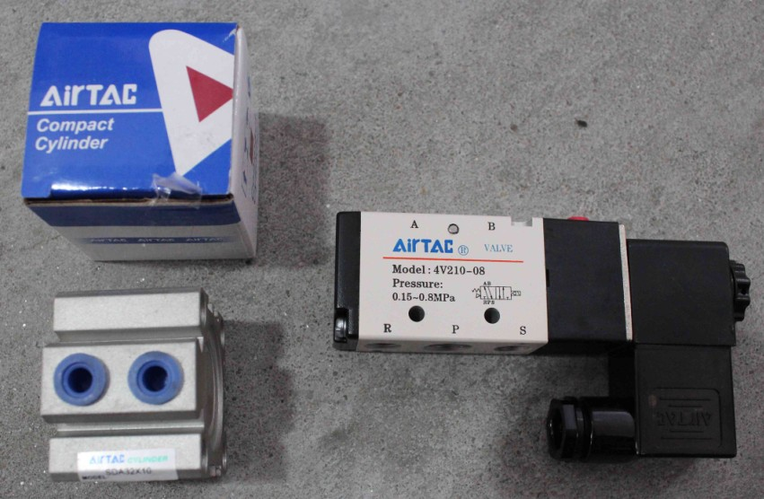 | 1set
Bearings | Main from German and Japan | 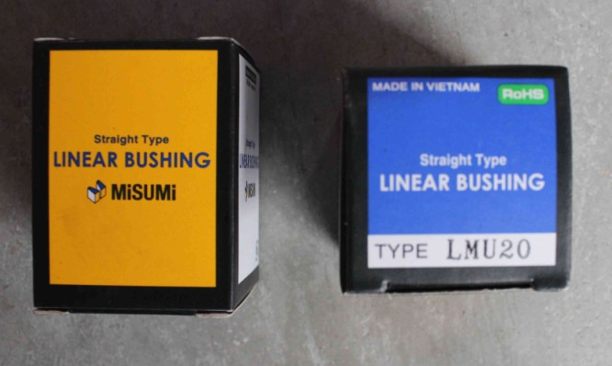

Tool box (includes free part, free tools and doc)
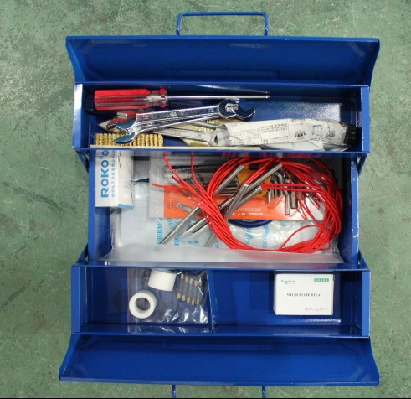
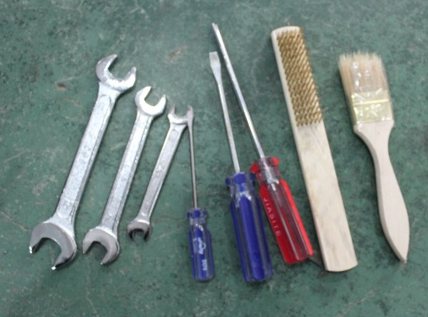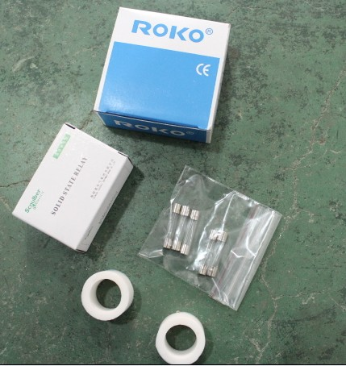
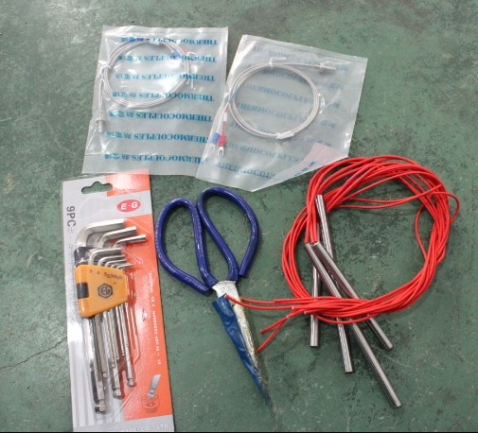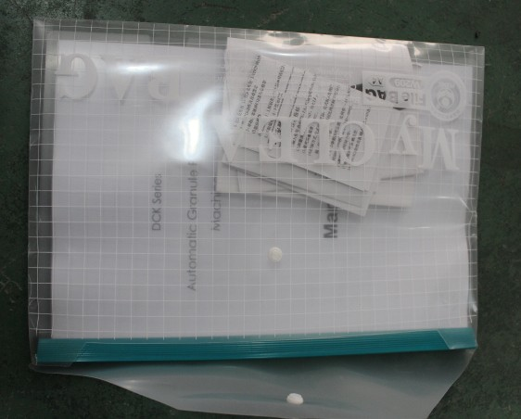

- Free part with Machine
Item | Description of Item | Qty.
01 | Gum over (fix the film etc) | 02
02 | Solid relay | 01
03 | Heat pipe | 04
04 | Thermocouple | 02
05 | Proximity switch | 01
06 | Zigzag jaw | 01
07 | Fuse(set) | 01

- Free tooling with Machine
Name | Spec | QTY
socket head wrench | STD | 1set
cross screwdriver | STD | 1Pc
straight screwdriver | STD | 1Pc
screwdriver | STD | 1Pc
scissors | STD | 1Pc
copper brush | STD | 1Pc
hairbrush | STD | 1Pc
Toolbox | STD | 1Pc

- Doc with Machine
Name | Spec | QTY
Manual | According to ordered machine | 1
Certificate of Quality | According to ordered machine | 1
Frequency conversion manual | According to ordered machine | 1
Temperature controller Manual | According to ordered machine | 1
Proxmity switch Manual | According to ordered machine | 1

