温州市益彰贸易有限公司

WENZHOU CHANGS INTERNATIONAL
ADD:#1105,Guoguang Mansion 发 票 No : 1231CHS14
(Opposite railway station
PROFORMA INVOICE DATE:31 december /2014

WENZHOU CHINA
Tel:+86-577-86051848

ATTN: KACETE HOCINE
Tizi ouzou Algerie
Number | Description &Specification | Quantity | Unit Price | Amount
 | SRZ-320A paper bag making machine  SZB1050S-350 Sheet-feeding Paper Bag Making Machine  Total  1, Delivery time: within 575workdays to finish the machine production after reciving 30% payment  2, Country of Origin: China  3, Payment Term:30% TT in advance, 70% balance before shipment  4,Warranty: 1 year limited warranty after installation.  Bank Information  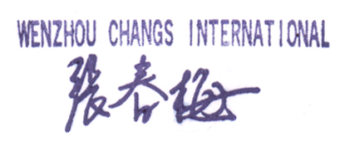  BENEFICIARY:  WENZHOU CHANGS INTERNATIONAL  BENEFICIARY BANK：  CHINA CONSTRUCTION BANK  WENZHOU BRANCH  SWIFT：PCBCCNBJZJW  BENEFICIARY A/C NO.：  33014013100229004101 | 1Set  1SET | EXWORK  USD128000.00  USD588000.00 | USD128000.00  USD588000.00  USD131000.00

SRZ-320A paper bag making machine
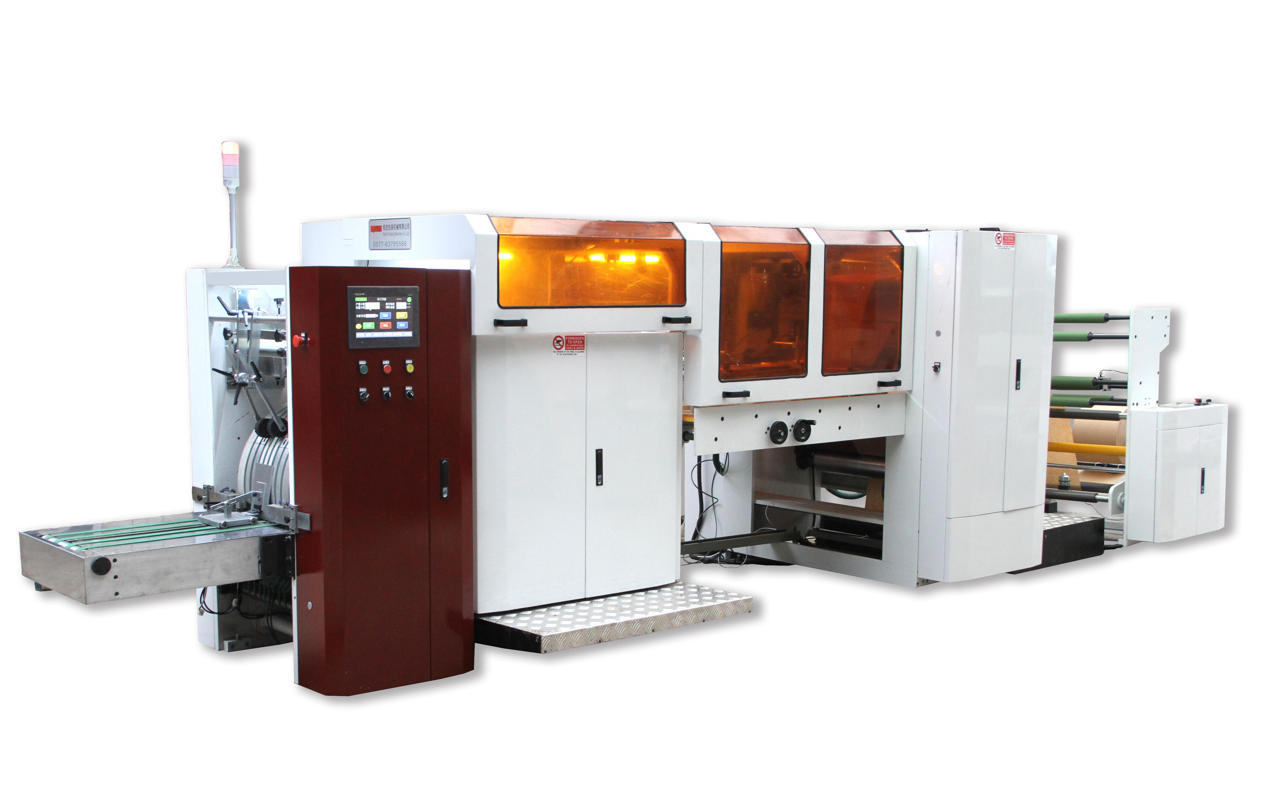
Sample:
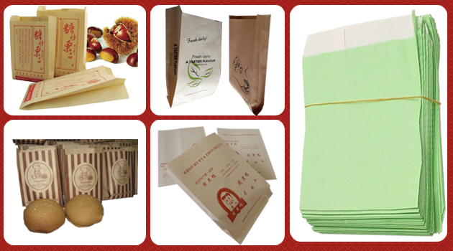
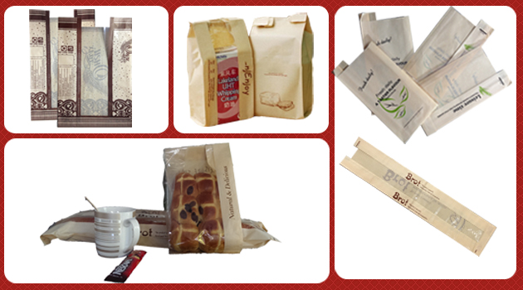
Introduction
This machine forming the paper bag in one process from roll paper, edge folding, tube forming, cutting, middle of bag gluing, bottom folding, bottom gluing and finishing bag. It is an ideal machine for producing food bags like bread bags, KFC bags and McDonald’s bags.
Features:
1. This machine adopts touch screen man-machine interface, regardless of correction, trimming can be arbitrarily set, alarm and operation state displayed on screen, easy to operate. The operation interface, English can be switched with each other.
2. With a touch screen and man-machine interface using the German import PC programmable control system, real-time working status display. PC system means we can solved problem through remote control.
3. Set the original Germany servo motor control, total three Germany servo motor for puncture,cut and bottom fold. Meantime including three Germany servo driver.
4. Printing color tracking system, using the Germany SICK color photoelectric tracking precision, with automatic calibration function.
5.Germany SICK Photoelectric sensor limiting automatic control system, to control bottom glue unit feed speed.
6. Taiwang Magnetic powder tension control with automatic constant tension control system, automatic calculation of roll diameter to achieve constant tension control
7.Italy edge position control system, including correct photocell, motor and module.
8. Machine have automatic stock system, and one special batch number alarm system.
9..This machine adopts Germany original electrical system, to ensure the machine more stable, reliable operation of the precision of the high-speed users from any menace from the "rear".
9.Safety protection design of the machine has a new humanity; full face cover design, fully guarantee the safety and product operator environment.
Main technical parameters：
Model | SRZ-320A
Max. Making Bag Speed | 500pcs/min
Mechanical speed | 150m/min; 600pcs/min
Bag length | 160- 700mm
Bag width | 80-320mm
Paper width | 100--1000mm
Paper roll diameter | 200--1000mm
Paper core diameter | Ø75mm
Paper material thickness | 35-80g/m2
The local electric power | 3phase 4line 380V 27kw
Total Weight | 5000kg
The machine dimensions | 7600x1900x1900mm

Name | QTY | Original/Brand | Remark
Control system
PC Programmable LogicControllers | 1 | Germany
Touch screen | 1 | France
Servo motor | 3 | Germany
Servo driver | 3 | Germany
The main motor | 2 | Taiwan
Frequency converter | 2 | Germany
Color mark tracking photo-sensor | 1 | Germany
Positioning  photoelectric eye | 1 | Germany
Hot Gluing System | 1 | Switzerland

SZB1050S-350 Sheet-feeding Paper Bag Making Machine：
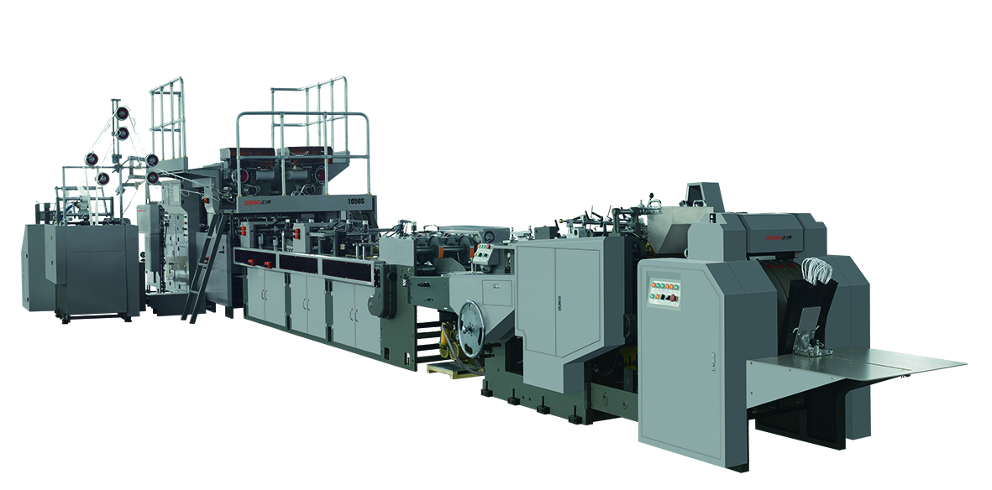
This machine is designed to manufacture square bottom paper bags with handles from sheet paper in blank or printed. Combined with a handle making machine, handle making, handle application, bag mouth folding, side gluing, tube forming, bottom impressing, bottom gluing, bottom forming and final product collection can be completed within a fully automatic process. It is an ideal equipment for making paper bags for foodstuff bags, shopping bags and so on, and can produce paper bags of different sizes.

Features:

- Paper Handle feeding system: Advanced concept of machanical design, machanical automatic tension adjustment, automatic adjusting paper handle position.
- Paper Handle forming system: hyperbolic rocker machanism, with the America ‘Nordson’’ hot melt glue box, computer control spray adhesive length and position, automatic slitting system.
- Feeding systerm: Enchanced pre-stack paper system, realize non-stop paper feeding, greatly save the time of paper stacking and adjusting.
- Front and side aligning system: According the aligning system, each paper can precision positioning, make sure mass production consistency.
- Opening edge cutting system: Can adjust the cutting position on line, make a good foundation for the paper handle paste.
- Reinforced cardboard gluing system: Can divide into conditions: Manually and automatic. Unified control by center computer, make sure uniform gluing, avoid no glue and much glue.
- Top folding system: Control by machine’s cam, to finish top fold, Improve the paper making process efficiency.
- Automatic side gluing system: Proprietary technology, can automatic gluing, uniform and steady.
- Automatic tube forming and gusset forming system: Can automatic forming bag tube.
- Automatic die cutting and hole punching system: Can automatic creasing and punching hole, with these two functions, more convenience.
- Automatic bottom sealing system: Use prod gripper to seal the bottom, no scrape of bag surface, protect the easy damaged bag surface.
- Automatic collection system: Can automatic counting, it’s convenience to collect the bags.

Parameters:

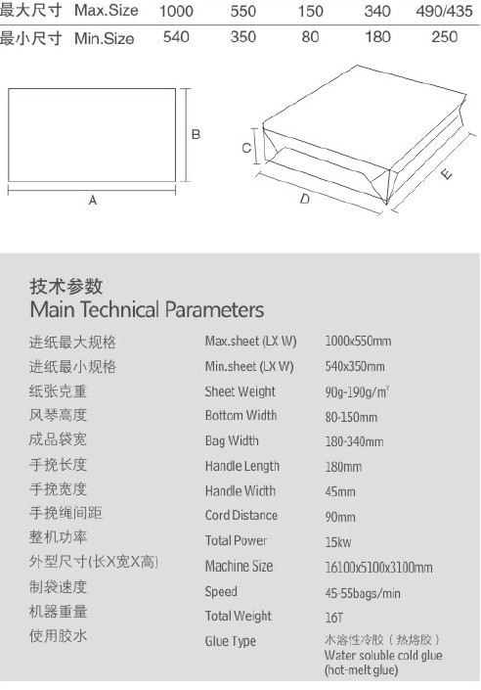

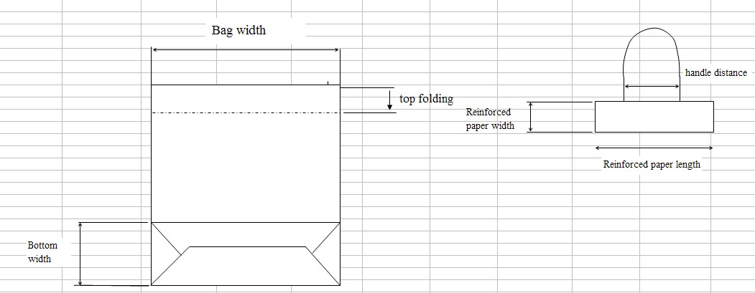

4） Part List
NO | Name | Producing place | Brand | NO. | Name | Producing place | Brand
1 | Frequency converter | French | Schneider | 5 | Electrical element | French | Schneider
2 | PLC | Taiwan | Delta | 6 | Main bearing | Japan | NSK
3 | Magnetic clutch | Taiwan | Chain Tail | 7 | Photoelectric switch | Japan | OMRON
4 | Touch screen | Taiwan | Weinview | 8 | CVT | Japan | Mikipulley



