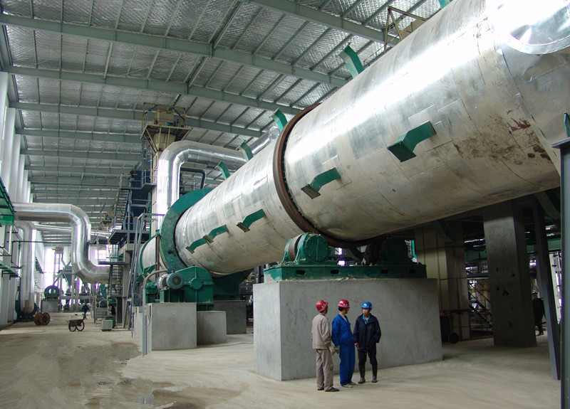

SUSTENTAP Consultoria Organic and inorganic fertilizer project
50,000MT/Y compound fertilizer production line
Preliminary proposal
Provide by JSRAT (JIANGSU RIGHT MACHINERY GROUP)
2015/01/06

Equipment list of NPK Fertilizer plant

JIANGSU RIGHT GROUP
SUSTENTAP Consultoria Organic and inorganic fertilizer project
50,000MT/Y compound fertilizer production line

No | Name | Q’ty | Power  （KW） | Remarks | Picture
W101-  W106  W108 | B500 Belt weight | 7 | 7×1.5 | Contain PLC control  Capacity: 4-8t/h  accuracy: ±0.5%  Material:Q235B | 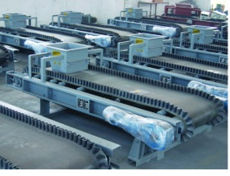
L101#1 | HL250 Bucket elevator | 2 | 5.5×2 | Capacity: 47.2-30m³/h  Bucket running speed: 1.5m/s  Transmission direction: right  Material: Q235B | 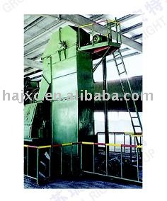
M101 | LF600 Cage miller | 2 | 16.5×2 | Production capacity:5-10t/h  Final grain: <1mm90%  Motor power: 11/7.5kw | 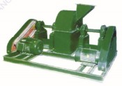
L103#2 | B650 Belt conveyor | 1 | 5.5 | Capacity≥8 m³/h  Speed of belt: 0.8m/s  Journey: 600mm  Gauge: 1200mm | 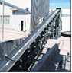
L102#1 | B650 Belt conveyor | 1 | 4 | Capacity≥5 m³/h  Speed of belt: 0.8m/s  Journey: 500mm  Gauge: 1000mm
L104#3 | B650 Belt conveyor | 1 | 5.5 | Capacity≥8 m³/h  Speed of belt: 0.8m/s  Journey: 600mm  Gauge: 1200mm
L105#4 | B650 Belt conveyor | 1 | 7.5 | Capacity≥8 m³/h  Speed of belt: 0.8m/s  Journey: 600mm  Gauge: 1200mm | 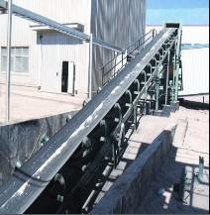
M102 | Ø1.8×7m  Revolving drum granulator | 1 | 15 | Wall thickness: δ=12  Production capacity: 10t/h  Rotational speed of cylinder:  11.5r/min  Reducer model: ZQ650  Material: Q235B PVC | 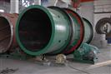
L106#5 | B650 belt conveyor | 1 | 5.5 | Capacity≥8 m³/h  Speed of belt: 0.8m/s  Journey: 600mm  Gauge: 1200mm | 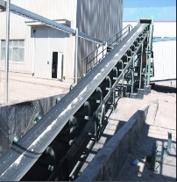
M103 | Ø2.2×22m  Dryer 1# | 1 | 37 | Wall thickness: δ=16  Production capacity: 8-14t/h  Rotational speed of cylinder:  3.29r/min  Reducer model: ZL65  Material: Q235B | 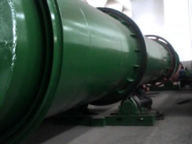
C101 | W4-68No8C Hot air fan | 1 | 18.5 | Pressure: 2177-1481pa  Blowing rate: 16985-30134m3/h  Material: CS+SS | 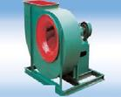
C105 | FRP4-72No.4.5A  Draught fan | 1 | 7.5 | Pressure: 2554-1673  Blowingrate:5712-10560m3/h  Material: FRP+SS
B101 | Combustion furnace | 1 |  | Coal Furnace  5000Kcal/kg  supply of steel parts and fan
S101#1 | Ø1800 Cyclone | 1 |  | Material: Q235B | 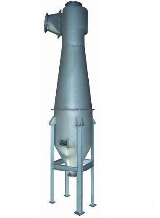
L107#6 | B650 Belt conveyor | 1 | 4 | Capacity≥8 m³/h  Speed of belt: 0.8m/s  Journey: 600mm  Gauge: 1200mm | 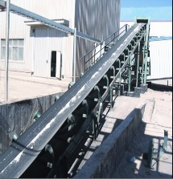
L108#2 | HL400  Bucket elevator | 1 | 11 | Capacity: 47.2-30m³/h  Bucket running speed: 1.5m/s  Material: Q235B | 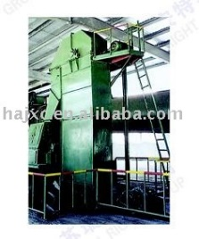
M104 | Ø1.8×16m Dryer2# | 1 | 18.5 | Wall thickness: δ=14  Production capacity: 5-7t/h  Rotational speed of cylinder:  3r/min  Reducer model: ZQ650  Material: Q235B
S102#2 | Ø2000 Cyclone | 1 |  | Material: Q235B | 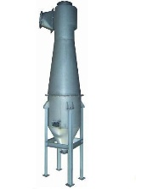
B102 | Combustion furnace | 1 |  | Coal furnace  5000kcal/kg  supply of steel parts and fan
L109#7 | B650 Belt conveyor | 1 | 3 | Capacity≥8 m³/h  Speed of belt: 0.8m/s  Journey: 600mm  Gauge: 1200mm | 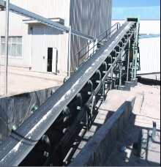
L110#3 | HL400  Bucket elevator | 1 | 7.5 | Capacity: 47.2-30m³/h  Bucket running speed: 1.5m/s  Material: Q235B
M105 | Ø1.5×6m Rotary sieve | 1 | 11 | Production capacity: 8-10t/h  Rotational speed of cylinder:  17r/min  Level: 1  Material: Q235B
M106 | LP700 Vertical crusher | 1 | 22 | Material: Q235B | 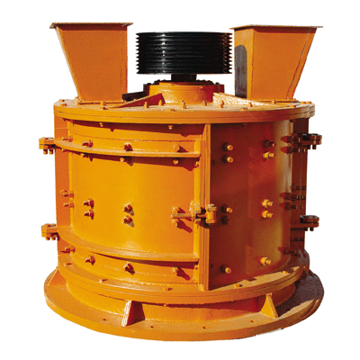
L112#9 | B500 Belt conveyor | 1 | 3 | Capacity≥5 m³/h  Speed of belt: 0.8m/s  Journey: 500mm  Gauge: 1000mm | 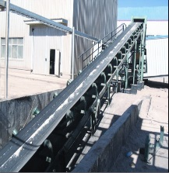
L113#4 | HL400 Bucket elevator | 1 | 11 | Capacity:47.2-30m³/h  Bucket running speed: 1.5m/s  Transmission direction: right  Material: Q235B | 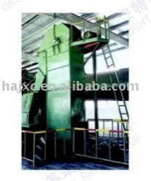
M107 | Ø1.8×16m Cooler | 1 | 18.5 | Wall thickness: δ=14  Production capacity: 5-7t/h  Rotational speed of cylinder:  3r/min  Reducer model: ZQ650  Material: Q235B | 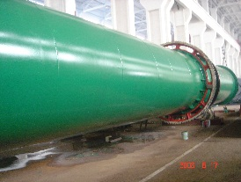
S103 | Ø1800 Cyclone | 1 |  | Material:Q235B | 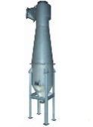
L114#5 | HL400 Bucket elevator | 1 | 11 | Capacity: 47.2-30m³/h  Bucket running speed: 1.5m/s  Material: Q235B | 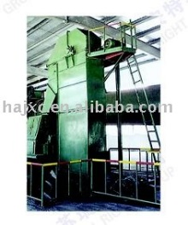
L117#6 | HL400 Bucket elevator | 1 | 11 | Capacity: 47.2-30m³/h  Bucket running speed: 1.5m/s  Material: Q235B
L118#7 | HL400 Bucket elevator | 1 | 11 | Capacity: 47.2-30m³/h  Bucket running speed: 1.5m/s  Material: Q235B
M108 | ZDS1450 Vibrating screen | 1 | 2.2X2 | Production capacity: 8-10t/h  Frequency: 960/min  Motor: ZG618-2.2  Material: Q235B | 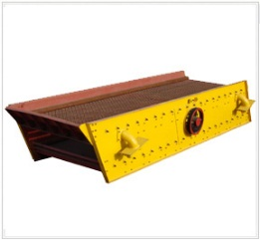
M109 | Ø1.4×4m  Coating machine | 1 | 11 | Wall thickness: δ=12  Production capacity: 8t/h  Rotational speed of cylinder:  15.05r/min  Reducer model: JZQ500  Material: Q235B | 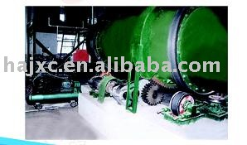
 | ￠1000  Coating Melting tank |  |  | Weight pump BLDY15-35
L115#10 | B500 Belt conveyor | 1 | 3 | Capacity≥8 m³/h  Speed of belt: 0.8m/s  Journey: 600mm  Gauge: 1200mm | 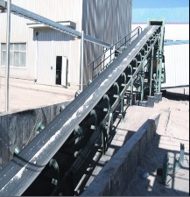
L116#11 | B650 Belt conveyor | 1 | 5.5 | Capacity≥8 m³/h  Speed of belt: 0.8m/s  Journey: 600mm  Gauge: 1200mm | 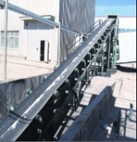
WL106  WL107  V101 | Automatic packaging unit  Include the Packing Weight belt  Final Product Hoper | 1 | 3 | Stainless steel  Material: SS304  LCS-50-I  F710 | 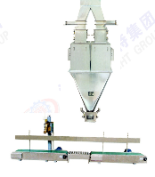
L111#8 | B500 Belt conveyor | 1 | 5.5 | Capacity≥5 m³/h  Speed of belt: 0.8m/s  Journey: 500mm  Gauge: 1000mm
C102 | G4-68-No10D 1# Dryer Fans | 1 | 55 | Draught fan pressure: 3403-2315pa  Blowing rate: 33173-58856m3/h
C104 | G4-68No9D Cooler Fans | 1 | 30 | Draught fan  Pressure: 2756-1873pa  Blowing  Rate: 24183-42906m3/h
C103 | G4-68No9D 2# Dryer Fans | 1 | 30 | Draught fan  Pressure: 2756-1873pa  Blowing  Rate: 24183-42906m3/h
T101 | Ø2×3m  Scrubber + chimney | 1 |  | Water circulating system FRP
 | Urea Melting System | 1 |  | R101 Tank R102 Tank  Include pump  1Cr18Ni9Ti | 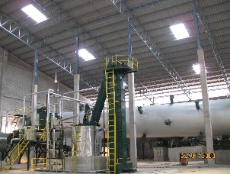
S104 | Gravity settling chamber 1# for Dryer1 |  |  | 15m×4.5m×8m
S105 | Gravity settling chamber 2# for Dryer 2 |  |  | 15m×4.5m×8m
S106 | Gravity settling chamber 2# for Dryer 3 |  |  | 15m×4.5m×8m
S107 | Exhaust sink |  |  | 8m×5m×3m
 | Steam boiler | 1 | 2ton  13MPa | Fuel material confirm by buyer later
 | Electrical control system  Operating floor, electric control cabinet, temperature control cabinet and cable |  |  |  | 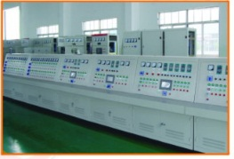
 | Un-standard parts |  |  | Duct, elbow, ladder stand, platform and son on (30t)
 | Design fee and know-how fee
 | Packing, commodity inspection and domestic transportation
 | Sea freight |  |  |  | After confirm

Spare parts list for the 1years operation

JSRAT will provide spare parts list in the details design

A. Commercial proposal
Price schedule for engineering scope of work
According to the result of negotiations to decided.
Price schedule for NPK Fertilizer plant equipment
¥ 4,4300,000 RMB (estimate)
Price for supervision
Calculated as man/day, it can be talk about in the negotiations.
Price for training
$100 per each engineer a day, it can be talk about in the negotiations.
Price for building projects
According to the result of negotiations to decided.

Term of payment
30% down payment
The rest of the progress payments
Equipment delivery must to pay 95%
After the commissioning pay last 5%

Guarantee
JSRAT warranty period is twelve (12) months after the date of running.
JSRAT will continue to provide technical support to ensure the normal operation of equipment.
And other guarantee we will in-depth consultation in the negotiations.

Note:
This proposal is the Preliminary proposal, for business negotiations between the two sides use. It will be negotiated in details during Delegations meeting in china to finalize.

