QUOTATION
Date: 16-01-2015 Validity of quotation: 1 month
No.:ZYJW20150116

SUBJECT OF QUOTATION
NO. | NAME OF GOODS | QUANTITY | UNIT PRICE | AMOUNT PRICE
1 | ZYYX26-200-1000 Roll Forming Machine | 1 SET | USD26,000 | USD26,000
 | Total | USD26,000 FOB NINGBO
DELIVERY: The machines will be ready within 50 days from receipt of down payment as well as approval of sales contract, technical scheme and profile drawing. The shipment will be made within 10 days after the seller receives the balance by T/T.

TERMS OF PAYMENT: 30% of the contract amount as down payment; the balance is to be paid by T/T before shipment or by L/C at sight. Installation charge is to be paid before installation by T/T.

COST OF INSTALLATION:
The buyer should pay the installation charges USD500 for one machine. The buyer pays the seller’s technician travel cost outside China, including round air tickets fee, accommodation and food, provide transportation from living hotel to the work place, necessary communication, and insurance, etc.

WARRANTY: 12 months limited warranty starting from date of delivery, excluding wear parts. Shipping cost for parts to be replaced during warranty period have to be borne by the customer.

OTHER TERMS: Attached please see the technical scheme

TECHNICAL SCHEME
- NAME OF GOODS: ZYYX26-200-1000 Roll forming machine
- PROFILE:
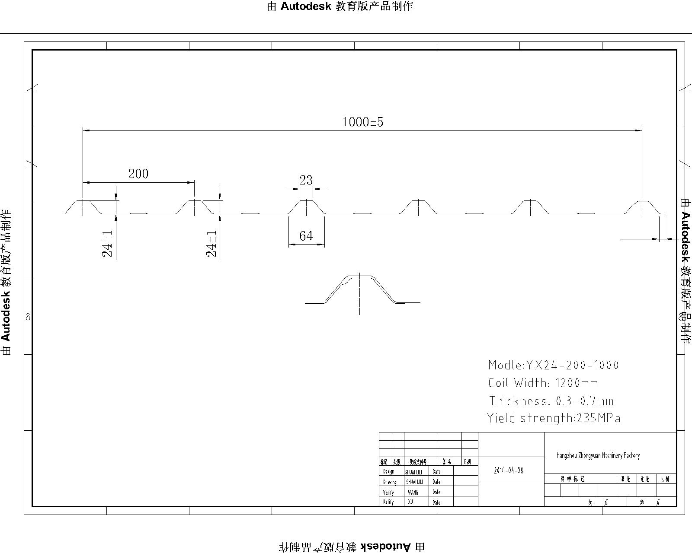
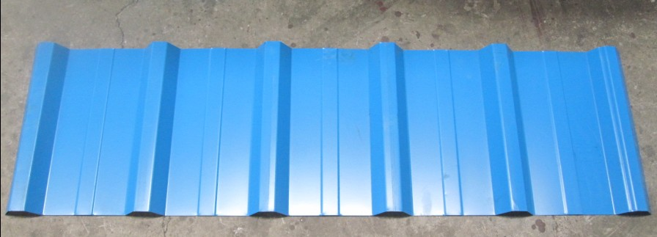
- MATERIAL:
1) Coil Width: 1200mm
2) Suitable Coil Thickness: 0.3 mm-0.7mm
3) Suitable Raw Materials: Aluminum coil
4) Yield strength of raw material: 240Mpa-300Mpa

- MACHINE COMPONENTS:
(1) Manual decoiler 1 set（Capacity: 5 tons）
(2) roll-Forming M/C 1 set
(3) Hydraulic Cutting 1 set
(4) Hydraulic station 1 set
(5) PLC Control System 1 set
(6) Product Rack (un-powered) 1 set (two pieces, total length is 3 meters)

- TECHNICAL SPECIFICATION
(1) Manual decoiler:
1) Un-power; manual decoiler; max. Capacity: 5000kg
2) Suit for coil inner-diameter: 508mm, suit for coil max outer diameter: 1000mm
3) Manual power expands the coil inner surface.
The decoiler out form reference:
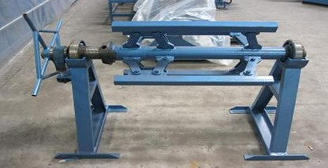

(2) Roll-Forming M/C:
- The main frame of machine is welded separately and the outside wall is connected by screw after being rotoblasted on the surface.
- Roller Material is high grade No.45 forged steel, with digital-controlled procession.
- Shafts of rollers are tooled by grinding machine for two times to ensure the precision of final product.
- The rollers are plated with hard chrome with thickness of 0.05mm on the surface after being machined by the exact machine tool. So that ensures long life of forming rollers.
- Shaft diameter is 72mm.
- Quantity of forming rollers : about 22 stations
- Chain and gear move the line, motor drives. All working actions are controlled by PLC electric cabinet automatically.
- Suitable power voltage:380V/50HZ/3Phase (can de designed according to buyer’s requirement)
- Line working speed (Forming speed)：about 20m/min (without cut time)
- Main machine motor power: about 5.5KW(Depend on final design)
- Total weight : about 8500kg
- Net size of main frame: about 10m x 1.7m x 1.4m (Length x Width x Height)

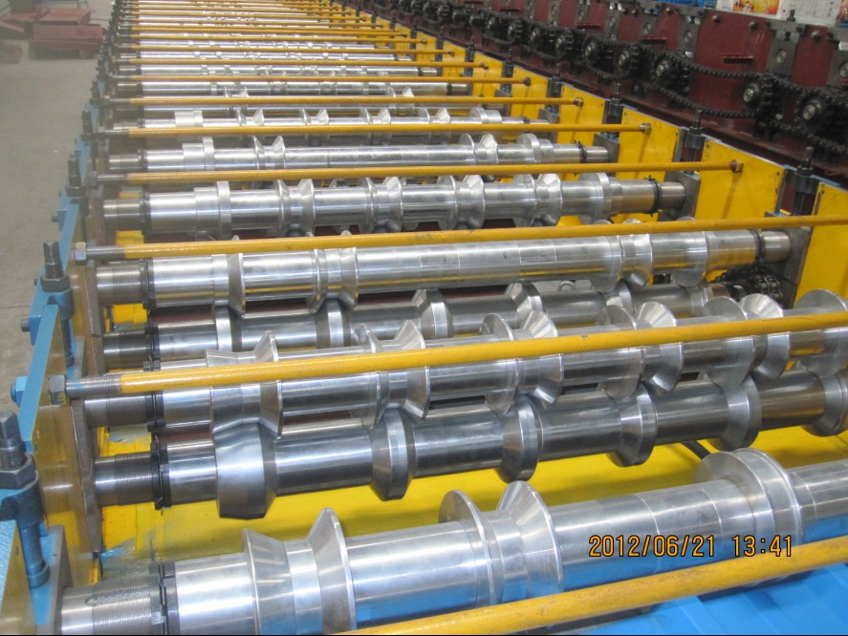
Roll forming system reference
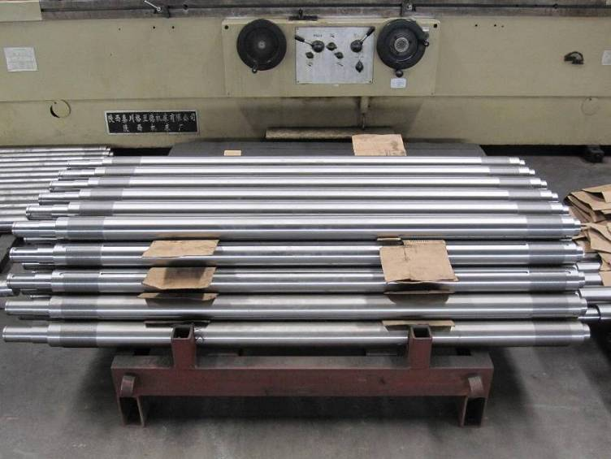
Tolled shafts

(3) Hydraulic Cutting
1) Adopts post cutting, Stop to cut;
2) The cutting blade material is Cr12 with quenched treatment.
2) Adopts welded frame for good rigidity.
4) Cutting frame has been heat treatment to avoid final product deformation. cutting length tolerance ±2mm.
5) The power of cutting is provided by hydraulic station.
6) The final product can be cut as per set length in PLC controller, and the length is automatically measured by encoder. When final product reaches the set length, machine will stop to cut the product automatically. Finish this action, machine will run again continuously.

(4)Hydraulic station:
1) It supplies the power for the hydraulic cutter.
2) All hydraulic accessories are all use Chinese famous brand products.
3) Hydraulic motor power: about 2.2KW
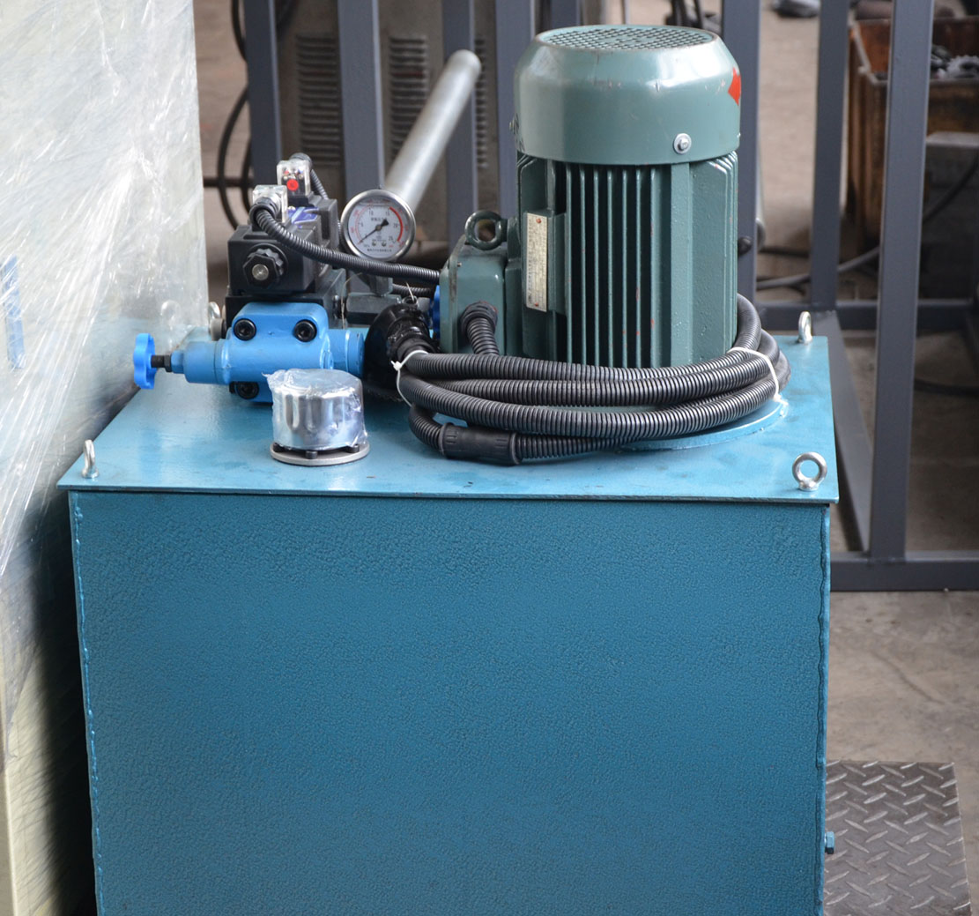
- PLC Control System:
- This system uses Mitsubishi PLC to control the all working actions. Production quantity and each piece length will be automatically measured. It is convenient to control the roll forming machine.
- Mitsubishi converter adjusts speed technology, realize the automatic production.
3) Touch screen is input and cancelled the working data.
4) Friendly man-machine interface system can be set batches to the workpiece, length, quantity, etc.
5) Encoder count, having function of count and measuring length.
6) Suitable power voltage:380V/50HZ/3Phase (can de designed according to buyer’s requirement)
System outer form reference:
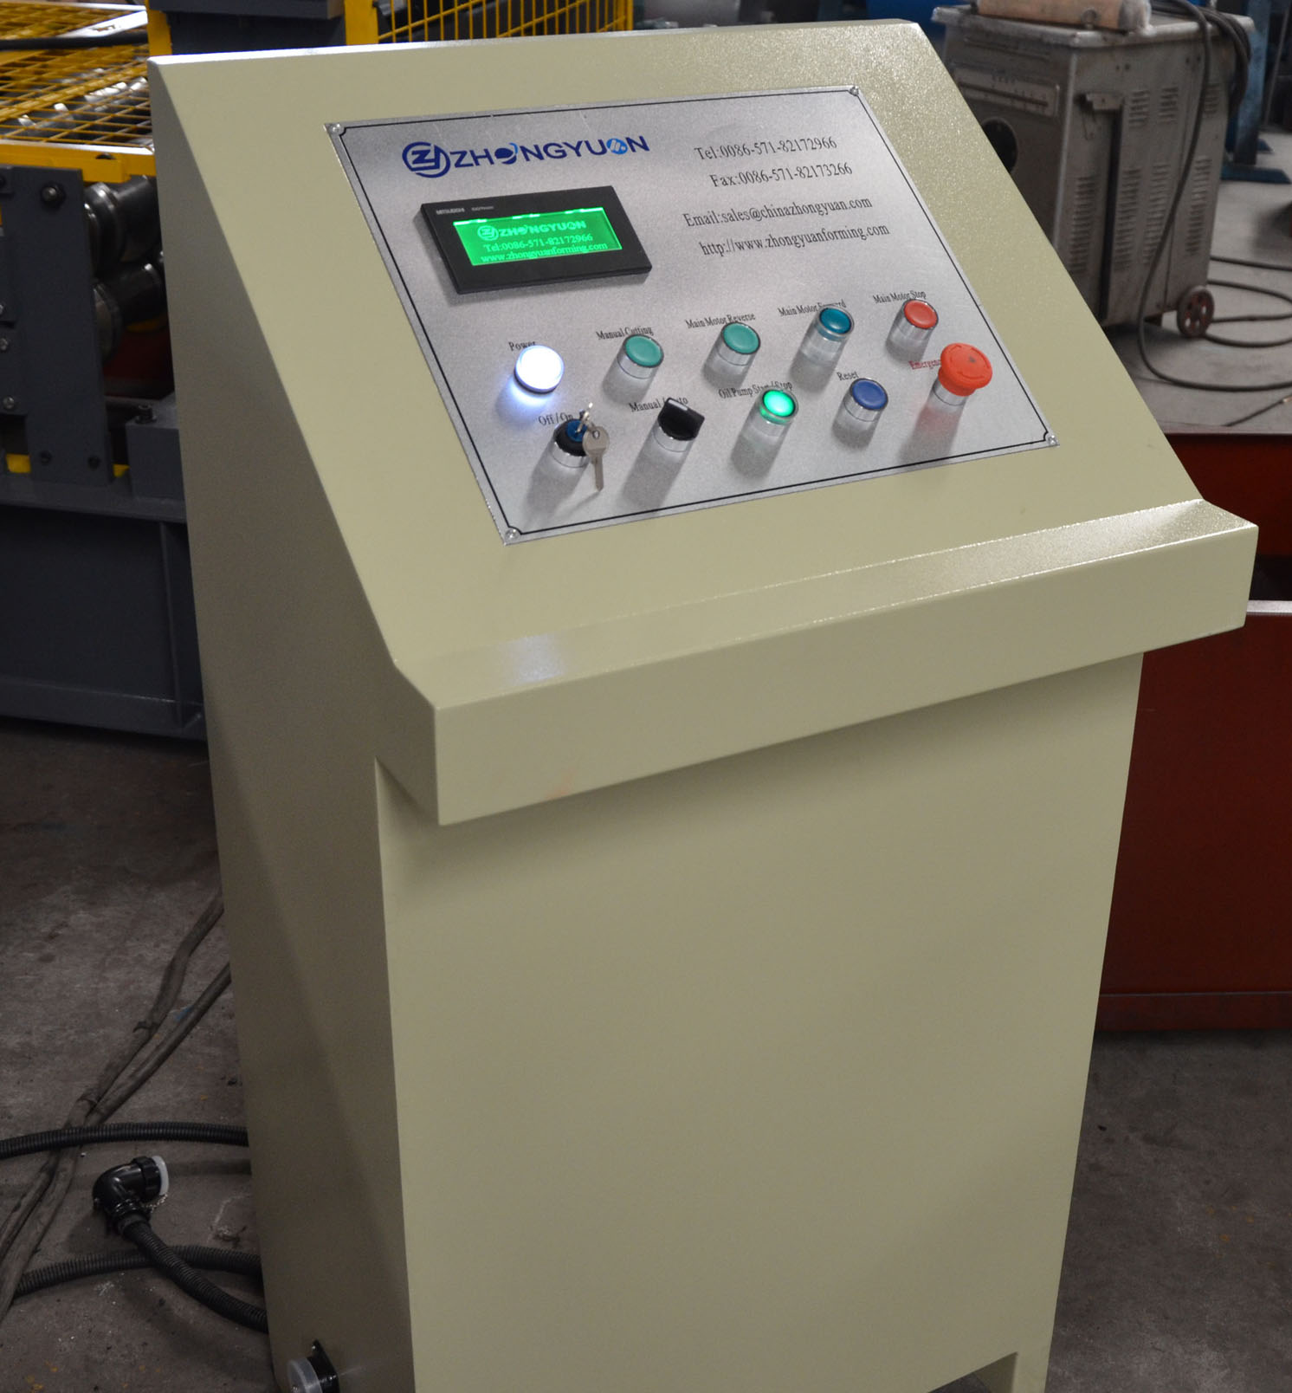

(6) Product Rack (un-powered):
1) They are used to put the final product when product coming out from cutting device.
2) Two pieces, Each piece length is 1.5m, total length is 3 meters.
3) Collect the final product and final products is convenient to be stacked by workers.
Outer former reference:
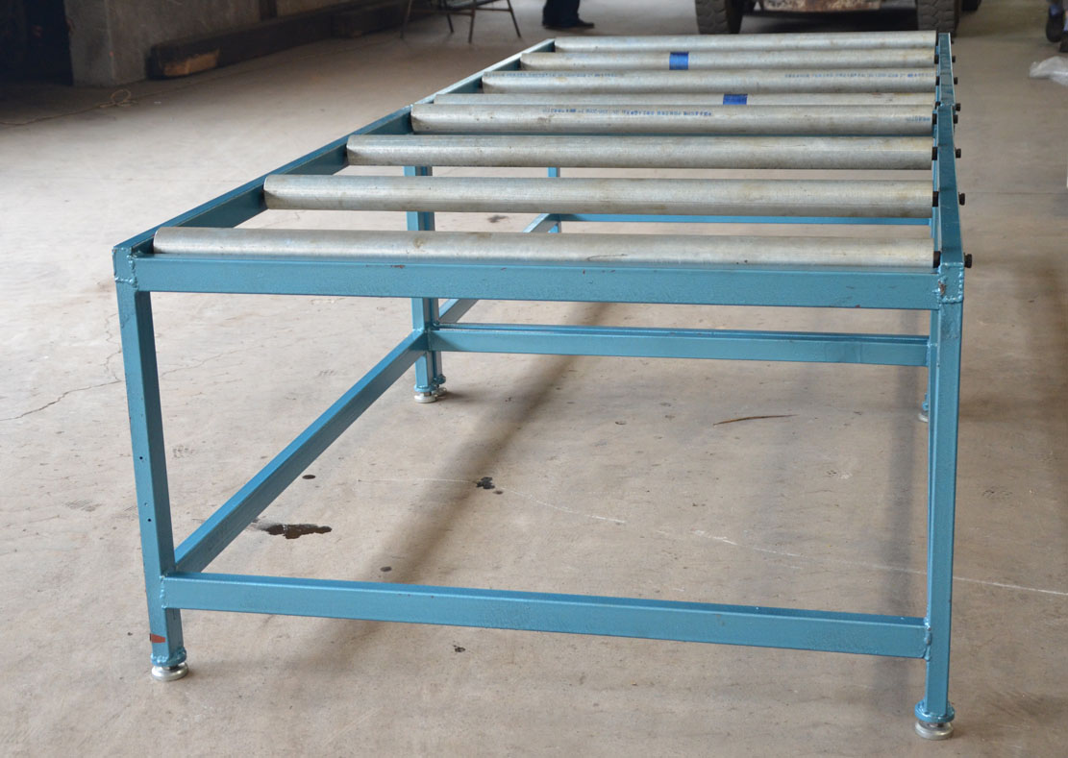
- Line working processing display
Decoiling the sheet→ guiding sheet →Roll forming→ Measure length and cutting the sheet→ Product to the run out table

- Reference view of machine
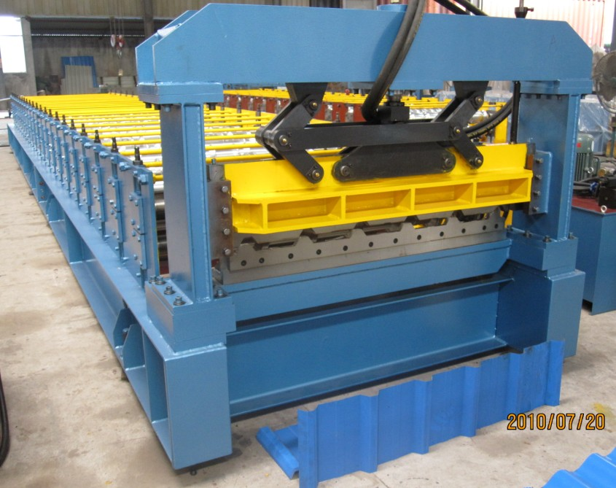
- Attached reference view of whole line’s layout drawing


