www

|  |  |  |  |  |  |  |  |  |  |  |  |
| --- | --- | --- | --- | --- | --- | --- | --- | --- | --- | --- | --- |
| **沧州市金泰衡器有限公司**  **CANGZHOU KINGTYPE WEIGHING APPARATUS CO.,LTD**  **truck scale quotation** | | | | | | | | | | | |
| **Buyer** |  | | | | | **Date** | **Jan. 28th 2015** | | | | |
| **Offer No.** | **KT20150128** | | | | |
| Seller | **Canzhou Kingtype Weighing Apparatus Co.,Ltd**  **Mob:+8615031787104 FAX: +86-317-2121857**  **Mandy** | | | | | **Validity**  **date** | **Feb. 28th 2015** | | | | |
| Full details | | | | | | | | | | | |
| **Item** | **Weight &**  **Volume** | | **Specification** | | **Unit Price** | | | **Quantity** | | | **Total Price** |
| **3MX18M**  **(100t)** | **9.0t**  **13cbm** | | **1.Structure:U-sharp beams**  **2.Flat plate: 10mm**  **3. Accuracy class:OIML(III)**  **4.Body:3section 6parts:**  **Each Part: 1.5WX5.7Lm**  **5.Across Bar:4parts**  **Each part: 0.22X3Lm** | | **7922 USD/set** | | | **1 set** | | | **7922 USD** |
| **Total Price: FOB TIANJIN** | | | | | | | | | **1 set** | | **7922 USD** |
| **The price above include:** | | | | | | | | | | | |
| **Standard part** | | 1. **Scale body 2.load cells 3.indicator 4.junction box 5.english weighing software**   **6.foundation plate 7.screws 8.cable(30m) etc** | | | | | | | | | |
| **Port of loading** | | **Tianjin port** | | **Port of delivery** | | | | | |  | |
| **Terms of payment** | | **30%T/T deposit advance payment, the 70%balance by copy of B/L.** | | | | | | | | | |
| **Delivery** | | **After received the deposit within 15 days** | | | | | | | | | |
| **Warranty** | | **3 years for scale body, 1 year for accessories** | | | | | | | | | |

|  |  |  |  |
| --- | --- | --- | --- |
| **Accessory parts** | **Specification** | **pictures** | **Packing** |
| **Load cell(20t)**  **ZEMIC**  **brand** | **1. Alloy steel construction**  **Nickel plated, hermetically welded**  **Oil-proof, waterproof and anti-corrosive gas and medium making**  **2. Dual shear beam**  **Easy installation, reliable performance**  **3. With OIML approval** |  | **8pcs/set** |
| **Indicator**  **(XK3190 D10)**  **YAOHUA**  **brand** | **1. A/D conversion with readability 1/30000**  **2. Save 1500 vehicle ID/net weight, 201 cargo ID/cargo name, 100 customer ID/customer name, 100 notes and 1501 weighing records**  **3. Display: 7 bits, LED, 7 status indications** |  | **1pc/set** |
| **Junction box(IP68)** | **Using water proof seal joint for prevent water special seal connection during and with perfect seal function** |  | **1pc/set** |
| **Weighing Soft** | **Install software in PC operate the truck ID, tare, net, gross, accumulation etc intelligence automatic system** |  | **1pc/set** |
| **Scews** | **Kingtype** |  | **many** |
| **Foundation plates** | **Kingtype** |  | **8pcs/set** |
| **Cables(30M )** | **Kingtype** |  | **1pc/set** |

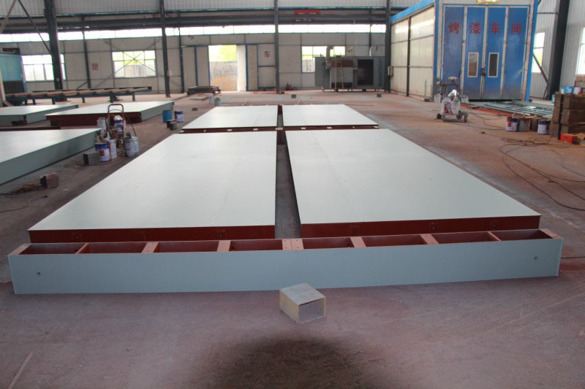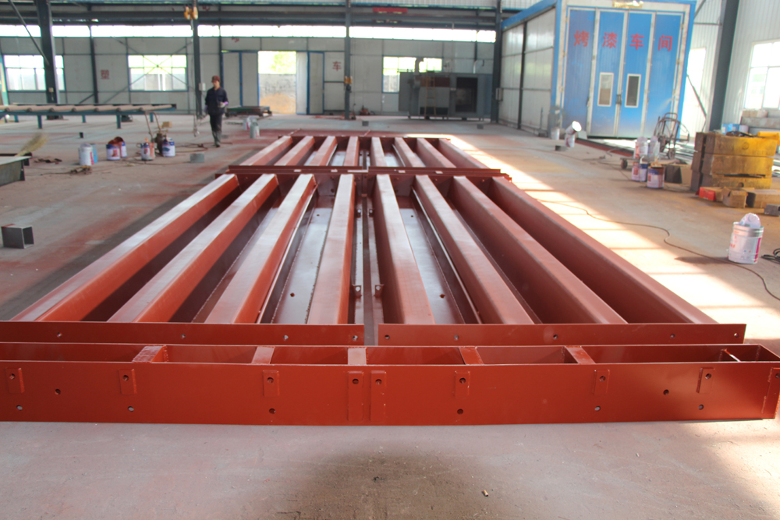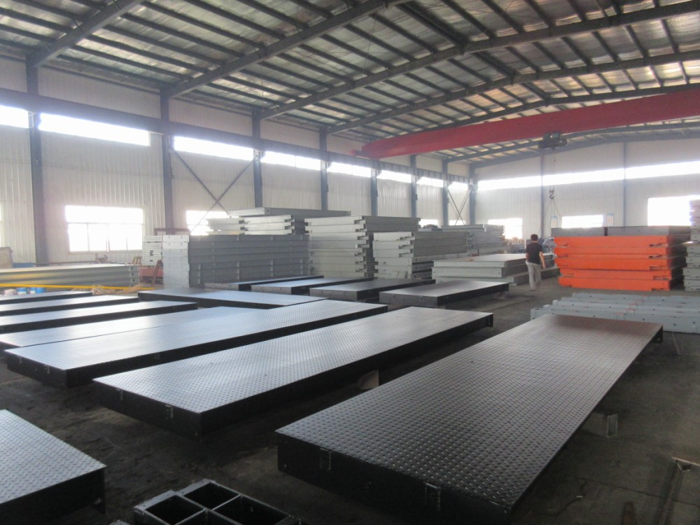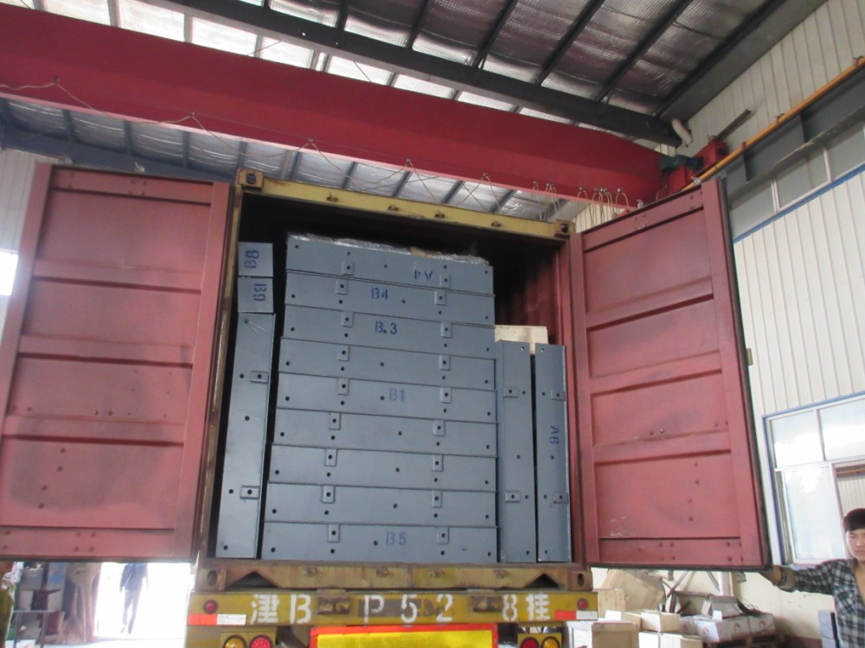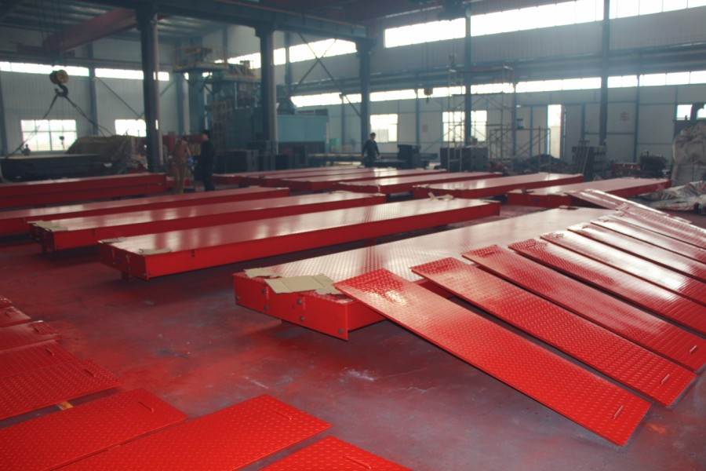

**CUSTOMER VISIT OUR PLANT:**

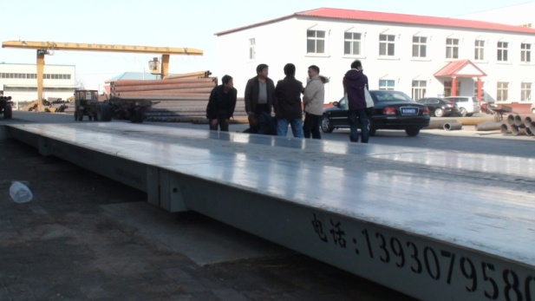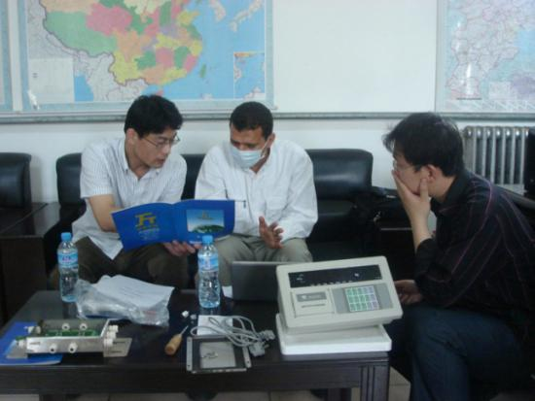

**(Australia) (Saudi Arabia)**

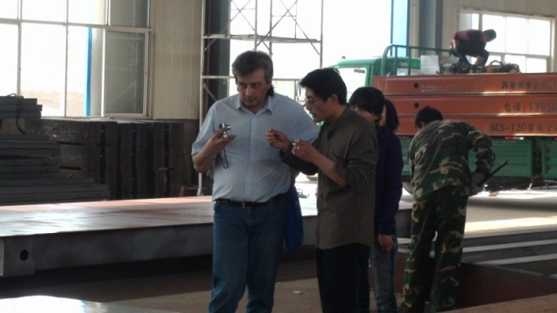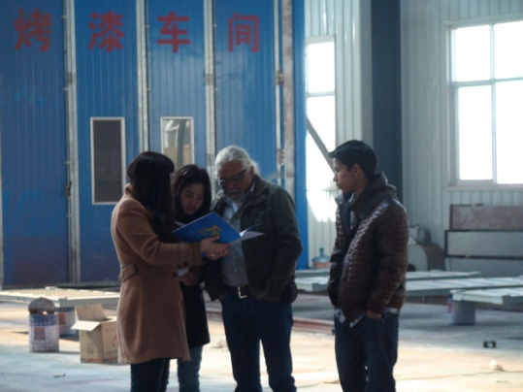

**(Russia) (Peru)**

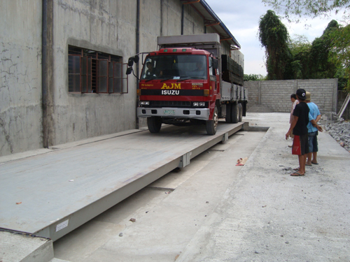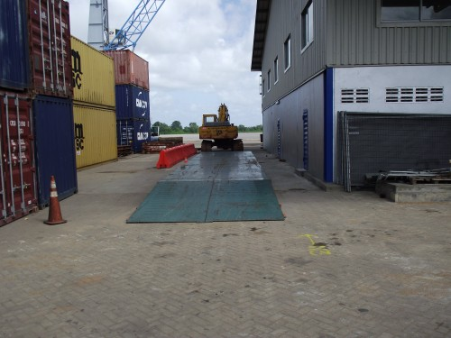

**( Philippines) (Surinam)**

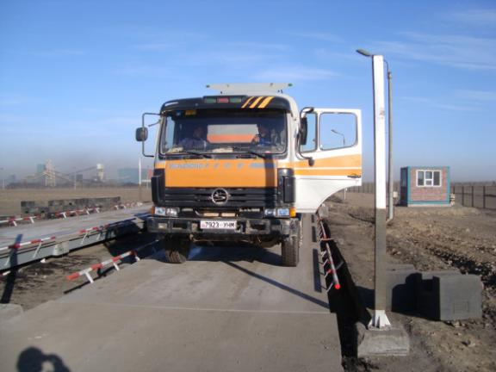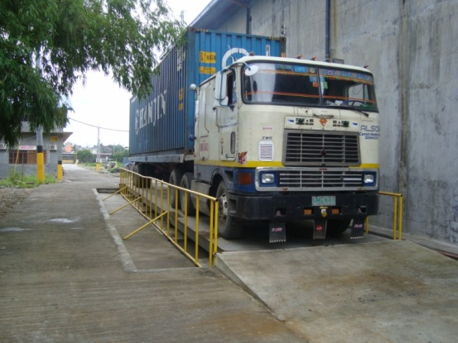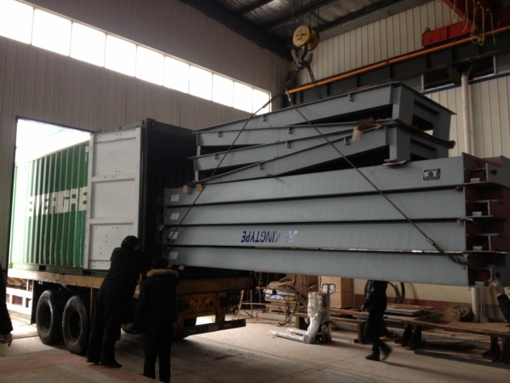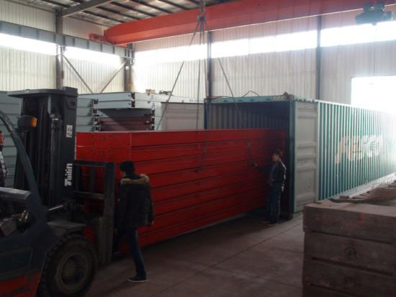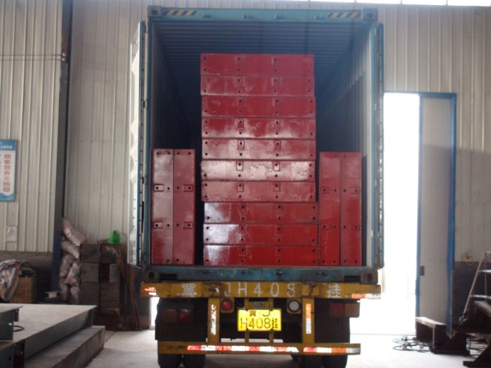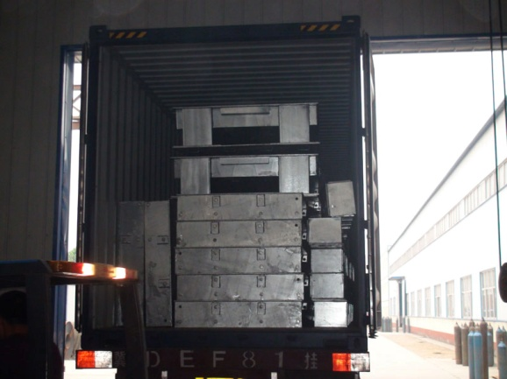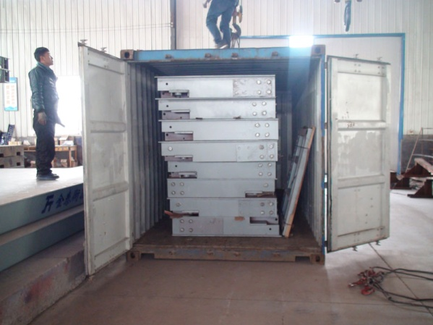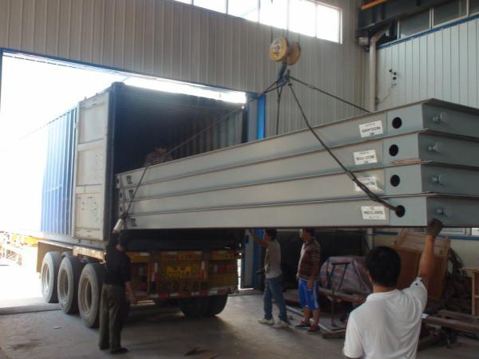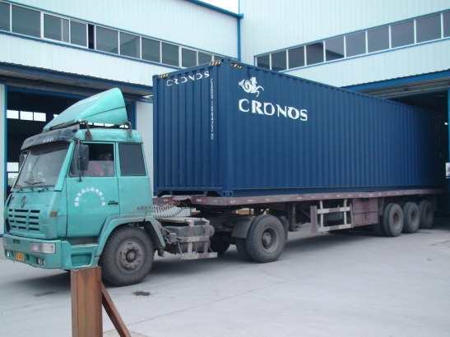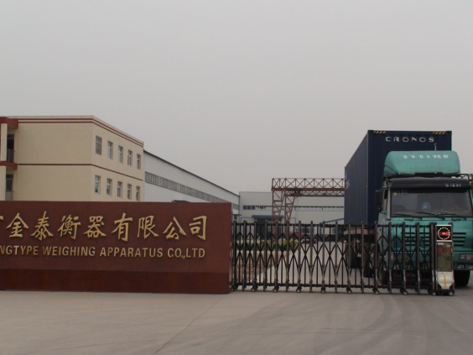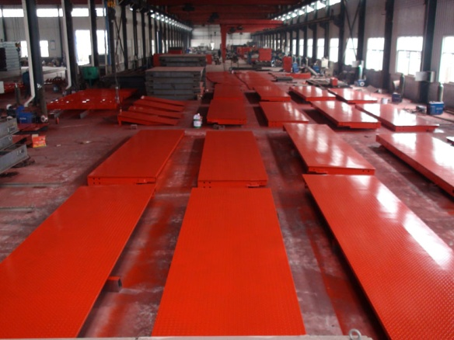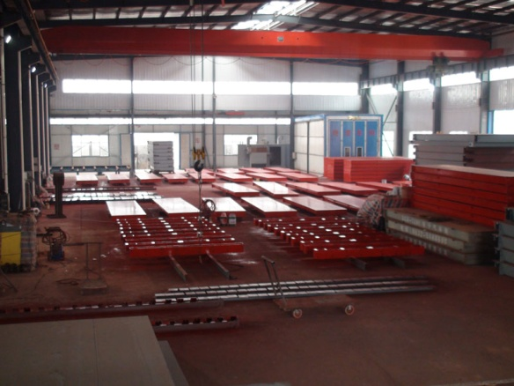

**Welcome to visit our plant and our weighbridge!!!**

**Contact detail:**

**NAME : Miss. Sally (Sales manager)**

**Direct: 86+0317-3158577 | Mobile: +86 15031787104**

**Fax: 86+0317-2121857 Email: mandy.0830@hotmail.com**

**Skype: pretty..mandy**

**QQ: 393746026**

**Alibaba ID: cn220064952**

**Wechat ID: Miss_Pretty-Mandy**

**Website: [www.scales-world.com](http://www.scales-world.com/)**