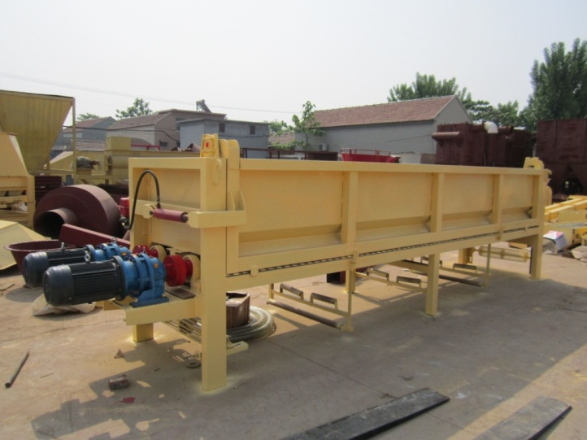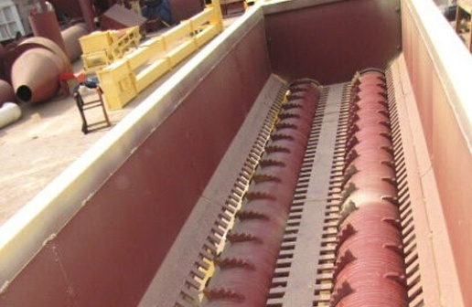
Log debarker machine
Model | YPM60
Motor (KW) | 7.5*2
Debarking diameter (cm) | 5-60
Capacity(ton/h ) | 2-3T bark/hour
Peeling rate | >95%
Timber lose rate | <2%

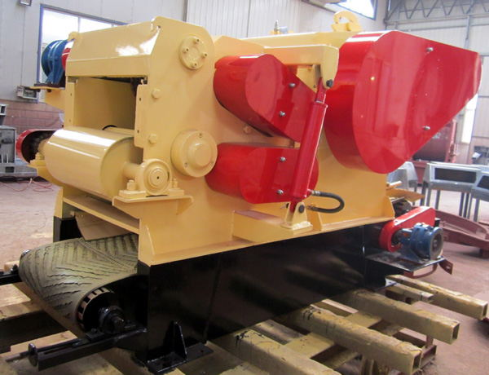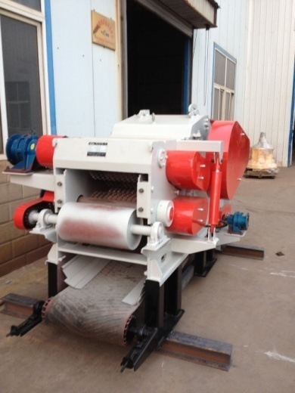
Wood chip machine
Quantity: 8-15Tons/hour
Max log diameter: no less than 300mm
Chip size: 2-5cm

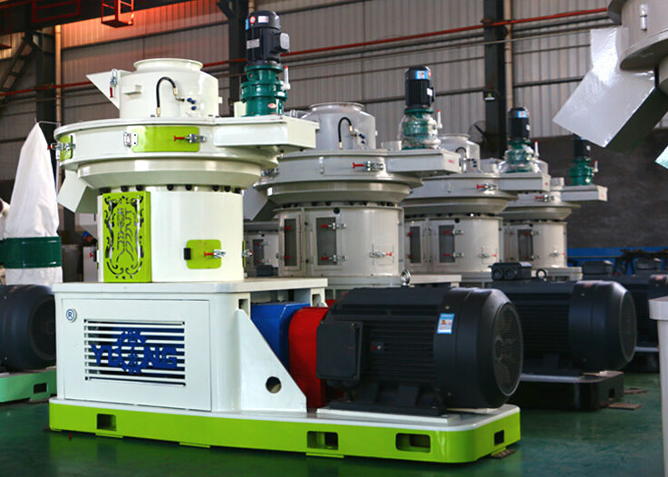
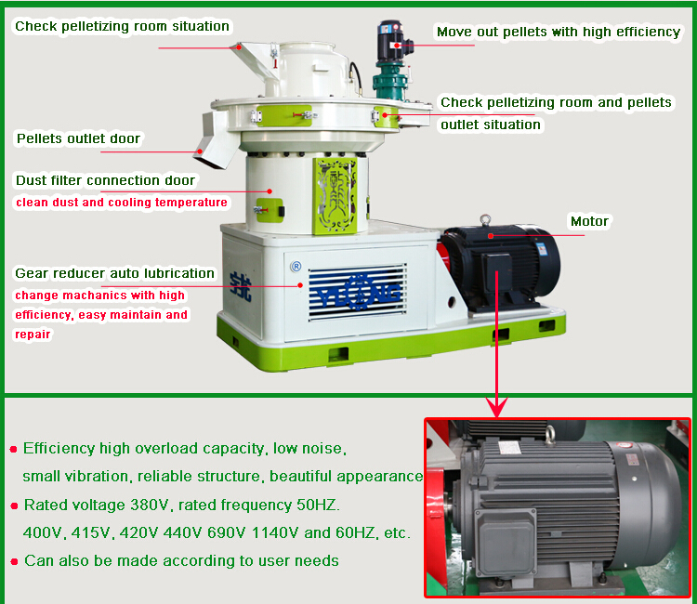
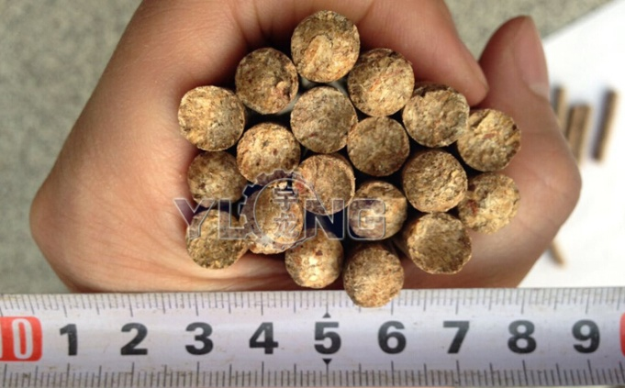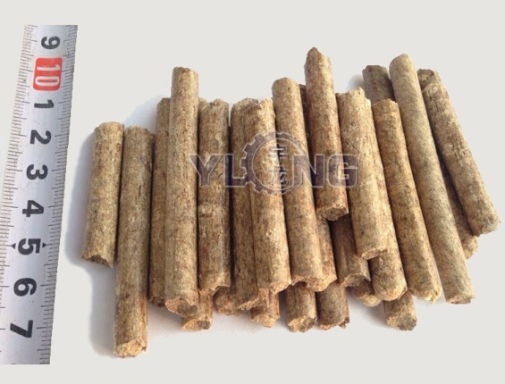
Model | Power (kw) | Capacity (t/h) | Product spec (mm) | Weight (t) | Dimension (mm)
XGJ560 | 90+3+0.25+1.5 | 1-1.5 | Φ4-12 | 5.3 | 2600x1300x2300
XGJ720 | 160+3+0.25+2.2 | 1.5-2 | Φ4-12 | 9.5 | 2900x1300x2400
XGJ850 | 220+4+0.55+3 | 2-3 | Φ4-12 | 14. 2 | 3300x1400x3100
XGJ920 | 315+5.5+3+0.55+3 | 3-4 | Φ4-12 | 18 | 3800x1680x3400
XGJ1050 | 360 | 5-6 | Φ4-12 | 2 4.5 | 3800x1880x3500
Wood Pellet Machine has filled the country blank in vertical feeding for ring die pellet mill and reached the international advanced level.
Wood Pellet Machine is mainly applicable for difficult molding materials with low adhesion rate, for example rice husk, sunflower husk, peanut shell and fruit shell; branch, stem, bark and other wood waste; a variety of crop stalks; rubber, cement, ash and other chemical materials.
Wood Pellet making Machinery can be used in feed mill, wood processing plants, fuel plants, fertilizer plants, chemical plants etc. Since it requires less investment and yield quicker result and that no risk. Vertical Ring-die Wood Pellet Machine for sale is an ideal dense compression molding equipment.

