QX-RC COTTON PAD MACHINE
- Main equipment configuration
1.1.Production process: raw material feeding, conveying, embossing, cutting, counting, output. The effective width of feeding part is 1 meter.。
1.2. The rack of the machine is wall-plate and the width of the steel is 30mm.The machine can produce both with and without embossing product. The embossing pattern can be customized according to client’s requirement. Horizontal and longitudinal cutting knives are made of imported good steel. The brand of bearing is NSK from Japan. It’s durable. It equips five high-precision oxidation aluminum roll for spread material. The machine equips 5 high-precision oxidation aluminum rollers for spread the material.
1.3. The machine equips one set of steel to steel heat embossing rollers. The rollers are solid. It can produce edge open or not open cotton pad.
1.4. The machine adopts pneumatic left and right dislocation counting. The size of product can be adjusted.（depending on the pattern）
1.5. The machine has 3 feeding rollers and you can feed one roll of cotton or two rolls of spun-lace nonwoven and one roll of cotton for recombination. When you just use one roll of cotton, the other two feeding rolls can be used for prepare material. It suitable for different kinds of material. The machine will automatic stop without raw material and it has emergency stop device. It equips three stop sensors. It equips waste output device.
1.6. The working table is made of #304 stainless steel. Long time serves.
1.7. The machine adopts high precision Siemens frequency converter, Siemens motor and authority imported electrical equipments. The machine operation sound is light, electric parts wiring specification is reasonable, safe, easy operation. Mechanical design is better than Japan discharge makeup cotton machine. The domestic initiative.
- Main parameter:
Type | QX-Rc
Producing speed | About 1000-2000 pcs/min, normal speed is about 1800 pcs/min
Product Dimension | W:5cm,L: Adjusted within 10cm
Raw material width | 100cm,diameter 70cm
Nominal voltage | 380V
Rater frequency | 50Hz
Total power | 4.5kw
Dimension | L:2700mm*W:1500mm*H:1900mm
Weight | 2600kg
3. The price of QX-Rc cotton pad machine: CNY141750. （plywood case, transportation to Shanghai port）
If the machine use Taiwan brand electric equipments, the price will be USD19650.
4. Main parts: Siemens frequency converter, Siemens motor, other electric equipments and switches are imported form Japan Mitsubishi.
5. The picture of similar machine:
Main machine: The rack of the machine is made of 30mm steel plate so that the machine will not rock. (If the machine rocks a little, it will have problem with counting and the products can no t output well) The machine size is small but the effective area is large. The machine has 3 feeding rollers and you can feed one roll of cotton or two rolls of spun-lace nonwoven and one roll of cotton for recombination. When you just use one roll of cotton, the other two feeding rolls can be used for prepare material.

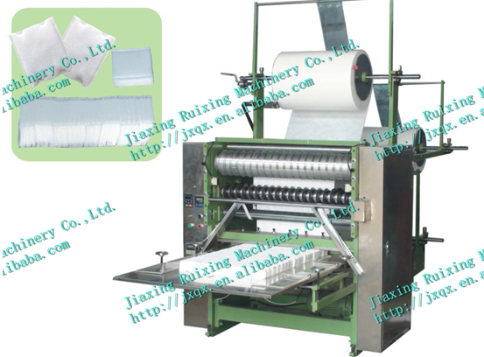
It adopts pneumatic left and right dislocation counting. It’s better for your workers counting and packing. The working table is made of stainless steel to ensure the cotton pads cleanly and health.

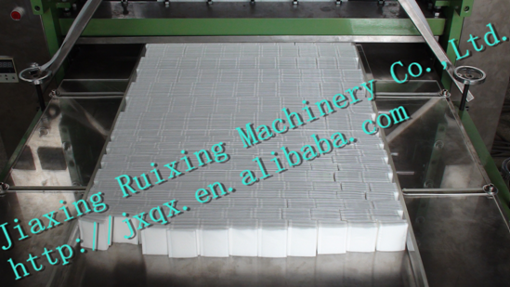

Embossing roller: The pattern can be customized according to clients’ requirements. The rollers are solid that it can press out of uniform pattern. If the rollers are hollow or the material is not well, the embossing rollers will be out of shape.

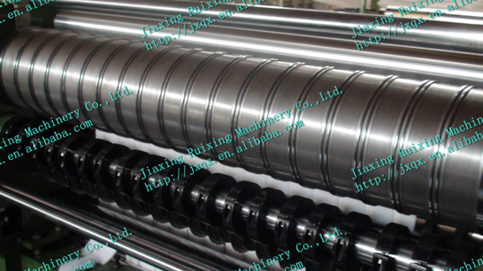

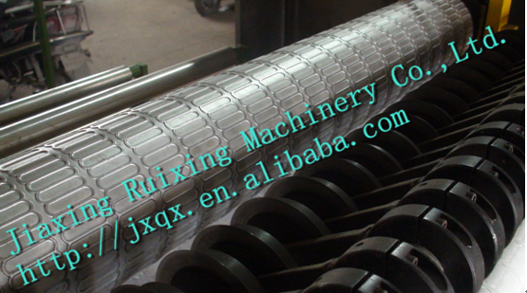

The longitudinal cutting knives are round type that they can cut the cotton roll as a scissors. So the cutting knives can use for a long time and cutting tidy. Each round longitudinal cutting knife can be changed independently and it’s very easy to change.

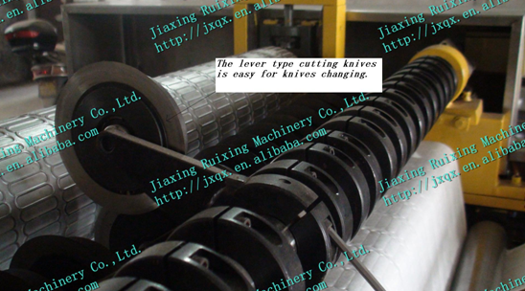

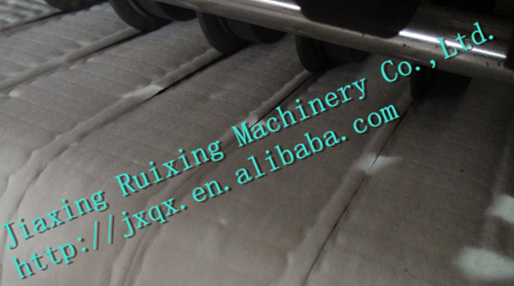

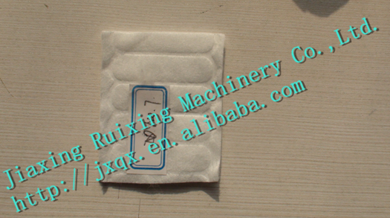

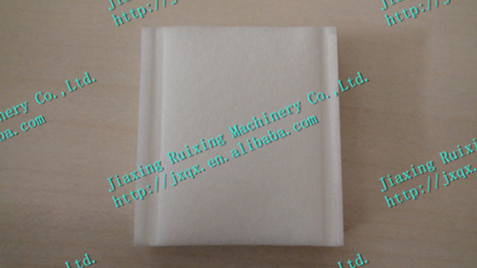

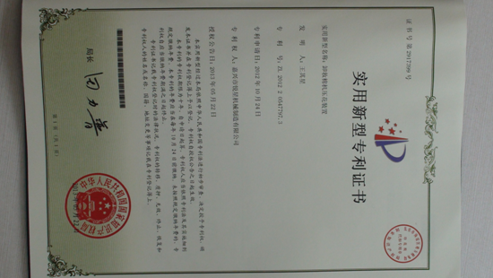
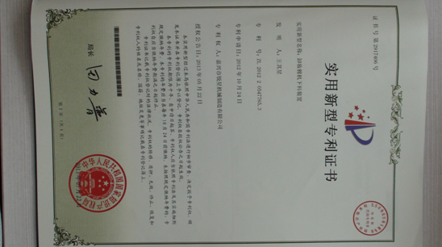
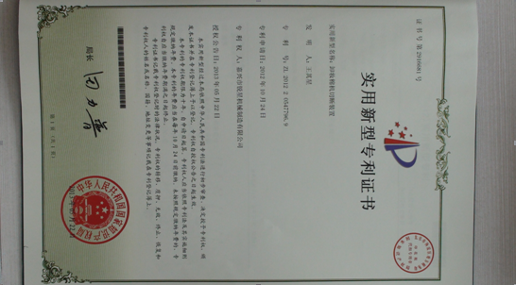

Jiaxing Ruixing Machinery Co., Ltd.
Tel: 008618257317361
Add: No.120 Fengyuan Road, Nanhu Industrial Garden, Jiaxing City, Zhejiang Province, China
2015-4-23

