Hi Mr.Juan Abad

How are you!

This is Jamko writing from Koller refrigeration equipment company. Thanks for your inquiry about our block ice machine.

1.Specification and quotation
The daily output of our salt water block ice machine with 5 kg block ice ranges from 1 ~ 5 tons. The block ice size (L*W*H) and weigh (kg) are customizable to our customers.
In following, we introduce three of our standard 3 tons, 2 tons & 1 ton block ice machine with 5 kg block ice for your preliminary reference first:

Model | Ice weight & ice dimension | Ice making period | Ice mould & water tank | Capacity / batch | Capacity / 24hrs | Germany Bitzer compressor | Cooling system | FOB price
MB30 | 5 kg / 80*165*500 mm | 4.8 hours | Stainless steel 304 | 120 pcs block ice | 600 pcs = 3 tons | 12 HP | Water cooling system | 14,700 USD
MB20 |  |  |  | 80 pcs block ice | 400 pcs = 2 tons | 9 HP |  | 11,100 USD
MB10 |  |  |  | 40 pcs block ice | 200 pcs = 1 tons | 4 HP | Air cooling system | 6,600 USD
*These prices are based on 220V, 60Hz, 3 P supply power in Peru and brand new compressor with R404a refrigerant (environmental and approved).

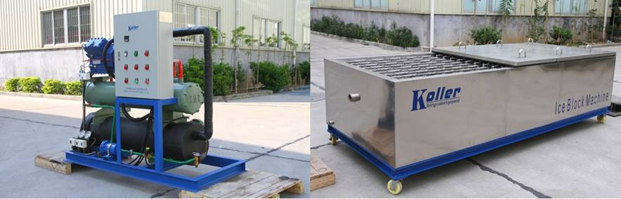
compressor unit salt water tank & ice moulds
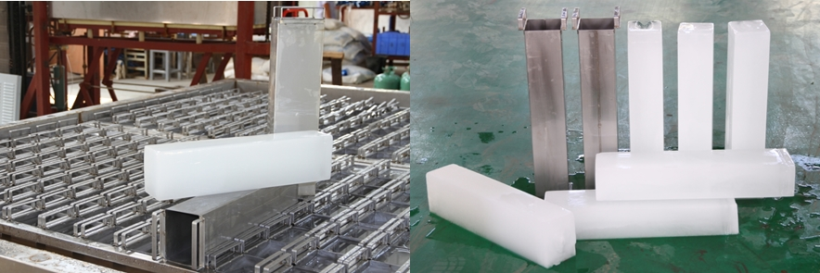
5 kg block ice

2. Cold room specification and quotation
To match up with 1~ 3 tons daily output lock ice machine for ice storage, our standard 10 m³ and 20 m³ cold room are most suitable.

Model | VCR20 | VCR10
Dimension (L*W*H) | 3.0 x 3.0 x 2.3 m (20 m³) | 2.5*2.0*2.2 (10 m³)
Storage capacity | Approx 4~6 tons | Approx 2~3 tons
Rated temperature | -10 ~ -15 ℃ for vegetable storage
Supply power | 220V, 60 Hz, 3 phase (industrial power)
Compressor | 2*1.5 HP Italy Aspera compressor
Refrigeration system (compressor + air cooler) | separated design
Cooling way | Air cooling system
Insulated room panel thickness | 100 mm
Entry | Swing door (0.8 x 1.8 m)
Refrigerant | R404a
FOB price | 5,256 USD | 4,526 USD
*This price is base on 220, 60 Hz, 3 P supply power and doubleside colorbond steel insulated panel.

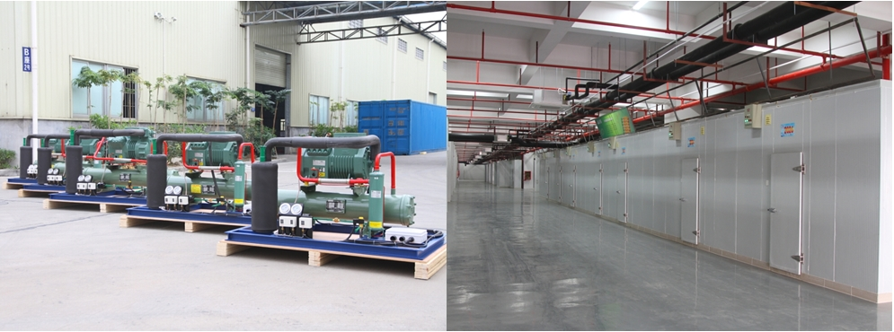
separated refrigeration system using industrial supply power

3.Payment term and delivery time
We would delivery the machine in 25 working days after getting 50 % of total value as advanced payment by T/T.
The 50 % balance should be pay off before shipping. If you are in urgent need, we could clear our production capacity to have priority for you.

We could be responsible to ship the machine to your destination port but we would charnge for shipping cost. After you decide the model, we would quote you the shipping cost together.

So Juan, could you tell us which of the three model of block ice machine you prefer?
If you need larger capacity of block ice machine, please tell us so that we could quote our 4 tons and 5 tons with 5 kg block ice!

Looking forward to your reply
Thanks

Best Regards,
Mr Jam ko (Sales Manager)
Mobile:0086-159 2053 7377 Facebook:Jamko Ye Whatsapp:0086-159 2053 7377
Skype:jamko_ye Viber: 0086-159 2053 7377 Wechat:422105828

