Dear Mr Francis Díaz

Good morning!

1.Ice size
We doesn't call 40 * 14 * 20.5 mm for a block ice any more because it is a very very small size.
In fact we could call it cube ice as the picture shows:
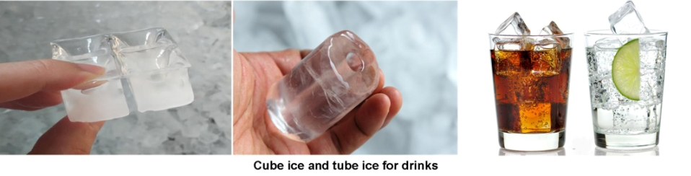

Here we share some of our standard ice size which could mostly meet your demand.
As you could see in the table, our smallest weight for MB10 block ice machine is 2 kg.
The more thickness of the block ice, the longer ice making period.

Ice weight | Ice dimension | Approx ice making period | Batch / 24 hours
2 kg | 50*150*330 mm | 4 hours | 6 batchs
2.5 kg | 75*110*406 mm | 4 hours | 6 batchs
5 kg | 80*165*500 mm | 4.8 hours | 5 batchs
10 kg | 100*205*610 mm | 6 hours | 4 batch

Of the above size, could you please tell us which one could meet your demand?
If you want to customize the ice, please provide reasonable ice dimension or ice weight.

2.Freight charge and CNF price
The price we used to quote you is for FOB Guanzhou Port price.(not including freight)

The total package volume of MB10 is 7 CBM, which can be delivered by less than container load.
The latest LCL shipping cost from Guangzhou Port to Callao Port is 70 USD / CBM, which is total 490 USD for MB10.
It takes around 41 days to arrive your port.( only valid before June 6 th, 2015)

Our CNF Callao Port price for 1 ton block ice machine MB10 with 5 kg block ice is 7,090 USD for a complete set including spare parts.

If you purchase the cold room with ice machine together, they could be shipped in a 20 feet container.
The latest 20 feet container shipping cost from Guangzhou Port to Callao Port is 2200 USD, which takes 31 days to arrive port.

Francis, do you need insurance for this order? If you do, please tell us so that we quote you CIF price (cost, insurance & freight).
The insurance charge is 3% of total value of the goods.

3.Cold room
We sell ice machines separately without cold room. The cold room price is base on the volume (m³) and temperature (℃) you require.
In my last email, I quoted you 10 & 20 m³ cold room with -10 ~ -15(minimum) storage temperature for you, also including the compressor brand and horsepower, please recheck it carefully.

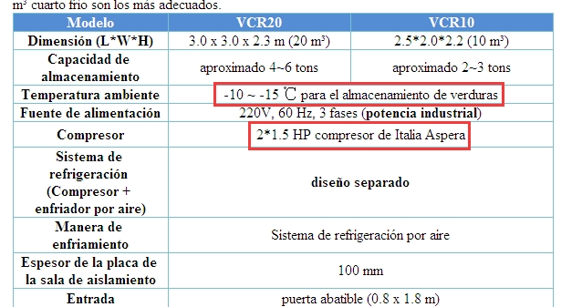
*Modification: -10~ -15 ℃ is suitable for ice storage, -5 ~ +5 is for fruit and vegetable storage

If you plan to storage meat in the cold room as well, then we would suggest -18 ~ -20 ℃ storage temperature for this room.

Could you please kindly tell us how many tons of meat you want to storage in the room so that we could quote our best for you?

Looking forward to your reply
Thanks

Best Regards,
Mr Jam ko (Sales Manager)

