Hi Mr Rossard

I am felling deeply sorry for missing your mail on April 28th.
I review your my mailbox and answer your question as following:

1.Container flake ice machine
We have two solution for the container flake ice machine:
(1)container flake ice machine work outdoor
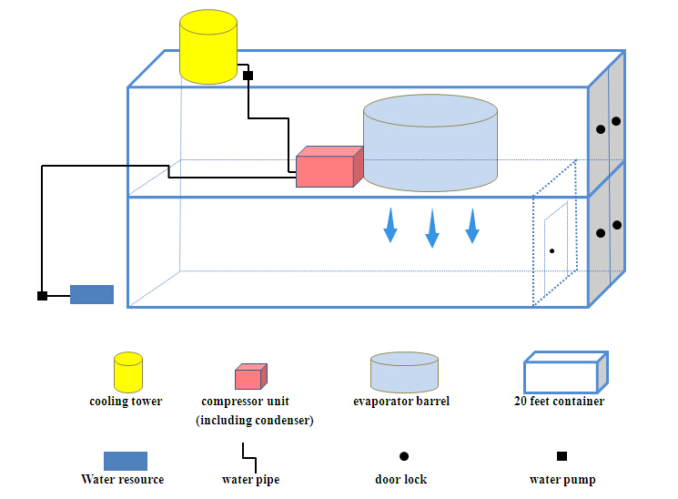

*From above picture, we can see the 10 ton flake ice machine is installed inside the upper container to prevent from sunshine and rain.
The flake ice drops through container floor and roof directly into the below container where is covered with insulated panel. The insulated room is without refrigeration system.Therefore, the insulated room is only for temporary storage of ice.

*There is a swing door of insulated room installed near container door side. If you need two door for convenient entrance, there could be another door on the length side of the lower container.

*The cooling tower is installed on the top of upper container, exposuring in outdoor to release heat.

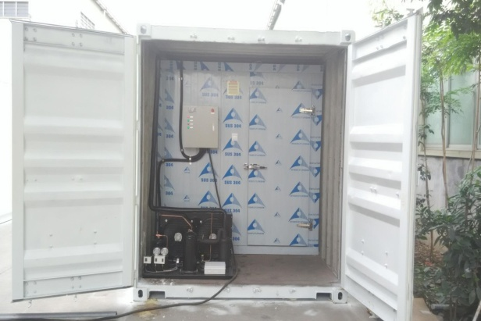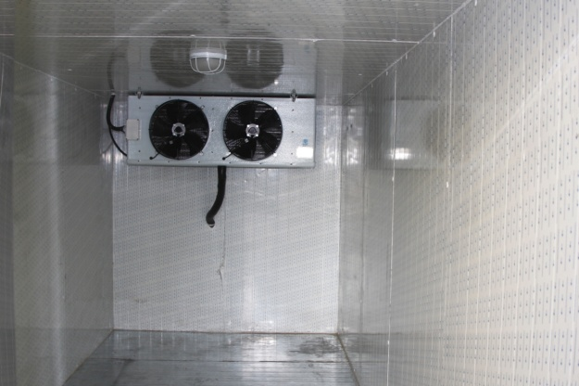
container cold room = container insulated room + refrigeration system

(2)container flake ice machine work indoor
We also have another similar container flake ice machine design. But it require a shelter to cover the flake ice machine, preventing from direct sunshine and rainy damage.
Even though it has location requirement, but the price is more economical!
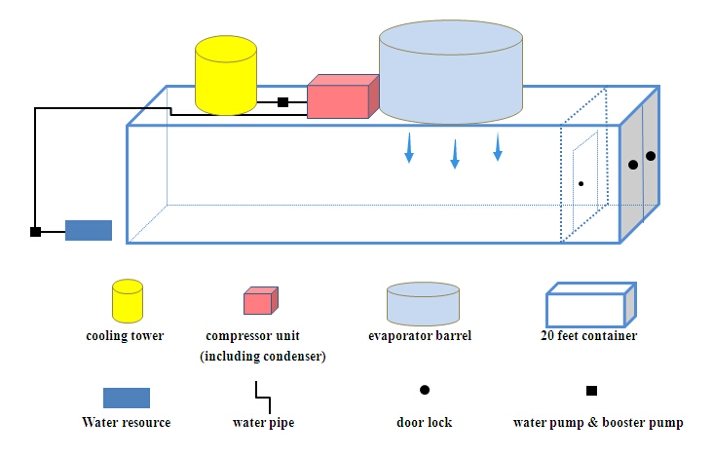

So Rossard, could you tell us you would prefer which design?

2.Marine engine
I contacted the supplier today and did some comparison. They said they could offer 2,233 USD for 44 HP engine as well.
It is said that the engine price is not only depend on its power but also its volume, weight, gearbox accessories origin and consumption.

They told us we can't simply draw a conclusion by comparing with different horsepower engine. That is totally different.
In addition, 2,100 USD is only for engine but 4,201 USD is for engine, hydraulic gearbox and all the other accessories.

But above all, you have to confirm what exactly horsepower engine you require, not just a vague range.
The warranty for engine is 6 months, and they can be responsible for supplying accessories in future maintenance.

Hope these information would be helpful to you, anyway, I am not professional in this area. It could be better for you to contact with the supplier directly.

Looking forward to your reply
Thanks

Best Regards,
Mr Jam ko (Sales Manager)

