温州市益彰贸易有限公司

WENZHOU CHANGS INTERNATIONAL
ADD:#1105,Guoguang Mansion 发 票
(Opposite railway station), PROFORMA INVOICE No 0508CHS15

WENZHOU,P.R. CHINA

Tel:+86-577-86051838 DATE: 08th May, 2015

TO: Plusbol S.R.L.
ADD: leonasociados@yahoo.es
Attn: Richard Castell
Tel. 344 5134 - 343 6285 - 345 1809
Santa Cruz - Bolivia

Mark&Number | Description &Specification | Quantity | Unit Price | Amount
 | DXDK-500 Automatic Granule Packing Machine  PLC,PLC touch screen,  Code printing  Stainless Steel Housing  sea freight charge from China to  LAGOS Port Nigeria  TOTAL  - Delivery time: 15workdays after  Receiving the payment.  2, 30% TT in advance,70% balance  before shippment  BENEFICIARY：WENZHOU CHANGS INTERNATIONAL  ADD:#1105,GUOGUANG MANSION,(OPPOSITE THE RAILWAY STATION),WENZHOU CHINA  BANK :BANK OF CHINA WENZHOU BRANCH  MAIN BUILDING OF XIHU JIN YUAN WENZHOU CHINA  SWIFT:BKCHCNBJ92B  A/C NO.:3506 5834 2969 | 1Set   | CNF  USD5670.00 | LA PAZ Port  USD5670.00  USD850.00  USD6520.00

DXDK-500 Automatic Granule Packing Machine

Quotation: 4500USD(EXWORK)
PLC：add210 USD
PLC touch screen: add 240USD
Code printing: add 300USD
Stainless Steel Housing: add 420USD
Delivery time:35 workdays

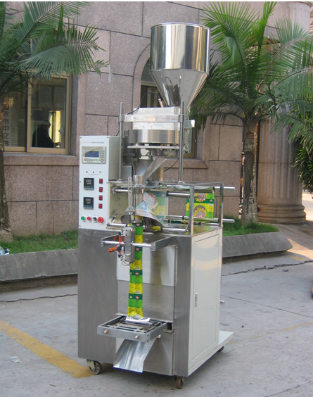
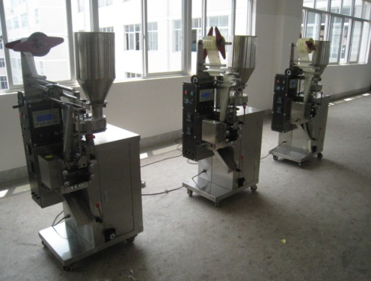

Description:
Grain packing machine suitable for automatically packaging of loose nonsticky, granular and powdered products such as foodstuffs, snack, grainy beverage, medicines tea, seeds, and chemicals etc. It is suitable for 30-150ml products automatic packaging.
All the work of bag making, measuring, filling, sealing, cutting, counting, heat-printing codes can be done automatically.
Packing Materials:
Paper/PE, PT/PE, PET/plated AL/PE, PET/PE, BOPP film, tea-leaf filtering paper and other heat able sealed laminates film, etc.

Sealing Type:
Three sides, four sides, pillow
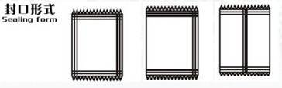

model | DXDK40 | DXDK150 | DXDK500 | DXDK1000
Speed (bag/min) | 50-90 | 35-75 | 35-70 | 25-50
Packing Volumn (ml) | 5-40 | 5-150 | 20-500 | 50-1000
Power(kw/V) | 1.3/220 | 1.7/220 | 1.5/220 | 1.7/220
Length of bag (mm) | 50-110 | 80-150 | 50-220 | 50-250
Width of bag(mm) | 30-80 | 30-110 | 30-150 | 50-200
Dimension (cm) | 790*600*1780 | 800*700*1900 | 1002*860*1900 | 1002*860*1900
Weight (kg) | 350 | 400 | 400 | 500
Parameters:





