Hi Mr Rossard

We thank you for your support and praise all this time along. Sorry to keep you waiting, the northern hemisphere is entering into summer and the peak season of ice machine is coming!
We have to handle a large number of email round the world every day, hope you understand!

1.Quotation
The following is the quotation of indoor & outdoor container flake ice machine design :

Material requirement | Unit price | Outdoor container flake ice machine design | Indoor container flake ice machine design
 |  | Quantity | Quantity
10 tons flake ice machine KP100 | 33,220 USD | 1 set | 1 set
20 feet container | 3,500 USD | 1 set | 2 set
20 m³insulated room | 2,098 USD | 1 set | 1 set
Installation and handling charge | 350 USD | 1 set | 2 set
Total FOB price |  | 39,168 USD | 4,3018 USD

*Components: The container flake ice machine mainly consist of 3 components: flake ice machine + insulated room + 20 feet container
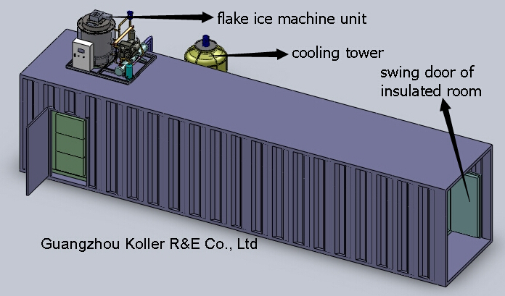

*Installation:
(1)Both for indoor & outdoor design, the insulated room will be installed well in the container before delivery.
(2)We would fix the machine inside the upper container for outdoor design before delivery.
(3)We would incise accessible entry on container for water pipe and other pipeline in advance. But before delivery, we will recover it temporarily to meet the shipping delivery standard.

(4)For indoor design, you have to lift up only the flake ice machine to the top of container insulated room and connect the cooling tower.
(5)For outdoor design, you have to lift up the whole container to the top of the other container.
(6)After that, you only have to uncover the incision hole, and assemble cooling tower, connect the water and power supply to the machine.

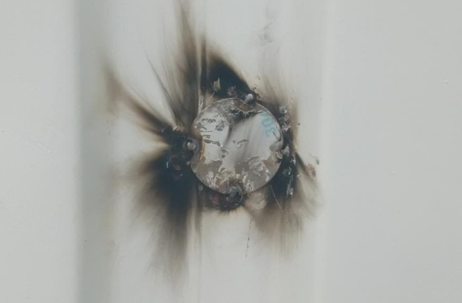
recover the hole before delivery

*Delivery:
(1)Outdoor design: There would be two container belong to your own at that time. One is container with flake ice machine fixed inside, the other is container with insulated room fixed well inside.
(2)Inoor design: The flake ice machine should be shipped by another 20 feet container, which is delivered separately from the 20 feet containerized insulated room.

Rossard, are you clear about that?

Looking forward to your reply
Thanks

Best Regards,
Mr Jam ko (Sales Manager)

