Hi Mr Christian

Good morning!

After viewing your drawing, here we have some question to confirm with you before quotation:

(1) Are all the sizes measured in meter or feet unit?

(2) What is the width of tunnel 4, 5 , 9 & 10 that marked by the question mark? Base on our calculating, we have no idea whether it is consistent with your requirement.

Size of tunnel 4 & 5: 8.10*5.55 m / Size of tunnel 9 & 10: 8.0*5.15 m, correct?

(3)What is the required temperature for the complete tunnel? Is every small tunnel has same storage temperature?

(4)Each small tunnel is connected by swing door, do you think it is good for you?

(5)Do you think it is necessary to equip with compressor unit (refrigeration system) for each small tunnel?

(6)What about the height (meter) of the tunnel?

(7)Do you need the cold room freezer (camara 1,2,3) in the middle of drawing? What about their height?

refer to following drawing:
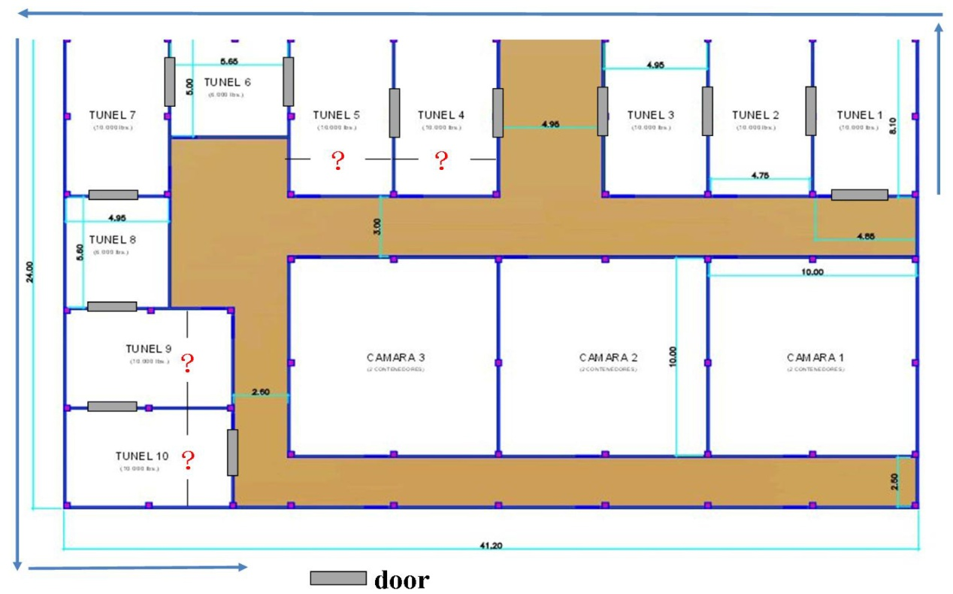

Looking forward to your reply
Thanks

Best Regards,
Mr Jam ko (Sales Manager)

