Hi Mr. Rossard

Good day!

We really appreciate for the effort you make in these day. From your words, it seems Morocco has very troublesome procedure no matter for land or payment application.
Get back to the point, we wonder if you have take a cold room into consideration for ice long term storage (make it in stock).

According to the feedback from our customer, they bag the ice and then storage them in the cold room in case whenever they need ice immediately.
The most important is, after a period storage in cold room, the ice will become lower temperature and more unlikely to melt during the long distance transportation.

Since the below container insulated room is only regarded as an ice collecting bin, without any refrigeration system.
If you were not going to build a shelter or plant of factory, then we would recommend the container cold room for you.

What do you think of it, Rossard?
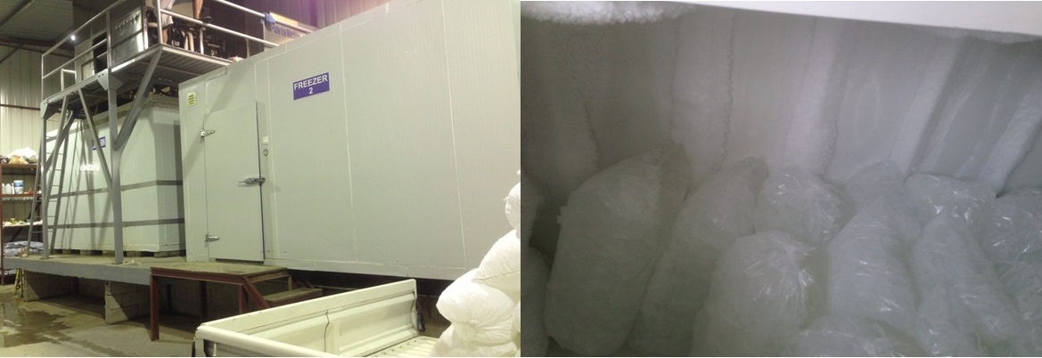
cold room for ice storage bags of ice in cold room
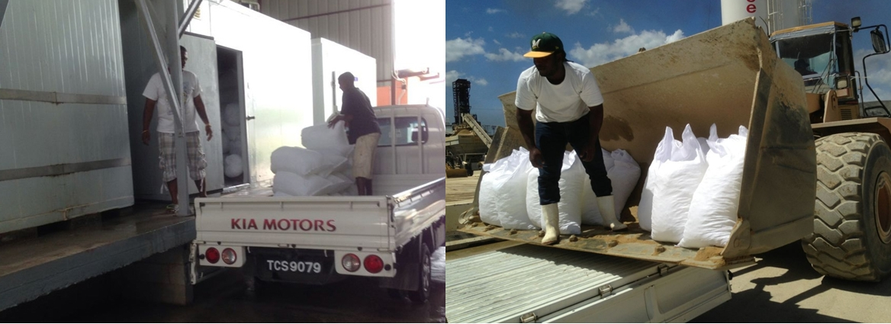distribution

Looking forward to your reply
Thanks

Best Regards,
Mr Jam ko (Sales Manager)

