Dear Mr.Maria Villanueva

We introduce ourselves a 10 years experience cold room (walk in freezer) manufacturer and exporter, located in China free trade zone area of Guangzhou, China.
We learn from Alibaba that you are in need of a cold storage room and want to see if we could offer help.

According to your requirement, we provide the cold room specification and quotation as follow:

Model | VCR24 | VCR07
Dimension (L*W*H) | 3.5 x 3.0 x 2.3m (24 m³) | 2.0 x 1.5 x 2.3 m (7 m³)
Storage capacity | Approx 4 ~ 6 tons | Approx 1 ~ 2 tons
Rated temperature | 5 ~ -5 ℃
Supply power | 220V, 60 Hz, 3 phases | 220V,60 Hz, single phase
Compressor | 2 HP Germany Bitzer compressor | 1 HP Monoblock refrigeration system
Air cooler | DL-3/15 | /
Cooling way | Air cooling system
Panel material | Double-sides colorbond painted steel sandwiched with polyurethane
Insulated room panel thickness | 100 mm
Panel density | 42 kg / m³
Entry | 1 pcs Swing door (0.8 x 1.8 m)
Refrigerant | R404a (approved & environmental)
FOB price | 5,526 USD | 4,216 USD
* These price are based on supply power in Mexico and a complete set of cold room.

*The monoblock refrigeration system for VCR07 is already with refrigerant before delivery. You only have to connect the power before operation without any flexible installation.

*The Bitzer refrigeration system for VCR24 is without the refrigerant before delivery, which requires welding, vacuum, refrigerant adding and testing process during the installation.
That works could be done by an ordinary air conditioner installer within 2~3 hours. We would provide the refrigerant and all the necessary part for you with machine delivery.

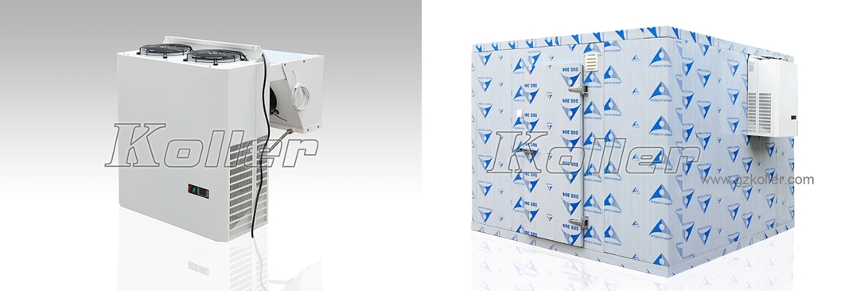
VCR07 with Monoblock refrigeration system
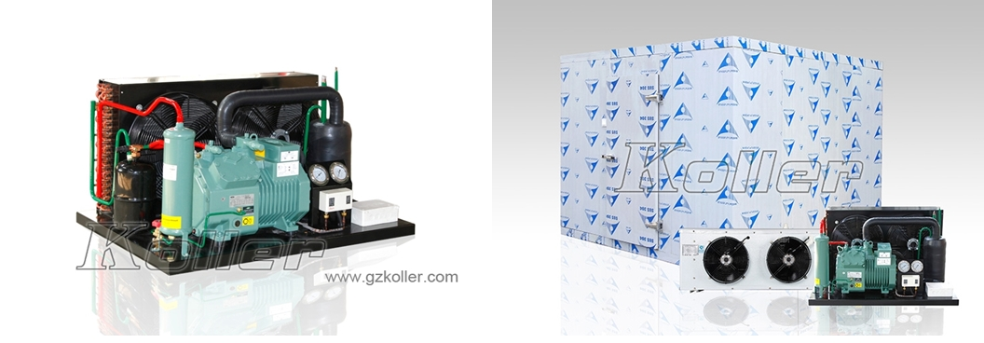
VCR24 cold room with Bitzer compressor unit

*Maria, could you please let us know your idea of the cold room?
*Considering of your local regulation, do you think it is necessary to improve the room panel with flame retardant?

Looking forward to your reply
Thanks

Best Regards,
Mr Jam ko (Sales Manager)

