Hi Rossard

Good day

1.Specification and quotation
Model | 40 feet container cold room | 20 feet container cold room
Insulated dimension (L*W*H) | 10.4 x 2.2 x 2.3 m (52.6 m³) | 4.2*2.2*2.3 (21.2 m³)
Storage capacity | Approx 10~15 tons | Approx 4~6 tons
Rated temperature | -5 ~ -12 ℃ for ice storage
Supply power | 380V, 50 Hz, 3 phases
Installed power | 2.55 KW | 1.87
Compressor | 4 HP USA Copeland compressor | 2 HP USA Copeland compressor
Air cooler | DD-4.1/22 | DD-2.2/12
Cooling way | Air cooling system
Insulated room panel thickness | 100 mm
Entry | Swing door (0.8 x 1.8 m)
Refrigerant | R404a
FOB price | 11,466 USD | 8,264 USD

*These prices include cold room, repainted container and installation service.
*The complete set of cold room would be well installed inside a container before delivery.
*The container can be settled in the open air. Besides, it is a completely mobile plant for ice storage.
*The shipping cost from China to Agadir Port is basically same as I used to quote you in my third reply email. But it might have a little change since it's the price in March.

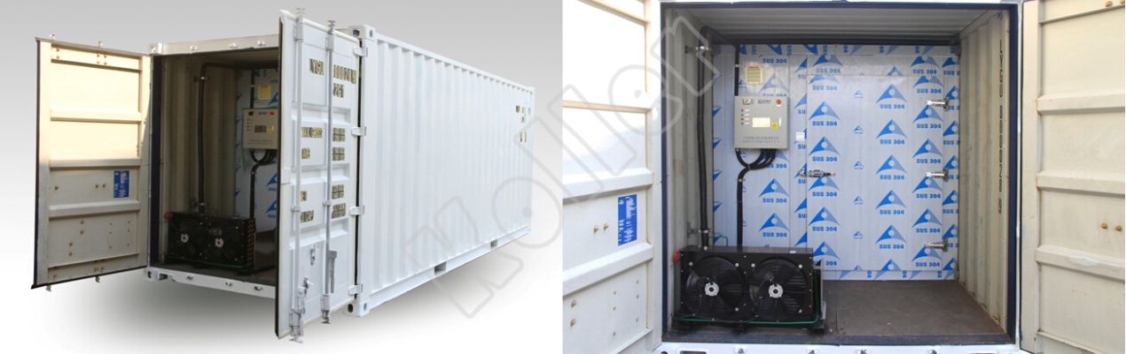
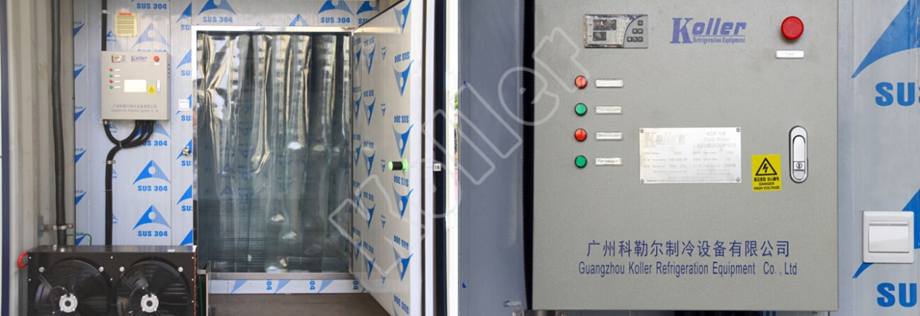
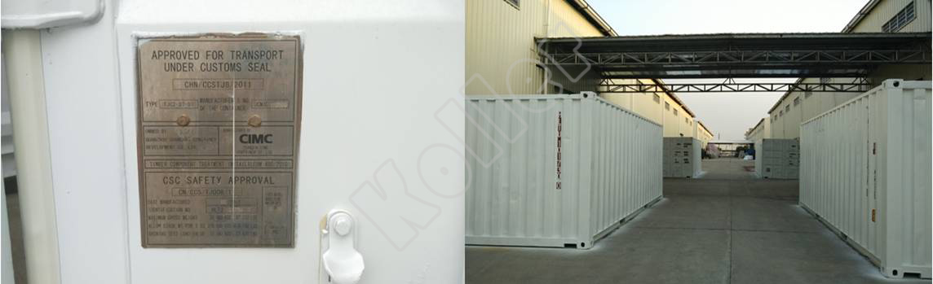

*Rossard, what do you think?

Looking forward to your reply
Thanks

Best Regards,
Mr Jam ko (Sales Manager)

