Hi Mr.Rossard

Good day!

*Actually, I have quoted you all the price in my 23Re and 27 Re email.

*Since the machine would be installed in a 20 feet container, the outer dimension for the 20 feet container is 6.05 * 2.44 *2.60 m, which cover around 15 ㎡ ground space area. Also you should prepare 4 * 1.5 m space for a ladder landing in front of container. If you need 1 container flake ice machine and 1 container cold room, you have to prepare total 52 m³ (8*6.5 m) ground space for this program at least.

*To ensure the machine running is normally, the concrete ground must be horizontal.

*The water & power line would be arranged according to the actual position on your spot.

*The double container flak ice machine, container cold room and all the other necessary parts should be delivery in three 20 feet container.

Please refer to one of our earlier order as follow:
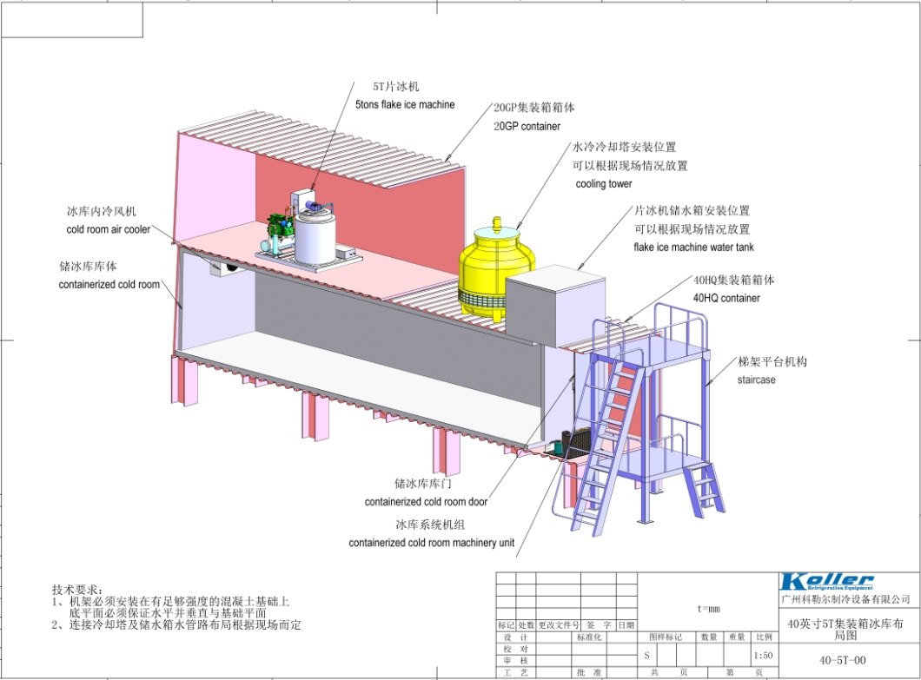

The design is basically as same as yours, but he require a 40 feet container cold room for ice collecting and temporary storage.
Also he used well water to make ice, so he need to prepare a water tank to storage supplying water in advance.

Do you think you prefer the below container to be a container insulated room or container cold room with refrigeration system?

Looking forward to your reply
Thanks

Best Regards,
Mr Jam ko (Sales Manager)

