Shandong Jinlun Machinery Manufacturing Co., Ltd
Tel: +86-15963998020 Fax: +86-6017787
E-mail: jinlun_machine@hotmail.com Skype: jinlun_machine
Add: No58. Volvo Road, Economic Development Zone, Linyi City, Shandong Province, China.

Quotation:
4ft Log Debarker ( HS code : 84659600)
Length of peeler log | 1400mm
Diameter of peeler log | 500mm
Speed | 50 meters/min
Size of the blade | 1500x140x12.7mm
Total Power | Double roller motor 7.5 kw
Total Power | Single roller motor 7.5kw
Total Power | Hydraulic roller motor 4 kw
Overall size | 3560x2150x1100mm
Weight | About 2400KG
FOB Qingdao | USD 7000.00/set

8ft Log Debarker ( HS code : 84659600)
Length of peeler log | 2600mm
Diameter of peeler log | 500mm
Speed | 40meters/min
Size of the blade | 2700x180x16mm
Total Power | Double roller motor 11 kw
Total Power | Single roller motor 11 kw
Total Power | Hydraulic roller motor 4 kw
Overall size | 4900x2200x1450mm
Weight | About 4800KG
FOB Qingdao | USD 12000.00/set

4ft Veneer Peeling Machine ( HS code : 84659600)
(Two-in-one veneer peeling and cutting machine)
Max peeling length of log | 1400mm
Max diameter of log | 450mm
Left log diameter | 28mm
Veneer Cutting thickness | 1.0-3.0mm
Size of peeler blade | 1400x180x16mm
Cutting speed | 48meters/min
Total Power | Single roller motor 5.5 kw
Total Power | Double roller motor 7.5 kw
Total Power | Feeding motor 5.5 kw
Total Power | Slitting motor 1.5 kw
Total Power | Conveyor motor 1.5 kw
Total weight | About 3800KG
Overall size | 2800x2100x1350mm
FOB Qingdao | USD 15000.00/set

8ft Veneer Peeling Machine ( HS code : 84659600)
(Two-in-one veneer peeling and cutting machine)
Max peeling length of log | 2600mm
Max diameter of log | 450mm
Left log diameter | 35mm
Veneer Cutting thickness | 1.0-3.0mm
Size of peeler blade | 2700x180x16mm
Cutting speed | 48meters/min
Total Power | Single roller motor 7.5 kw
Total Power | Double roller motor 5.5 kw*2
Total Power | Feeding motor 5.5 kw
Total Power | Slitting motor 3 kw
Total Power | Conveyor motor 4.5 kw
Total weight | About 7500KG
Overall size | 5000x2450x1450mm
FOB Qingdao | USD 26000.00/set

Log loader ( HS code : 84283910)
Type | 2600MM | 1300MM
Power | 3KW | 1.5KW
FOB Qingdao | USD 2500.00/set | USD 1500.00/set

8ft Spindle Face Veneer Peeling Machine
( HS code : 84659600)
Max peeling length of log | 2600mm
Max diameter of log | 1700mm
Left log diameter | 130mm
Veneer Cutting thickness | 0.1-3.0mm
Size of peeler blade | 2700x160x12.7mm
Cutting speed | 30meters/min
Power | 25.5KW
Total weight | About 6500KG
Overall size | 4500x2200x2000mm
FOB Qingdao Price | USD 19000.00/set

Veneer Rotary Cutter ( HS code : 84659600)
Max working width | 2600 mm
Working length | As your setting
Feed speed | 30 m/min
Total power | 3kw
Weight | 1200 KG
Overall size | 4000x1700x1800mm
FOB Qingdao | USD 3500.00/set

Core Veneer Composer ( HS code : 84793000)
Veneer length | More than 100mm
Veneer width | Lower than 1300mm
Veneer thickness | 1-4mm
Motor power | 13 KW
Heat power | 5.7 KW
Air condition power | 1.5 HP
Dimension | Main(3800x2400x2400mm)  loading(3700x1900x2400)
Total power | 22kw
Overall size | 10000x2400x2400mm
capacity | 3000-4000pics/8hours
FOB Qingdao | USD 50000.00/set

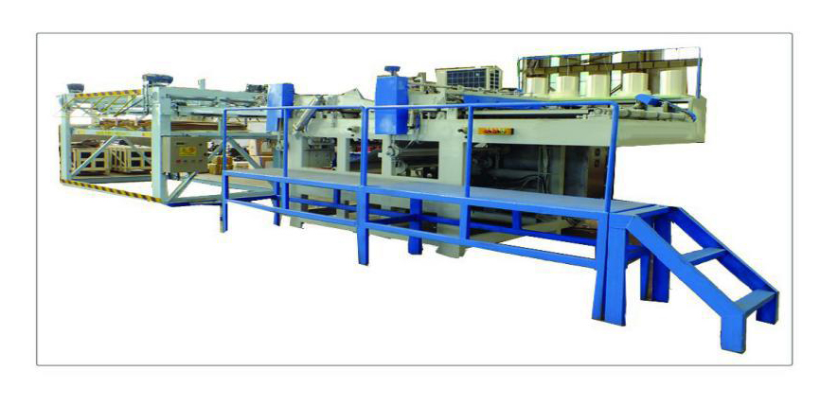

Automatic trimming saw ( HS code : 84659100)
Long saw cutting size | 1830-2440mm
Lateral saw cutting size | 915-1220mm
Working speed | 10-30m/min
Power | 42KW
Saw blade dimension | Diameter 305mm, inner diameter 25.4mm
Capacity | 8-12 pics/min
The working style | Infrared ray guidance
Feed way | Full automatic
Work methods | Full automatic
Weight | 5000KG
Overall dimension | 8000*5000*1200mm
FOB Qingdao | USD 23800.00/set

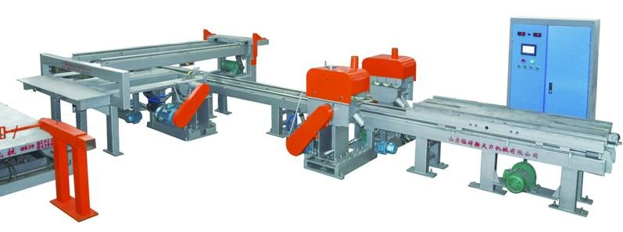

Cold Press (HS code: 84793000)
Total pressure | 400T
Board feeding direction | Transverse
Layers | 1
Layer spacing | 1800mm
Work plate size | 2700*1370mm
Stoke | 1000mm
Cylinder | ø320mm*2pcs
Power | 11KW
Overall dimension | 3550mm*1370mm*4200mm
Weight | 13 Tons
Working methods | Full automatic
Composite frame | assembled
FOB Qingdao | USD 25000.00/set

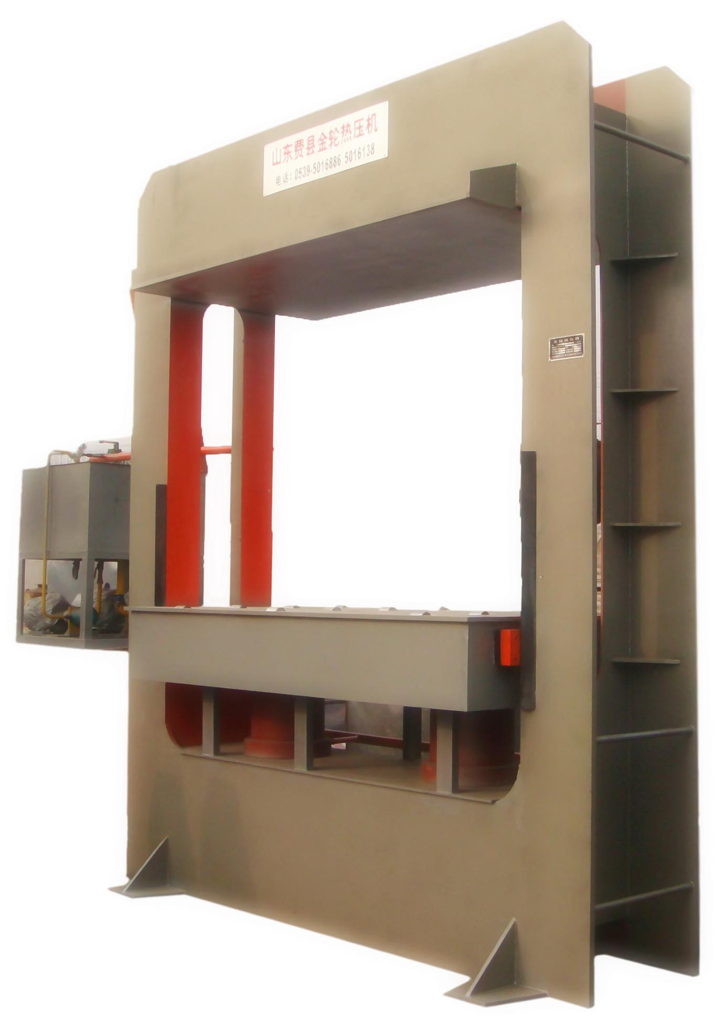

Hot Press (HS code: 84793000)
Total pressure | 500T
Board feeding direction | Transverse
Layer | 15
Layer spacing | 70mm
Number of hot press plate | 16
Hot press plate size | 2700*1370*42mm
Cylinder | ø360mm*2pcs
Stroke | 1050mm
Compression resistance | 25 Mpa
Power | 23KW
Overall dimension | 3550*1370*4200mm
Weight | About 35 tons
Working methods | Full automatic
Composite frame | Assembled
FOB Qingdao | USD 48000.00/set

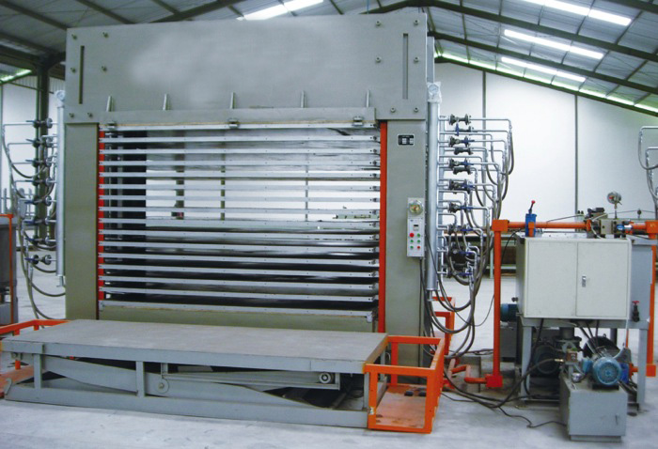

Belt sander (HS code: 84659300)
Working width | 40mm-1300mm
Working thickness | 2-100mm
No.1 sand belt speed | 19m/min
No.2 sand belt speed | 18m/min
Feed speed | 6-30m/min
Size of sand belt (W*P) | 1330*2200mm
Main motor | 35KW 20KW
Total motor power | 57.62KW
Working air pressure | 0.55Mpa
Air consumption | 0.2m3/min
Speed of dust collecting | 25-30m/min
Volume of dust collection | 9000m3/h
Overall dimension | 2625*2680*2130mm
Total weight | 3400KG
FOB Qingdao | USD 24000.00/set

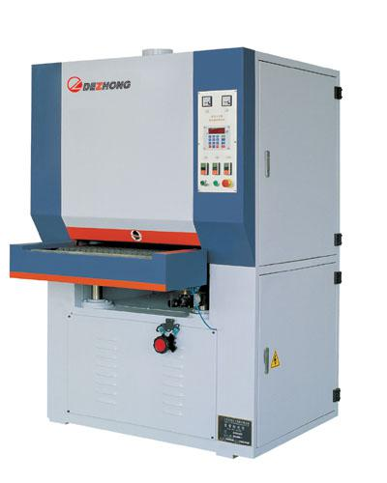

Glue mixer  HS code: 84743100  FOB Qingdao USD 500.00/set | 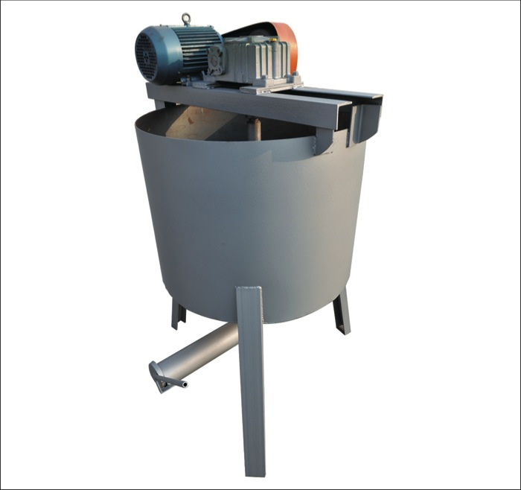
Glue spreader  HS code: 84659900  FOB Qingdao USD 3500.00/set | 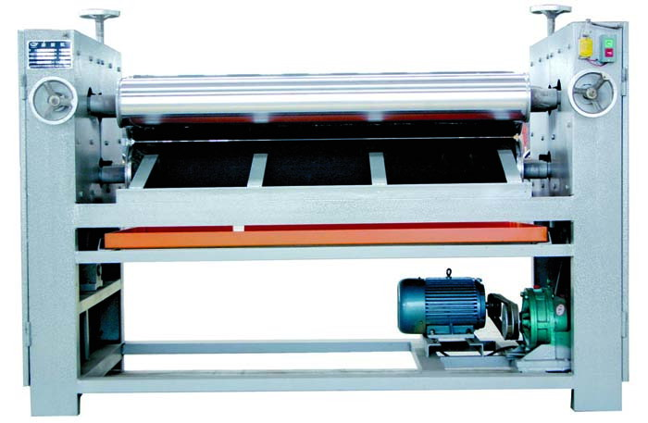
Core veneer dryer  HS code: 84193200  FOB Qingdao USD 13500.00/set | 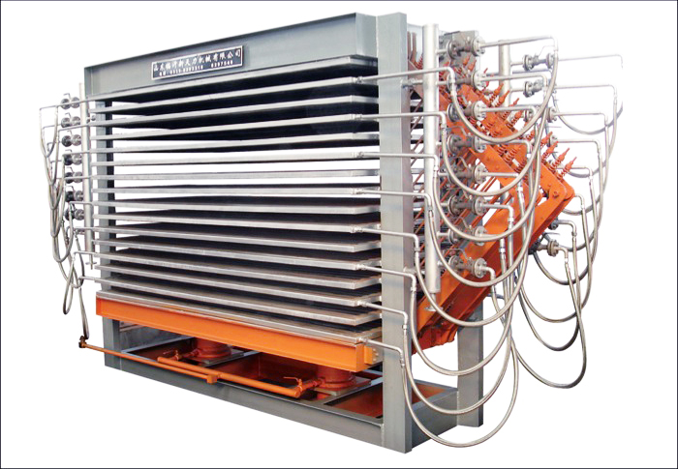
Lift table  HS code: 84289090  FOB Qingdao USD 2000.00/set | 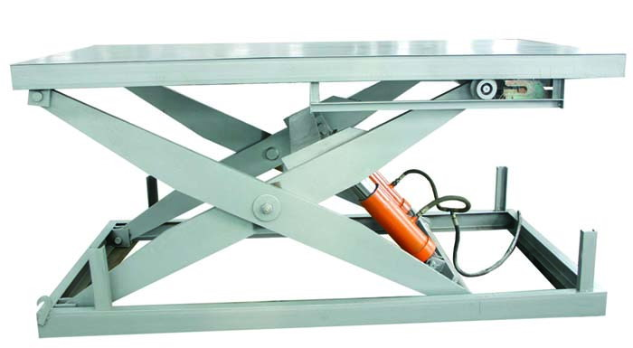

Notice:
1. MOQ: 1 set
2. Payment term: T/T 30% as deposit and 70% balance paid before loading
3. Lead time: 25 days after received the deposit
4. Packing: Standard export loading

Best regard

jimmy
Shandong Jinlun Machinery Manufacturing Co., Ltd
Tel: 86-15963998020
Fax: 86-539-6017787
Skype: jinlun_machine
E-mail:jinlun_machine@hotmail.com
Web: www.timber-machinery.com
Add: No 58. Volvo Road, Economic Development Zone, Linyi City, Shandong Province, China.

