Hi Mr.Jose

Good day!

Did you receive our quotation of 3 tons block ice machine with 5 kg block ice on June 6th? Could you kindly let us know your idea?

1. Ice using purpose
Here I want to do some comparison of the ice characteristic, wish that would give you some inspiration of which kind of machine you really need:
*Block ice machine price is ranking at the second place, which has longest storage period and suitable for fish long distance transportation.
The block ice would be used for fish storage after crushed.
*Flake ice machine is the most economical one but it is most likely to melt in a short time. It widely used for fish short or medium distance transportation.

2.Flake ice machine quotation
Jose, since the output capacity of our flake ice machine range from 1~ 20 tons, here we quote you our 3 tons for your preliminary reference first:

Model | Daily capacity | Hourly capacity | Ice size | Water resource | Cooling system | Germany made Bock Compressor | Dimension | FOB price
KP30 | 3 tons | 125 kg | 1.8-2.0 mm | Fresh water | Air cooling system | 15 HP | 1760 *1120 1460 mm | 10,050 USD

* This price is base on 380 V,50 Hz, 3 phases supply power in Angola , carbon steel evaporator barrel and R22 refrigerant.

*The ice making process is completely automatic, which is controlled by Germany siemens PLC intelligent system.

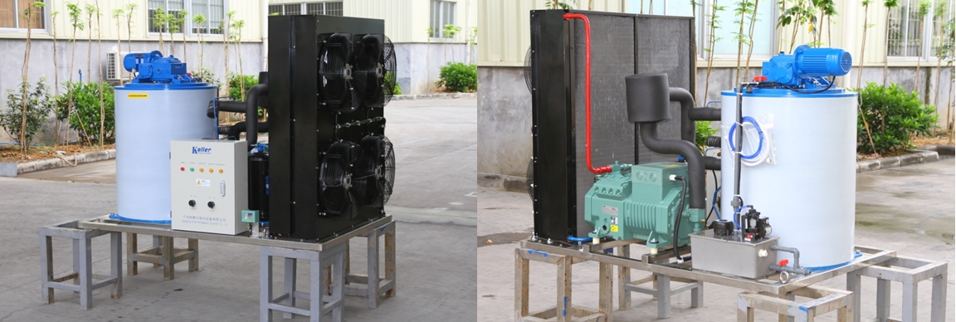
KP30 3 tons flak ice machine

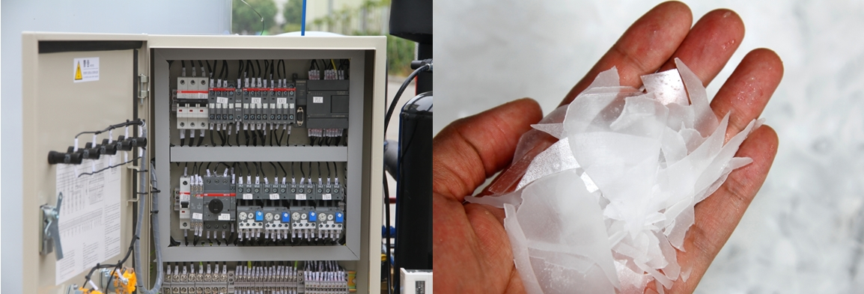
world famous brand ABB electrical components
flake ice- dry and longer preservation

Mr.Jose, could you tell us how many tons of ice you would require for your fish business per day?

Looking forward to your reply
Thanks

Best Regards,
Mr Jam ko (Sales Manager)
Mobile:0086-159 2053 7377 Facebook:Jamko Ye Whatsapp:0086-159 2053 7377
Skype:jamko_ye Viber: 0086-159 2053 7377 Wechat:422105828

