Dear Mr. Antonio Mateos

This is Jamko writing from Koller refrigeration equipment company. Thanks for your inquiry about our flake ice machine.

1.Specification and quotation
The daily output capacity of flake ice machine range from 200kg ~ 20 ton with different prices.
In the following, we quote our standard 5 tons & minimum 200 kg model for your preliminary reference:

Model | Capacity/24 hours | Capacity/ hour | Water resource | Cooling system | Compressor | Equip with ice collecting bin | Power supply | FOB price
KP02 | 200 kg | 9 kg | Fresh water | Air cooling system | 1.25 HP Italy Aspera | √ | 220V (household) | 3,750 USD
KP50 | 5 tons | 209 kg |  | Water cooling system | 20 HP Germany Bock | × | 380V (industrial) | 23,000 USD

*This price is base on machine using supply power in Spain, carbon steel evaporator barrel and brand new compressor with widely used and approved R404a refrigerant.

*The ice collecting bin, ice handcart and ice shovel are provided for free with the KP02 flake ice machine.

*Germany Bitzer compressor is also accessible for the 5 tons flake ice machine with same price as Bock compressor.

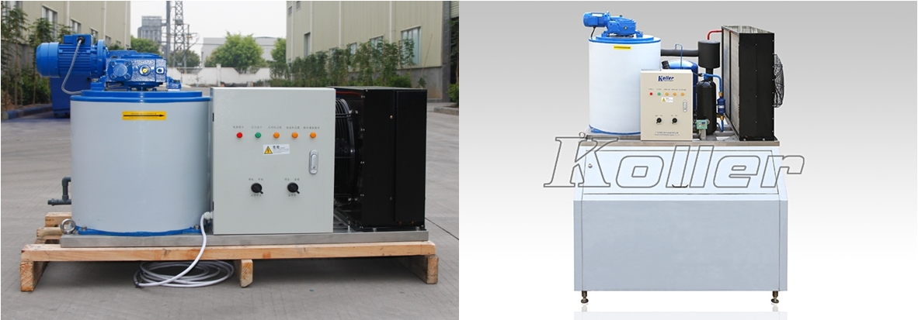
KP02 flake ice machine Combined with ice bin
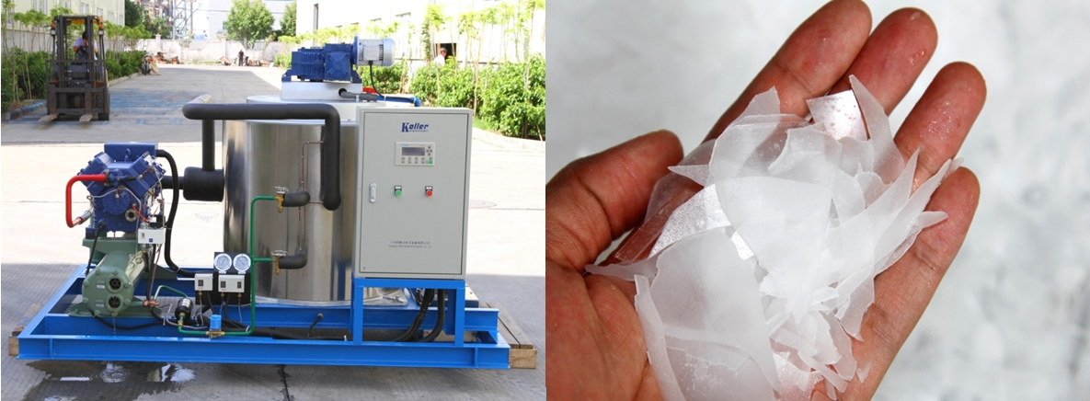
5 ton flake ice machine KP50 flake ice

***So Antonio, could you kindly tell us how many tons of ice you require per day, so that we could have the right recommendation?

Looking forward to your reply
Thanks

Best Regards,
Mr Jam ko (Sales Manager)

