from: http://www.icemachineschina.ru
----------------------------------------------------
Dear Марченков андрей Борисович

How are you!

This is Jamko writing from Koller refrigeration equipment company. Thanks for your inquiry about our cube ice machine.

1.Specification and quotation for cube ice machine

The daily output capacity of cube ice machine range from 1~20 tons. The ice has 22*22*22 mm or 29*29*22 mm two size for customer preference.

Model | Ice size | Ice making time | Batch capacity | Daily capacity | Framework and ice storage bin material | Cooling system | Germany made Bock Compressor | FOB price
CV1000 | 22*22*22 mm | 20 mins /batch | 14 kg | 1,000 kg | Food-grade stainless steel 304 | Water cooling | 4 HP | 10,500 USD
CV2000 |  |  | 28 kg | 3,000 kg |  |  | 12 HP | 14,600 USD

In following, we quote 1 ton & 2 tons daily output capacity for your preliminary reference:

*These price is base on 380V, 50 Hz, 3 phase supply power in Russia and brand new Bitzer compressor with R404a refrigerant (environmental and approved).

Youtube video share: https://www.youtube.com/watch?v=GBjl4h5nc0c

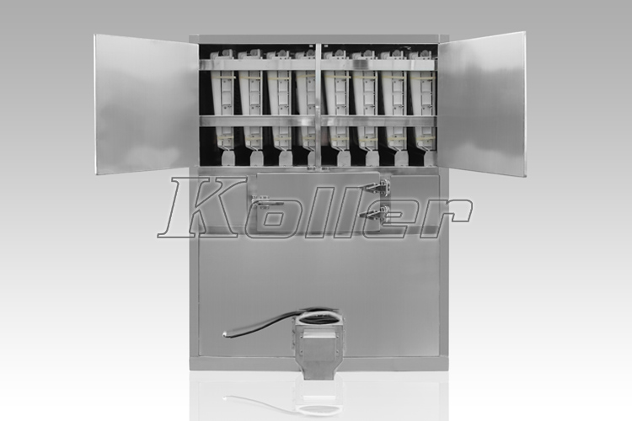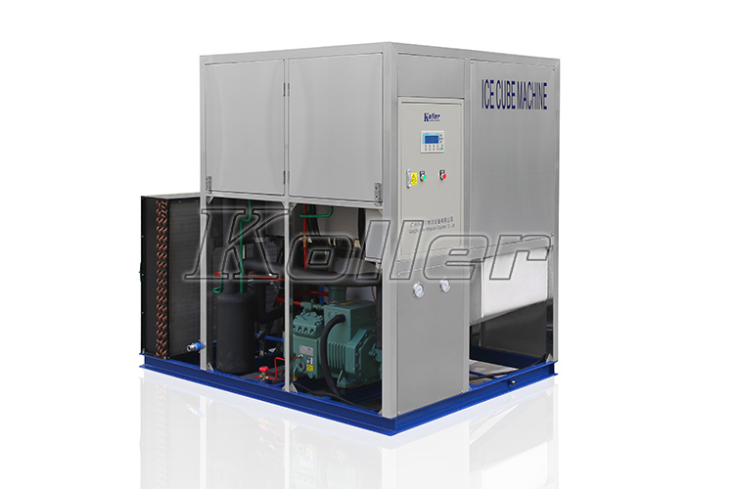
2 tons cube ice machine with air cooling system

2.Марченков андрей Борисович, are you going to install this machine in Russia?

Since the temperature in Russia is moderate for our machine working, we suggest to equip with air cooling system, which integrated with cube ice machinery unit for more flexible movement.

What do you think?

Looking forward to your reply
Thanks

Best Regards,
Mr Jam Ko (Sales Manager)

