Dear Walter Iriarte

How are you!

We would like to introduce ourselves as a ice machine manufacturer and exporter, located in China free trade zone area of Guangzhou, China.

We learn from Alibaba that you are in need of edible ice machine and want to see if we could help for establishing ice production line.

According to your description, we suppose that our 2 tons cube ice machine and 2 tons tube ice mchine would mostly meet your demand, please refer to the specification table:

Model | Ice size | Ice making time | Batch capacity | Daily capacity | Framework | Cooling system | Germany Bitzer Compressor | FOB price
TV200 | 22*22*22 mm | 20 mins /batch | 28 kg | 2,000 kg | Food-grade stainless steel 304 | Water cooling | 9 HP | 14,640USD
CV2000 |  |  |  |  |  |  |  | 15,000 USD

*These prices are based on maching using 220V, 60 Hz, 3 phases power in Peru, brand new Bitzer compressor with environmental refrigerant R404a.
*The cube ice machine equip with ice bin (including in price) not only for ice storage but for ice packing process. While the tube ice machine have to equip with external ice bin (sold separately) for storage and packing.

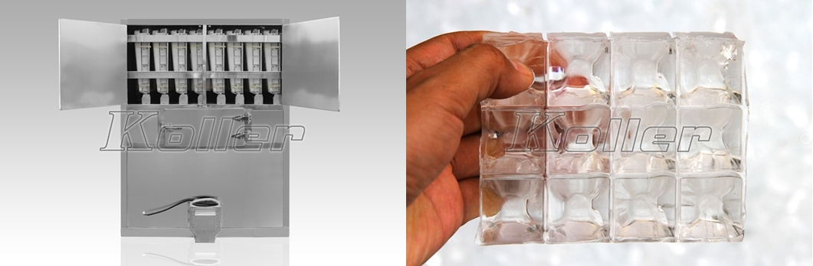
CV2000 commercial cube ice machine

Youtube video of cube ice machine: https://www.youtube.com/watch?v=GBjl4h5nc0c

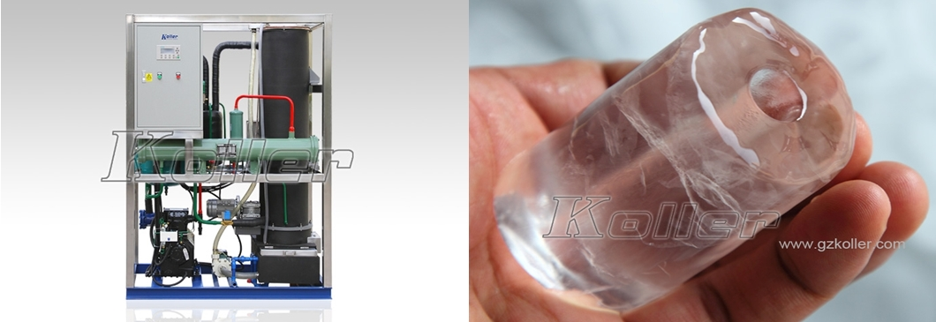
TV20 tube ice machine

Youtube video of tube ice machine: https://www.youtube.com/watch?v=yG1CCZK3izo

*Walter, could you please kindly tell us which kind of ice you prefer, tube ice or cube ice?

Looking forward to your reply
Thanks

Best Regards,
Mr Jam ko (Sales Manager)

