2Re:XXXX, flake ice machine and block ice machine capacity from Koller refrigeration

Dear XXX

How are you!

We would like to introduce ourselves as a flake ice & block ice machine manufacturer and exporter, located in China free trade zone area of Guangzhou, China.

1.Mr XXX, before we quote you price, we need to confirm how many tons of flake ice you require from the machine per day?

We design and manufacture 200 kg ~ 20 tons flake ice machine with Germany Bitzer compressor.

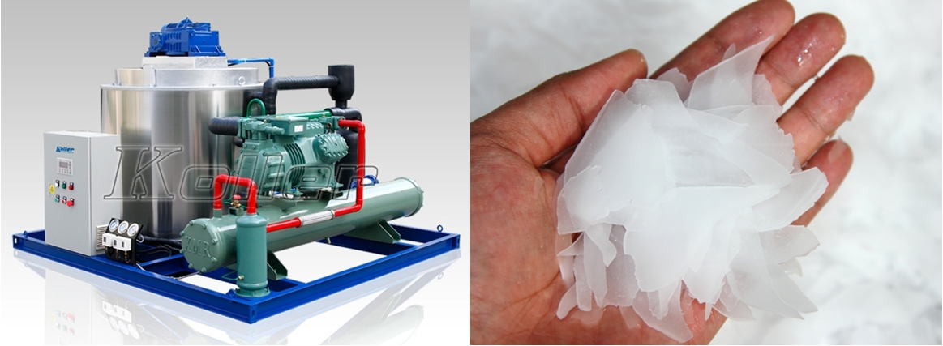

2.Also we suppose you might be in need of a block ice machine, we manufacture block ice machine from 1 ~ 30 tons for export sales. The block ice weight and dimension are customizable.

(1)How much kilograms of each block ice do you want?
(2)How many pieces of block ice do you want per day?
(3)Do you require industrial block ice or edible block ice?

Since it might be the first time to invest the block ice business, here we share the relationship of ice size and freezing time for your reference.
As we can see in the table, the more bigger and thickness for the block ice we made, the longer ice making time that required.

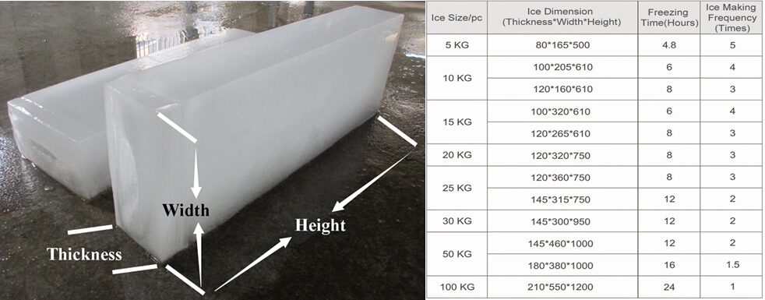

Looking forward to your reply
Thanks

Best Regards,
Mr Jam ko (Sales Manager)
Mobile:0086-159 2053 7377 Facebook:Jamko Ye Whatsapp:0086-159 2053 7377
Skype:jamko_ye Viber: 0086-159 2053 7377 Wechat:422105828

