Hi Ouattara

Good day!

We wonder if you had received our mail about the differences between brine water type and directly freezing type block ice machine on July 4th.

According to your description, here we recommend some of our model for your reference:

1.10 tons brine water type block ice machine for fishery and farming storage

Model | Capacity / batch | Ice weight & ice dimension | Ice making period | Capacity / 24hrs | Compressor | Cooling system | FOB price
MB100 | 250 pcs block ice | 10 kg / 100*205*610 mm | 6 hours / batch | 1000 pcs = 10 tons | 25 HP Germany Bock compressor | Water cooling system | 37,600 USD

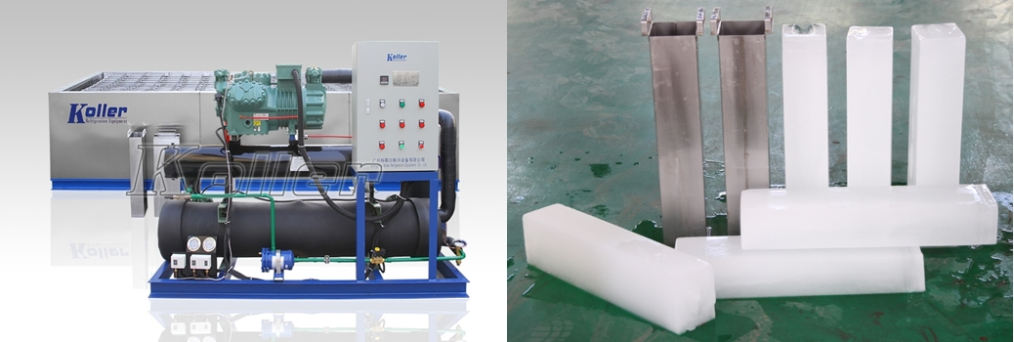

2.10 tons edible cube ice machine for human consumption

Model | Ice size | Ice making time | Batch capacity | Daily capacity | Framework and ice storage bin material | Compressor | Cooling system | FOB price
CV10000 | 22*22*22 mm | 20 mins /batch | 139 kg | 10 tons | Food-grade stainless steel 304 | 2 * 25 HP Germany Bock compressor | Water cooling system | 50,260 USD

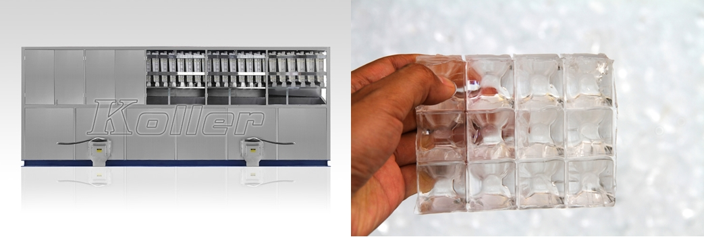

3.10 tons flake ice machine for fishery or industrial cooling purpose

Model | Water resource for ice making | Capacity / 24 hours | Evaporator barrel | Compressor | Cooling system | Equip with ice collecting bin | FOB price
KP100 | Fresh water | 10 tons | Carbon steel | 40 HP Germany Bock compressor | Water cooling system | × | 32,540  USD

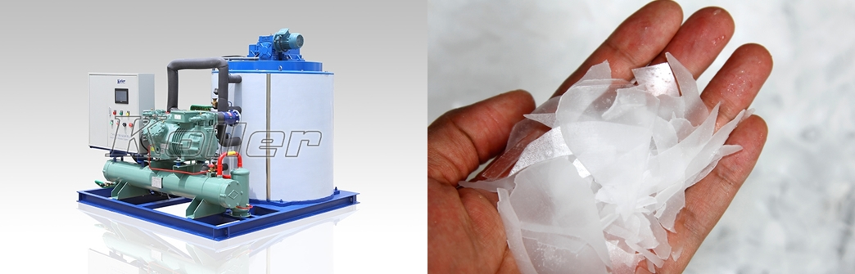

It is estimated that the total investment for all these facilities is around 120,000 USD. If you required largeer production capacity, then you have to invest more.

Ouattara, what do you think?
What kind of edible ice do you want? Currently, we have edible cube ice, tube ice and block ice machine on sales?

Waiting for your most kindness reply
Thanks

Best Regards,
Mr Jam ko (Sales Manager)

