Dear Заза

How are you!

This is Jamko writing from Koller refrigeration equipment company. Thanks for your inquiry about our ice machine.

Since our product cover from cube ice & tube ice machine for human consumption, flake ice and plate ice machine for seafood fast processing and storage and block ice machine for fishery long storage and industrial cooling purpose.

And normally, the the output capacity range from 1~20 tons ice per 24 hours.

*Could you kindly tell us which kind of ice machine you are interested?
Also how many tons of ice you require the machine output per day?

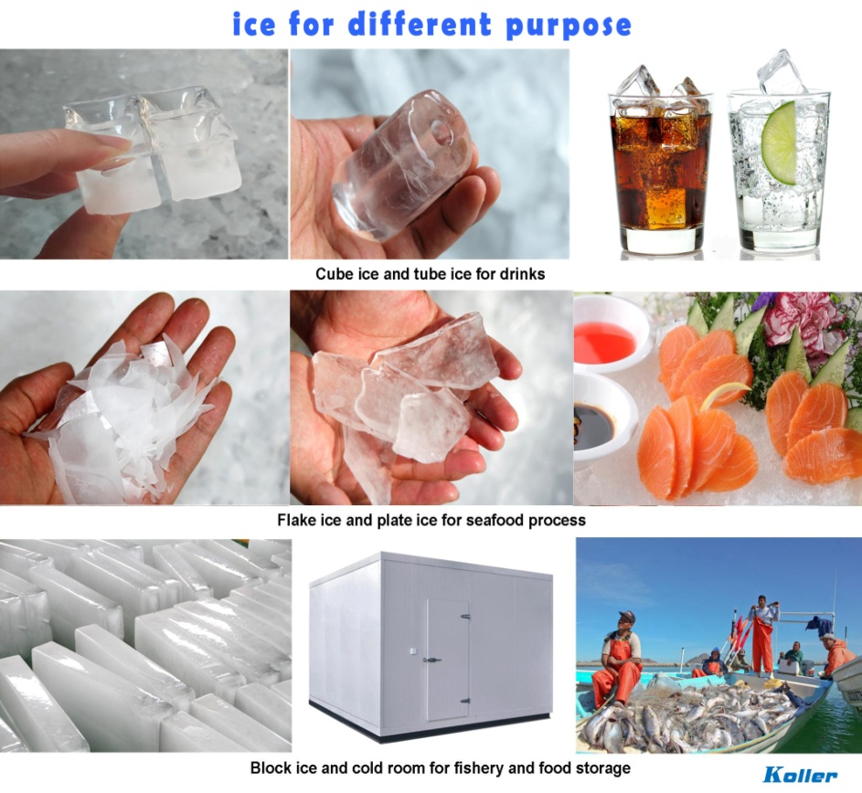
Looking forward to your reply
Thanks

Best Regards,
Mr Jam ko (Sales Manager)

