Hi Заза

Thanks for your reply!

The daily output capacity of cube ice machine range from 1~25 tons.
As for 750 kg daily output capacity, we recommend our 1 ton commercial cube ice machine model CV1000 for your reference:

1.Specification
Model | Ice size | Ice making time | Batch capacity | Daily capacity | Framework and ice storage bin material | Cooling system | Germany made Bock Compressor | FOB price
CV1000 | 22*22*22 mm | 20 mins / batch | 14 kg | 1,000 kg = 1 ton | Food-grade stainless steel 304 | Air cooling system | 4 HP | 10,500 USD

*This price is base on a complete set of machine running under 380V, 50 Hz, 3 phases supply power in Russia, brand new Germany compressor with R404a environmental refrigerant.

*The 29*29*22 mm cube ice size is also available with same price.

Youtube video share: https://www.youtube.com/watch?v=GBjl4h5nc0c

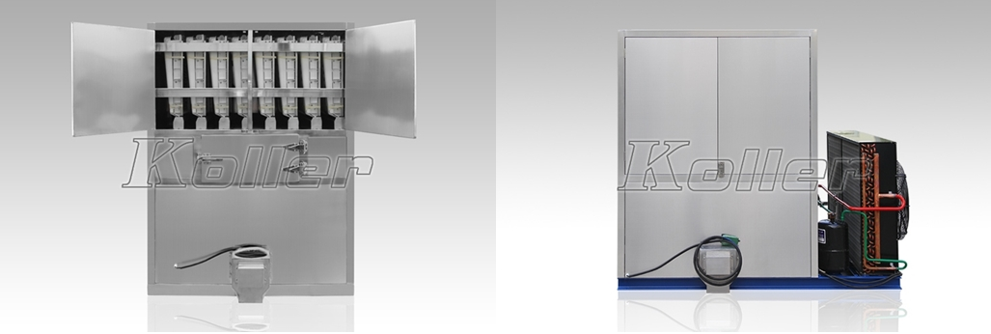
cube ice machine with air cooling system
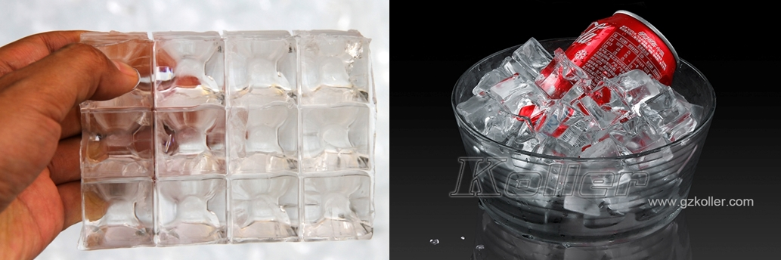
cube ice

2.With developed ice bin
Unlike the traditional household cube ice machine, the packing bin is developed not only for ice temporary storage but for convenient packing ice.
There is a screw conveyor on the bottom of the bin, which can convey the ice into plastic bags by controlling the pedal switch.
In that way, you can pack 3kg, 5 kg, 10 kg or whatever standard of bags ice for the market selling.

One point of another, the bin, the screw conveyor and the framework are all made of food grade stainless 304 to guarantee the ice quality.

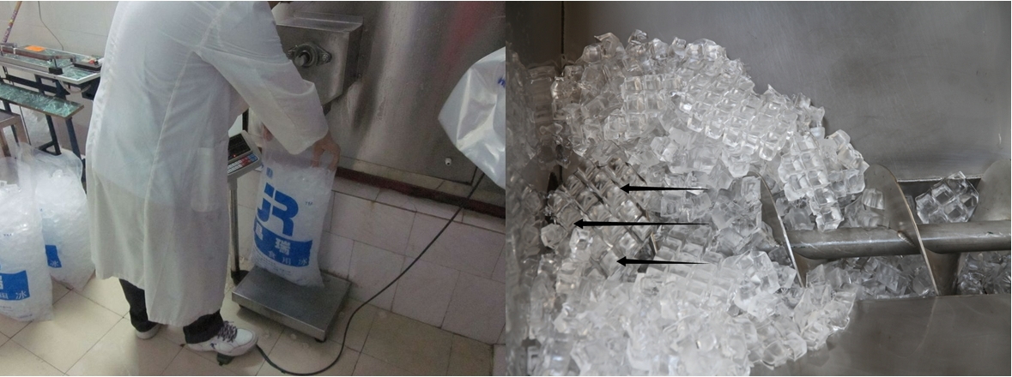
cube ice packing

Заза, whether our 1 tons commercial cube ice machine meet your demand or not?
We will appreciate if you tell us your real name.

Waiting for your most kindness reply
Thanks

Best Regards,
Jamko Ye (Sales Manager)

