Hi Mr. Ahmed

How are you!

This is Jamko writing from Koller refrigeration.Thanks for your inquiry about our block ice machine.

1.The daily output of our salt water block ice machine ranges from 1 ~ 30 tons. The block ice size (L*W*H) and weigh (kg) are customizable to our customers.

Since it might be the first time to invest the block ice business, here we share the relationship of ice size and freezing time for your reference.
As we can see in the table, the more bigger and thickness for the block ice we made, the longer ice making time that required.
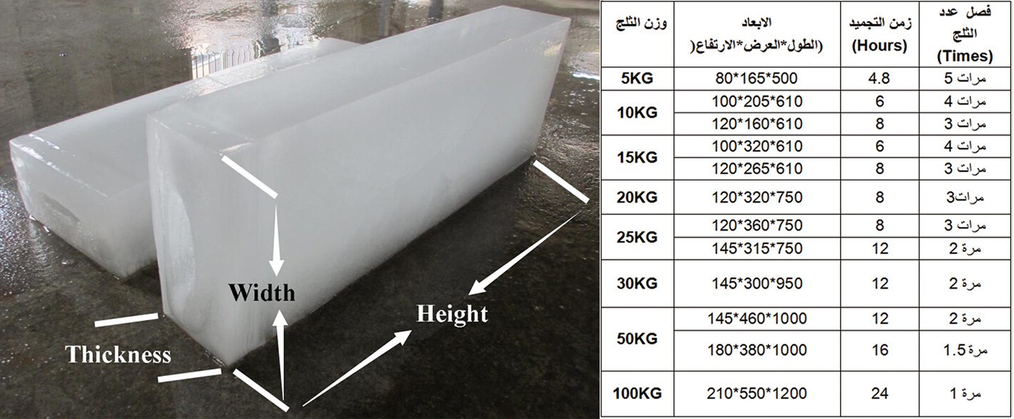
* Mr Ahmed, how much kilograms of each block ice piece do you want?

2.Specification and quotation

For your reference first, we quote you our 8 tons and 5 ton block ice machine in following:
Model | Capacity / batch | Ice weight | Ice making time | Capacity / 24hrs | Compressor | Cooling system | FOB price
MB80 | 134 pieces block ice | 20 kg | 8 hours / batch | 402 pcs = 8 tons | 40 HP Germany Bock compressor | Water cooling system | 28,840 USD
MB50 | 125 pieces block ice | 10 kg | 6 hours / batch | 500 pcs = 5 tons | 25 HP Germany Bock compressor |  | 19,360 USD

*These price are base on a complete set of machine working under 380V,60 Hz, 3 phase supply power in Saudi Arabia.

*To protect from brine water corrosion, the brine water tank and ice moulds are made of anti-rust stainless steel 304.(not painted iron)

2.Pictures and video

*Youtube video of MB50: https://www.youtube.com/watch?v=x9U3F3iW8eQ

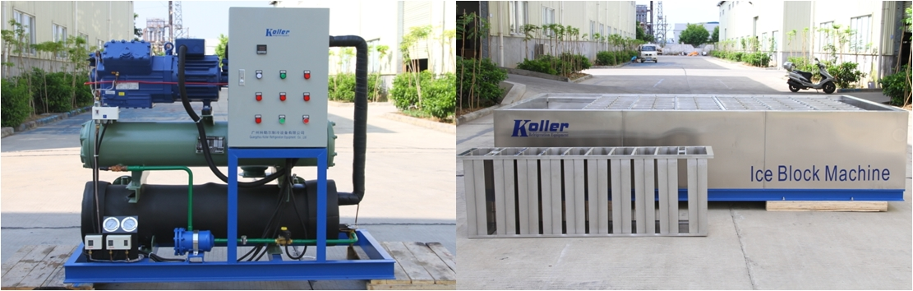
MB80 block ice machine - consist of 1 compressor unit, 1 brine water block ice machine and 1 cooling tower
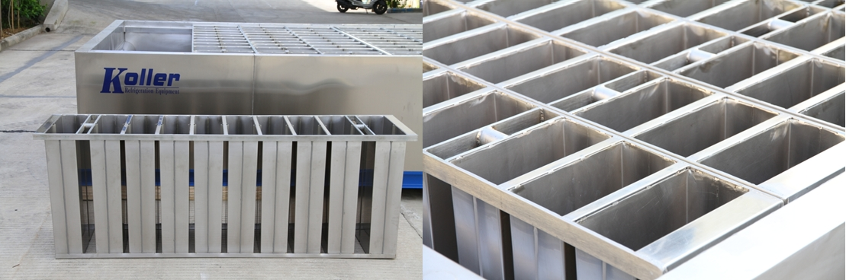
row ice moulds -To protect from the corrosion of salt water, the salt water tank and ice moulds are made of complete stainless steel 304 materical. (not iron sheet)
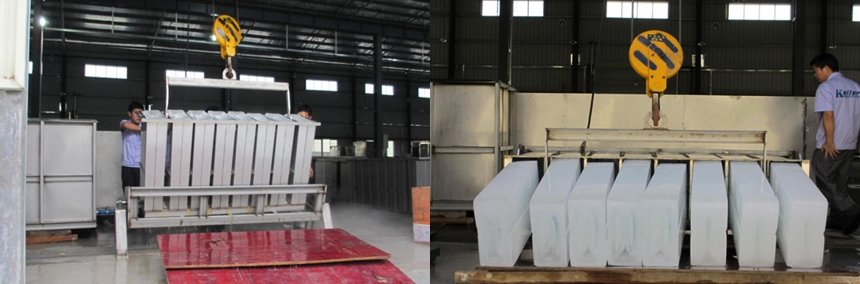
hard and solid block ice - capacity is 100% guaranteed

*Benny, do you think our 8 tons per day capacity block ice machine is good for you?

Looking forward to your reply
Thanks

Best Regards,
Jamko Ye (Sales Manager)

