SPE156/10 Automatic Textile Screen Printer
Quotation: 31000USD(FOB Ningbo) 6Color2dryer/10 Pallets.

Video Link: http://v.youku.com/v_show/id_XMzE2Njc1NDky.html

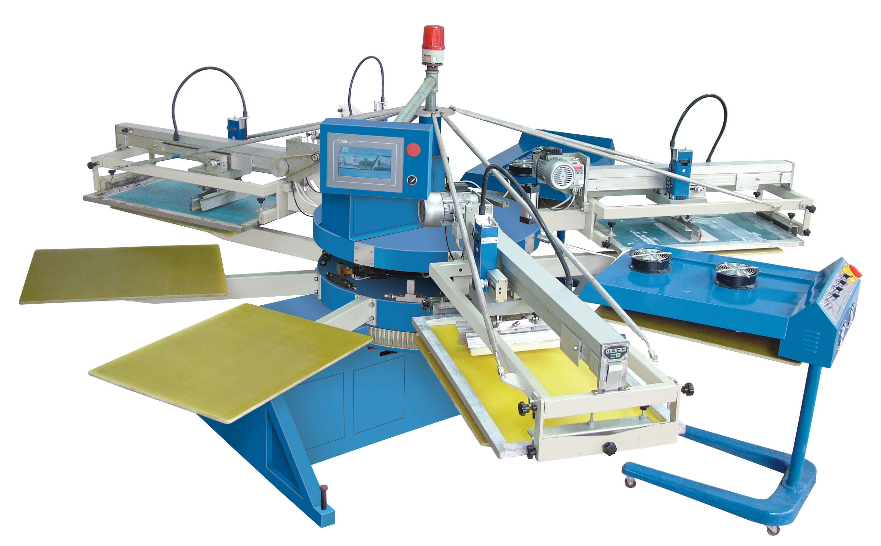

Brief Introduction:
SPE series is the multifunctional automatic screen printers. This equipment series is suitable for printing on all kinds of textile products like t shirt, cloth, socks, umbrella, PVC plate, label, bags and so on.
With intelligent micro-processor, touch screen and servo motor driven system equipped, it brings into high printing stability and colors registration tolerance up to±0.05mm. All parts of the machine body are tested precisely before installation, ensuring minimal maintenance and easy operation. The SPE series automatic screen printer must be your ideal printer in printing industry.

Features:
1, Servo motor driven and high-tech system built in
2, Turntable Rotates freely for high positioning nice registration.
3, Print/flood speeds adjusted electrically
4, Print pressure, print strokes , and it angle are adjustable.
5, The movable dryer can be put inside of any print stations as necessary

Advantages:

1．Heavy-duty steel structure and tough clamps system to keep the frame steady angles on horizontal & vertical during printing
2．Touch screen control center and independent versatile membrane control system in each print heads
3．Turn table driven by servo motor, electrical running print head and micro color-to-color registration system with +/-0.02mm clearance.
4．Real-time production data and self-diagnostic alarming system.
5．Loading and flash curing time control, high production and easy operation.
6．Print/flood speed and pressure calibrated adjustment
7．Front/back stroke length adjustment and easy operation, reducing fatigure.

Main Technical Parameter:

Model | SPE-156/10
Print Color/Station | 6/10
Max. print Area | 400×600/mm
Pallet Size | 500×700/mm
Frame Size | 580×880/mm
Air | ≥1.0Mpa
Max.Output | 700pcs/h
Power | 2.0Kw
Dryer Unit Power | 13.5Kw
Size | φ4000×1850/mm
Weight | 2400Kg
Configuration list:
名称(Name) | SPE品牌(Brand)
触摸屏(Touch Screen) | 台达(DELTA)（colorful)
伺服电机(Servo Motor) | 南京苏强(2KW)
变频器(Transducer) | 台达(DELTA)(0.75KW/220V)
交流接触器  (AC Contactor) | 施耐德(SCHNEIDER)
中间继电器(Middle Relay) | 欧姆龙（OMRON）(24VDC)
接近开关(Proxity Switch) | 欧姆龙(OMRON)
电源滤波器(Power Source Filter) | 埃德(AERODEV)(20A/220V)
急停按钮(Emergency Switch) | 施耐德(SCHNEIDER)(BE102C
带锁开关(Switch With Lock) | 施耐德(SCHNEIDER)(BE101C0
旋钮开关(Spin Switch) | 施耐德(SCHNEIDER)(BE101C
空气压力表Air Manometer | 日本SMC
特 制 主气 缸(Special Cylinder) | 优力克（UNIQUC）(Single-head Cylinder)
消 声 器(Muffler) | 亿日（EASUN）
调 压 阀(Air Vent Valve) | 优力克（UNIQUC）
二通膜片阀(Two-way Valve) | 台湾纽曼（PNEUMAN）
二位三通电磁阀(Electromagnetic Valve) | 优力克（UNIQUC）
Belt | Megadyne(Italy)

Also we suggest other accessary equipment as below:

Here is the video links for processes before printing.
Step1: Screen Stretching
http://v.youku.com/v_show/id_XMjI1NDc3NjE2.html
Step2: Image Making
http://v.youku.com/v_show/id_XMjIzMTAwMDk2.html
Pre-print Equipments
A.SQ Screen Stretcher:
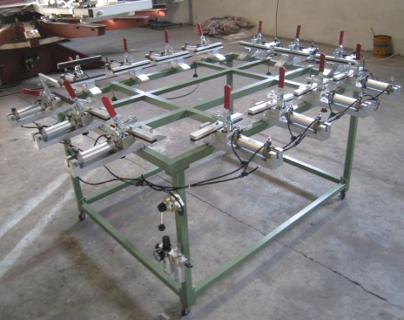

Parameters
Model | SQ
Air Pressure | 0.3-0.6Mpa
Max. Stretch Area | 1200×900/mm
Number of Screen Clamps | 14
Cylinder Specification | ∮50×60/L
Weight | 280Kg

B. SBW1400 Series Exposure Machine
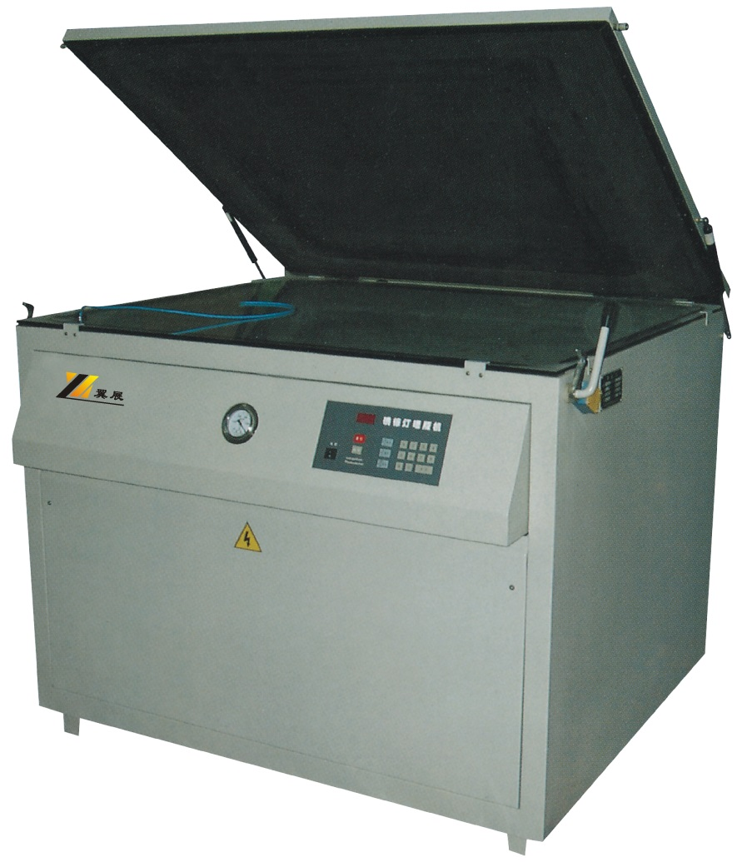

STANDARD FEATUERS

1, Automatic lights shutting off time can be pre-set by the operators

2, Heavy-duty construction but easy to assemble/ dissemble
3, High-powered halogen point light source offers faster but more excellent exposure result
4, Built-in light reflector maximizes the image resolution
5, The unique cabinet design and tabletop operation interface enable its unit to fit through a standard doorway
6, Gas shock system let the blanket frame poping up/down being a pleasure
7, LED timer and air pressure gauge outer display system allows for easy clear information readout

8, All emulsion materials are available: direct, capillary and indirect
9, Two safety yellow lamps features for viewing and setup indicator
10, Top vacuum environment delivers a pure intimate contact between blanket and screen.

SPECIFICATION

Model | SBW-1400
Exposure area | 1300×1150mm
Frame | 1000×850mm
Power | 3.5kw
Size | 1400×1250×1080/mm
N.W/G.W | 140/175kg
Packing size | 1600* 1480* 1270MM

C.SHB FILM POSITIONING & SCREEN FRAME DRYING MACHINE
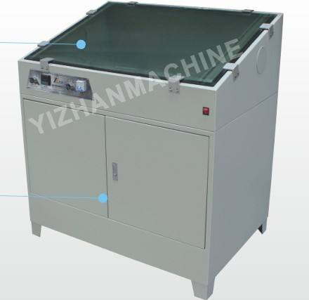
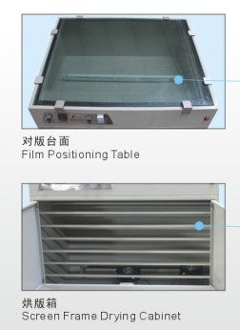
Model | SHB
Screen Frame Size | 1200*900mm(Optinal)
Power | 3.0kw 220V 50/60Hz
Dimension | 1350*1000*1300/mm
Weight | 100kg

D. Screen Frame Cleaner
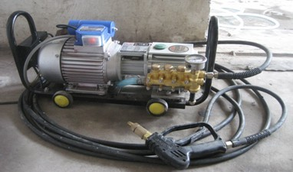

After-printing

E.SCD IR Conveyor Dryer,
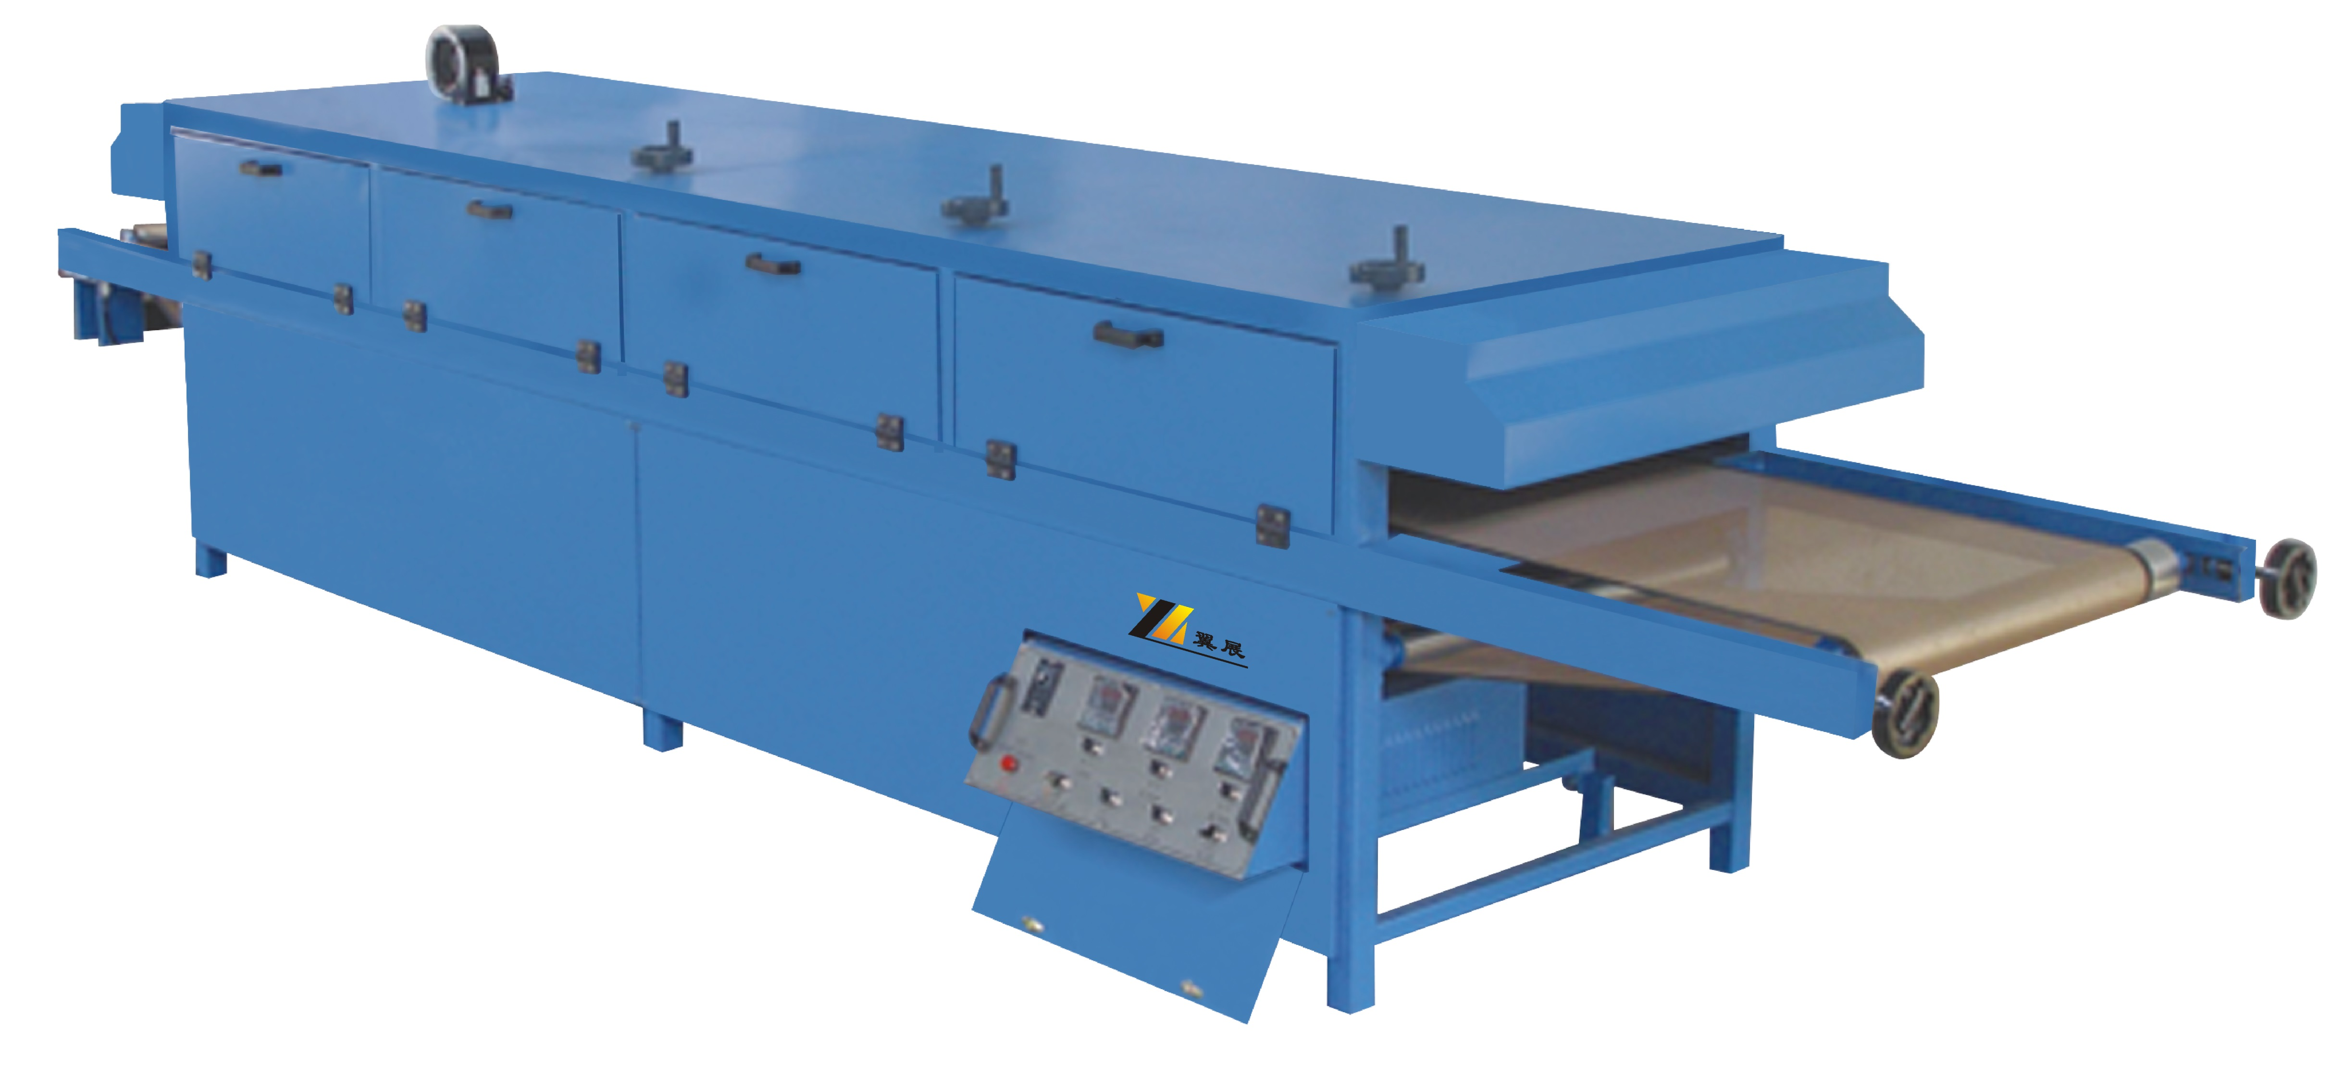

STANDARD FEATURES
1, Extremely high powered multiple infrared curing elements
2, Three turbo fans provide for heat air flows circulation, cooling, harmful exhaust respectively
3, The curing chamber is divided into three zones that can be controlled independently
4, Visible temperature LED display delivers high precision temperature control
5, Automatic shutdown system backed with multiple thermoldoubles saves more electric energy
6, Filled-in asbestos heat resistant structure eliminates accidental contact and prevents heat migration.
7, Teflon coated fiberglass belt can be extended to 2000mm width wider.
8, Adjustable infrared curing panel height
9, Anodized tougn steel rollers for positive belt tracking
10, Innovative drawer-shaped control panel can be hided if not used
11, In feed / out feed extensions are available according to customer requirements

SPECIFICATION:
Model | SCD
Speed | 8m/min (Adjustable)
Belt Width | 800/mm(Optional)
Max. Temperature | 200℃
Tunnel Length | 7000/mm(Optional)
Size | 5560×1520×1300/mm
Voltage/Frequency | 3Ph 380V/50Hz
Heat Power | 27Kw

